**Ref 1 :**

* Create the React App

>>> npx create-react-app your_project_name

* Run the React App

>>> npm start

**Ref 2:**

* Routing in React
* Install the package react-router-dom

>>> npm i react-router-dom

* In App.js, Import Some react router dom package and Import Component u want to render. 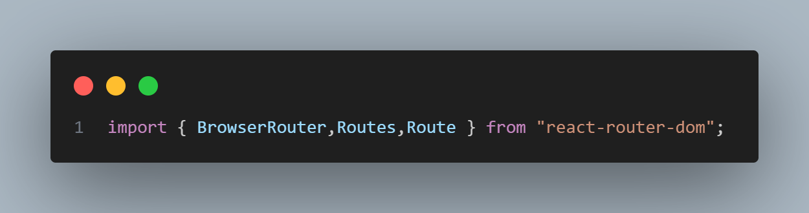
* Use this syntax to route to another

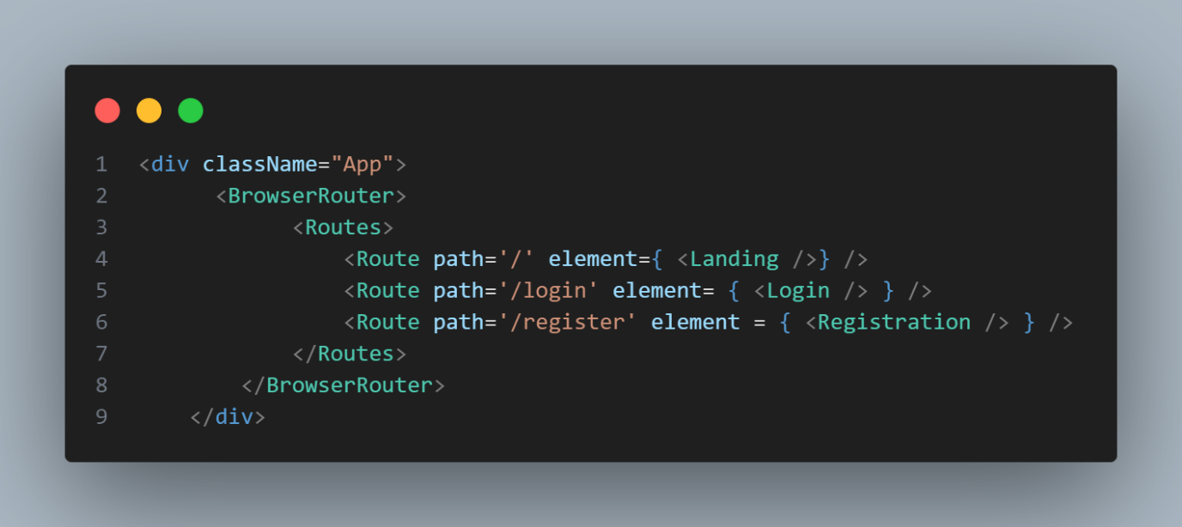

Ref 3:

* Simple get data from form and save it in state.

