***Deployment***

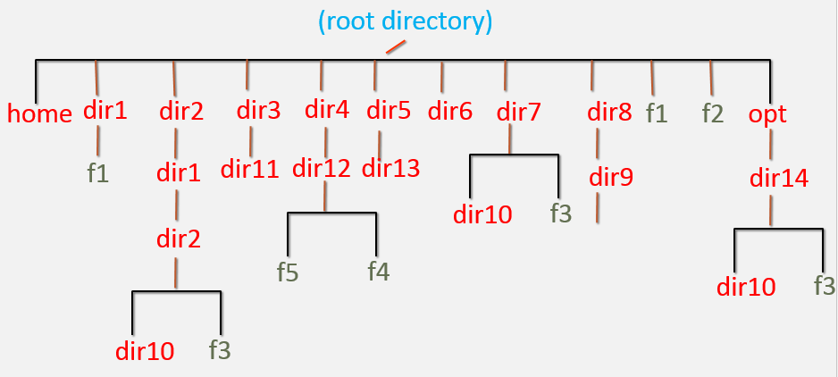

1. Login to the server as super user (root) and perform below
2. Create the file and directory structure shown in the above diagram.
3. Perform below steps
   1. Create directory – /dir6/dir4
   2. Create file – /f3
   3. Write this text “Linux assessment for an DevOps Engineer!! Learn with Fun!!” to the /f3 file and save it.
   4. Replace the “DevOps” text to “devops” in the /f3 file without using VI  editor.
   5. Search for the pattern “Engineer” and replace with “engineer” in the file /f3 using single command using VI Editor.
   6. Move the file from “/dir1/f1” to “/dir2/dir1/dir2”
   7. Rename the file ‘/f2′ to /f4’
   8. Create directory – “/home/user2/dir1”
   9. keeping  “/dir2/dir1/dir2/dir10” as present working directory; create file “/opt/dir14/dir10/f1” using relative path method.
   10. Move the file from “/opt/dir14/dir10/f1” to  user2/dir1 directory
   11. Delete the directory recursively “/dir4”
   12. Delete all child files and directories under “/opt/dir14” using single command.
   13. Create file “/dir1/f2”
   14. Delete /dir6
   15. Delete /dir8
   16. Delete /f3
   17. Search for the file name ‘f4’ in the server and list all absolute paths where f4 file is found.
   18. Show the count of the number of files in the directory ‘/’
   19. Delete /dir1
   20. Delete /dir2
   21. Delete /dir3
   22. Delete /dir5
   23. Delete /dir7
   24. Delete /f1 & /f4
   25. Delete /opt/dir14