# Ex.No: 12 Memory Management Using Paging Technique

# Date : 29.04.2021

**Aim:**

# To write a program for memory management using paging technique.

**Algorithm:**

* Start
* Get the size of the program and size of the page from the user
* In a program every page has equal size and equal number of instructions.so it is enough to get pagesize of anyone of the page in the program from the user.
* And display the number of pages needed , by dividing program size by page size
* declare an array to create logical memory which contains the pages and instructions inside each page.
* Then declare another array to create a page table which contains the frame number of each page.
* Then calculate the physical memory address where the pages of the program need to be stored. • The physical memory address can be calculated by the formula • ((Frame number * page size) + offset
* Frame number is present in the page table ,page size is got from the user,and offset means the instruction for which physical memory address is to be calculated.
* Then display the physical memory address of each and every page along with the physical memory address of every instruction of a particular page.
* End program

**Program:**

#include<stdio.h>

void main()

{  
int prs,pas,pn,i,j,sum=0;

int a[30],p[50];

printf(“enter the size of the program in kb : “);

scanf(“%d”,&prs);

printf(“enter the size of the page in kb : “);

scanf(“%d”,&pas);

pn=prs/pas;

printf(“Number of pages needed : %d”,pn);

for(i=0;i<prs;i++)

{  
a[i]=sum;

sum++;

}

Sum=0;

for( i=0;i<pn;i++)

{

Pt[i]=sum;

Sum=sum+2;

}

For{;i<50;i++)

{

Pt[i]=-1;

}

//calculating physical memory address

sum=1;

y=1;

for(i=0,x=0;i<5 && x<prs ;i++)

{

printf(“\nphysical memory address of page %d with %d instructions “,sum,pas);

sum++;

for(j=0;j<pas;j++)

{

P=((pt[i]*pas)+x);

Printf(“\n physical memory address of instruction %d :: “,y);

Printf(“%d”,p);

X++;

Y++;

}}}

**Output:**

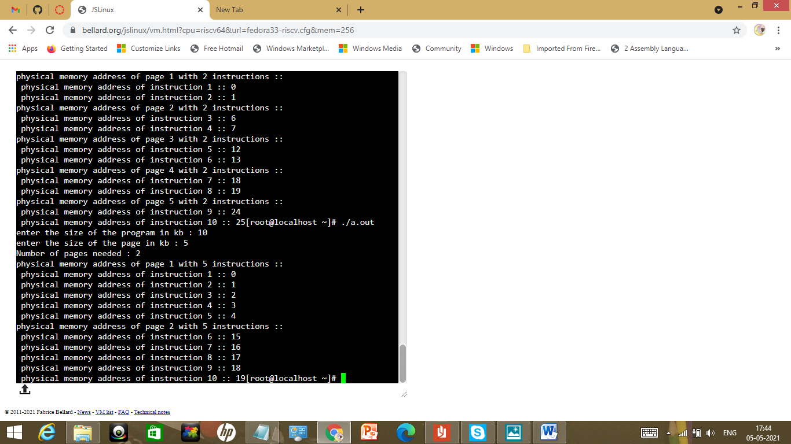

|  |  |
| --- | --- |
| Observation(20) |  |
| Record(5) |  |
| Total(25) |  |
| Initial |  |

**Result:**

# Thus the program for memory management using paging technique was successfully executed and outputs were noted.