

Name: Mobile Computing for Modern App Development Name: Yuvaraj D (192421230)

Course Code: ITA0306

21) In Figma, design a mobile app interface that prioritizes user connectivity and convenience. Highlight key elements.

Aim:
To design a mobile app interface that prioritizes user connectivity and convenience.
Highlight key elements.

Procedure:
- Create a file
- Add The First Frame
- Add Shapes
- Add Text
- Create The Second Frame
- Add Prototyping Design:
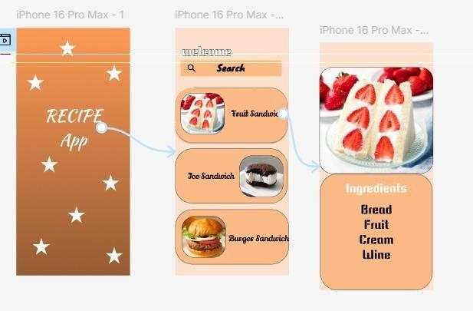

Result:
Hence the mobile app interface that prioritizes user connectivity created and executed successfully.

