Phase 2

Student name : K. YUVARAJ

Register number : 422623104302

Institution : ANNA UNIVERSITY,PANRUTI

Department : COMPUTER SCIENCE AND ENGINEERING

Date of submission **: 09.05.2025**

1. **Problem Statement :**

Traditional customer support systems often struggle with high response times, inconsistent service quality, and limited scalability, especially during peak hours. Customers frequently face long wait times and repetitive interactions, leading to dissatisfaction and decreased loyalty. There is a critical need for an intelligent, automated solution that can efficiently handle a wide range of customer queries, provide 24/7 assistance, and deliver consistent, personalized experiences.

1. **Project Objectives :**

* fast, personalized, and consistent responses to improve customer satisfaction and engagement.
* Ensure Scalability and Reliability: Build a system that can handle high volumes of concurrent user interactions without performance degradation Develop an Intelligent Chatbot: Design and implement a chatbot powered by natural language processing (NLP) and machine learning (ML) to understand and respond to customer queries accurately and contextually**.**
* Automate Customer Support Tasks: Automate routine support functions such as FAQs, order tracking, appointment scheduling, and issue resolution to reduce human agent workload.
* Enhance Customer Experience: Deliver

3. Flowchart of the Project Workflow

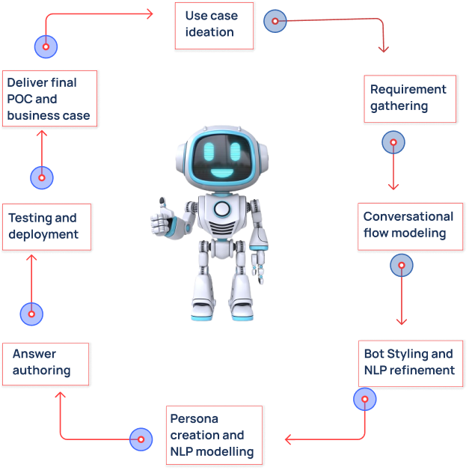

4.Data Description :

1**. Types of Data Used:**

* Customer Queries (Text): User inputs/questions in natural language format.
* Chatbot Responses: Predefined and dynamically generated answers.
* Knowledge Base Articles: Support documentation, FAQs, and troubleshooting guides.
* Interaction Logs: Records of conversations between users and chatbot.

**2. Data Sources:**

* Live customer support chat records (historical and real-time).
* Company’s existing knowledge base or help center.
* CRM platforms (e.g., Salesforce, Zendesk) for user profiles and service history.

5. Data Preprocessing :

* Gather text data from multiple sources: past chat logs, FAQs, CRM systems, and support documentation.
* Merge and standardize data formats (e.g., JSON, CSV, plain text).
* Address class imbalance in intent categories by oversampling minority classes or using techniques like SMOTE.

6. Exploratory Data Analysis (EDA) :

**1. Univariate Analysis:**

* Helps check for class imbalance, which affects model training
* Bar chart showing the frequency of each intent class
* Gauges chatbot performance based on user satisfaction.

**2.Bivariate Analysis :**

* Determine if certain types of queries tend to be longer or shorter
* Box plot of query length grouped by intent
* Violin plot for visualizing distribution shape

**3.Insights summary:**

* Chatbots gather valuable data from customer interactions, businesses with insights into customer preferences and behaviors. This information can be used to improve products, services, and overall customer experience
* Intelligent chatbots are transforming customer support by automating routine tasks, providing instant responses, and delivering personalized experiences. Here's an overview of how intelligent chatbots are revolutionizing customer service:

**7.feature engineering:**

**1.Automated data collection:**

* Chatbots can efficiently gather structured and unstructured data from user interactions, surveys, and feedback forms. This automation accelerates the data collection process, providing a rich dataset for feature engineering.

**2.enhanced feature extraction:**

* By analyzing conversations and interactions, chatbots can identify emerging trends, user sentiments, and frequently mentioned topics. This analysis aids in extracting relevant features that reflect user needs and preferences.

**3.Real-time Feedback integration:**

* Chatbots enable the continuous collection of user feedback, allowing for the dynamic adjustment of features based on real-time data. This responsiveness ensures that product features evolve in alignment with user expectations.

**4.personalized feature integration:**

* Leveraging user data, chatbots can suggest personalized features or improvements, guiding the development team toward enhancements that resonate with individual users.

**9.visualization of results and model insights:**

* ChatGPT now supports interactive visualizations, including bar, line, pie, and scatter plots. These charts allow users to hover over data points for tooltips, adjust colors, and download images in various formats. For more complex visualizations like histograms or heatmaps, ChatGPT provides static images with downloadable options.
* Users can upload datasets from Google Drive or Microsoft OneDrive, enabling seamless integration and real-time data analysis
* After generating a visualization, ChatGPT offers a “View Analysis” link that reveals the underlying Python code used to create the chart. This feature is particularly useful for users interested in understanding the analytical processes behind the visualizations.
* Additionally, users can customize charts by adjusting colors, labels, and other elements to suit their presentation needs. For instance, when analyzing monthly sales trends, ChatGPT allows you to modify line colors and download charts in your preferred format.

**10.Tools and Technologies used:**

**Programming languages**

* **Python:** The primary language for developing and training ChatGPT models, including GPT-3 and GPT-4.
* **C**++: Used for performance-critical components, especially in deep learning operations.
* **CUDA**: Employed for GPU-accelerated computing, enhancing the efficiency of model training and inference.

**Team members and roles:**

**Name Role Responsibilities**

**A.KANIMOZHI data cleaning** data cleaning is fundamental

Fundamental responsibility in

Data analysis and data

Science,ensuring that

Datasets are accurate,

Consistent,and ready

For analysis.

**P.NISANTHI EDA** testing assumptions and

Checking the quality of

Data.

**P.SUNDAR Feature Engineering**  focusing on transforming raw

Data into meaningful features

that enhance model

performance.

**S.VIJAYARAJA Model development** transforming raw data into

Actionable insights through

Predictive modeling.

**K.YUVARAJ documentation and** Ensuring transparency

**Reporting** reproducibility,and

Effective communication of

Analytical processes

And outcomes.