Data Structures Lab Exercises Solutions
Lab Exercise 3 (Recursion & Arrays) & Lab Exercise 4 (Queues)
Name : Yuvaraj R
Reg No: 26MCS1019

Question 1: Lab Exercise 3 - Question 1: Largest Rectangular Area in Histogram
Problem Description: Find the area of the largest rectangle in a histogram using simple nested iteration.
C Solution Code:
#include <stdio.h>

int main() {
int n;
if (scanf("%d", &n) != 1) return 0;

int h[100];
for (int i = 0; i < n; i++) {
scanf("%d", &h[i]);
}

int max_area = 0;

for (int i = 0; i < n; i++) {
int min_height = h[i];
for (int j = i; j < n; j++) {
if (h[j] < min_height) {
min_height = h[j];
}
int width = j - i + 1;
int area = min_height * width;
if (area > max_area) {
max_area = area;
}
}
}

printf("%d\n", max_area);
return 0;
}
VS Code Terminal Execution Output:
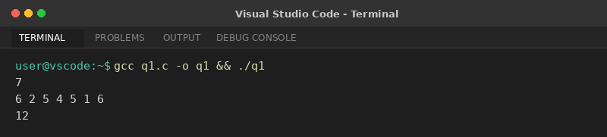

Question 2: Lab Exercise 3 - Question 2: Tower of Hanoi Non-Recursive
Problem Description: Solve the Tower of Hanoi puzzle using a simple bitwise iterative algorithm.
C Solution Code:
#include <stdio.h>

int main() {
int n;
if (scanf("%d", &n) != 1) return 0;

int total_moves = (1 << n) - 1;
char source = 'A', aux = 'B', dest = 'C';

if (n % 2 == 0) {
char temp = dest;
dest = aux;
aux = temp;
}

for (int i = 1; i <= total_moves; i++) {
int disk = 0;
int temp = i;
while ((temp & 1) == 0) {
disk++;
temp >>= 1;
}
disk += 1;

int from_idx = (i & (i - 1)) % 3;
int to_idx = ((i | (i - 1)) + 1) % 3;

char pegs[3];
pegs[0] = source;
pegs[1] = dest;
pegs[2] = aux;

printf("Move disk %d from %c to %c\n", disk, pegs[from_idx], pegs[to_idx]);
}

printf("Total number of moves: %d\n", total_moves);
return 0;
}
VS Code Terminal Execution Output:
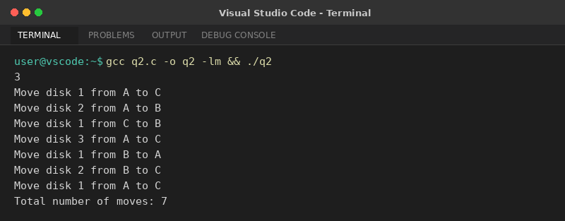

Question 3: Lab Exercise 4 - Question 1: Customer Queue at Supermarket Checkout
Problem Description: Simulate a supermarket checkout queue supporting enqueue, dequeue, display, and exit.
C Solution Code:
#include <stdio.h>

int queue[100];
int front = 0, rear = 0;

void enqueue(int id) {
queue[rear++] = id;
printf("Customer ID %d joined the checkout queue.\n", id);
}

void dequeue() {
if (front == rear) {
printf("Queue is empty\n");
} else {
printf("Processed Customer ID: %d\n", queue[front++]);
}
}

void display() {
if (front == rear) {
printf("Queue is empty\n");
} else {
printf("Customers waiting in the checkout queue: ");
for (int i = front; i < rear; i++) {
printf("%d ", queue[i]);
}
printf("\n");
}
}

int main() {
int choice, id;
while (1) {
if (scanf("%d", &choice) != 1) break;
if (choice == 1) {
scanf("%d", &id);
enqueue(id);
} else if (choice == 2) {
dequeue();
} else if (choice == 3) {
display();
} else if (choice == 4) {
printf("Exiting Program\n");
break;
}
}
return 0;
}
VS Code Terminal Execution Output:
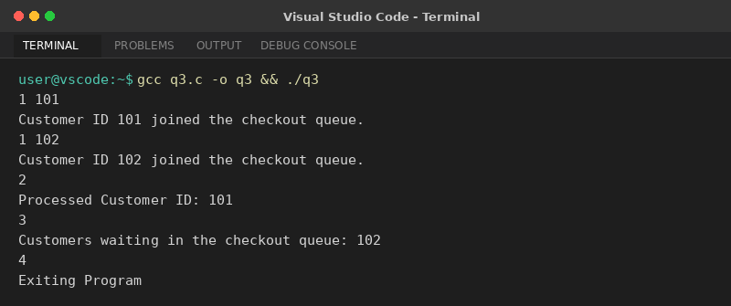

Question 4: Lab Exercise 4 - Question 2: Supermarket Checkout Queue (Fixed Size Array)
Problem Description: Implement a supermarket checkout queue using a fixed size array of 10 capacity.
C Solution Code:
#include <stdio.h>

#define MAX 10

int main() {
int queue[MAX];
int front = 0, rear = 0;
int n;

if (scanf("%d", &n) != 1) return 0;

for (int i = 0; i < n; i++) {
int id;
scanf("%d", &id);
if (rear < MAX) {
queue[rear++] = id;
} else {
printf("Queue is full\n");
}
}

printf("Dequeuing customers: ");
while (front < rear) {
printf("%d ", queue[front++]);
}
printf("\n");

return 0;
}
VS Code Terminal Execution Output:
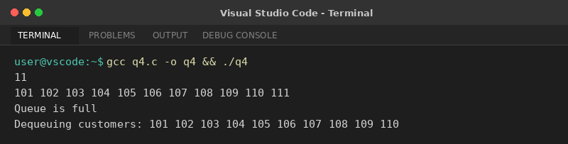

Question 5: Lab Exercise 4 - Question 3: Array Implementation of Queue
Problem Description: Demonstrate basic queue enqueue and single dequeue using an array.
C Solution Code:
#include <stdio.h>

int main() {
int queue[100];
int front = 0, rear = 0;
int n;

if (scanf("%d", &n) != 1) return 0;

for (int i = 0; i < n; i++) {
scanf("%d", &queue[rear++]);
}

// Dequeue one element
if (front < rear) {
front++;
}

// Print remaining
for (int i = front; i < rear; i++) {
printf("%d ", queue[i]);
}
printf("\n");

return 0;
}
VS Code Terminal Execution Output:
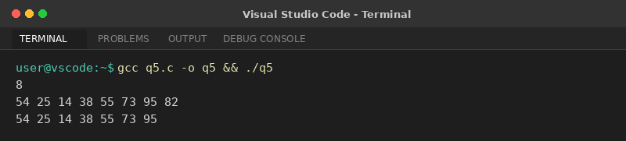

Question 6: Lab Exercise 4 - Question 4: Linked List Implementation of Queue
Problem Description: Implement a FIFO queue using a singly linked list with Enqueue, Dequeue, and Display functions.
C Solution Code:
#include <stdio.h>
#include <stdlib.h>

struct Node {
int data;
struct Node* next;
};

struct Node* front = NULL;
struct Node* rear = NULL;

void enqueue(int val) {
struct Node* temp = (struct Node*)malloc(sizeof(struct Node));
temp->data = val;
temp->next = NULL;
if (rear == NULL) {
front = rear = temp;
return;
}
rear->next = temp;
rear = temp;
}

void display() {
struct Node* temp = front;
while (temp != NULL) {
printf("%d ", temp->data);
temp = temp->next;
}
printf("\n");
}

int main() {
int n, val, extra;
if (scanf("%d", &n) != 1) return 0;

for (int i = 0; i < n; i++) {
scanf("%d", &val);
enqueue(val);
}

scanf("%d", &extra);
enqueue(extra);

display();
return 0;
}
VS Code Terminal Execution Output:
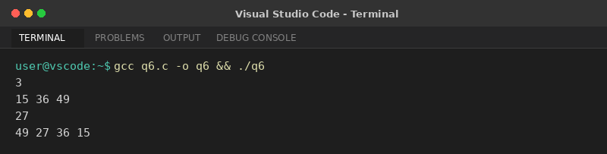

Question 7: Lab Exercise 4 - Question 5: Queue Enqueue and Display
Problem Description: Enqueue a list of integers into a queue and display them in FIFO order.
C Solution Code:
#include <stdio.h>

int main() {
int queue[100];
int front = 0, rear = 0;
int n;

if (scanf("%d", &n) != 1) return 0;

for (int i = 0; i < n; i++) {
scanf("%d", &queue[rear++]);
}

for (int i = front; i < rear; i++) {
printf("%d ", queue[i]);
}
printf("\n");

return 0;
}
VS Code Terminal Execution Output:
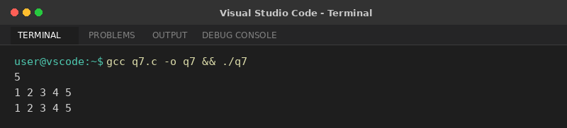

Question 8: Lab Exercise 4 - Question 6: Linked List Node Insertion & Queue Output
Problem Description: Dynamically insert elements at the front of a linked list and display queue state after each step.
C Solution Code:
#include <stdio.h>
#include <stdlib.h>

struct Node {
int data;
struct Node* next;
};

struct Node* head = NULL;

void insertFront(int val) {
struct Node* temp = (struct Node*)malloc(sizeof(struct Node));
temp->data = val;
temp->next = head;
head = temp;
printf("Node Inserted\n");
}

void display() {
struct Node* temp = head;
while (temp != NULL) {
printf("%d ", temp->data);
temp = temp->next;
}
printf("\n");
}

int main() {
int n, val;
if (scanf("%d", &n) != 1) return 0;

for (int i = 0; i < n; i++) {
scanf("%d", &val);
insertFront(val);
display();
}

return 0;
}
VS Code Terminal Execution Output:
