Part - B

11) a)

(i) OS Services (7 marks)  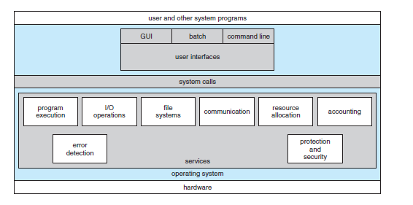  1) User interface  2) Program execution  3) I/O operations  4) File system manipulation  5) Communications  6) Error detection  7) Resource allocation  8) Accounting  9) Protection and security | (ii) Types of System Calls (6 marks)  1) Process control  → end, abort  → load, execute  → create process, terminate process  → get process attributes, set process attributes  → wait for time  → wait event, signal event  → allocate and free memory  2) File management  → create file, delete file  → open, close  → read, write, reposition  → get file attributes, set file attributes  3) Device management  → request device, release device  → read, write, reposition  → get device attributes  → set device attributes  → logically attach or detach devices  4) Information maintenance  → get time or date, set time or date  → get system data, set system data  → get process, file, or device attributes  → set process, file, or device attributes  5) Communications  → create, delete communication connection  → send, receive messages  → transfer status information  → attach or detach remote devices

11) b)

(i) Process States and Context Switching (7 marks)  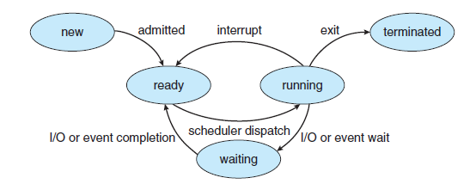  1) New  2) Running  3) Waiting  4) Ready  5) Terminated  Actions taken by kernel to context-switch:  1) State save (in PCB)  2) State restore  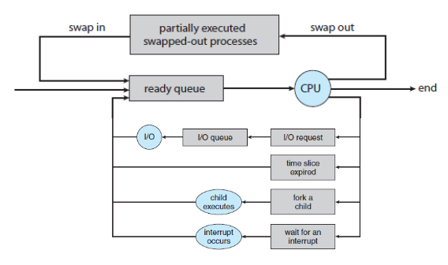 | (ii) Sockets, RPC, and Pipe Mechanism (6 marks)  Sockets  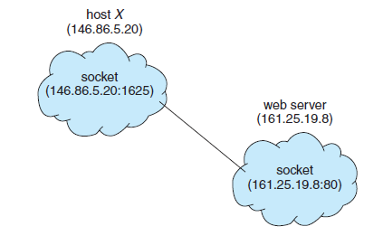  1) Endpoint for communication  2) Pair of processes employ a pair of sockets  3) Identified by IP address + port number  4) All connections have a unique pair of sockets  5) Telnet - port 23; FTP - port 21; HTTP - port 80  Remote Procedure Calls (RPCs)  1) Message-based communication for remote service  2) Messages are well-structured, not packets of data  3) Specify the function to execute, parameters to pass  4) Function is executed  5) Output is sent back in a separate message  Pipes  1) One of the first IPC mechanisms  2) Ordinary pipes  → unidirectional  → parent-child relationship required  → unnamed  → anonymous pipes  → ceases to exist once processes have finished communicating  3) Named pipes  → bidirectional  → once established, can have several processes/writers  → continue to exist after communicating processes are finished

12) a)

(i) Multithreaded Program to Find Prime Numbers (7 marks)  typedef struct {  int start;  int end;  } Range;  int is_prime(int n) {  // check if n is prime  }  void* find_primes (void* arg) {  // find prime numbers in the given range  // display them  }  int main() {  // get n from user  pthread_t threads[5];  // define ranges for each thread  Range ranges[5];  int segment=n/5;  for (int i=0; i<5; ++i)  pthread_create(&threads[i], NULL, find_primes, &ranges[i]);  for (int i=0; i<5; ++i)  pthread_join(threads[i], NULL);  return 0;  }  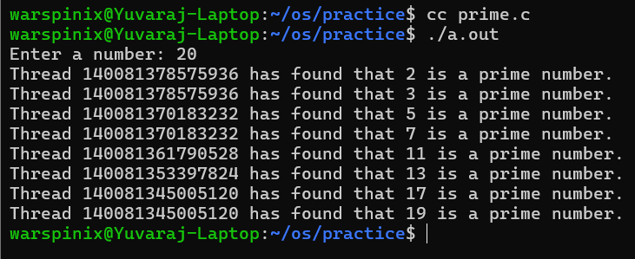 | (ii) Solutions for Critical Section Problem (6 marks)  1) Peterson’s Solution  2) Test and Set  3) Compare and Swap  4) Mutex  5) Semaphores  6) Monitors  Explanation of each solution (OR) code for each.

12) (b) (i) CPU Process Scheduling

(A) Gantt Charts (10 marks)

FCFS

SJF
SRTF

Priority Preemptive

Priority Non-Preemptive
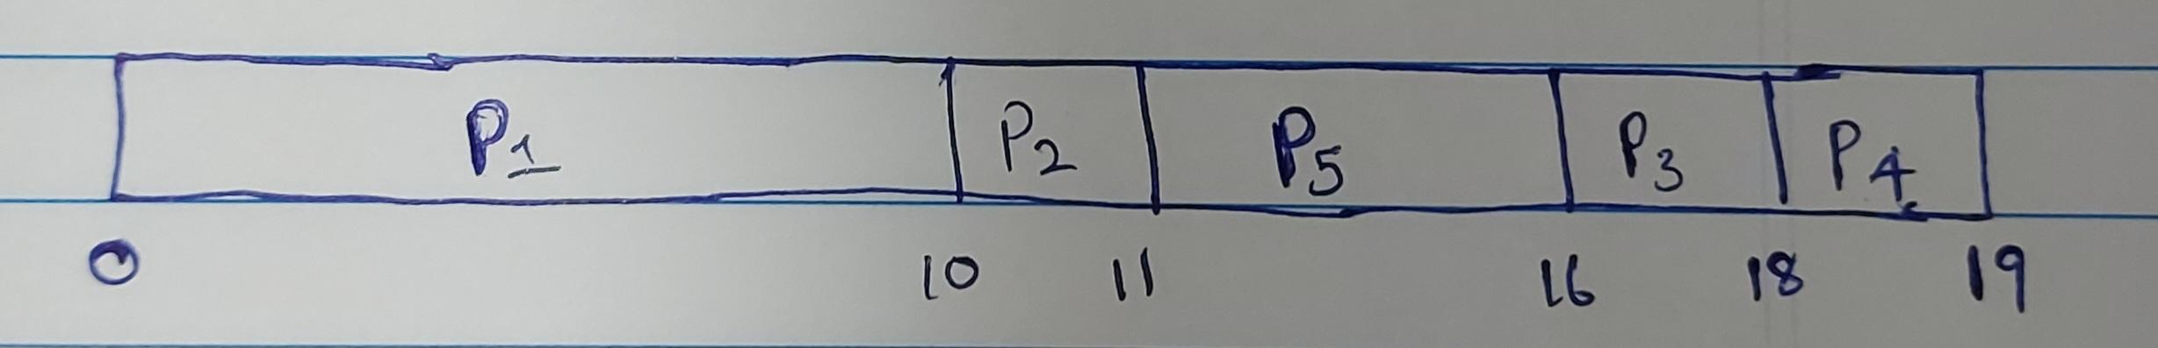

(B) Average Waiting Time, Minimum Average Waiting Time (3 marks)

Algorithm | AWT (ms)
FCFS | 8.2
SJF | 8.2
SRTF | 2.8
Priority Preemptive | 7.4
Priority Non-Preemptive | 9.8

Minimum AWT = 2.8 ms (SRTF)

Also check if response time, waiting time, and turnaround time are calculated for each process in each algorithm.

13) (a)

(i) File Attributes, Operations, Types, Structure (7 marks)  1) File Attributes  → Name  → Identifier  → Type  → Location  → Size  → Protection  → Time, date. and user identification  2) File Operations  → Create  → Write  → Read  → Seek  → Delete  → Truncate  3) File Types  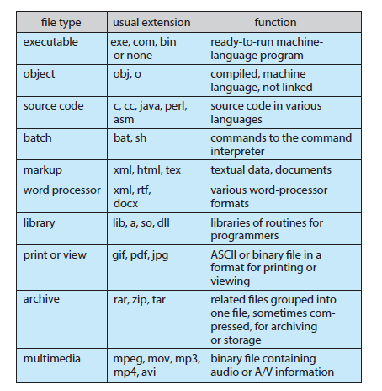  4) File Structure  → OS supports minimal file structures  → Application program must interpret input file to appropriate structure  → All OSes must support at least executable file structure | (ii) Directory Structure (6 marks)  Directory  → Symbol table  → Translates file names to directory entries  → Can be organised in many ways  Single-Level Directory  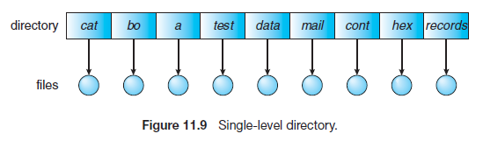  Two-Level Directory  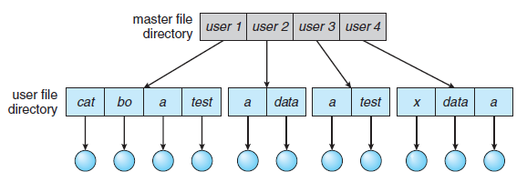  Tree-Structured Directories  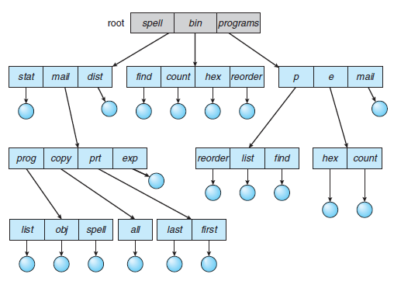  Acyclic-Graph Directories  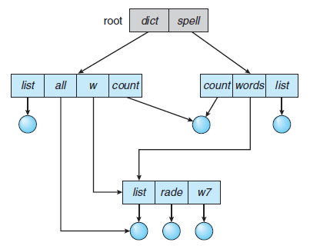

13) (b)

(i) File Allocation Methods (7 marks)  Contiguous Allocation  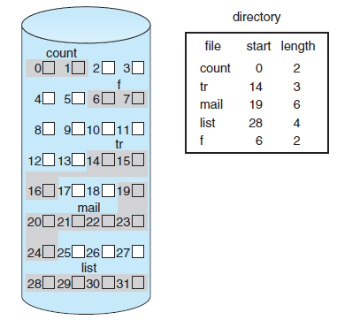  → Contiguous blocks for each file  → Easy access  → External fragmentation  → Compaction - too costly  Linked Allocation  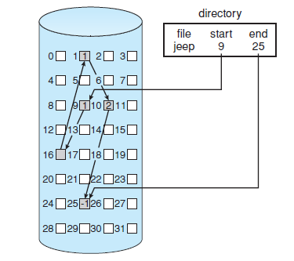  → Avoids external fragmentation  → Direct access is inefficient  Indexed Allocation  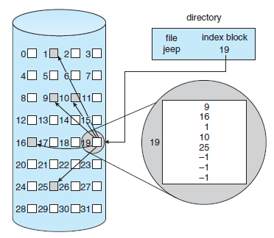  → Index blocks solve direct access problem  → Wasted space | (ii) Free Space Management (6 marks)  Free-space list maintained by the system to keep track of free disk space. Record all free disk blocks. Can be implemented in different ways.  1) Bit Map/Bit Vector  2) Linked List  3) Grouping  4) Counting  5) Space Maps  Explanation for each.

14) (a) (i)

(A) Copy-on-write (3 marks)
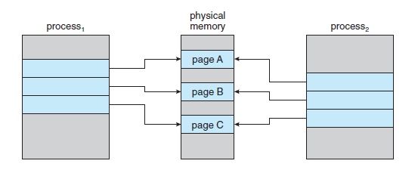
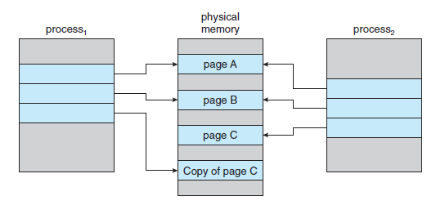

(B) Thrashing (5 marks)

→ High paging activity
→ Processes spending more time paging than executing

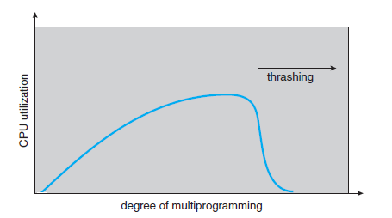
(C) Kernel Memory Allocation Strategies (5 marks)
1) Buddy System  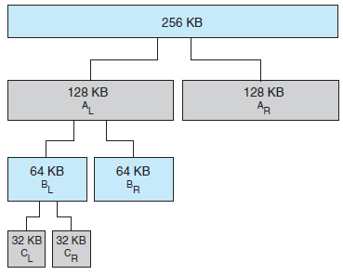 | 2) Slab Allocation  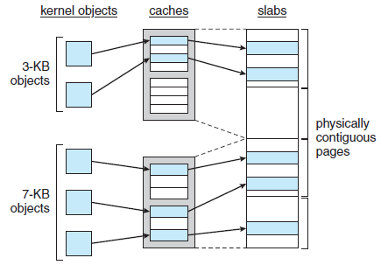

14) (b) (i)

(A) Paging Scheme (7 marks)  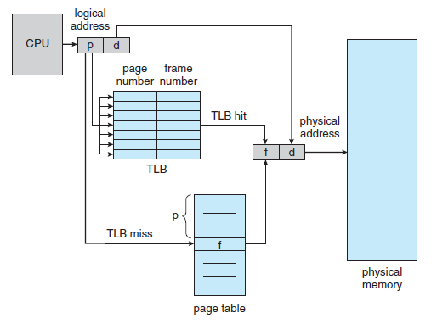  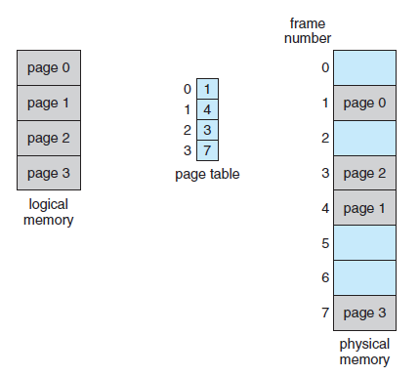 | (B) Handling Page Faults (6 marks)  Page Replacement  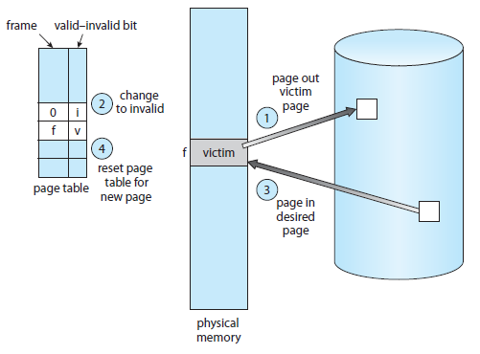  1) Find the location of the desired page on the disk.  2) Find a free frame:  → If there is a free frame, use it.  → If there is no free frame, use a page-replacement algorithm to select  a victim frame.  → Write the victim frame to the disk; change the page and frame tables  accordingly.  3) Read the desired page into the newly freed frame; change the page and frame tables.  4) Continue the user process from where the page fault occurred.

15) (a) (i) Kernel I/O Subsystem (13 marks)

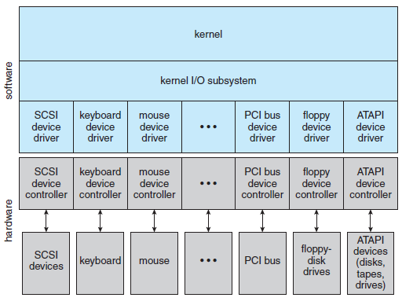

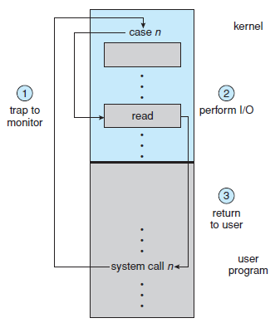
1) I/O Scheduling

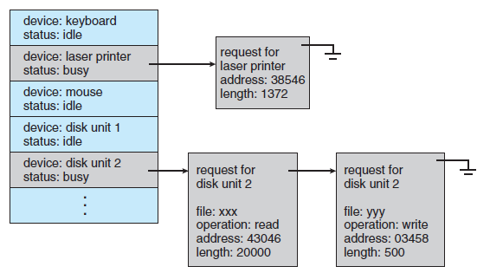

2) Buffering
3) Caching
4) Spooling and Device Reservation
5) Error Handling
6) I/O Protection
7) Kernel Data Structures

15) (b) (i) Disk Scheduling (13 marks)

Total No. of Cylinders: 8000 (0-7999)
Request Queue: 2078, 300, 4235, 1618, 2800, 3568, 7834, 3681, 2800, 540
Current Pointer: 4250

Algorithm | Request Scheduling Order | Head Movements
FCFS | 2078, 300, 4235, 1618, 2800, 3568, 7834, 3681, 2800, 540 | 24012
SSTF | 4235, 3681, 3568, 2800, 2800, 2078, 1618, 540, 300, 7834 | 11484
SCAN - Left | 4235, 3681, 3568, 2800, 2800, 2078, 1618, 540, 300, 0, 7834 | 12084
SCAN - Right | 7834, 7999, 4235, 3681, 3568, 2800, 2800, 2078, 1618, 540, 300 | 11448
C-SCAN - Left | 4235, 3681, 3568, 2800, 2800, 2078, 1618, 540, 300, (0, 7999), 7834 | 4415/12414
C-SCAN - Right | 7834, (7999, 0), 300, 540, 1618, 2078, 2800, 2800, 3568, 3681, 4235 | 7984/15983
LOOK - Left | 4235, 3681, 3568, 2800, 2800, 2078, 1618, 540, 300, 7834 | 11484
LOOK - Right | 7834, 4235, 3681, 3568, 2800, 2800, 2078, 1618, 540, 300 | 11118
C-LOOK - Left | 4235, 3681, 3568, 2800, 2800, 2078, 1618, 540, 300, 7834 | 11484
C-LOOK - Right | 7834, 300, 540, 1618, 2078, 2800, 2800, 3568, 3681, 4235 | 15053

Part - C

16) (i) Page Replacement (10 marks)

Page Reference String: 1, 2, 3, 4, 5, 3, 4, 1, 6, 7, 8, 9, 5, 4, 2

Algorithm | Page Faults
 | Frame Size = 1 | Frame Size = 2 | Frame Size = 3 | Frame Size = 4
FIFO | 15 | 15 | 13 | 13
LRU | 15 | 15 | 13 | 13

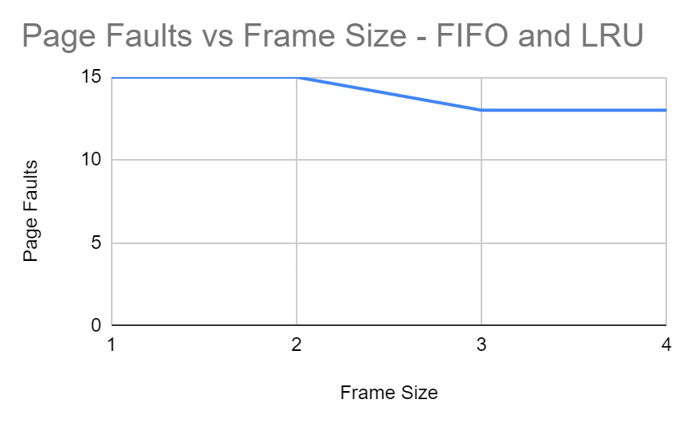
Neither algorithm suffers from Belady’s anomaly.

16) (ii) Compare and Swap (5 marks)

1) Without Bounded Waiting
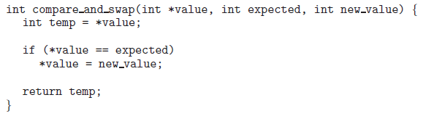
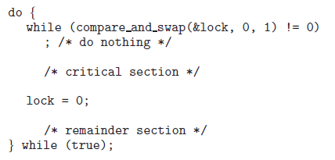

Guarantees mutual exclusion, but not bounded waiting,
2) With Bounded Waiting

Modify the above do-while code with any bounded implementation - counters that set the lock to 0, i.e. unlocked after a certain upper limit has been reached.

int counter=0;
// max wait counter = 5
do {
while (compare_and_swap(&lock, 0, 1) != 0) {
counter++;
if (counter==5) {
counter=0;
lock=0;
}
}
// critical section
lock=0;
// remainder section
} while (true);

If the counter reaches 5, the processes get swapped, and the counter value resets to 0.

