

IT5013
VISUALIZATION TECHNIQUES

VISUALIZING THE GREATEST OF FOOTBALL

Done By

Mohamed Jamal Basha K | 2022506001
Rithvik Krishna K | 2022506003
Yuvaraj K | 2022506079
Krishnaa S | 2022506104
Saravanan R | 2022506120

DEPARTMENT OF INFORMATION TECHNOLOGY
MADRAS INSTITUTE OF TECHNOLOGY,
ANNA UNIVERSITY, CHENNAI – 600 044

October 2024
TABLE OF CONTENTS

S. No | Title | Page No
1 | The Premier League | 1
2 | A Brief Overview of the Dataset | 1
3 | Initial Visualisations | 3
4 | Points Tables | 8
5 | Premier League Winners | 13
6 | Performance of Individual Teams | 17
7 | Points by Individual Teams | 21
8 | Conclusion | 23
9 | Links, References, and Tools | 24

The Premier League

The Premier League, or the English Premier League, is the highest level of the English football league system. It was founded as the FA Premier League on 20 February 1992. It is contested by 20 clubs over a full year, and operates on a system of promotion and relegation – teams finishing in the last 3 positions at the end of the season get demoted to a lower league called the EFL Championship, and the top 3 teams from the EFL Championship get promoted to the Premier League.

For years, the Premier League has been the most-watched and most popular sports league in the entire world. It is ranked first in the UEFA coefficient rankings – essentially classifying it as the best and most competitive football league in the world.

A Brief Overview of the Dataset

Kaggle is the world’s largest online data science community. It contains numerous public datasets that can be used in order to make useful analyses and create interesting visualizations. The Premier League 1993-2023 dataset is taken from Kaggle. It contains data of all the matches played from the 1992-1993 season to the 2022-2023 season of the Premier League. This is the dataset that will be utilised in this visualization report.

The dataset consists of the following fields:

Field | Description | Data Type
Season_End_Year | The year the season ends | Numerical
Wk | The week of the season | Numerical
Date | The match date | Temporal
Home | Home team | Categorical
HomeGoals | Goals scored by the home team | Numerical
AwayGoals | Goals scored by the away team | Numerical
Away | Away team | Categorical
FTR | Full-time result | Categorical
The dataset was downloaded as a .csv file, and then uploaded into a Colab Runtime Environment, where it was converted into a Pandas dataframe in order to view and shape it. The name of the file is premier-league-matches.csv.

from google.colab import files
uploaded = files.upload()
df = pd.read_csv(“premier-league-matches.csv”)

Shape of the dataset is…

df.shape

(12026, 8)

The first ten rows of the dataset are…

df.head(10)

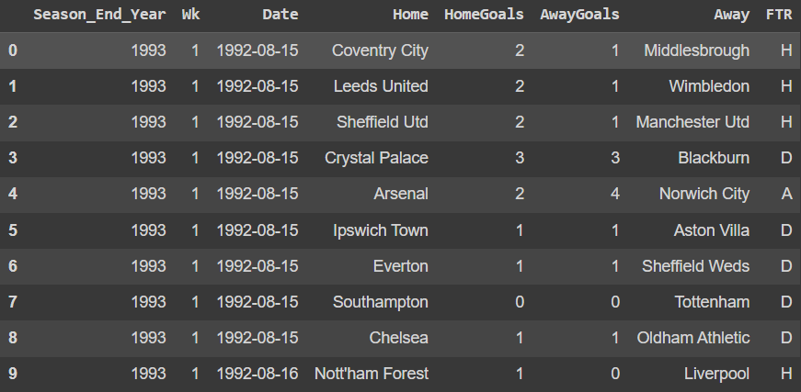

Initial Visualisations

There are some very obvious questions that can be asked by looking at the dataset. The simplest of them all could just be how many games were played in each season.

games_per_season = df.groupby(‘Season_End_Year’).size()

plt.figure(figsize=(12, 8))
ax = games_per_season.plot(kind=’bar’, color=’skyblue’)
plt.title(‘Number of Games Played in Each Season’, fontsize=14)
plt.xlabel(‘Season End Year’, fontsize=12)
plt.ylabel(‘Number of Games’, fontsize=12)
plt.xticks(rotation=45, ha=’right’)

for i in ax.containers:
ax.bar_label(i, label_type=’edge’, fontsize=12, padding=3)

plt.tight_layout()
plt.show()

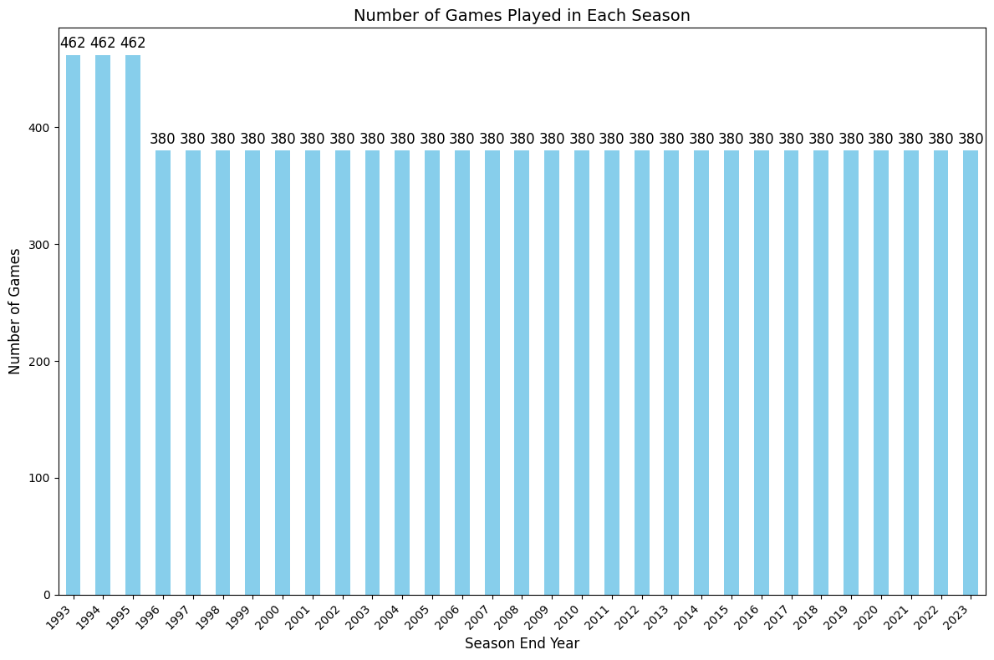
As we can quite clearly notice, there were initially more games played in a single Premier League, indicating there were more teams. A total of 462 games were played in the first three iterations of the Premier League, meaning there were 22 teams competing for the title. This was reduced to 20 teams, thus bringing the total number of games per season to 380.

How about the number of goals that were scored by the home teams and the away teams? A distribution of these could help us arrive at some basic and probably obvious conclusions.

plt.figure(figsize=(8, 6))
df[‘HomeGoals’].plot(kind=’hist’, bins=20, title=’Home Goals’)
plt.xlabel(‘No. of Goals’, fontsize=10)
counts, bins, patches = plt.hist(df[‘HomeGoals’], bins=20)
for count, x in zip(counts, bins[:-1]):
if count>0:
plt.text(x + (bins[1] – bins[0]) / 2, count, str(int(count)), ha=’center’, va=’bottom’)
plt.xticks(range(0, 11))
plt.show()

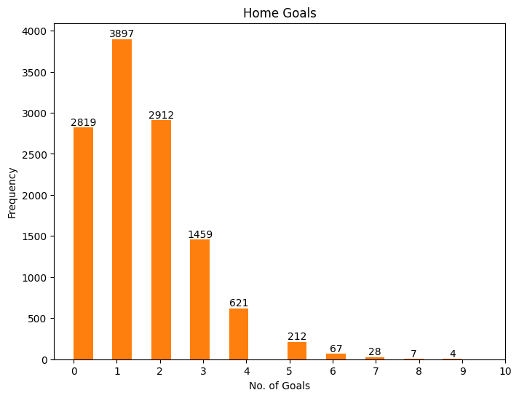
The number of goals scored by the home team in matches seems to range from 1 to 2 in the majority, with slightly lesser instances of no goals being scored and even lesser instances of 3 or more goals being scored. What this graph alone tells us is that the average number of goals scored by the home team in the Premier League is somewhere between 1 and 2. Of course, the exact number could also be found using a simple average function, which upon doing so gives us the average of 1.52. However, visualising it gives us a broader idea, a good sense of the goal spread by the home team.

No game is truly a game without an opponent, though.

plt.figure(figsize=(8, 6))
df[‘AwayGoals’].plot(kind=’hist’, bins=20, title=’Away Goals’)
plt.xlabel(‘No. of Goals’, fontsize=10)
counts, bins, patches = plt.hist(df[‘AwayGoals’], bins=20)
for count, x in zip(counts, bins[:-1]):
if count>0:
plt.text(x + (bins[1] – bins[0]) / 2, count, str(int(count)), ha=’center’, va=’bottom’)
plt.xticks(range(0, 11))
plt.show()

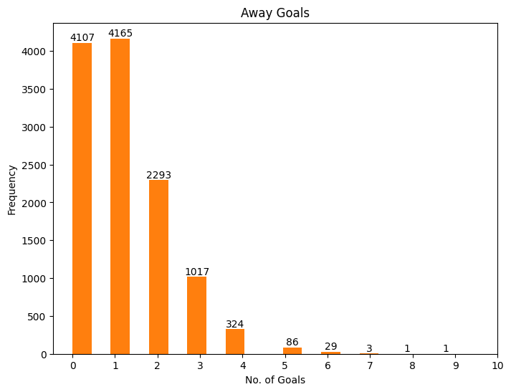
There is a dramatic increase in 0 goals being scored by the away team when compared to the home team. The average number of goals scored as well seems to be somewhere around 1, more specifically, 1.14, which is considerably less than the average number of home goals scored.

One very obvious inference from this is that the home side seems to perform better in terms of the goal statistics, and while it may seem far-fetched, it is also sensible to assume that the home side emerges victorious and is more dominant more often than not.

We don’t need to predict this with just the goals data, though. We do have the full-time results of all the matches, which can back-up our inference.

What we’re expecting, from the goals distribution, and maybe from some general knowledge as well, is that there will be more victories for the home team when compared to the victories of the away team. But another result that is a possibility is a draw, so not only are we going to check if the home team supremacy exists, but we’re also going to consider how stalemates factor into the state of things.

plt.figure(figsize=(8, 6))

df.groupby(‘FTR’).size().plot(kind=’barh’, color=sns.palettes.mpl_palette(‘Dark2’), title=’Full Time Results’)

plt.xlabel(‘Frequency’, fontsize=10)

for index, value in enumerate(df.groupby(‘FTR’).size()):
if value > 0:
plt.text(value, index, str(int(value)), va=’center’, rotation=270)

plt.show()

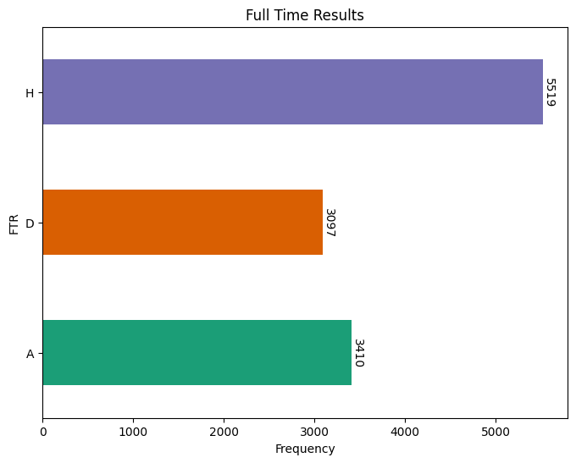

As quite clearly predicted, the home side seems to have won in more matches. We saw quite clearly that there were 12026 rows in the dataset, excluding the header, meaning there were 12026 matches played over the 31 years of the Premier League, and in that, the home side has emerged victorious in nearly half of the matches, more specifically, 5519 matches.

If we’re considering the number of matches in which the home side has remained unbeaten – which means we have to count the home side victories as well as the home side draws, the count comes to 8616 out of 12026, which is about 71% of the total number of matches played, which speaks volumes of the home side dominance and advantage that teams have in the Premier League.

The above data could potentially be viewed as a pie chart, showcasing the division of the full time results, but that could lead to some confusion in differentiating between close values without the data labels, such as the 3097 draws and the 3410 away side victories we have here. In this bar chart, however, it is clear to see which is higher and which is lower, even without the labels.
Points Table

As seen above, the data as it is can be visualised in many ways, but maybe reshaping it into something different could prove to be quite beneficial. One very useful and obvious reshaping, which could be considered in itself as its own visualisation, is to create points tables for each of the seasons just from the match results data. Points tables for each season will further help in developing more effective visualisations and drawing interesting insights.

The following Python script is used for the conversion.

def calculate_points_table(df):

points_table_list = []
seasons = df.groupby(‘Season_End_Year’)

for season, matches in seasons:
teams = {}

for index, match in matches.iterrows():
home_team = match[‘Home’]
away_team = match[‘Away’]
home_goals = match[‘HomeGoals’]
away_goals = match[‘AwayGoals’]
result = match[‘FTR’]

if home_team not in teams:
teams[home_team] = {‘Team’: home_team, ‘Played’: 0, ‘Won’: 0, ‘Drawn’: 0, ‘Lost’: 0, ‘GF’: 0, ‘GA’: 0, ‘GD’: 0, ‘Points’: 0}
if away_team not in teams:
teams[away_team] = {‘Team’: away_team, ‘Played’: 0, ‘Won’: 0, ‘Drawn’: 0, ‘Lost’: 0, ‘GF’: 0, ‘GA’: 0, ‘GD’: 0, ‘Points’: 0}

teams[home_team][‘Played’] += 1
teams[away_team][‘Played’] += 1
teams[home_team][‘GF’] += home_goals
teams[home_team][‘GA’] += away_goals
teams[away_team][‘GF’] += away_goals
teams[away_team][‘GA’] += home_goals

if result == ‘H’:
teams[home_team][‘Won’] += 1
teams[away_team][‘Lost’] += 1
teams[home_team][‘Points’] += 3

elif result == ‘A’:
teams[away_team][‘Won’] += 1
teams[home_team][‘Lost’] += 1
teams[away_team][‘Points’] += 3

elif result == ‘D’:
teams[home_team][‘Drawn’] += 1
teams[away_team][‘Drawn’] += 1
teams[home_team][‘Points’] += 1
teams[away_team][‘Points’] += 1

teams[home_team][‘GD’] = teams[home_team][‘GF’] – teams[home_team][‘GA’]
teams[away_team][‘GD’] = teams[away_team][‘GF’] – teams[away_team][‘GA’]

season_table = pd.DataFrame(teams.values())
season_table[‘Season_End_Year’] = season
season_table = season_table.sort_values(by=[‘Points’, ‘GD’, ‘GF’], ascending=False)
season_table[‘Position’] = range(1, len(season_table) + 1)
points_table_list.append(season_table)

final_points_table = pd.concat(points_table_list, ignore_index=True)
return final_points_table

points_table = calculate_points_table(df)

Once converted, the new data exists as a single dataframe that contains the points tables of all the first 31 premier league seasons.

points_table.head(626)

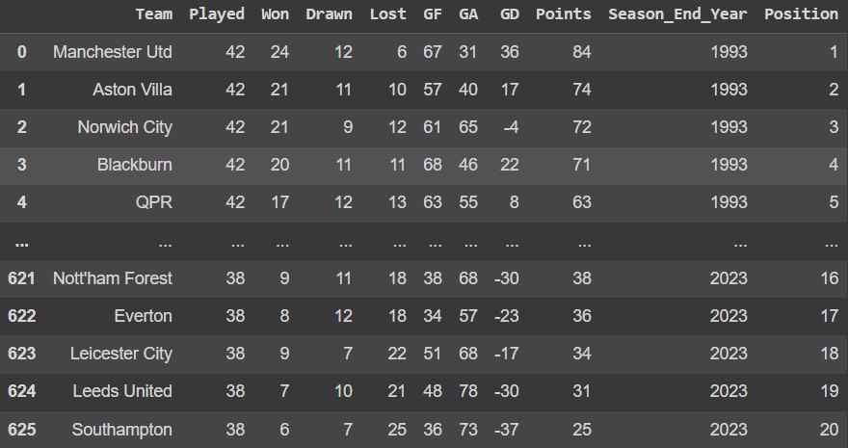

We could separate this into multiple tables for each season.

points_table_dict = {}

for season, season_table in points_table.groupby(‘Season_End_Year’):
points_table_dict[season] = season_table

points_table_dict.keys()

dict_keys([1993, 1994, 1995, 1996, 1997, 1998, 1999, 2000, 2001, 2002, 2003, 2004, 2005, 2006, 2007, 2008, 2009, 2010, 2011, 2012, 2013, 2014, 2015, 2016, 2017, 2018, 2019, 2020, 2021, 2022, 2023])

Now, we can access the points table of each season by using the season end year as the key of the dictionary.

points_table_dict[2020]

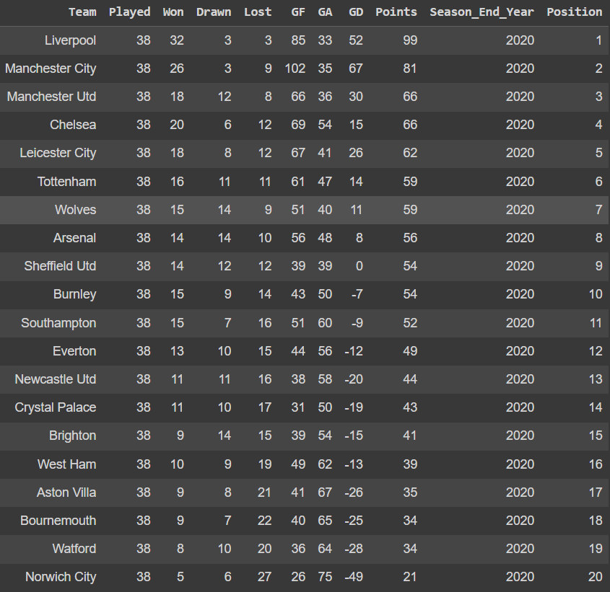

Now, further data visualisation can be performed using this points table as well. It can be done in the Colab environment, or better yet, the dataframe can be exported to a spreadsheet, which arguably contains better, more efficient tools for visualisation.

Saving all the dataframes to a Google Sheet involves providing authentication, creating the Google Sheet, and then uploading the required data.

from google.colab import auth
auth.authenticate_user()

import gspread
from google.auth import default
from gspread_dataframe import set_with_dataframe

creds, _ = default()
gc = gspread.authorize(creds)

spreadsheet = gc.create(‘Premier League’)

for year, df in points_table_dict.items():
worksheet = spreadsheet.add_worksheet(title=str(year), rows=df.shape[0], cols=df.shape[1])
set_with_dataframe(worksheet, df)

All the dataframes have thus been successfully stored in a Google Sheet, wherein each worksheet is named after the season end year and contains the points table for that season. For example, the 2019-2020 season’s points table is found in the worksheet named ‘2020’.

In addition, the dataframe that contains all the tables of all the seasons in one is also added to the Google Sheet, in the worksheet ‘Main’. In some cases, it might make certain visualisations easier.

worksheet = spreadsheet.add_worksheet(title=”Main”, rows=points_table.shape[0], cols=points_table.shape[1])
set_with_dataframe(worksheet, points_table)

Premier League Winners

Now that the data has been made more… versatile, in a sense, we could dive deep and obtain so much more nuanced, specific, and probably mind blowing information.

But where do we really start? That’s probably the most important and confusing question. The thing is, to answer to this question is also a question. Or rather, many, many questions. In order to really gather many things from whatever data it is that we have, it is imperative to ask questions about the data that could possibly be answered. Finding the right way to answer these questions, realising the right method, or methods, is what visualisation is all about.

What are the teams that have won the Premier League, and how many times?

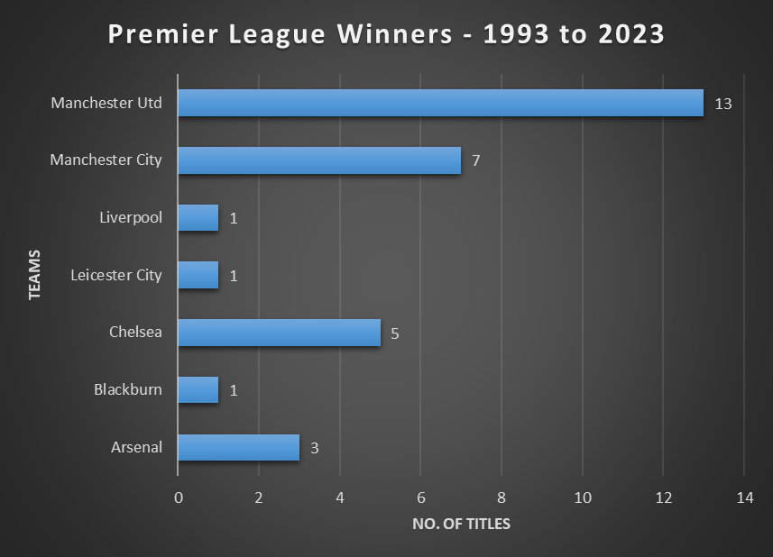

Winning the Premier League is the best indicator of how successful a team has been in the league, and from that, it is clear to see that Manchester United is the most successful team in the Premier League. Manchester City, Chelsea, and Arsenal are some of the other prominent teams that have made their mark. Liverpool, Leicester City, and Blackburn have all won it once, showing that while they might be good teams, they are also very inconsistent.
But maybe a better indicator of consistency could be to see who’ve won the league in the last ten years. Maybe some of the teams here were exceptional in the past, but not anymore.

What are the teams that have won the Premier League, and how many times, in the last 10 years?

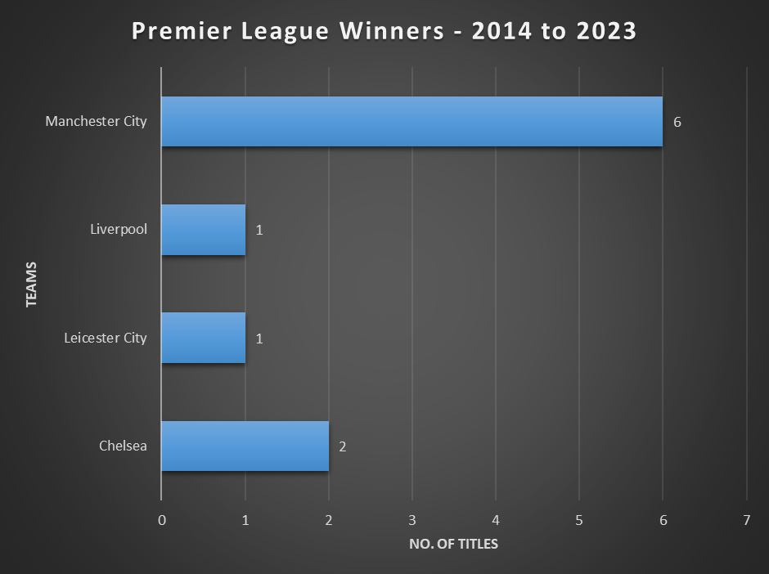

Now we see a much different story. Manchester United is nowhere to be seen here, so it is clear that it was a successful team in the past, but not anymore, not in recent times. In fact, it is their rivals Manchester City that have been incredibly successfully in the last decade.

Manchester City has actually dominated the Premier League, having won 6 out of the available 10 titles. It showcases an unparalleled level of supremacy to lead the charts all year long for several years.

But maybe Manchester United have just been unlucky. Maybe they’ve finished in the second or third or fourth positions instead of the first over the past few years, which is still an impressive feat.
What are the teams that have finished in the top 4 over the last 10 years, and how many times?

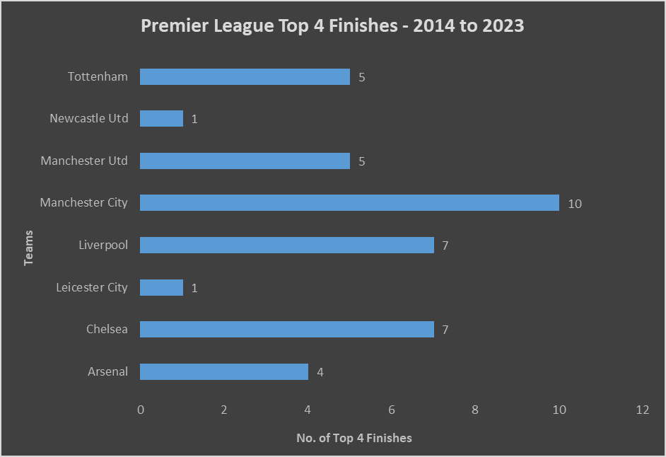

Now we have some new revelations. Liverpool and Chelsea seem to actually be the joint most consistent teams in the last decade, second only to Manchester City. Manchester City has, in fact, finished in the top 4 in every single season from the 2013-2014 to the 2022-2023 season.

Clearly, Manchester City is objectively the best team in the Premier League right now, there is simply no doubt about that.

Meanwhile, Manchester United and Tottenham Hotspurs are teams that have finished in the top 4 for a total of 5 times in the last 10 years, but neither have managed to be at the utmost top. Neither have managed to win the Premier League. Manchester United, not in the last 10 years, and Tottenham Hotspurs, never in the history of the Premier League.

So, these teams have been somewhat consistent, but we do know that they’ve never actually won the Premier League in this period, so they do lack the killer blow, the strength required to finish at the top after 38 weeks of intensity.

The same can be said for Arsenal as well, who have had 4 finishes in the top 4 in the last decade.

Leicester City has had only one top 4 finish in the last 10 years, and we know that it is the year in which they finished at the top of the table. So, one could say that it was a miracle that they had won the Premier League, that it was something that no one really expected them to achieve.

Performance of Individual Teams

It will be quite intriguing to track the progress of some of these clubs over the years. Manchester City has won the Premier League 7 times, 6 of which seem to have come in the last 10 years. So, weren’t they good before that? What about Liverpool? They finished 7 times in the top 4 over the last decade, and yet only won the Premier League once. And since we’re tracking the positions of these clubs over a period of time, it is best to use a line chart to visualise it.

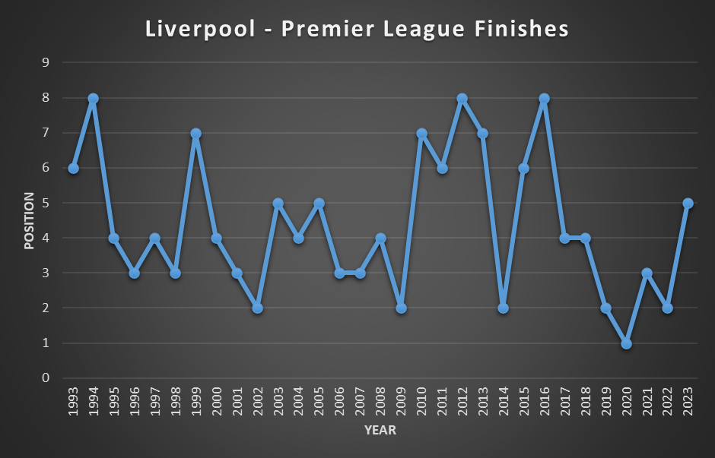

Since 2017, Liverpool have never finished outside of the top 5, showcasing good consistency in the Premier League in recent years. They emerged victorious in the year 2020, their only ever Premier League title. Their worst finish in the Premier League has been 8th, which is admirable. There have been two distinct periods of time in which Liverpool has been a fixed top 5 team, namely 2002-2009 and 2017-2023. In all the other occasions, they have been suffering from a certain amount of inconsistency.

Now let us look at how Manchester City has fared. We do know how the last 10 years go for the club, but what about before that? Clearly, they weren’t as good, but were they always top contenders?

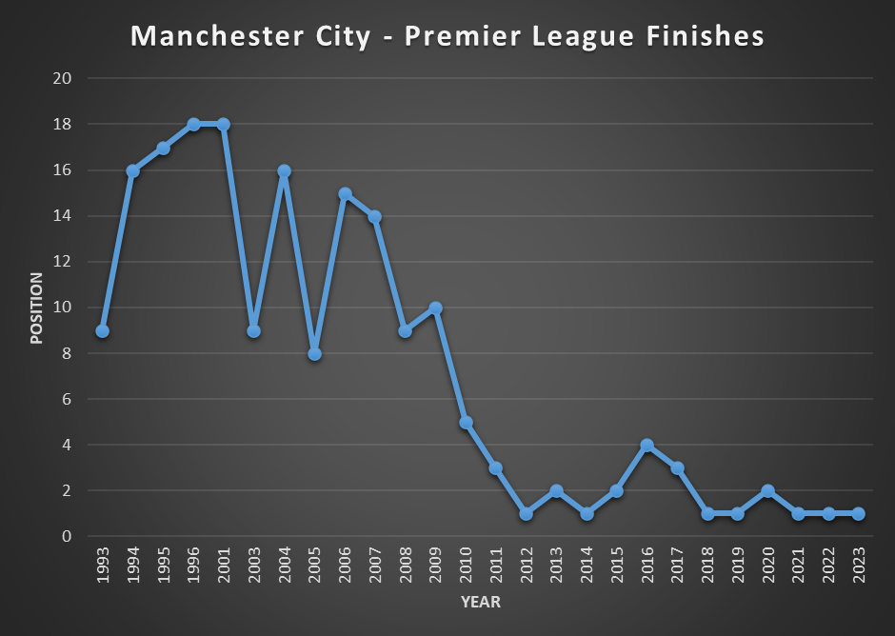

This chart is so much more different than Liverpool’s, and so much more fascinating as well. While Liverpool’s worst position ever in the Premier League is 8th, Manchester City’s is 18th. In fact, they didn’t even play in the Premier League for a few years there.

In the Premier League, the teams which finish at the bottom three get relegated to the EFL Championship, as mentioned before. In the 1995-1996, Manchester City finished 18th, which is the first of those bottom three positions. So, they got relegated and didn’t return back to the Premier League until the 2000-2001 season.

But they got relegated again, immediately after their return to the Premier League. This time, however, they got promoted and came back, again, one year later, in the 2002-2003 season. So, in the 31 years of the Premier League, Manchester City has actually not even been in the league for 5 of them.

Furthermore, their first top 4 finish came in 2011, but since that year, they’ve always consistently stayed up there. Also, they have won every single Premier League the 2017-2018 season, except for the 2019-2020 season, which was won by Liverpool.
So, Manchester City has been the best team in the Premier League recently, but what about back then? Because, if we remember, a certain other Manchester side seemed to have quite a few Premier League trophies under their belt.

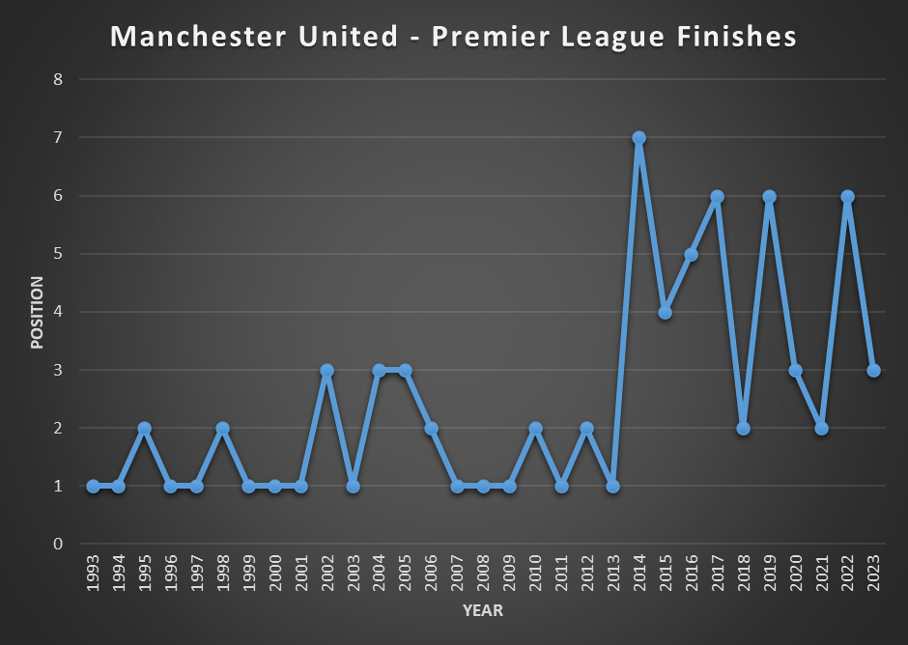

This graph is the complete opposite of Manchester City’s. Manchester United was the dominant force in the Premier League for 20 full years. But then, it’s safe to say that they just fell off. Their best finish in the Premier League in the last decade was 2nd, a stark contrast from the glory days which went from 1993 to 2013. Funnily enough, their fall from glory were somewhat synchronised Manchester City’s rise to the top.

One thing to note is that Manchester United is still a competent team, for their worst finish in the Premier League has been 7th, similar to Liverpool’s 8th, and unlike Manchester City’s 18th. But these finishes may be seen as clear failures by the club and its fans, who have been so used to winning and winning for 2 whole decades.

What’s clear, though, is that the Premier League is always dominated by a club from Manchester.

The below radar map gives a different, and maybe a better view of how the aforementioned teams have performed, highlighting their consistency, or the lack thereof, over the years. Another team has been added into the fray, one that seems to be a very consistent team, but one that finishes in the bottom half of the Premier League table pretty much every season.

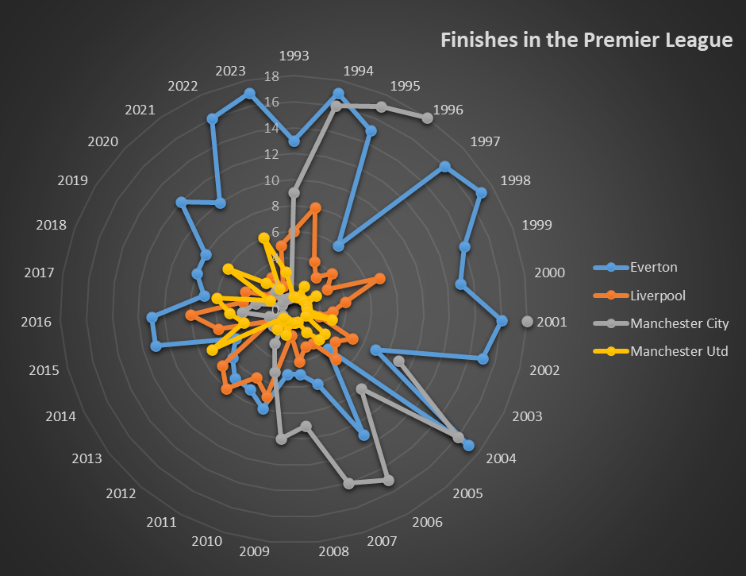

In this radar map, the teams that have an actual, discernible shape are clearly the well-established teams who are known for how and where they finish, whereas the teams with a highly unpredictable and pretty much shapeless figure are the ones that are… surprising, to say the least. Amongst the four teams showcased above, Liverpool and Manchester United have maps that are focused into the top 8, as we can very clearly see. Everton, on the other hand, has a much larger shape, finishing outside the top 8 almost every single season, bar a few exceptions. Manchester City is neither consistently good or consistently bad, and don’t really have a defined shape. They were really bad once, but exceptionally good now.
Points by Individual Teams

Another interesting metric to compare over the years would be the points accumulated by teams in each season. Consider the following theory – maybe Manchester United has been performing the same way in every single Premier League season, getting the same amount of points every single year. Maybe they didn’t really decline, and it’s just that Manchester City has stepped up its game in the last ten years, getting more points on average than Manchester United.

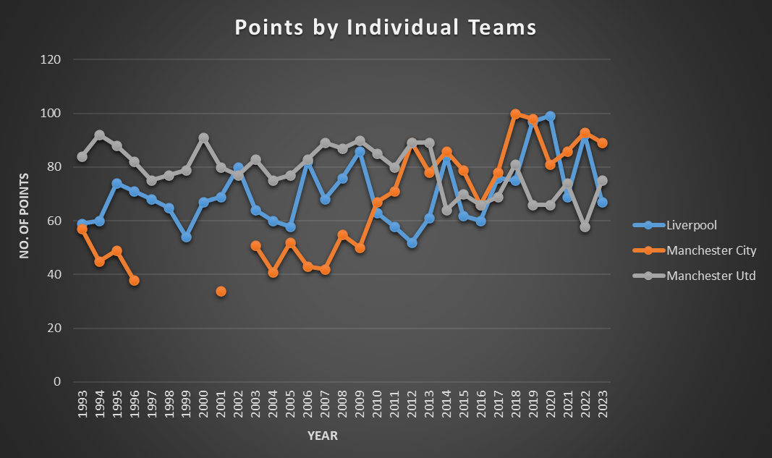

Our assumption is somewhat right, and somewhat incorrect. It is true that Manchester City have become much, much better, getting a maximum of 100 points in a single season, when Manchester United of the old struggled to get to even 90 points and yet still won the league.

But in the last decade, Manchester United has also declined in the points that they have obtained per season. They were consistently getting 80 points, give or take a few, for the first 20 years, but in the last decade, their average points obtained per season have been bordering the 60s, which showcases the stark decline that the club has been through.

Obviously, something significant happened during this period to have resulted in this, and a little research would show that their long-serving and successful manager, Sir Alex Ferguson, resigned and retired from football management in 2013. Since then, Manchester United has been jumping from one manager to the next, and none of them have really managed to attain the peaks that the previous manager did.

Manchester City, on the other hand, has gone from a measly 40 points or not even being in the Premier League to consistently racking up 80, 90, and even 100 points, showcasing very clearly the improvements that the team has seen in a rather sudden and unexpected manner.

Or maybe it isn’t that surprising if we connect a few dots here and there. In 2008, the Abu Dhabi United Group became the new owners of Manchester City. It is a private equity company linked to the Vice President of UAE, Sheikh Mansour bin Zayed Al Nahyan. His wealth brought along an influx of cash that helped Manchester City spend big in the transfer market, and their performance slowly but steadily began to grow and improve. There’s of course more to the story, but this is pretty much all that one probably

In the case of Liverpool, similar to every other visualisation we saw for them, they’ve been… fluctuating. They could have a really good peak in one season, but then could fall off in the next, only to rise back up in the season after that, kind of like they burn themselves out in one season and need another whole year to recover, or maybe they’re just inconsistent. But then again, we have seen that they’ve always been a top 8 team at the very least, showcasing some form of consistency, and also indicating that when they do shine, they shine bright.

Conclusion

We could look into the performances of many of the other teams that have played in the Premier League, obtain more and more engaging information and insights about each and every one of these teams and their evolution (or devolution) over the years.

There is so much data available here, from the original dataset itself, and so much more after we transformed it. And as we are all very much aware, more data means more things that we can acquire from it, assuming the data is actually useful and proper, which in this case it really is.

We focused more on the top half of the table and the top teams in this study. Another thing that we could do, that could potentially be worthy of our attention, is to study the bottom half and analyse how close the relegation battle is. Maybe there were a lot of cases where even the 12th place or even the 10th place team at the end of the season were just 2 or 3 points shy of relegation. There is a possibility of this happening, which is what makes the league even more enjoyable. The gritty, survival-esque football employed by the bottom-half teams in order to ensure they remain in the Premier League is always a fascinating watch.

Then there’s also the mid-table sides, teams that have always stayed in the Premier League. They’ve never been relegated, or maybe they’ve been relegated just once or twice, but they’ve also never actually won the league. In some form, they also show some level of consistency to always remain at the top-flight of English football, and it would certainly be quite stimulating to visualise and analyse that.

The point is, we could be here for days or weeks to try and visualise everything that we could possibly do from all of this data, but that’s not really why data visualisation exists. It’s a tool, or rather a platform that we can use effectively when we need to understand something from all the statistics and numbers that we have been provided with. The results data or the points table data in itself do tell a lot of things, but when we ask the right questions and choose the right way in order to visualise and answer them, we gain something so valuable that we couldn’t have obtained otherwise.

Links, References, and Tools

Colab Workbook | https://colab.research.google.com/drive/1B8qAVRb2hcw3tKAZ5EWOGtg4Ak1eBlPo?usp=sharing
Dataset | https://www.kaggle.com/datasets/evangower/premier-league-matches-19922022
Manchester City | https://en.wikipedia.org/wiki/Manchester_City_F.C.
Manchester United | https://en.wikipedia.org/wiki/Manchester_United_F.C.
Google Colab | For Preliminary Analysis of Dataset
Microsoft Excel | For Pivot Table Visualisations

