


IT5611
Embedded Systems and Internet of Things Laboratory

A Practical Record

Submitted By

Yuvaraj K
2022506079
B. Tech Information Technology (6/8)

Department of Information Technology
Madras Institute of Technology
Anna University, Chennai – 600 044
January – May 2025

Bonafide Certificate

Name | : Yuvaraj K
Register No. | : 2022506079
Subject | : IT5612 Embedded Systems and Internet of Things Laboratory
Department | : Information Technology

Certified to the bonafide record of practical work done by Mr. Yuvaraj K in the IT5611 Embedded Systems and Internet of Things Laboratory during the period January 2025 to May 2025.

Date:

Submitted for the Practical Examination held on: 28/04/2025

Dr. S. Umamaheswari
Staff In Charge

Table of Contents

Exp No. | Date | Title of the Experiment | Page No. | Signature
1 | 27/01/25 | Study of 8051 Microcontroller | 1
2 | 27/01/25 | Implementation of Arithmetic Operations using 8051 Microcontroller  - N-number Addition  - Multibyte Addition  - Multibyte Subtraction  - 16-bit and 8-bit Multiplication  - 8-bit Division | 22
3 | 03/02/25 | Implementation of Array-Based Programs using 8051 Microcontroller  - Reversing a String  - Palindrome  - Largest in Array  - Smallest in Array  - Bubble Sort | 34
4 | 10/02/25 | Programming I/O Ports  - Toggle LEDs with Arbitrary Delay  - Toggle LEDs with 1 s Delay  - Toggle LEDs with 1 s Delay by Timer  - Read Switches’ Status, Write on LEDs  - Read Switch and Reflect on LED | 46

Exp No. | Date | Title of the Experiment | Page No. | Signature
5 | 17/02/25 | Waveform Generation  - Triangle Wave of 2 KHz Frequency  - Sawtooth Wave of 2 KHz Frequency  - Sine Wave of Arbitrary Frequency  - Count Pulses and Reflect on LEDs | 62
6 | 24/02/25 | Serial Communication and Interrupt Handling  - Toggle LEDs with 1 s Delay and Generate Square Wave of 75% Duty Cycle using Interrupts  - Continuously Transmit Message  - Transmit and Receive – No Serial  - Transmit and Receive using Serial Communication | 76
7 | 10/03/25 | 8051 Programming in Embedded C  - Toggle LEDs with Arbitrary S/W Delay  - Toggle LEDs with 1 s Delay by Timer  - Read Switches’ Status, Write on LEDs  - Read Switch, Reflect on LED  - Triangle Wave of 2 KHz Frequency  - Sawtooth Wave of 2 KHz Frequency  - Sine Wave of Arbitrary Frequency  - Count Pulses and Reflect on LEDs  - Toggle LEDs with 1 s Delay and Generate Square Wave of 75% Duty Cycle using Interrupts  - Continuously Transmit Message  - Transmit and Receive using Serial Communication | 94

Exp No. | Date | Title of the Experiment | Page No. | Signature
8 | 10/03/25 | Programming for Accessing External Memory Data  - External Memory and Internal Memory Data Exchange in Assembly  - External Memory and Internal Memory Data Exchange in C | 122
9 | 17/03/25 | Basic Arduino Programming for Digital I/O  Toggle LED with 1 s Delay  Read and Transmit Serially  Read Switch, Reflect on LED  Traffic Signal | 127
10 | 24/03/25 | Arduino Programming for Development of IoT Applications  Box Junction  Thermistor + Buzzer  Ultrasonic Sensor + LED  IR Sensor + Servo Motor  Motion Detector | 139
11 | 21/04/25 | Development of IoT Applications using Wireless Technologies  Wi-Fi  Bluetooth  GPS | 157

Toggle LEDs using Arbitrary Software Delay

Address | Label | Instruction | Comment
 |  | ORG 0H
 |  | LJMP 100H | ;
 |  | ORG 100H
100 | LOOP: | MOV P1, #0FFH | ; toggle LED on
103 | ON: | ACALL DELAY | ; call delay routine
105 |  | MOV P1, #0H | ; toggle LED off
108 | OFF: | ACALL DELAY | ;
10A |  | SJMP LOOP | ; continue toggling
 |  | ORG 200H
200 | DELAY: | MOV R1, #02H | ; arbitrary value 1
202 | DLY1: | MOV R2, #0B4H | ; arbitrary value 2
204 | DLY2: | MOV R3, #0FFH | ; arbitrary value 3
206 | DLY3: | DJNZ R3, DLY3 | ; innermost loop
208 |  | DJNZ R2, DLY2 | ; inner loop
20A |  | DJNZ R1, DLY1 | ; outer loop
20C |  | RET | ; end of subroutine
 |  | END

Output

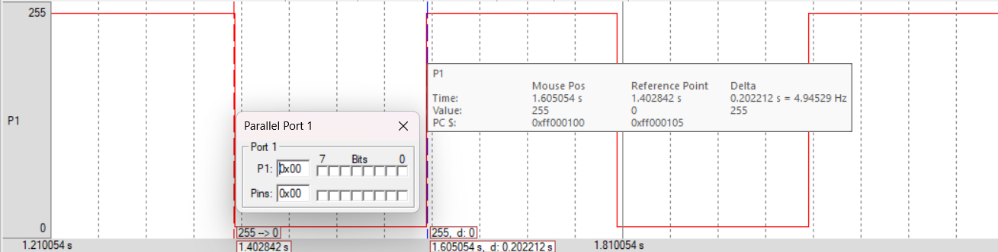

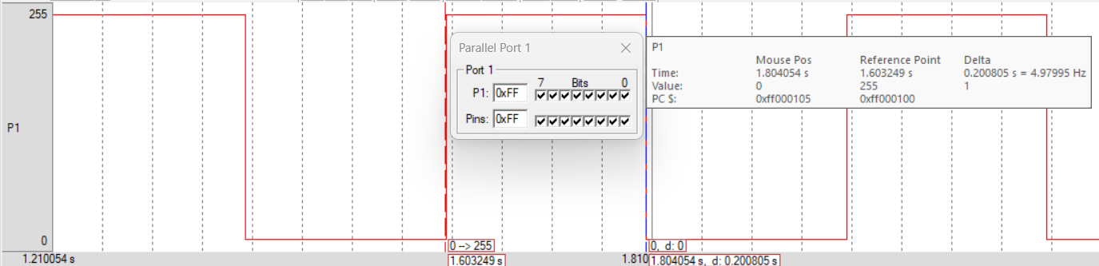

Toggle LEDs using 1 Second Software Delay

Address | Label | Instruction | Comment
 |  | ORG 0H
 |  | LJMP 100H | ;
 |  | ORG 100H
100 | LOOP: | MOV P1, #0FFH | ; toggle LED on
103 | ON: | ACALL DELAY | ; 1s delay
105 |  | MOV P1, #0H | ; toggle LED off
108 | OFF: | ACALL DELAY | ; 1s delay
10A |  | SJMP LOOP | ; continue toggling
 |  | ORG 200H
200 | DELAY: | MOV R1, #14H | ; to repeat 0.5s delay 20 times
202 | DLY1: | MOV R2, #5AH | ; inner loop counter
204 | DLY2: | MOV R3, #0FFH | ; innermost loop counter
206 | DLY3: | DJNZ R3, DLY3 | ; innermost loop
208 |  | DJNZ R2, DLY2 | ; inner loop
20A |  | DJNZ R1, DLY1 | ; outer loop
20C |  | RET | ; end of subroutine
 |  | END

Output

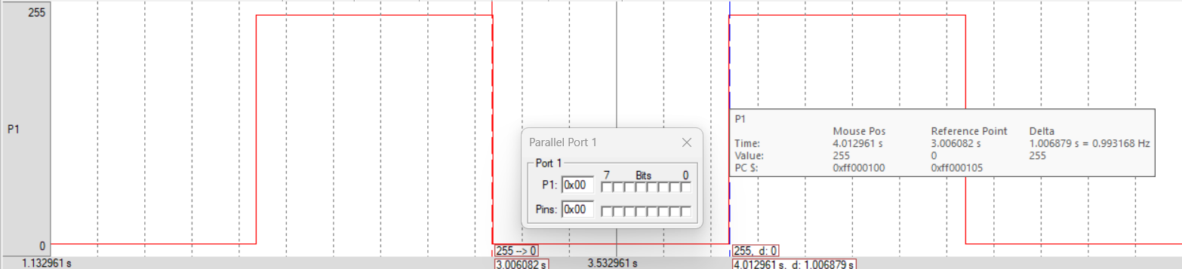

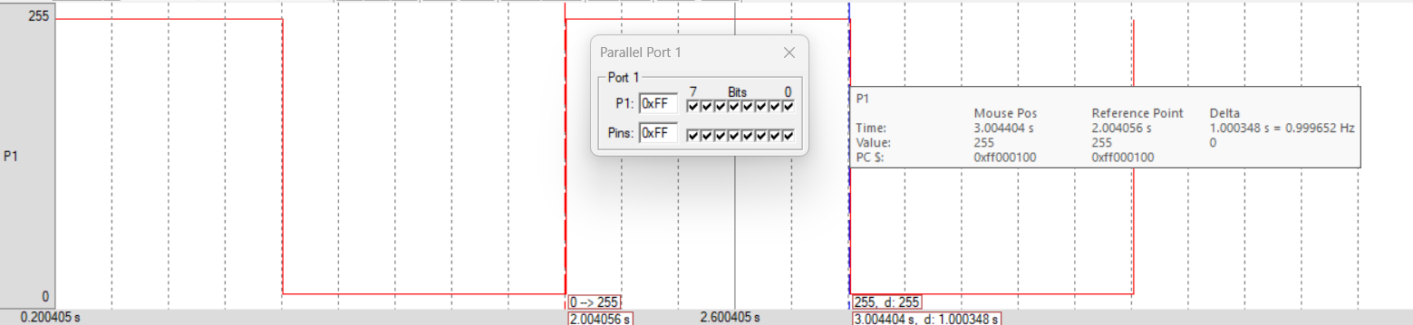

Toggle LEDs using 1 Second Timer Delay

Address | Label | Instruction | Comment
 |  | ORG 0H
 |  | LJMP 100H | ;
 |  | ORG 100H
100 |  | MOV TMOD, #01H | ; set timer 0 in mode 1 – 16-bit timer
103 | LOOP: | MOV P1, #0FFH | ; toggle LED on
106 | ON: | ACALL DELAY | ; 1s delay routine
108 |  | MOV P1, #0H | ; toggle LED off
10B | OFF: | ACALL DELAY | ;
10D |  | SJMP LOOP | ; continue toggling
 |  | ORG 200H
200 | DELAY: | MOV R1, #14H | ; to run 0.05s delay 20 times
202 | DLY: | MOV TLO, #0FDH | ; lower byte of 16-bit timer
205 |  | MOV THO, 46H | ; upper byte of 16-bit timer
208 |  | SETB TR0 | ; start timer 0
20A | CHECK: | JNB TF0, CHECK | ; monitor timer 0’s flag
20D | STOP: | CLR TF0 | ; clear timer flag
20F |  | CLR TR0 | ; end timer 0
211 |  | DJNZ R1, DLY | ; repeat 0.05s delay
213 |  | RET | ; end subroutine
 |  | END

Output

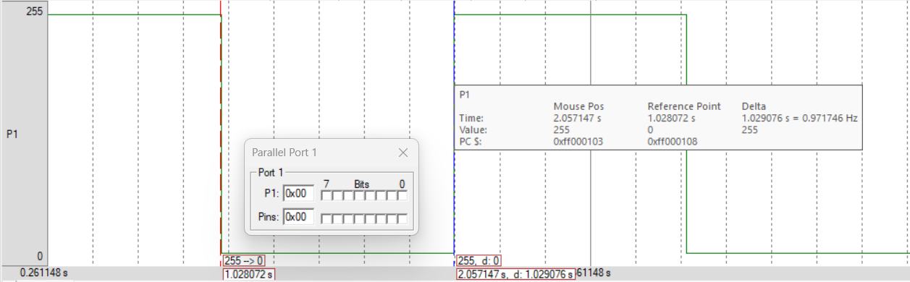

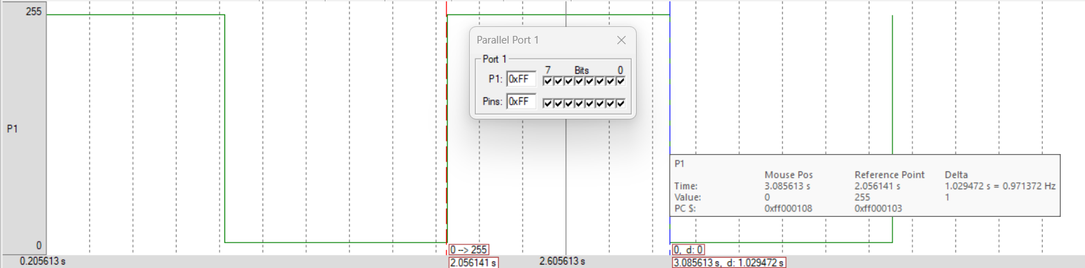

Read Status of Switches, Write to LEDs

Address | Label | Instruction | Comment
 |  | ORG 0H
 |  | LJMP 100H
 |  | ORG 100H
100 |  | MOV P2, #0FFH | ; configure port 2 as input
103 | LOOP: | MOV P1, P2 | ; write status of port 2 switches to port 1 LEDs
106 |  | SJMP LOOP | ; continue reading status of switches
 |  | END

Input 1 Input 2

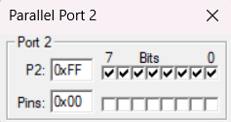
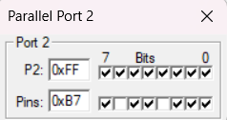

Output 1 Output 2

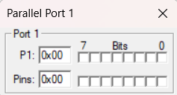
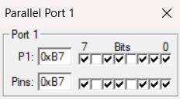

Read Status of Switch, Write to LED

Address | Label | Instruction | Comment
 |  | ORG 0H
 |  | LJMP 100H | ;
 |  | ORG 100H
 |  | MOV P3, #0FFH | ; configure port 2 as input
 | LOOP: | JB P3.2, SETBIT | ; check status of switch in port 3
 |  | CLR P1.3 | ; reflect switch off status in port 1 LED
 |  | SJMP HERE | ;
 | SETBIT: | SETB P1.3 | ; reflect switch on status in port 1 LED
 | HERE: | SJMP LOOP | ; continue reading status of switch
 |  | END

Input 1 Input 2

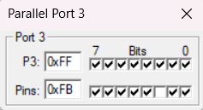
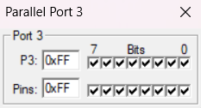

Output 1 Output 2

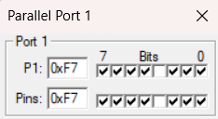
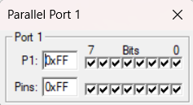

Triangle Wave – 2kHz Frequency

Address | Label | Instruction | Comment
 |  | ORG 0H
0 |  | LJMP 100H
 |  | ORG 100H
100 |  | MOV TMOD, #02H | ; configure timer for wave generation
103 |  | MOV TH0, #19H | ; value required to generate 0.25 ms delay
106 | HERE: | MOV P1, #00H | ;
109 |  | CLR A | ; indicates rise
10A |  | ACALL WAVE | ; rise part of wave
10C |  | INC A | ; indicates fall
10D |  | ACALL WAVE | ; fall part of wave
10F |  | SJMP HERE | ;
 |  | ORG 200H
200 | WAVE: | SETB TR0 | ; subroutine
202 |  | JNZ FALL | ;
204 | RISE: | INC P1 | ; rise part, only increments
206 |  | JNB TF0, RISE | ;
209 |  | SJMP ENDT | ;
20B | FALL: | DEC P1 | ; fall part, only decrements
20D |  | JNB TF0, FALL | ;
210 | ENDT: | CLR TF0 | ;
212 |  | CLR TR0 | ;
214 |  | RET
 |  | END

Output

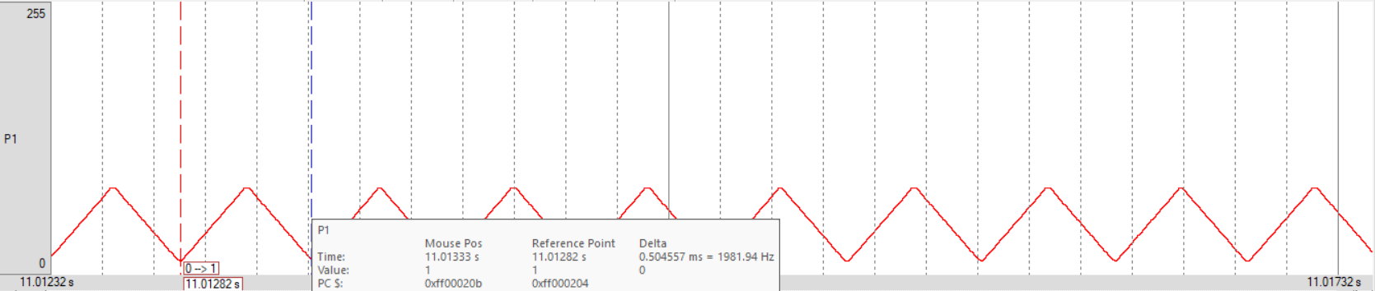

Sawtooth Wave – 2kHz Frequency

Address | Label | Instruction | Comment
 |  | ORG 0H
0 |  | LJMP 100H
 |  | ORG 100H
100 |  | MOV TMOD, #01H | ; configure timer for wave generation
103 |  | MOV P1, #00H | ;
106 |  | CLR A | ; indicates rise
107 | HERE: | ACALL WAVE | ; rise part of wave
109 |  | INC A | ; indicates fall
10A |  | ACALL WAVE | ; fall part of wave
10C |  | SJMP HERE | ;
 |  | ORG 200H
200 | WAVE: | MOV TH0, #0FEH | ; TH value for 0.5 ms delay
203 |  | MOV TL0, #33H | ; TL value for 0.5 ms delay
206 |  | SETB TR0 | ;
208 |  | JNZ FALL | ;
20A | RISE: | INC P1 | ; rise part, only increments
20C |  | JNB TF0, RISE | ;
20F |  | SJMP ENDT | ;
211 | FALL: | MOV P1, #00H; | ; fall part, instantly goes down to 0
214 | ENDT: | CLR TF0 | ;
216 |  | CLR TR0 | ;
218 |  | RET | ;
 |  | END | ;

Output

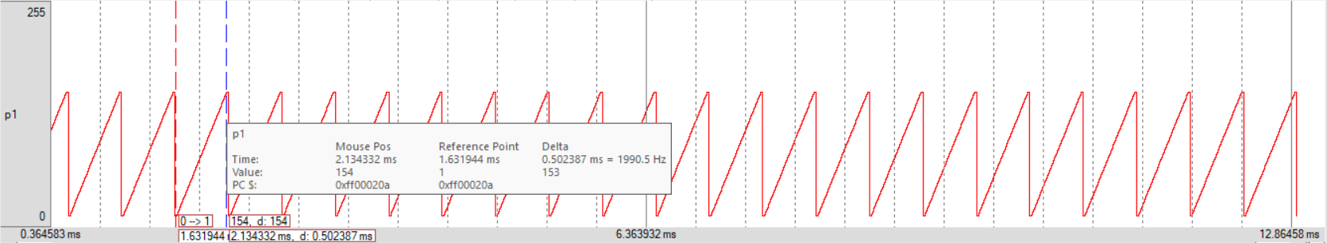

Sine Wave – Arbitrary Frequency

Address | Label | Instruction | Comment
 |  | ORG 0H
0 |  | LJMP 100H | ;
 |  | ORG 100H
100 | CYCLE: | MOV DPTR, #DACIN | ; location of lookup table of sine values
103 |  | MOV R1, #4AH | ; no. of sine values
105 | LOOP: | CLR A | ;
106 |  | MOVC A, @A+DPTR | ; current sine value copied to Acc
107 |  | MOV P1, A | ; generating the sine wave
109 |  | INC DPTR | ;
10A |  | DJNZ R1, LOOP | ;
10C |  | SJMP CYCLE | ;
 |  | ORG 200H
 | DACIN: | DB 127, 138, 149, 160, 170, 180, 190, 200, 209, 217, 224, 231, 237
 |  | DB 242, 246, 250, 252, 254, 255, 254, 252, 250, 246, 242, 237, 231
 |  | DB 224, 217, 209, 200, 190, 180, 170, 160, 149, 138, 127, 116, 105
 |  | DB 94, 84, 73, 64, 54, 45, 37, 30, 23, 17, 10, 8, 4, 2, 1, 0, 1, 2, 4, 8
 |  | DB 10, 17, 23, 30, 37, 45, 54, 64, 73, 84, 94, 105, 116, 127
 |  | END

Output

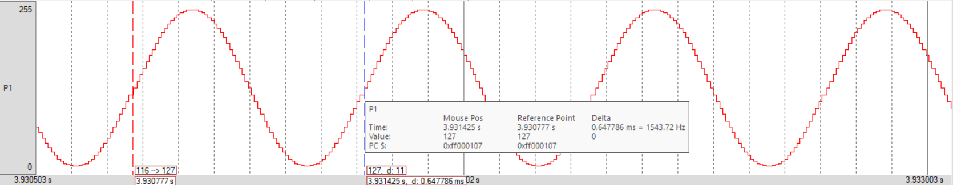

Count Pulses

Address | Label | Instruction | Comment
 |  | ORG 0H
0 |  | LJMP 100H | ;
 |  | ORG 100H
100 |  | MOV TMOD, #60H | ; configure counter 1 in mode 2
103 |  | MOV TH1, #0H | ; initially, counter is 0
106 |  | SETB P3.5 | ; configure pin T1 to generate clock pulses
108 |  | SETB TR1 | ; start counter
10A | COUNT: | MOV P1, TL1 | ; reflect count value on LEDs
10D |  | SJMP COUNT | ; continue reflecting
 |  | END

Input
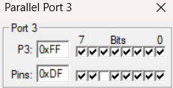
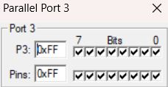
Non-periodic intervals

Output

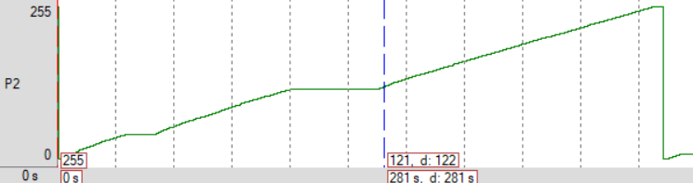

Interrupts – Toggle LEDs + Square Wave

Address | Label | Instruction | Comment
 |  | ORG 0H
0 |  | LJMP 100H
 |  | ORG 100H
100 | MAIN: | MOV TMOD, #01H | ; timer 0 in mode 1 for 0.05 s delay
103 |  | MOV IE, #82H | ; enable timer 0 interrupt
106 |  | MOV TH0, #4BH | ;
109 |  | MOV TL0, #0FDH | ;
10C |  | SETB TR0 | ;
10E |  | MOV R0, #14H | ; counter for LED toggle
110 |  | MOV R1, #2H | ; counter for ‘ON’ part of square wave
112 |  | MOV P1, #0FFH | ; LED on
115 |  | MOV P2, #0FFH | ;
118 |  | SETB P2.7 | ; ‘ON’ part of wave
11A | HERE: | SJMP HERE | ;
 |  | ORG 0BH
0B |  | DEC R0 | ; LED counter decremented after every 0.05 s
0C |  | ACALL SR | ; subroutine to handle LED and square wave
0E |  | RETI | ;
 |  | ORG 150H
150 |  | CLR TF0 | ;
152 |  | CLR TR0 | ;
154 |  | MOV A, R0 | ; counter for LED copied to Acc
155 |  | JNZ SQW | ; if counter = 0, toggle LED, else square wave
157 | LED: | JB P1.0, LOFF | ; if LED is ON, turn if OFF, and vice versa

15A | LON: | MOV P1, #0FFH | ; LED is OFF, so toggle it ON
15D |  | MOV R0, #14H | ; reinitialise counter for LED toggle
15F |  | SJMP SQW | ; go handle square wave
161 | LOFF: | MOV P1, #0H | ; LED is ON, so toggle it OFF
164 |  | MOV R0, #14H | ; reinitialise counter for LED toggle
166 | SQW: | MOV A, R1 | ; counter for ‘ON’ part of wave copied to Acc
167 |  | JZ OFF | ; if counter = 0, ‘ON’ over, go to ‘OFF’
169 | ON: | SETB P2.7 | ; ‘ON’ part of wave
16B |  | DEC R1 | ; counter for ‘ON’ part of wave decremented
16C |  | SJMP ST | ; need to restart timer
16E | OFF: | CLR P2.7 | ; ‘OFF’ part of wave
170 |  | MOV R1, #3H | ; reinitialising counter for ‘ON’ part
172 | ST: | MOV TH0, #4BH | ;
175 |  | MOV TL0, #0FDH | ;
178 |  | SETB TR0 | ;
17A |  | RET | ;
 |  | END

Output

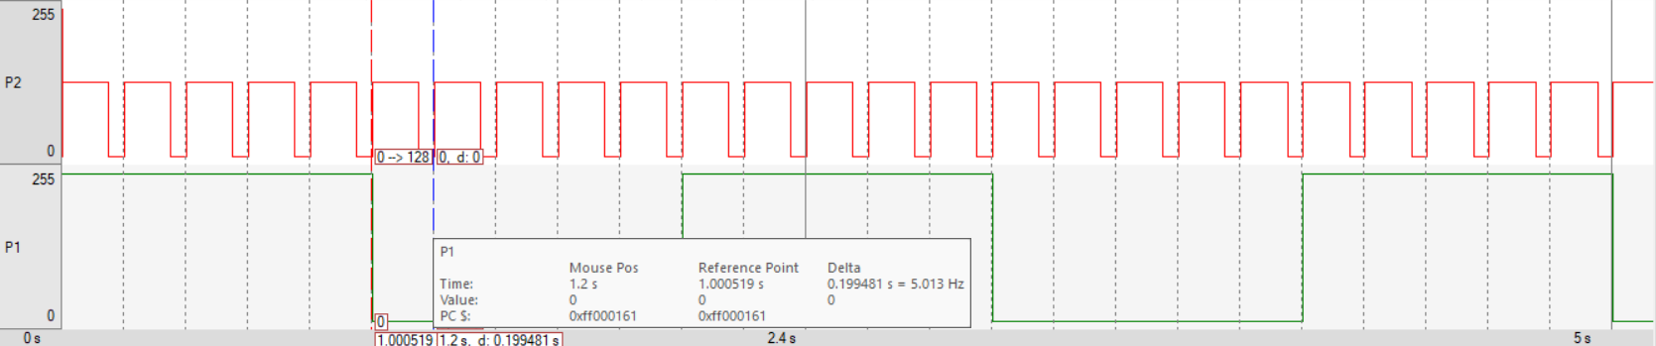

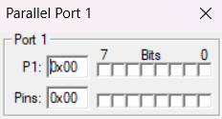
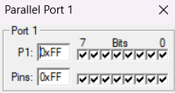
Every 1 second

Transmit Message Serially

Address | Label | Instruction | Comment
 |  | ORG 0H
0 |  | LJMP 100H
 |  | ORG 100H
100 |  | MOV TMOD, #20H | ; configure timer for serial communication
103 |  | MOV TH1, #-3 | ; set baud rate of 9600
106 |  | MOV SCON, #40H | ; enable serial transmission
109 |  | SETB TR1 | ; start baud rate of 9600
10B | CYCLE: | MOV DPTR, #MSG | ; location of input message
10E | LOOP: | CLR A | ; using Acc as offset, hence setting it to 0
10F |  | MOVC A, @A+DPTR | ; store current character in Acc
110 |  | INC DPTR | ; go to next character
111 |  | MOV SBUF, A | ; transmit character serially
113 | WAIT: | JNB TI, WAIT | ; wait for transmission to complete
116 |  | CLR TI | ; transmission complete
118 |  | JZ CYCLE | ; if end of string reached, reinitialise
11A |  | SJMP LOOP | ; continue transmitting
 |  | ORG 200H
 | MSG: | DB ‘Welcome to IT Department’, 0
 |  | END

Output

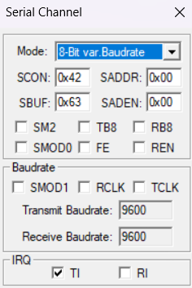

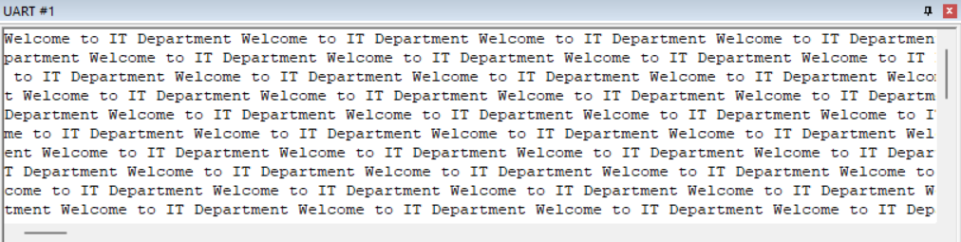

Transmit and Receive – without Interrupts

Address | Label | Instruction | Comment
 |  | ORG 0H
0 |  | LJMP 100H
 |  | ORG 100H
100 |  | MOV TMOD, #20H | ; configure timer for serial communication
103 |  | MOV TH1, #-3 | ; baud rate = 9600
106 |  | MOV SCON, #50H | ; enable serial transmission and reception
109 |  | MOV P0, #0FFH | ; configure port 0 switches for input
10C |  | SETB TR1 | ; start baud rate of 9600
10E | TRA: | MOV SBUF, P0 | ; transmit switches reading to SBUF
111 | TWAIT: | JNB TI, TWAIT | ; wait till transmission is complete
114 |  | CLR TI | ;
116 | RWAIT: | JNB RI, RWAIT | ; receiving character from SBUF
119 | REC: | MOV P1, SBUF | ; move received character to LED
11C |  | CLR RI | ;
11E |  | SJMP TRA | ; continue transmission and reception
 |  | END

Input

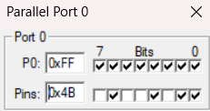
Change the value in Port 0; the value will be transmitted serially to SBUF.

For reception, type a character in the UART window. It will be serially received.

Output

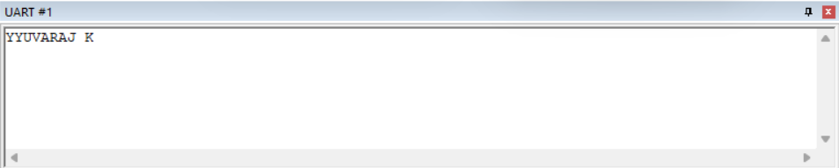

Transmitted characters appear on UART Window.

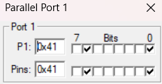

Received characters are written to Port 1.

Transmit and Receive – with Interrupts

Address | Label | Instruction | Comment
 |  | ORG 0H
0 |  | LJMP 100H
 |  | ORG 100H
100 |  | MOV TMOD, #20H | ; configure timer for serial communication
103 |  | MOV TH1, #-3 | ; baud rate = 9600
106 |  | MOV SCON, #50H | ; enable serial transmission and reception
109 |  | MOV IE, #90H | ; enable serial port interrupt
10C |  | MOV P0, #0FFH | ; configure port 0 switches for input
10F |  | SETB TR1 | ; start baud rate of 9600
111 |  | MOV SBUF, P0
114 | HERE: | SJMP HERE
 |  | ORG 23H
23 | ISRTI: | JNB TI, ISRRI
26 |  | ACALL SRTI | ; call transmit subroutine
28 |  | RETI
29 | ISRRI: | ACALL SRRI | ; call receive subroutine
2B |  | RETI
 |  | ORG 200H
200 | SRTI: | CLR TI | ; transmission done, so clearing TI
202 |  | MOV SBUF, P0 | ; transmit next character
205 |  | RET | ;
 |  | ORG 220H
220 | SRRI: | MOV P1, SBUF | ; display serially received character on LED
223 |  | CLR RI | ; reception done, so clear RI

225 |  | RET | ;
 |  | END | ;

Input

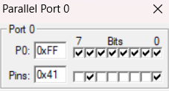
Change the value in Port 0; the value will be transmitted serially to SBUF.

For reception, type a character in the UART window. It will be serially received.

Output

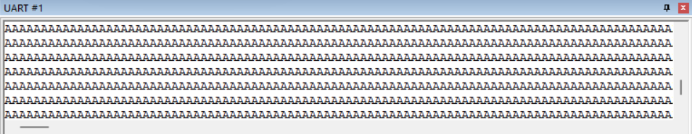

Transmitted characters appear on UART Window.

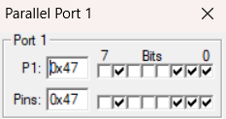

Received characters are written to Port 1.

Toggle LEDs with Arbitrary S/W Delay

#include <reg51.h>

void delay() {
unsigned int i, j;
for (i=0; i<267; i++)
for (j=0; j<1275; j++);
}

void main() {
while(1) {
P1 = 0xFF;
delay();
P1 = 0x00;
delay();
}
}

Output
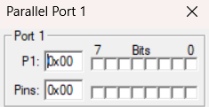
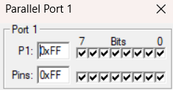
Arbitrary Delay

Toggle LEDs with 1s Delay

#include <reg51.h>

void delay() {
unsigned int i;
for (i=0; i<20; i++) {
TL0 = 0xFD;
TH0 = 0x4B;
TR0 = 1;
while (TF0==0);
TR0 = 0;
TF0 = 0;
}
}

void main() {
TMOD = 0x01;
while (1) {
P1=0xFF;
delay();
P1=0x00;
delay();
}
}

Output

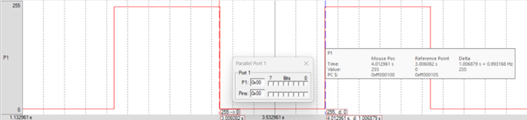
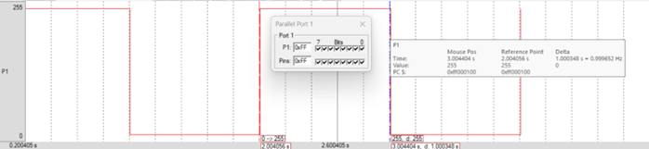

Read Status of Switches, Write to LEDs

#include <reg51.h>

void main() {
P2 = 0xFF;
while (1)
P1 = P2;
}

Input 1 Input 2




Output 1 Output 2




Read Status of Switch, Write to LED

#include <reg51.h>

sbit my_switch = P3^2;
sbit led = P1^3;

void main() {
my_switch=1;
while (1)
led = my_switch;
}

Input 1 Input 2




Output 1 Output 2




Triangle Wave – 2kHz Frequency

#include <reg51.h>

void wave() {
TR0 = 1;
if (P1==0)
while (TF0==0)
P1++;
else
while (TF0==0)
P1--;
TR0 = 0;
TF0 = 0;
}

void main() {
TMOD = 0x02;
TH0 = 0x19;
while (1) {
P1 = 0;
wave();
wave();
}
}

Output

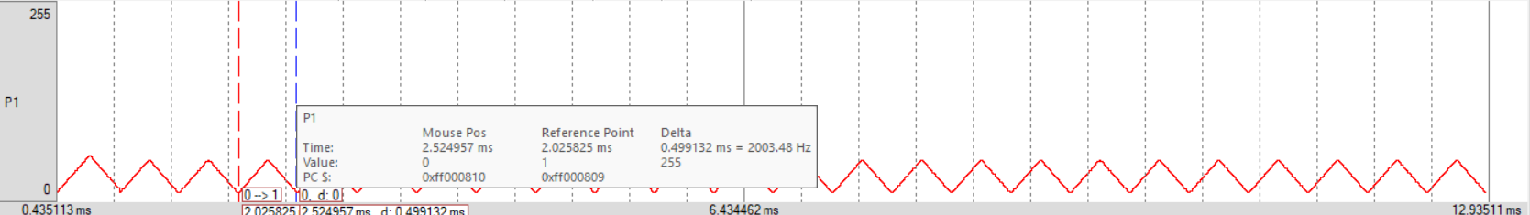

Sawtooth Wave – 2kHz Frequency

#include <reg51.h>

void wave() {
TH0 = 0xFE;
TL0 = 0x33;
TR0 = 1;
while (TF0==0)
P1++;
TR0 = 0;
TF0 = 0;
}

void main() {
TMOD = 0x01;
while (1) {
P1 = 0;
wave();
}
}

Output

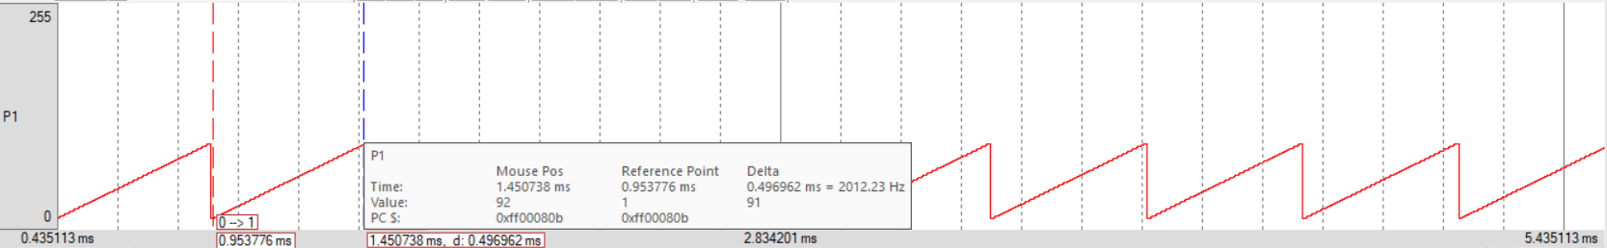

Sine Wave – Arbitrary Frequency

#include <reg51.h>

void main() {
unsigned char sin_vals[] = {
127, 138, 149, 160, 170, 180, 190, 200, 209, 217, 224, 231, 237, 242, 246, 250,
252, 254, 255, 254, 252, 250, 246, 242, 237, 231, 224, 217, 209, 200, 190, 180, 170, 160, 149, 138, 127, 116, 105, 94, 84, 73, 64, 54, 45, 37, 30, 23, 17, 10, 8, 4, 2, 1, 0, 1, 2, 4, 8, 10, 17, 23, 30, 37, 45, 54, 64, 73, 84, 94, 105, 116
};
unsigned int i;
while (1)
for (i=0; i<sizeof(sin_vals); i++)
P1 = sin_vals[i];
}

Output

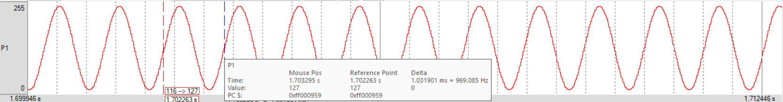

Count Pulses

#include <reg51.h>

sbit pulse = P3^5;

void main() {
TMOD = 0x60;
TH1 = 0x00;
pulse = 1;
TR1 = 1;
while (1)
P1 = TL1;
}

Input


Non-periodic intervals

Output



Interrupts – Toggle LEDs + Square Wave

#include <reg51.h>

sbit pin = P2^7;
unsigned char led_c;
unsigned char wave_c;

void timer0() interrupt 1 {
led_c--;
TR0 = 0;
TF0 = 0;
if (led_c == 0) {
P1 = P1^0xFF;
led_c = 20;
}
if (wave_c == 0) {
pin = 0;
wave_c = 3;
} else {
pin = 1;
wave_c--;
}
TH0 = 0x4B;
TL0 = 0xFD;
TR0 = 1;
}

void main() {
TMOD = 0x01;
IE = 0x82;
TH0 = 0x4B;
TL0 = 0xFD;
led_c = 20;
wave_c = 2;
P1 = 0xFF;
P2 = 0;
pin = 1;
TR0 = 1;
while (1);
}

Output





Every 1 second

Transmit Message Serially

#include <reg51.h>

void main() {
unsigned char message[] = "Welcome to IT Department";
TMOD = 0x20;
TH1 = -3;
SCON = 0x40;
TR1 = 1;
while (1) {
unsigned int i;
for (i=0; i<sizeof(message); i++) {
SBUF = message[i];
while (TI==0);
TI = 0;
}
}
}

Output




Transmit and Receive with Interrupt

#include <reg51.h>

void serial() interrupt 4 {
if (TI==1) {
TI = 0;
SBUF = P0;
} else {
P1 = SBUF;
RI = 0;
}
}

void main() {
TMOD = 0x20;
TH1 = -3;
SCON = 0x50;
IE = 0x90;
P0 = 0xFF;
TR1 = 1;
SBUF = P0;
while (1);
}

Input


Change the value in Port 0; the value will be transmitted serially to SBUF.

For reception, type a character in the UART window. It will be serially received.

Output



Transmitted characters appear on UART Window.



Received characters are written to Port 1.

Toggle LEDs – External Interrupt

#include <reg51.h>

sbit it0 = TCON^0;
sbit int0pin = P3^2;
sbit it1 = TCON^2;
sbit int1pin = P3^3;

void int0() interrupt 0 {
P1 = P1 ^ 0xFF;
}

void int1() interrupt 2 {
P2 = P2 ^ 0xFF;
}

void main() {
IE = 0x85; // IE = 1000 0101 = 85H
it0 = 1;
int0pin = 1;
it1 = 1;
int1pin = 1;
P1 = 0xFF;
P2 = 0xFF;
while (1);
}

Output

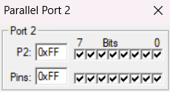
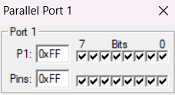
Upon triggering P3.3
Upon triggering P3.2

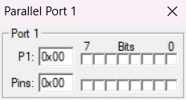
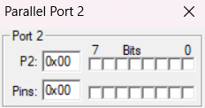

Internal RAM and External RAM Data Exchange – Assembly

Address | Label | Instruction | Comment
 |  | ORG 0H
0 |  | LJMP 100H
 |  | ORG 100H
100 |  | MOV DPTR, #100H | ; external RAM data starting location
103 |  | MOV R2, #10 | ; no. of bytes of data, acts as counter
105 |  | MOV R0, #40H | ; internal RAM data starting location
107 | LOOP: | MOV A, @R0 | ; internal RAM data to Acc
108 |  | MOV R1, A | ; temporarily store internal RAM data in R1
109 |  | MOVX A, @DPTR | ; external RAM data to Acc
10A |  | MOV @R0, A | ; external RAM data to internal RAM
10B |  | MOV A, R1 | ; internal RAM data to Acc
10C |  | MOVX @DPTR, A | ; internal RAM data to external RAM
10D |  | INC R0 | ; go to next byte in internal RAM
10E |  | INC DPTR | ; go to next byte in external RAM
10F |  | DJNZ R2, LOOP | ; continue until all 10 bytes are exchanged
111 | HERE: | SJMP HERE
 |  | END

Input

Output

Internal RAM and External RAM Data Exchange – Embedded C

#include <reg51.h>
#include <absacc.h>

void main() {
unsigned int i;
unsigned char internal[] = "JIHGFEDCBA";
unsigned char val = 'A';
for (i=0; i<10; i++) {
XBYTE[i]=val;
val++;
}
for (i=10; i<20; i++)
XBYTE[i]=internal[i-10];
for (i=0; i<10; i++)
internal[i]=XBYTE[i];
while(1);
}

Input

Output

Exp No: 9
17/03/2025

Basic Arduino Programming for Digital I/O

Objective

To write and execute basic Arduino sketches for

- toggling LED
- serial transmission
- reading switch and reflecting it on LED
- traffic signal simulation

Components Required

S. No. | Component | Quantity
1 | Arduino Mega 2560 | 1
2 | Power Cord | 1
3 | Male-to-Male Wires | Required Amount
4 | LED | 3

Toggle LEDs – 1s Delay

int led = 13;

void setup() {
pinMode(led, OUTPUT);
digitalWrite(led, LOW);
}

void loop() {
digitalWrite(led, HIGH);
delay(1000);
digitalWrite(led, LOW);
delay(1000);
}

Circuit Diagram

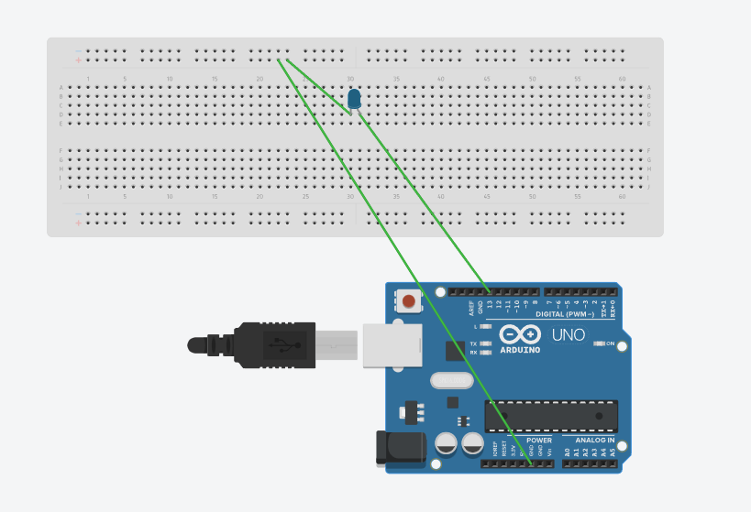

Output

LED is toggled ON and OFF every 1 second.
Aim

To write and execute an Arduino sketch that toggles the LED with a delay of 1 s.

Read and Serial Transmit

int my_switch = 7;

void setup() {
Serial.begin(9600);
pinMode(my_switch, INPUT);
}

void loop() {
if (digitalRead(my_switch)==HIGH)
Serial.write("H");
else
Serial.write("L");
}

Circuit Diagram

Switch is LOW. | Switch is HIGH.
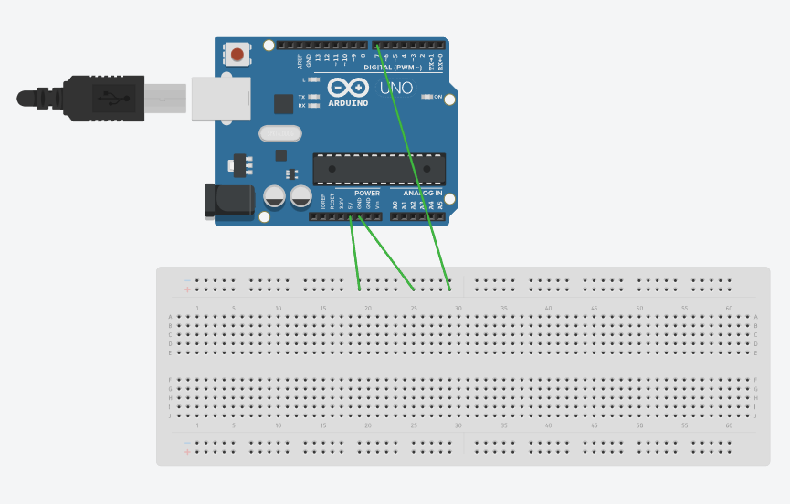 | 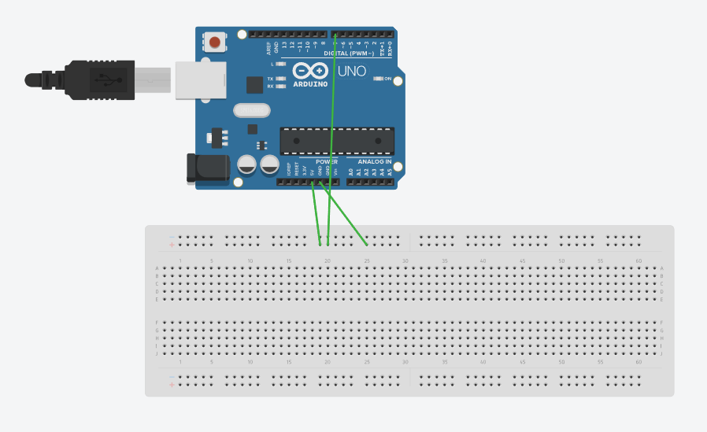

Output

When switch is LOW, “L” is serially written.
When switch is HIGH, “H” is serially written.

Aim

To write and execute an Arduino sketch that reads the switch and serially transmits a corresponding message.
Read from Switch, Reflect on LED

int my_switch = 7;
int led = 13;
int val = 0;

void setup() {
pinMode(my_switch, INPUT);
pinMode(led, OUTPUT);
}

void loop() {
digitalWrite(led, digitalRead(my_switch));
}

Circuit Diagram

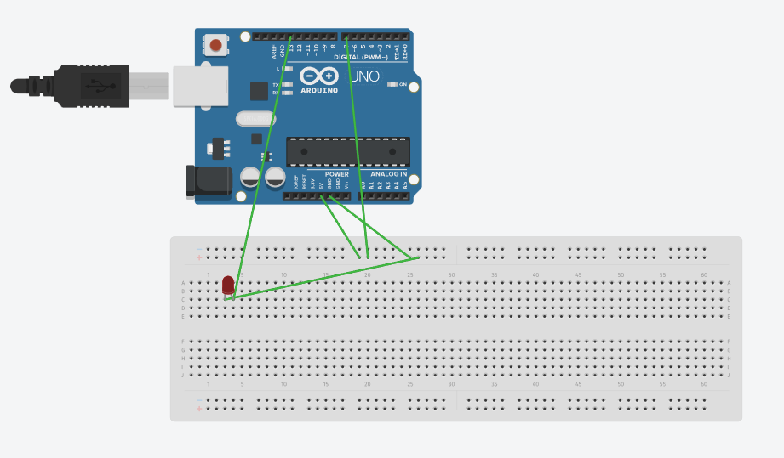

Output

When switch is LOW, LED is OFF.
When switch is HIGH, LED is ON.

Aim

To write and execute an Arduino sketch that reads from a switch and reflects it on the LED.
Traffic Lights

int red = 11;
int yellow = 12;
int green = 13;

void setup() {
pinMode(red, OUTPUT);
pinMode(yellow, OUTPUT);
pinMode(green, OUTPUT);
}

void loop() {
digitalWrite(red, HIGH);
delay(5000);
digitalWrite(red, LOW);
digitalWrite(yellow, HIGH);
delay(2000);
digitalWrite(yellow, LOW);
digitalWrite(green, HIGH);
delay(3000);
digitalWrite(green, LOW);
digitalWrite(yellow, HIGH);
delay(2000);
digitalWrite(yellow, LOW);
}

Aim

To write and execute an Arduino sketch that simulates the working of traffic lights.
Circuit Diagram

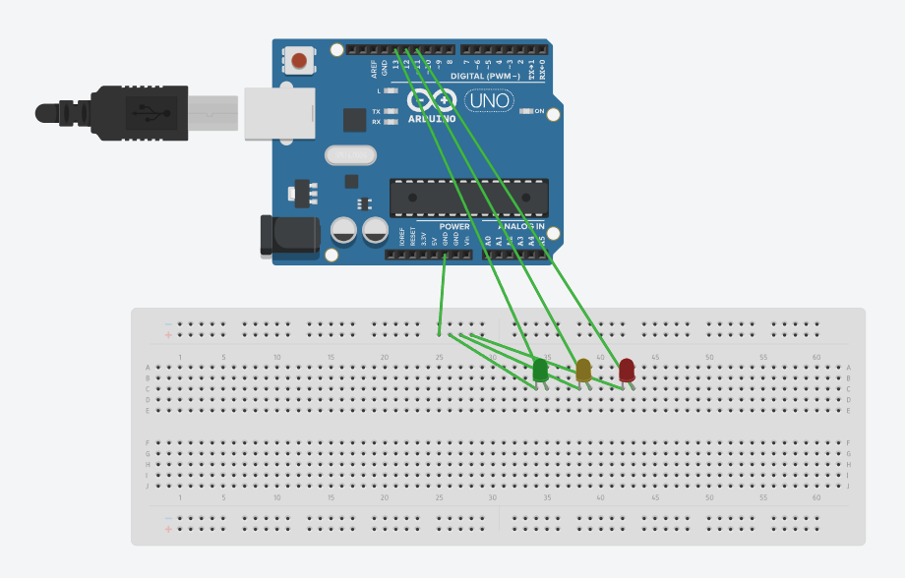

Output

Red – 5s
Yellow – 2s
Green – 3s
Yellow – 2s

This sequence is simulated forever, thus simulating traffic lights.

Result

Hence, the following Arduino sketches were successfully implemented.

- Toggle LED
- Read and Transmit Serially
- Switch to LED
- Traffic Signal

Exp No: 10
24/03/2025

Arduino Programming for Development of IoT Applications

Objective

To develop simple IoT applications using Arduino, sensors, and actuators.

Components Required

S. No. | Component | Quantity
1 | Arduino Mega 2560 | 1
2 | Power Cord | 1
3 | Male-to-Male Wires | Required Amount
4 | Male-to-Female Wires | Required Amount
5 | LED | 8
6 | Thermistor | 1
7 | Ultrasonic Sensor | 1
8 | IR Sensor | 1
9 | Servo Motor | 1
10 | Motion Detector | 1

Box Junction

int g1 = 6, r1 = 7, g2 = 8, r2 = 9, g3 = 10, r3 = 11, g4 = 12, r4 = 13;

void setup() {
int pins[] = {g1, r1, g2, r2, g3, r3, g4, r4};
for (int i=0; i<8; i++) {
pinMode(pins[i], OUTPUT);
digitalWrite(pins[i], LOW);
}
}

void loop() {
// 1
digitalWrite(r2, HIGH);
digitalWrite(r3, HIGH);
digitalWrite(r4, HIGH);
digitalWrite(g1, HIGH);
delay(5000);
// 2
digitalWrite(r3, LOW);
digitalWrite(g3, HIGH);
delay(5000);
digitalWrite(g1, LOW);
digitalWrite(g3, LOW);
digitalWrite(r1, HIGH);
digitalWrite(r3, HIGH);
// 3
digitalWrite(r2, LOW);
digitalWrite(g2, HIGH);
delay(5000);
// 4
digitalWrite(r4, LOW);
digitalWrite(g4, HIGH);
delay(5000);
digitalWrite(g2, LOW);
digitalWrite(g4, LOW);
digitalWrite(r2, HIGH);
digitalWrite(r4, HIGH);
// 5
digitalWrite(r3, LOW);
digitalWrite(g3, HIGH);
delay(5000);
digitalWrite(g3, LOW);
Aim

To write and execute an Arduino sketch that simulates the working of traffic lights in a box junction.

digitalWrite(r3, HIGH);
// 6
digitalWrite(r4, LOW);
digitalWrite(g4, HIGH);
delay(5000);
digitalWrite(g4, LOW);
digitalWrite(r4, HIGH);
}

Circuit Diagram

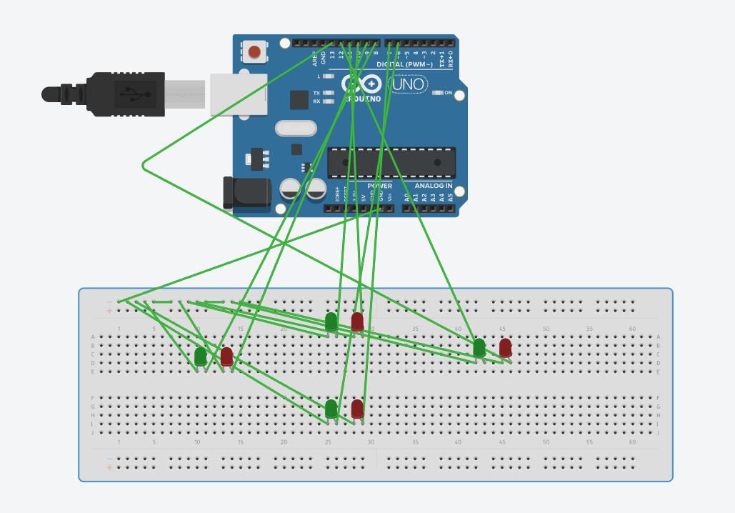

Output

A box junction traffic is simulated. There are 6 possible combinations which are repeated infinitely.

- South is allowed to go straight and right. The others are OFF.
- South and North are allowed to go straight. The others are OFF.
- West is allowed to go straight and right. The others are OFF.
- West and East are allowed to go straight. The others are OFF.
- North is allowed to go straight AND right. The others are OFF.
- East is allowed to go straight AND right. The others are OFF.

Thermistor

float value, temperature;
int thermistor = A0;
int buzzer = 13;

void setup() {
Serial.begin(9600);
pinMode(thermistor, INPUT);
pinMode(buzzer, OUTPUT);
}

void loop() {
value = analogRead(thermistor);
temperature = (value*5000/1024)/10;
Serial.print("Temperature: ");
Serial.println(temperature);
if(temperature >= 30)
digitalWrite(buzzer, HIGH);
else
digitalWrite(buzzer, LOW);
}

Aim

To write and execute an Arduino sketch that activates the buzzer when the temperature exceeds a predefined threshold.
Circuit Diagram

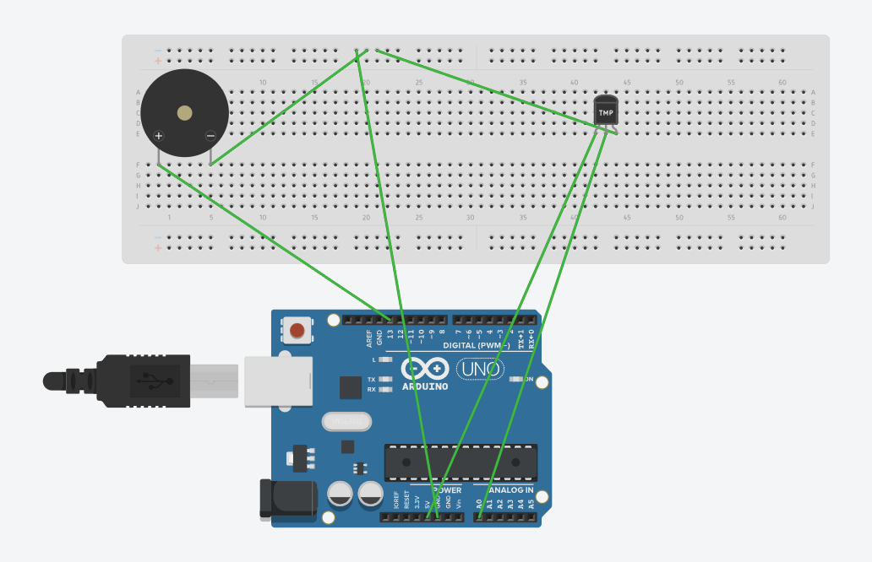

Output

When temperature is below 30°C, buzzer is OFF.
When temperature is equal to or above 30°C, buzzer is ON.

Ultrasonic Sensor

int led = 7, trigger = 8, echo = 9;
float timing = 0.0, distance = 0.0;

void setup() {
pinMode(echo, INPUT);
pinMode(trigger, OUTPUT);
pinMode(led, OUTPUT);
digitalWrite(trigger, LOW);
digitalWrite(led, LOW);
Serial.begin(9600);
}

void loop() {
digitalWrite(trigger, LOW);
delay(2);
digitalWrite(trigger, HIGH);
delay(10);
digitalWrite(trigger, LOW);

timing = pulseIn(echo, HIGH);
distance = (timing*0.034)/2;
Serial.print("Distance: ");
Serial.println(distance);

if (distance <= 50)
digitalWrite(led, HIGH);
else
digitalWrite(led, LOW);
}

Aim

To write and execute an Arduino sketch that activates the LED when the distance from the ultrasonic sensor is below a certain predefined upper limit.
Circuit Diagram

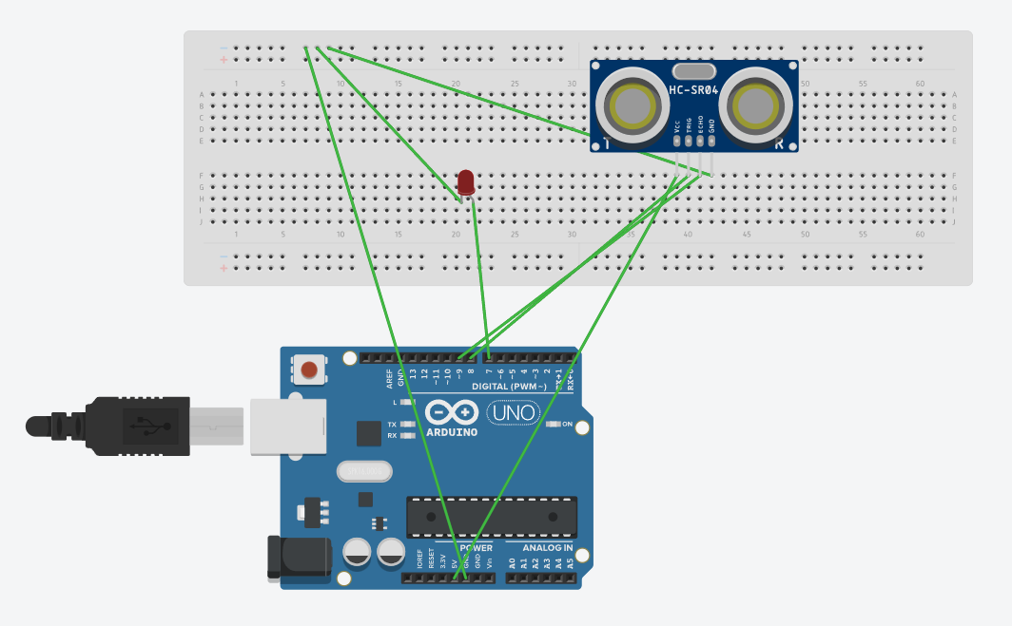

Output

When there is an object at a distance of less than 50 cm from the sensor, LED is ON.
Otherwise, LED is off.

IR Sensor + Servo Motor

#include <Servo.h>

Servo sb;
int ir = 7;

void setup() {
pinMode(ir, INPUT);
sb.attach(8);
sb.write(90);
Serial.begin(9600);
}

void loop() {
if (digitalRead(ir) == HIGH) {
Serial.println("Obstacle!");
sb.write(180);
delay(2000);
sb.write(90);
} else {
sb.write(90);
}
}

Circuit Diagram

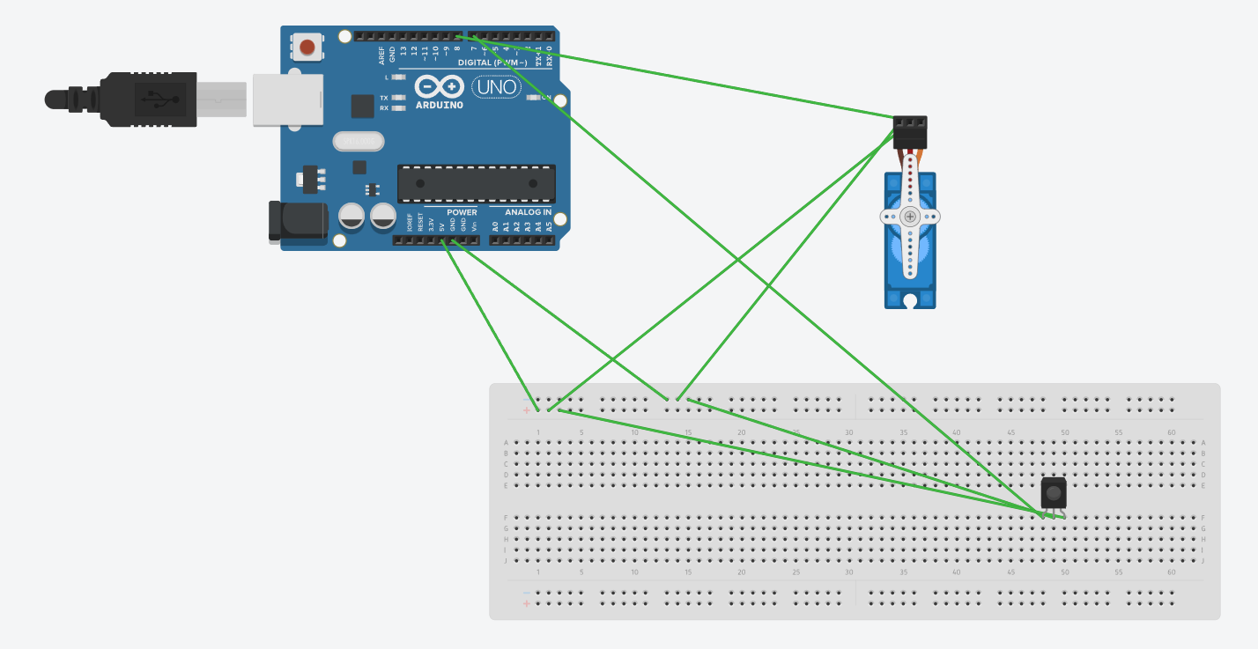

Output

The servo motor is initially at the 90° position.

When an object is detected in the proximity of the IR sensor, the servo motor rotates to 180°, stays in that position for 2 s, then goes back to the 90° position.

Otherwise, the servo motor remains at its 90° position.
Aim

To write and execute an Arduino sketch that rotates the servo motor when an object is detected by the infrared sensor.

Motion Detector

int led = 13;
int motion_detector = 12;

void setup() {
pinMode(led, OUTPUT);
pinMode(motion_detector, INPUT);
Serial.begin(9600);
}

void loop() {
if (digitalRead(motion_detector) == HIGH) {
Serial.println("Motion detected!");
digitalWrite(led, HIGH);
} else {
digitalWrite(led, LOW);
}
}

Circuit Diagram

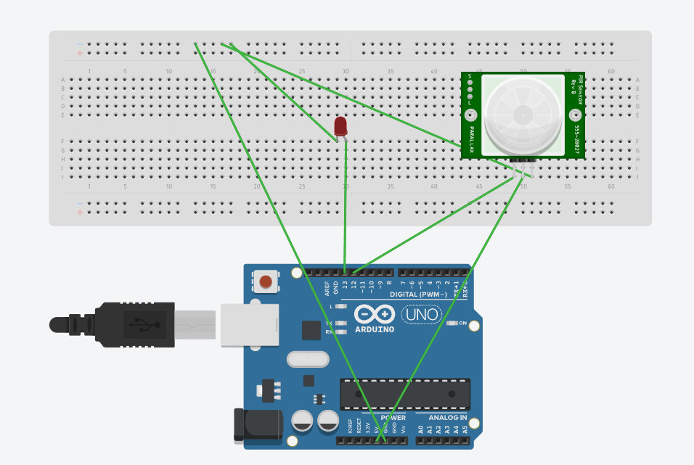

Output

When motion is detected anywhere within 6 m of the PIR sensor, LED is ON.
Otherwise, LED is OFF.

Aim

To write and execute an Arduino sketch that activates the LED upon the detection of motion.

Result

Hence, the following IoT applications using Arduino sketches were successfully implemented.

- Box Junction
- Thermistor + Buzzer
- Ultrasonic + LED
- IR Sensor + Servo Motor
- Motion Detector + Buzzer

Exp No: 11
21/04/2025

Development of IoT Applications using Wireless Technologies

Objective

To develop simple IoT applications by interfacing with different wireless technologies.

Components Required

S. No. | Component | Quantity
1 | NodeMCU | 1
2 | Power Cord | 1
3 | HC05 Bluetooth Module | 1
4 | NEO-6M GPS Receiver Module | 1
5 | LED | 1
6 | Resistor – 330 ohms | 1
7 | Male-to-Female Wires | Required Amount
8 | Female-to-Female Wires | Required Amount

Wi-Fi

#include <ESP8266WiFi.h>
#include <ESP8266WebServer.h>

const char* ssid = "Team 12";
const char* pw = "anuniyuv";

IPAddress local_ip(192,168,2,1);
IPAddress gateway(192,168,2,1);
IPAddress subnet(255,255,255,0);

ESP8266WebServer server(80);

uint8_t led = D2;
bool status = LOW;

void setup() {
Serial.begin(9600);
pinMode(led, OUTPUT);

WiFi.softAP(ssid, pw);
WiFi.softAPConfig(local_ip, gateway, subnet);

server.on("/", onConnect);
server.on("/ledOn", ledOn);
server.on("/ledOff", ledOff);
server.onNotFound(NotFound);

server.begin();
Serial.println("HTTP server started.");
}

void loop() {
server.handleClient();
if(status)
digitalWrite(led, HIGH);
else
digitalWrite(led, LOW);
}

Aim

To write and execute an Arduino sketch that enables NodeMCU as an HTTP server with Wi-Fi Access Point mode and controls an LED connected at the server, from the client.

void onConnect() {
status = LOW;
server.send(200, "text/html", sendHTML(false));
}

void ledOn() {
status = HIGH;
server.send(200, "text/html", sendHTML(true));
}

void ledOff() {
status = LOW;
server.send(200, "text/html", sendHTML(false));
}

void NotFound(){
server.send(404, "text/plain", "Not found");
}

String sendHTML(uint8_t led){
String html = "" +
"<!DOCTYPE html>\n" +
"<html>\n" +
"<head>\n" +
"<title>LED Control</title>\n" +
"</head>\n" +
"<body>\n" +
"<h1>LED</h1>\n" +
"<form method=\"get\">\n" +
(led ?
"<input type='button' value=\"LED OFF\" onclick=\"window.location.href='/ledOff'\">\n"
:
"<input type=\"button\" value=\"LED ON\" onclick=\"window.location.href='/ledOn'\">\n") +
"</form>\n" +
"</body>\n" +
"</html>\n";
return html;
}

Circuit Diagram

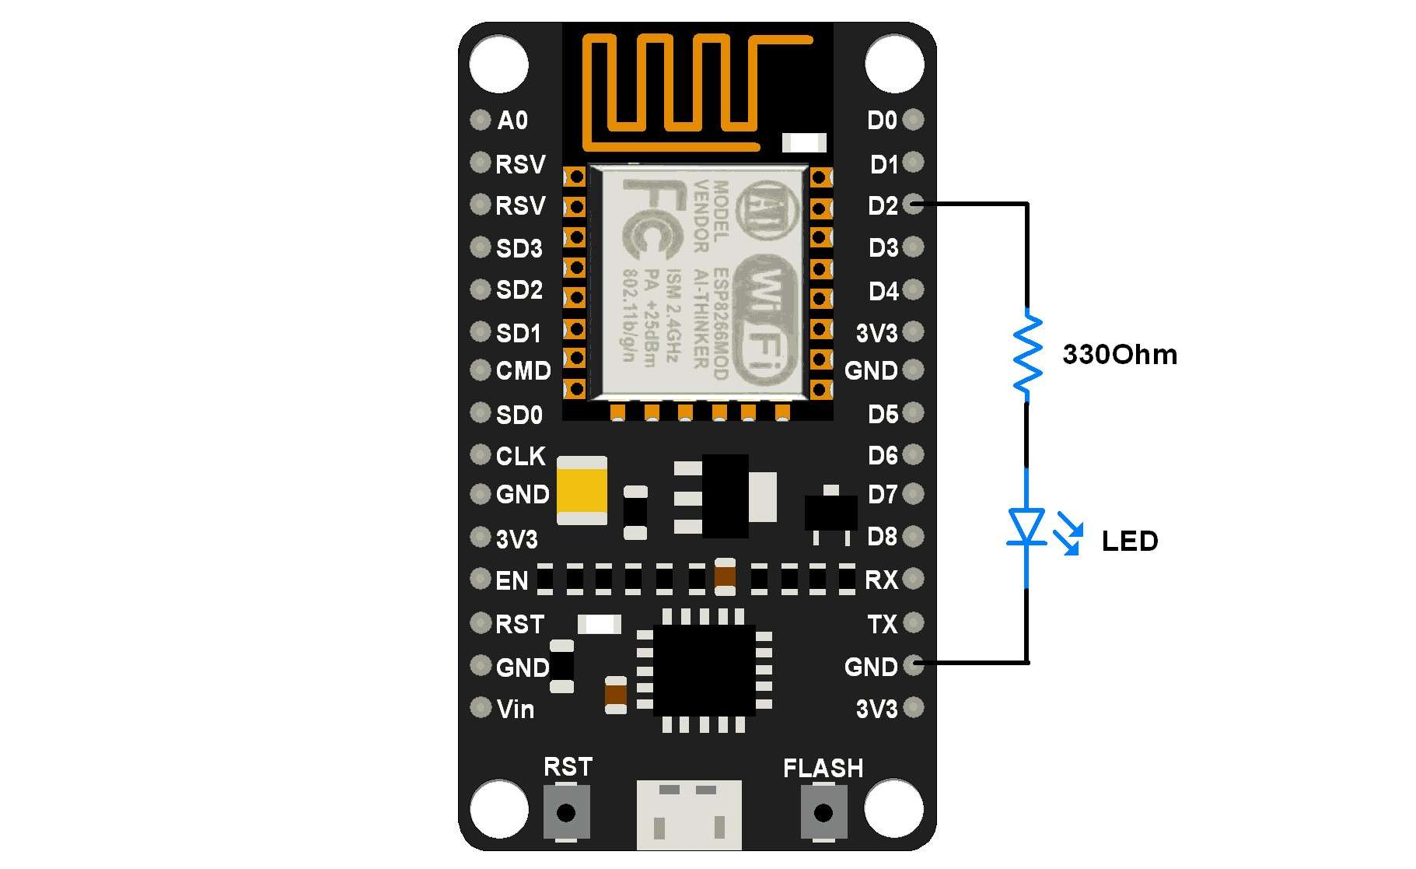

Output

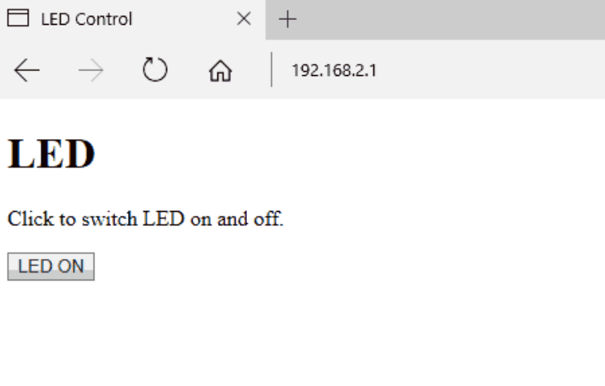

Bluetooth

int led = D4;

void setup() {
pinMode(led, OUTPUT);
Serial.begin(9600);
Serial1.begin(9600);
}

void loop() {
if (Serial1.available()) {
char data;
data = Serial.read();
if (data == '0') {
digitalWrite(led, LOW);
Serial1.println("LED turned OFF.");
} else if (data == '1') {
digitalWrite(led, HIGH);
Serial1.println("LED turned ON.");
} else
Serial1.println("Select either 0 or 1.");
}
}

Aim

To write and execute an Arduino sketch that toggles the LED through commands given via a smartphone that is connected to NodeMCU by Bluetooth.
Circuit Diagram

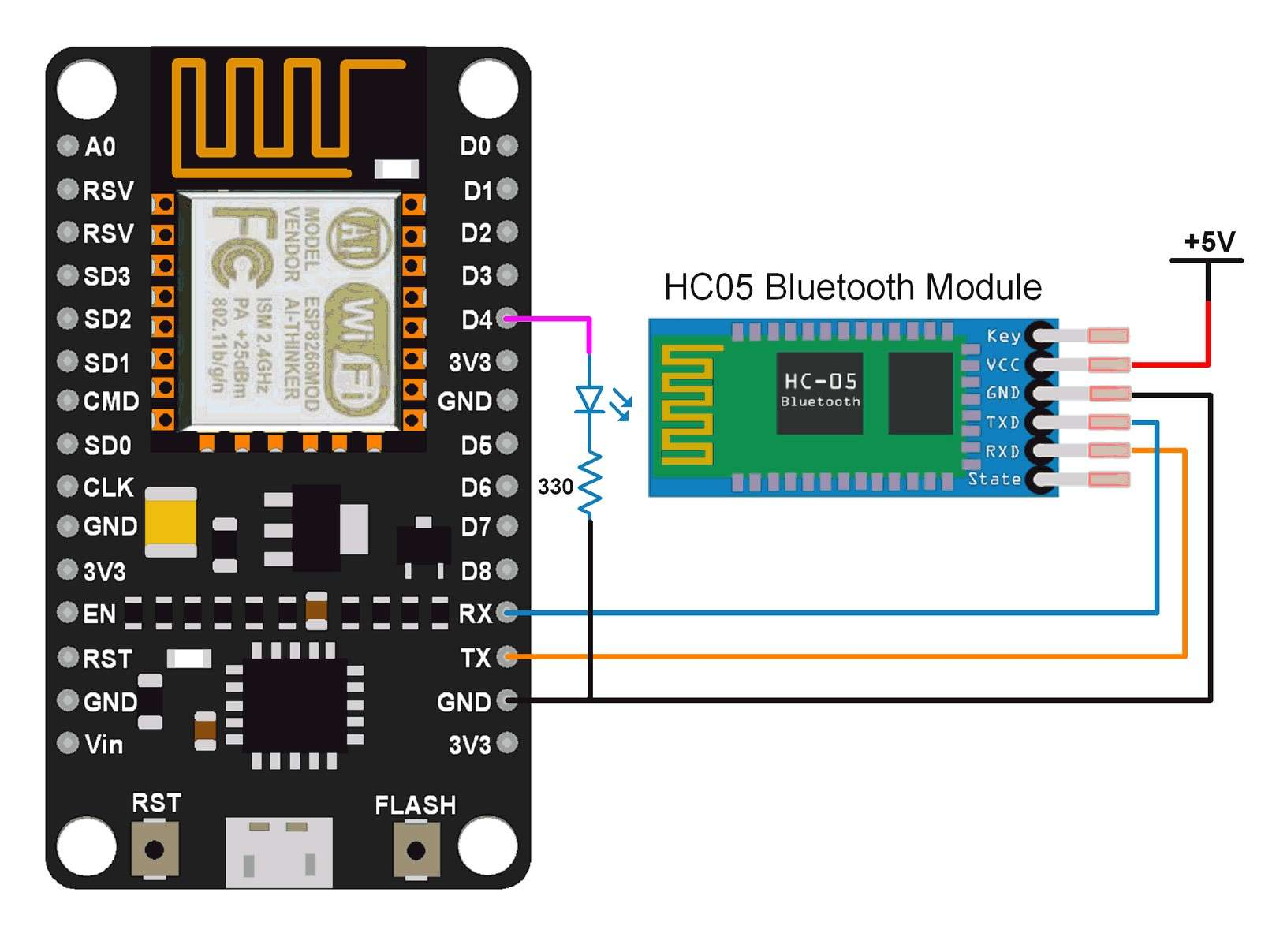

Output

Select either 0 or 1.
1
LED turned ON.
0
LED turned OFF.
Y
Select either 0 or 1.
1
LED turned ON.
0
LED turned OFF.

GPS

#include <TinyGPS++.h>
#include <SoftwareSerial.h>

SoftwareSerial bt(4, 3);
TinyGPSPlus gps;

float minutes, seconds;
int degree, secs, mins;

void setup() {
Serial.begin(9600);
bt.begin(9600);
}
void loop() {
smartDelay(1000);
double lat, lng, alt;
uint8_t hr, min, sec;
bool loc_v, alt_v, time_v;
lat = gps.location.lat();
loc_v = gps.location.isValid();
lng = gps.location.lng();
alt = gps.altitude.meters();
alt_v = gps.altitude.isValid();
hr = gps.time.hour();
min = gps.time.minute();
sec = gps.time.second();
time_v = gps.time.isValid();
if (!loc_v) {
Serial.println("Latitude:\t*****");
Serial.println("Longitude:\t*****");
} else {
Serial.print("Latitude:\t");
Serial.println(lat, 2);
Serial.print("Longitude:\t");
Serial.println(lng, 2);
DegMinSec(lat);
Serial.print("Latitude in Decimal Degrees: ");
Serial.println(lat, 2);
Serial.print("Latitude in Degrees Minutes Seconds: ");
Serial.print(degree);
Serial.print(" ");
Serial.print(mins);
Aim

To write and execute an Arduino sketch that finds the latitude, longitude, altitude, and time through the GPS receiver module and displays the details on the serial monitor.

Serial.print(" ");
Serial.println(secs);
DegMinSec(lng);
Serial.print("Longitude in Decimal Degrees: ");
Serial.println(lng, 2);
Serial.print("Longitude in Degrees Minutes Seconds: ");
Serial.print(degree);
Serial.print(" ");
Serial.print(mins);
Serial.print(" ");
Serial.println(secs);
}
if (!alt_v)
Serial.println("Altitude:\t*****");
else {
Serial.print("Altitude:\t");
Serial.println(alt, 2);
}
if (!time_v)
Serial.println("Time:\t*****");
else {
char time_string[32];
sprintf(time_string, "Time:\t%02d/%02d/%02d\n", hr, min, sec);
Serial.print(time_string);
}
}
static void smartDelay(unsigned long ms) {
unsigned long start = millis();
do {
while (bt.available())
gps.encode(bt.read());
} while (millis()-start < ms);
}
void DegMinSec(double tot_val)
{
degree = (int)tot_val;
minutes = tot_val - degree;
seconds = 60 * minutes;
minutes = (int)seconds;
mins = (int)minutes;
seconds = seconds - minutes;
seconds = 60 * seconds;
secs = (int)seconds;
}

Circuit Diagram

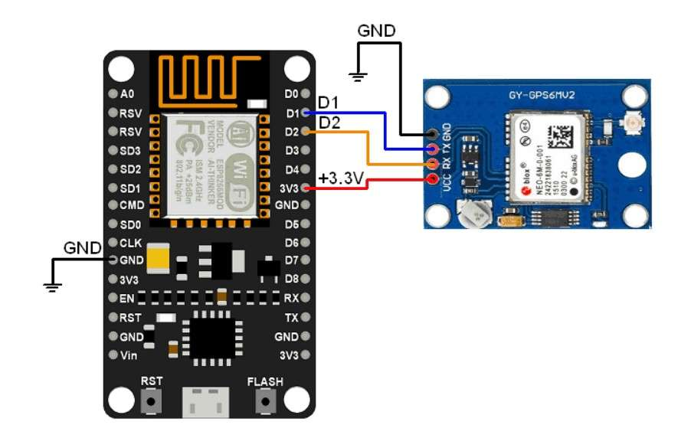

Output

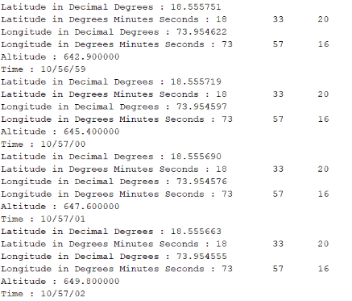

Result

Hence, IoT applications were successfully developed by interfacing with different wireless technologies such as

- Wi-Fi
- Bluetooth
- GPS

