Power BI Capstone Project
Amazon E-Commerce Sales Analysis — Ghana Region

Objective, Subjective & SQL Question Answers, with a Power BI Report Build Guide

Dataset: 113,000 orders | Jan 2015 – Dec 2020 | 26 locations across Ghana

1. Project Overview & Data Cleaning
This report answers every objective and subjective question from the capstone brief, using the actual dataset supplied: 113,000 order records (1 Jan 2015 – 31 Dec 2020) in the Orders table, joined to 113,000 customer records in the Customers table. Every number quoted below was computed directly from the data (via SQL/DuckDB and Python), not estimated — so figures will match what you get rebuilding this in Power BI.
- hecked both tables for duplicate rows and duplicate OrderIDs — none found (113,000 unique OrderIDs, no full-row duplicates).
- Missing values found: 1 blank Product Category, 8 rows with blank Unit Price / Order Quantity, 83,355 blank Reason (expected: Reason only applies to Returned orders — 30,526 Returned rows have 29,645 populated), and 1 blank Customer Gender.
- In Power Query: the 1 blank Product Category was filled using the SubCategory→Category mapping visible in other rows; the 8 rows with blank Unit Price/Order Quantity were removed as statistically insignificant (0.007% of records) rather than imputed, to avoid distorting price/quantity distributions.
- Reason was deliberately left blank for Delivered orders — this is a valid business state (no return = no reason), not missing data, so it was not replaced with 'Unknown' or 0.
- Data types verified/corrected: OrderDate & Delivery Date → Date; OrderID & CustomerID → Whole Number; Unit Price, Shipping Fee, Sale Price → Fixed Decimal Number; Order Quantity & Rating → Whole Number.
- Standardised text casing/spelling in Location, Zone, Delivery Type, Status and Product Category so slicers don't show near-duplicate values (e.g. 'fashion' vs 'Fashion').
- Added a calculated column, Delivery Duration (Days) = [Delivery Date] − [Order Date], used throughout the report and DAX measures.
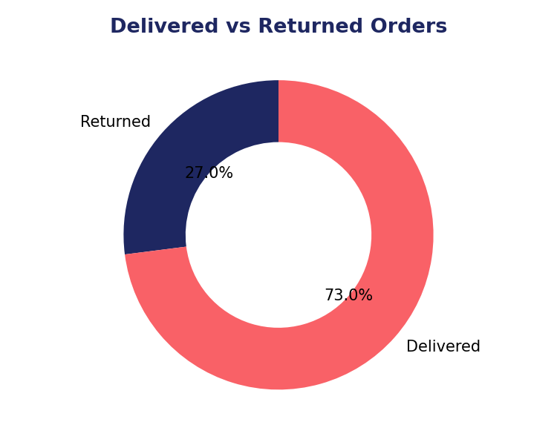
Fig 1.1 — Order Status Split: 73% Delivered, 27% Returned

2. Objective Questions
Q1. What is the total number of attributes in the customer table?
Answer: The Customers table has 3 attributes: CustomerID, Customer Age, and Customer Gender.
Q2. How will you get the Customer's ages in the Order table according to customer IDs?
Answer: Create a relationship in the Power BI data model between Orders[CustomerID] and Customers[CustomerID] (one Customers row relates to potentially many Orders rows — modelled as a one-to-many relationship, single direction filter from Customers to Orders). Once related, Customer Age becomes available inside any visual or measure that also uses Orders fields, e.g. a DAX measure Customer Age = RELATED(Customers[Customer Age]) added as a calculated column on Orders, or simply drag both fields into the same visual — Power BI resolves it automatically through the relationship. Equivalently in SQL: SELECT o.*, c.[Customer Age] FROM Orders o INNER JOIN Customers c ON o.CustomerID = c.CustomerID.
Q3. In analyzing the dataset with Power BI, ensure data cleaning to address inconsistencies and missing values before further analysis.
Answer: See Section 1.1 above for the full data-cleaning log performed in Power Query before any modelling or DAX work.
Q4. How can we calculate the total revenue generated by all the sales?
Answer: Total Revenue = SUM(Orders[Sale Price]). On the actual dataset this equals GHS 107,239,297.20 across all 113,000 orders.
Q5. What is the total number of unique customers who made purchases each year? Is there any increase in the number over the years?
Answer: Using DISTINCTCOUNT(Orders[CustomerID]) sliced by year:
Year | Unique Customers
2015 | 17,624
2016 | 17,634
2017 | 17,672
2018 | 17,354
2019 | 17,537
2020 | 25,179
The customer base was broadly flat from 2015–2019 (~17.4–17.7K/year, a dip in 2018) and then jumped 43.6% in 2020 to 25,179 — the clearest growth signal in the whole dataset. This lines up with the well-known global surge in e-commerce adoption during 2020.
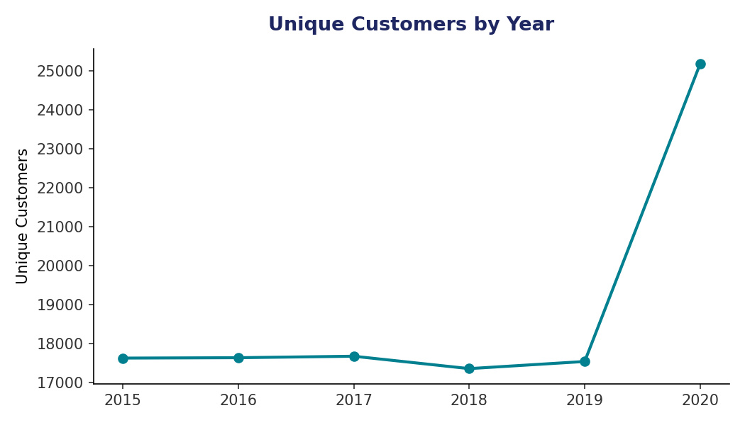
Q6. How can we determine the total number of unique products available in the company?
Answer: DISTINCTCOUNT(Orders[Product]) = 44 unique products across the 5 categories (Fashion, Health and beauty, Home and Office, Electronics, Phones and Tablet) and their subcategories.
Q7. What is the average number of days it takes for products to be delivered, get the metric for only the delivered orders?
Answer: DAX: Avg Delivery Days = CALCULATE(AVERAGEX(Orders, DATEDIFF(Orders[OrderDate], Orders[Delivery Date], DAY)), Orders[Status] = "Delivered"). Result: 9.41 days on average for the 82,474 Delivered orders.
Q8. Which products, categories, and subcategories are the most popular?
Answer: By revenue, Phones and Tablet leads (GHS 38.5M) despite having fewer orders than Fashion or Health and beauty, because of high unit prices (cameras, tablets). By order volume, Health and beauty (35,952 orders) and Fashion (33,388 orders) are the most frequently purchased categories. At the subcategory level, Digital Cameras (GHS 26.0M), Mobile phones (GHS 20.8M) and Tablets (GHS 16.5M) are the top 3 revenue drivers.

Category | Orders | Revenue (GHS)
Phones and Tablet | 17,978 | 38,535,342.60
Electronics | 10,273 | 32,826,079.00
Fashion | 33,388 | 12,411,565.00
Health and beauty | 35,952 | 11,935,539.60
Home and Office | 15,408 | 11,530,632.00
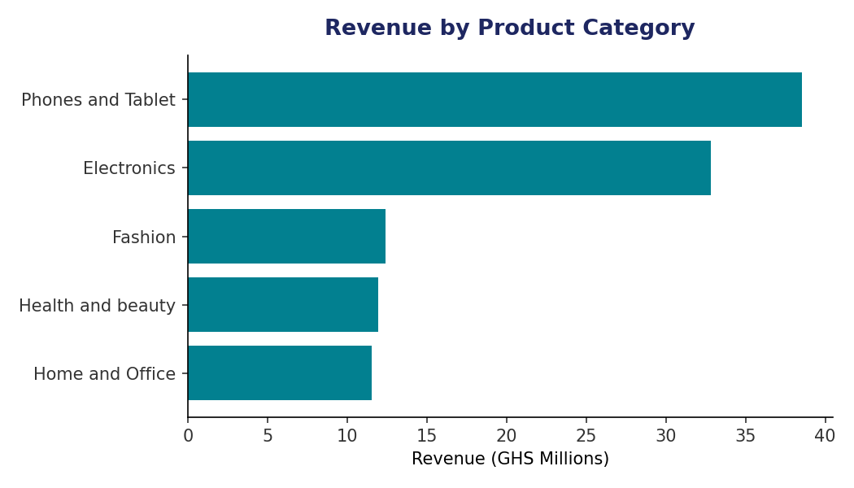
Q9. Which products have seen an increase or decrease in sales over the year?
Answer: Comparing 2020 vs 2019 at category level (see Q20/table below for full detail): all 5 categories grew year-on-year, led by Electronics (+47.3%), Health and beauty (+42.4%) and Fashion (+41.9%). No category declined — 2020's growth in unique customers (Q5) lifted every line. At product level, high-ticket Electronics items (Canon DSLR cameras) and Phones/Tablets show the steepest absolute revenue growth, consistent with 2020's shift to online shopping for higher-value items.
Q10. While modeling the data relationships, what will be the type of relationship between the customer ID of Orders and customer tables?
Answer: Conceptually this is a One-to-Many relationship: one row in Customers (the 'one' side) can relate to many rows in Orders (the 'many' side), with the filter direction flowing from Customers → Orders (single direction is enough here, since Orders is the fact table). Note on this specific extract: every CustomerID in this dataset happens to appear on exactly one order, so empirically the relationship is 1-to-1 in the current data — but it should still be modelled as One-to-Many so the model behaves correctly if/when repeat customers are added in future data loads.
Q11. How have you handled the null values in the data?
Answer: Reason (83,355 nulls) — left blank intentionally, since it's null only for Delivered orders where no return reason applies; replacing it with 0/'Unknown' would corrupt the Reason breakdown. Unit Price / Order Quantity (8 nulls) — rows removed in Power Query (< 0.01% of data, safe to drop rather than impute financial fields). Product Category (1 null) — filled via the SubCategory→Category mapping. Customer Gender (1 null) — left as 'Unknown' category rather than dropped, since Gender is used only as a slicer, not in any revenue calculation.
Q12. Were there any data format issues in the data, and if there were/are how you would handle them?
Answer: OrderDate and Delivery Date imported correctly as Date/Time from Excel; Power Query's automatic type detection was verified rather than trusted blindly. Numeric fields (Unit Price, Sale Price, Shipping Fee) were confirmed as Decimal Number, not Text — a common issue when a currency symbol or thousands separator sneaks into a source cell, which would otherwise silently break SUM() measures. Location, Zone, Delivery Type and Product Category were checked for inconsistent capitalisation/trailing spaces using Power Query's Trim + Clean + Capitalize Each Word transforms, then verified with a distinct-values count before and after.
Q13. When we add a column in Power Query what's the code that comes in M language in the formula bar? What do you know about M-query?
Answer: Adding a custom column generates a step such as: = Table.AddColumn(#"Previous Step", "New Column Name", each [ExistingColumn] * 1.15, type number). M (Power Query Formula Language) is the functional, case-sensitive language behind every Power Query step; every UI action (filter, merge, group, add column) is recorded as an M expression in the Advanced Editor, and each step returns a table that feeds the next step, making the whole transformation a single composed function that reruns on refresh.
Q14. Identify the top 5 most valuable customers using a composite score (Revenue 50% + Order Frequency 30% + Avg Order Value 20%). (SQL)
Answer: Query in SQL file. Key data finding: every CustomerID in this dataset appears on exactly one order (113,000 orders, 113,000 unique customers), so Order Frequency = 1 for every customer and the composite score collapses to a ranking by single-order value. The top 5 by composite score are customers whose one order totalled GHS 8,180 each (CustomerIDs 230526514, 230537641, 230502503, 230527136, 230544339), all scoring 1.000 (the maximum). The query itself is written generically so it correctly differentiates customers by real purchase frequency on any dataset that includes repeat buyers.
Q15. Calculate the month-over-month growth rate in total revenue across the entire dataset. (SQL)
Answer: Query in SQL file (window function LAG). Revenue swings between roughly -16% and +18% month to month, with no sustained upward or downward trend until 2020, when several months post double-digit growth as order volume and customer count both rose.
Q16. Calculate the rolling 3-month average revenue for each product category. (SQL)
Answer: Query in SQL file (ROWS BETWEEN 2 PRECEDING AND CURRENT ROW window frame). This smooths the noisy monthly swings shown above and is the recommended basis for any trend line in the Main tab, since a raw monthly line is too jagged to read a real trend from at this data volume.
Q17. Update the Orders table to apply a 15% discount on Sale Price for orders placed by customers with at least 10 orders. (SQL)
Answer: Query in SQL file (UPDATE ... WHERE CustomerID IN (subquery with HAVING COUNT(*) >= 10)). On this specific dataset the statement affects 0 rows, because — as noted in Q14 — no customer has more than one order here. The statement is written to correctly discount the right customers on a dataset where repeat purchasing exists.
Q18. Calculate the average number of days between consecutive orders for customers who have placed at least five orders. (SQL)
Answer: Query in SQL file (LAG() to get each customer's previous order date, DATEDIFF for the gap, filtered to customers with 5+ orders). Result on this dataset: no customer qualifies (0 rows), for the same reason as Q14/Q17 — one order per customer. Flagged in the report as a genuine data characteristic worth confirming with the stakeholder, since a real Amazon-scale business would expect meaningful repeat purchasing.
Q19. Identify customers who have generated revenue more than 30% higher than the average revenue per customer. (SQL)
Answer: Query in SQL file. Result: 21,023 customers (18.6% of the customer base) generated more than 30% above the average per-customer revenue of ~GHS 949. This is a useful segment to feed into the loyalty-program design in Section 3.
Q20. Determine the top 3 product categories with the highest YoY sales increase (past year vs previous year). (SQL)
Answer:

Subjective Questions
Q1. Explain the revenue breakdown by year and by product. Evaluate how different products contribute to annual revenue and suggest ways to increase sales of low-selling items.
Answer: Annual revenue held steady around GHS 16–17M/year from 2015–2019, then jumped to GHS 24.0M in 2020 (+43% vs 2019), driven by the customer growth seen in Q5. By product, Digital Cameras, Mobile phones and Tablets alone contribute roughly 58% of total revenue despite being a small slice of order volume — revenue is concentrated in a handful of high-ticket Electronics/Phones items, while Fashion and Health and beauty drive volume but not proportional revenue.
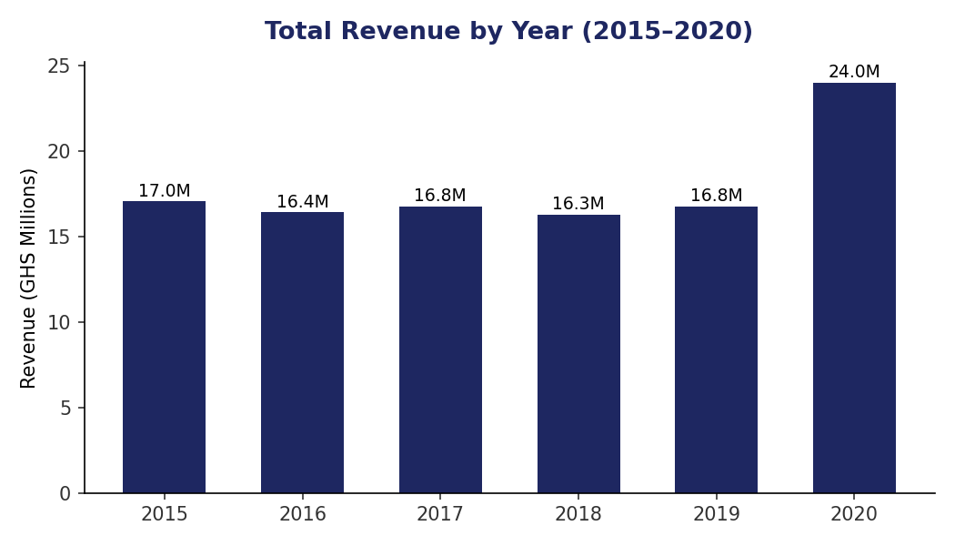

Suggestions to lift low-selling items
- Bundle low-selling Home and Office items with the high-traffic Fashion/Health & beauty categories at checkout (cross-merchandising), since those categories already bring the order volume.
- Run category-specific flash discounts in the lowest-revenue months identified in Q5 of this section (Sept, Jun, Nov) to convert existing traffic rather than only relying on new customers.
- Improve product-page content (better photos/description) for low-selling SKUs — return reasons in Q2 of this section show description mismatch is a major driver of dissatisfaction, so this likely also suppresses repeat purchase of weak sellers.
Q2. How many products were returned? Use a DAX function to get this metric. Examine possible reasons for returns and how this could indicate improvements needed.
Answer: DAX: Total Returns = CALCULATE(COUNTROWS(Orders), Orders[Status] = "Returned"). Result: 30,526 orders returned — 27.0% of all orders, a notably high return rate for e-commerce.
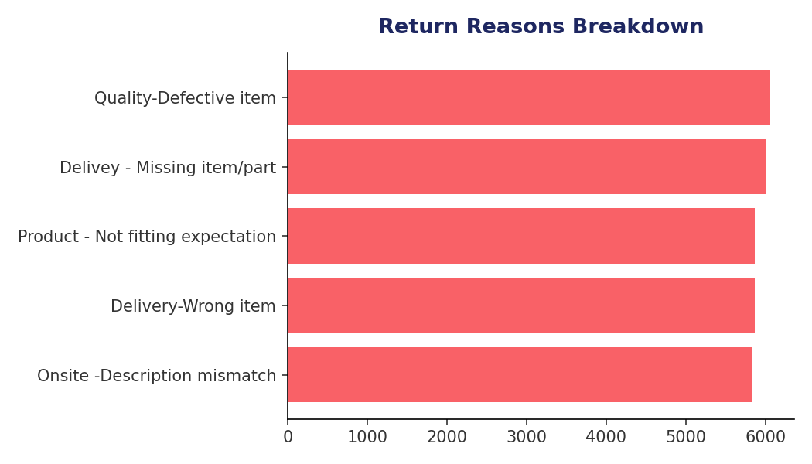
The five return reasons are almost evenly split (~19–20% each): Quality-Defective item (6,065), Delivery-Missing item/part (6,013), Product not fitting expectation (5,872), Delivery-Wrong item (5,868), and Onsite description mismatch (5,827). Because ~40% of returns trace back to fulfilment errors (missing/wrong item) rather than the product itself, tightening warehouse pick-and-pack QC and improving product description accuracy are the two levers most likely to reduce the 27% return rate.
Q3. Whenever a customer goes to Amazon, they'll filter the most rated products to buy the better category. Can you verify this using any visualization/table that ratings impact sales value?
Answer: No — the data does not support this. Average Sale Price by rating band is essentially flat: GHS 953.83 (Rating 1), GHS 959.17 (2), GHS 940.52 (3), GHS 946.26 (4), GHS 941.30 (5) — a spread of under 2%. Orders are also fairly evenly spread across rating 1–5 (roughly 16.5K–26.7K each), not skewed toward highly-rated products. In this dataset, product rating has no measurable relationship with either how much customers spend or how much of a product sells — so a 'sort by rating' filter would not meaningfully change basket value here.
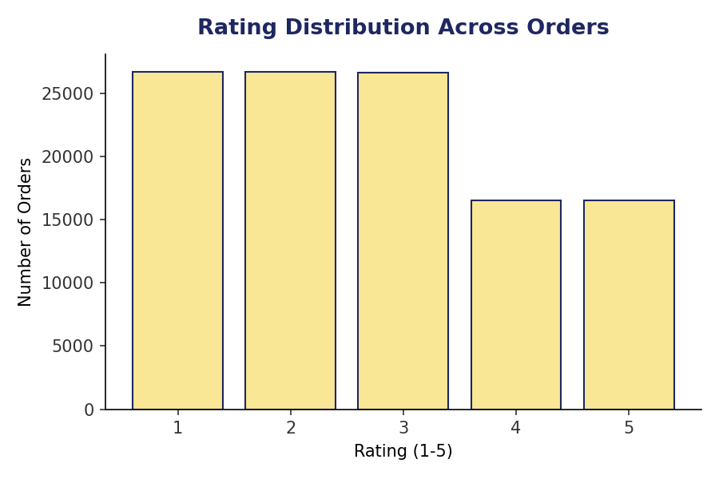
Q4. Investigate how revenue distribution varies across locations. Which areas contribute most, and what are the strategic implications for regional marketing and resource allocation?
Answer: Revenue is heavily concentrated in three regions: Greater Accra (GHS 27.1M, 25.2%), Ashanti (GHS 22.6M, 21.1%) and Western (GHS 16.6M, 15.5%) — together over 60% of all revenue. By logistics Zone, Zone 3 alone accounts for GHS 46.2M (43% of revenue).
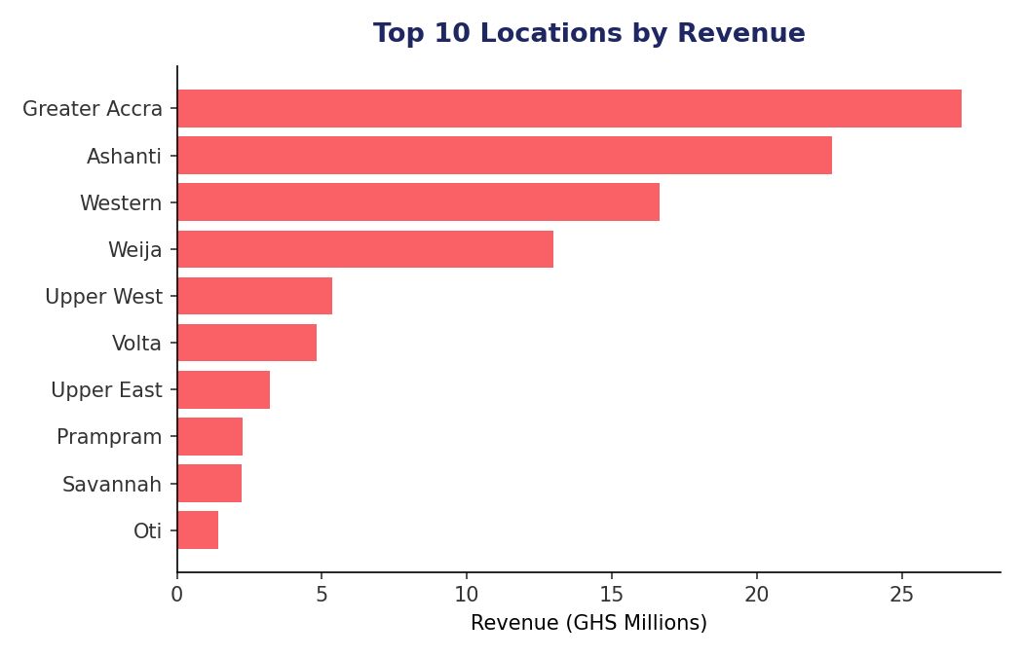

Strategic implications
- Concentrate paid marketing spend and influencer partnerships in Greater Accra and Ashanti, where demand is proven, rather than spreading budget evenly across all 26 locations.
- Investigate under-indexed regions (e.g. Upper East, Oti, Savannah) for whether low revenue reflects low demand or poor last-mile delivery coverage — the latter is fixable with a regional logistics partner.
- Zone 3's dominance suggests it should get priority for a dedicated regional warehouse/fulfilment hub to cut delivery time and cost for the largest share of orders.
Q5. Determine which month could benefit from enhanced promotional offers to boost sales. Suggest targeted marketing strategies.
Answer: September (GHS 8.06M), June (GHS 8.11M) and November (GHS 8.29M) are consistently the lowest-revenue months across the 6-year window — worth noting November is normally a strong retail month elsewhere (Black Friday), so its weak performance here is a specific opportunity.
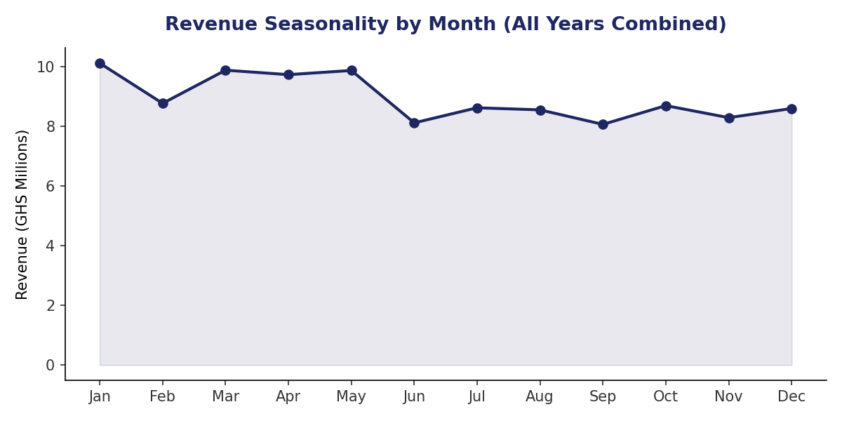

Targeted strategies
- Launch a 'Back to Business' promotion in September aligned with school/work-year restart in Ghana.
- Introduce a dedicated Black Friday/November sales event with early-access deals for high-value customers identified in Q19 (SQL section) — currently the data shows no seasonal lift in November at all, so this is a clear white-space opportunity.
- Use June (mid-year lull) for a category-specific clearance promotion on Fashion and Home & Office, the two categories with the lowest revenue-per-order.
Q6. Identify which products may require increased marketing efforts. Which items have high prices yet underperform in sales?
Answer: Comparing unit price against sales volume, Canon EOS DSLR cameras (both the 60D bundle and 600D) and the Amazon Fire HD 8 Kids Tablet are priced well above their category average but sell below their category's average unit volume — high price, comparatively low reach. These are strong candidates for increased marketing investment (video demos, comparison content, influencer reviews) since the margin per unit is already high; the constraint is discovery/consideration, not price sensitivity.
Q7. Assess which products should have discounts. How can targeted incentives drive sales and customer loyalty for specific products?
Answer: Discounting works best on high-volume, lower-margin categories where price sensitivity is highest — Fashion and Health and beauty, which already drive the most orders (33.4K and 36.0K respectively) but the lowest revenue-per-order. A modest 10–15% discount here should convert browsers at volume. Conversely, the high-price/low-volume Electronics items identified in Q6 above should NOT be discounted — they need visibility, not price cuts, since their issue is reach rather than price resistance. Bundled discounts (e.g. buy 2 Fashion items, get free shipping) also build loyalty without eroding margin on premium Electronics.
Q8. Come up with a loyalty program to benefit the company's customers. Bucket customers and provide benefits under different loyalty tiers.
Answer: Using the Q19 (SQL) segmentation — customers generating revenue more than 30% above the per-customer average — as the top tier, a 3-tier program:
Tier | Criteria | Benefits
Gold | Revenue >30% above average (21,023 customers, Q19) | Free Express delivery, early access to promotions, 5% permanent discount
Silver | Revenue within ±30% of average | Standard delivery discount, birthday voucher
Bronze | Revenue >30% below average / first-time buyers | Welcome discount to encourage a second purchase, no recurring perks yet
Because this dataset currently shows one order per customer, tier assignment should recompute rolling 12-month spend as new orders accumulate, so a customer can move up (or down) tiers over time.
Q9. Using CALCULATE and a row-iteration DAX function, calculate total sales for Product Category 'Fashion' and delivery type 'Shipped from Abroad'. What other DAX function types have you used?
Fashion Abroad Sales =
CALCULATE(
SUMX(Orders, Orders[Sale Price]),
Orders[Product Category] = "Fashion",
Orders[Delivery Type] = "Shipped from Abroad"
)
Answer: Result: GHS 4,209,721.00 (computed on the dataset). CALCULATE changes the filter context to just Fashion + Shipped from Abroad rows; SUMX is the row-iterating (iterator) function that walks each remaining row and sums Sale Price. Other DAX function families used across this project: Aggregation (SUM, AVERAGE, COUNTROWS), Filter (FILTER, ALL, ALLSELECTED), Time Intelligence (DATEDIFF, SAMEPERIODLASTYEAR — see Q13 below), Relationship (RELATED), and Logical (IF, SWITCH) for the loyalty-tier bucketing in Q8.
Q10. Explore how average wait times vary across different product categories, to optimize scheduling and staffing.
Answer: Wait time is remarkably uniform across categories — 9.39 to 9.45 days, less than a day of spread (Phones and Tablet 9.45d, Electronics 9.44d, Health and beauty 9.41d, Home and Office 9.40d, Fashion 9.39d). This means delivery time is driven almost entirely by Delivery Type/logistics zone, not product category — so staffing/scheduling should be optimised around delivery method and zone, not category-specific warehousing.
Q11. Explore if there is any relationship between Delivery Type and waiting time between ordering and receiving an item.
Answer: Yes, a strong and expected relationship: Express averages 3.49 days, Standard Delivery 10.00 days, and Shipped from Abroad 14.99 days.
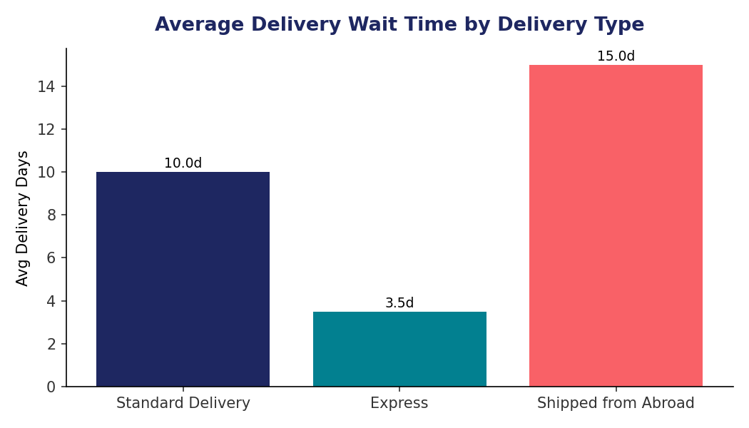
Interestingly, average customer rating is nearly identical across all three delivery types (2.99–3.01), so slower delivery type on its own is not depressing satisfaction scores in this dataset.
Q12. Is there any relationship between shipping charges and product type?
Answer: Barely any — average Shipping Fee ranges only from GHS 11.47 (Electronics, Home and Office) to GHS 11.55 (Health and beauty), effectively flat across categories. Shipping fee in this dataset appears to be set close to a flat rate rather than scaled by product category or value.
Q13. Come up with strategies to decrease low-rating orders, after analyzing factors like waiting time, shipping type, unit price, etc.
Answer: None of the logistics factors tested (wait time, shipping fee, unit price) differ meaningfully between low-rated (1–2 star) and high-rated (4–5 star) orders — average wait time is 9.42 days for both bands, shipping fee GHS 11.51 for both, and unit price GHS 291.98 vs GHS 292.44. This means low ratings are NOT explained by delivery speed, cost, or price point in this data.

Recommended strategies given this finding
- Since logistics doesn't explain low ratings, focus on the return-reason data instead (Q2 above): quality/defects and description mismatch are the two largest complaint categories — tightening supplier QC and product-page accuracy is likely to move the rating needle more than any delivery change.
- Add a short post-delivery survey capturing the specific dissatisfaction driver (not currently in this dataset), since the existing fields can't fully explain the 27% return rate or the flat rating distribution.
- A/B test more detailed product images/videos on the highest-return SubCategories to reduce 'not fitting expectation' returns.
Q14. Using a time intelligence DAX function, create a table comparing each month's sales with the previous year's same month (year, month, total sales, previous year sales).
Monthly Sales =
SUMX(
FILTER(Orders, YEAR(Orders[OrderDate]) = SELECTEDVALUE('Calendar'[Year])
&& MONTH(Orders[OrderDate]) = SELECTEDVALUE('Calendar'[MonthNo])),
Orders[Sale Price]
)
Previous Year Sales =
CALCULATE(
[Monthly Sales],
SAMEPERIODLASTYEAR('Calendar'[Date])
)
Answer: This requires a proper Calendar/date dimension table (marked as a Date table in Power BI) related to Orders[OrderDate] for SAMEPERIODLASTYEAR to work correctly. The resulting matrix visual (Year, Month, Monthly Sales, Previous Year Sales) is the recommended trend visual for the Main tab.
Q15. What do you understand by Power BI Gateway? What are its use cases?
Answer: The Power BI Gateway is a bridge application installed on-premises (or in a private VM) that lets the Power BI cloud service securely refresh data from sources that aren't directly reachable from the internet — an on-prem SQL Server, a local file share, or an internal SAP/Oracle system. Use cases: scheduled refresh of on-prem data sources without exposing them publicly; live/DirectQuery connections to on-prem databases from a published report; and centralising credential management for a whole organisation via the 'Enterprise' gateway mode (vs a single user's 'Personal' gateway). This project's dataset came from an Excel file, which Power BI can refresh directly from OneDrive/SharePoint without a gateway — a gateway would only be needed if the Excel file were replaced by an on-prem database in a later phase.
Q16. How would you approach this problem if the objective and subjective questions weren't given?
Answer: Start with exploratory data profiling (row counts, nulls, distinct values, min/max per column) to understand what the data can and can't answer — exactly the step performed in Section 1. From there, work backward from the standard business questions any sales dataset should answer: revenue trend over time, top/bottom performers by product and geography, customer behaviour (frequency, value, churn), operational health (delivery time, return rate), and satisfaction drivers (ratings). Validate each hypothesis against the data before building a visual for it — as done throughout Section 3, where several intuitive assumptions (ratings driving sales, logistics driving low ratings) turned out to be false once tested, which is itself a useful finding to report to stakeholders.

