# Problem: Maven is not able to download the repositories from Bamboo / Terminal ?

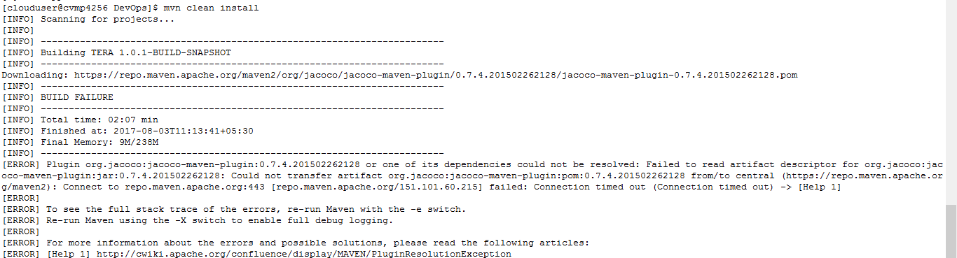

Solution :

Please update the Settings.xml with below lines

/opt/apache-maven-3.3.9/conf/settings.xml

<proxies>

<proxy>

<id>myhttpproxy</id>

<active>true</active>

<protocol>http</protocol>

<host>10.254.40.121</host>

<port>8080</port>

<nonProxyHosts>localhost</nonProxyHosts>

</proxy>

<proxy>

<id>myhttpsproxy</id>

<active>true</active>

<protocol>https</protocol>

<host>10.254.40.121</host>

<port>8080</port>

<nonProxyHosts>localhost</nonProxyHosts>

</proxy>

</proxies>