

SCHOOL OF COMPUTER SCIENCE AND ENGINEERING

KLE TECHNOLOGICAL UNIVERSITY

WEB TECHNOLOGY PROJECT

ON

**BLOGGING PLATFORM FOR KLE TECH STUDENT COMMUNITY**

***SUBMITTED BY***

MANAGLGOURI P KADEMANI 01FE23BCS422

YUVARAJ P RATHOD 01FE23BCS423

PRAGATI HIPPALAKAR 01FE22BCS288

SHRUTI NAGAVE 01FE23BCS421

**GUIDE:**

**MANJULA PAWAR**

**INTRODUCTION**

In today’s digital age, blogging has become a powerful medium for sharing knowledge, ideas, and personal experiences. For students, blogging serves as a platform to express creativity, document achievements, and engage in meaningful discussions. However, the lack of a centralized, exclusive platform for a community like KLE Tech limits students' ability to collaborate and showcase their skills effectively.

**OBJECTIVE**

* To create a collaborative space for academic discussions, personal stories, and event updates.
* To encourage students to express their creativity in areas such as technology, arts, lifestyle, academics, and more.
* To encourage participation through blogs and conversations in order to strengthen connections between learners, lecturers, and seniors.
* To organize blogs into categories and tags to make it easier for students to find content relevant to their interests or needs.

**MODULES ASSIGNED FOR IMPLEMENTATION**

* Registration Module
* Login Module
* Home page Module
* Profile Module
* Comments Module

**FLOWCHART OF BLOGGING PLATFORM**

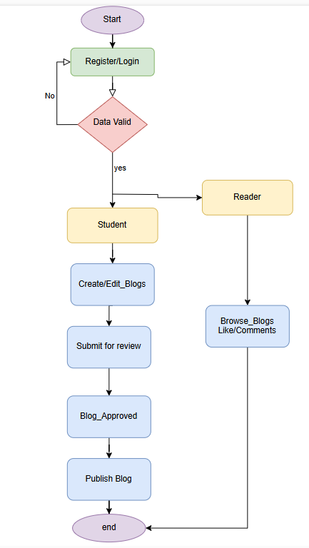

**FUNCTIONAL REQUIREMENTS**

* **Student:** Users can sign up and log in with an email and password.
* **System:** Validates registration details, stores encrypted passwords, and establishes sessions for logged-in users.
* **Student :** Receives clear error messages for issues like failed login or incomplete blog content.
* **System:** Validates data for login, registration, and blog posts, and provides relevant error messages.
* **Student :** Logged-in users can view, create, edit, and delete their own blog posts.
* **System:** Validates blog content, saves posts with author info and timestamp, and restricts editing/deleting rights to post authors.
* **Student :** Authors can view all published posts and click to see details.
* **System:** Retrieves and displays a list of published posts, along with details of selected posts.
* **Student :** Logged-in users can comment on posts.
* **System:** Saves comments linked to the relevant post and user.
* **Student :** Logged-in users can like or unlike posts.
* **System:** Updates like counts in the database based on user actions.
* **Student :** Users can view and update their profile information (e.g., bio, username).
* **System:** Retrieves, displays, and saves profile updates to the database.

**NON-FUNCTIONAL REQUIREMENTS**

* **Performance:** Ensure API/server response under 2 seconds for requests, supporting 100+ concurrent users.
* **Maintainability:** Use modular SOLID code, centralized logging, 90% test coverage, and support zero-downtime updates.
* **Compatibility:** Ensure cross-browser/mobile support and responsiveness for screens from 320px to 1920px.

**ER-DIAGRAM FOR BLOGGING PLATFORM:**

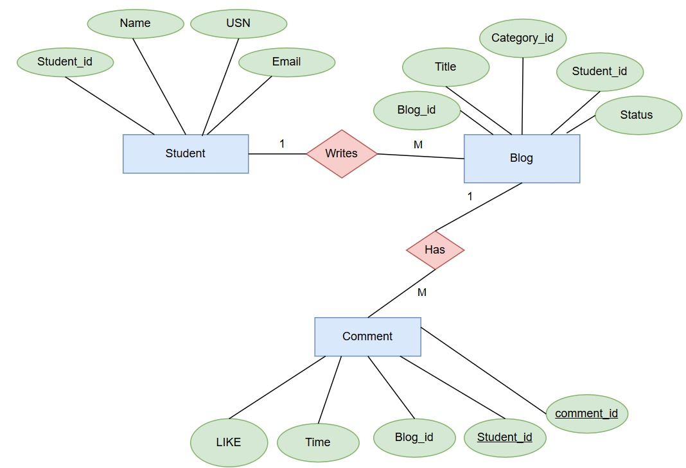

**RELATIONAL SCHEMA FOR BLOGGING PLATFORM:**

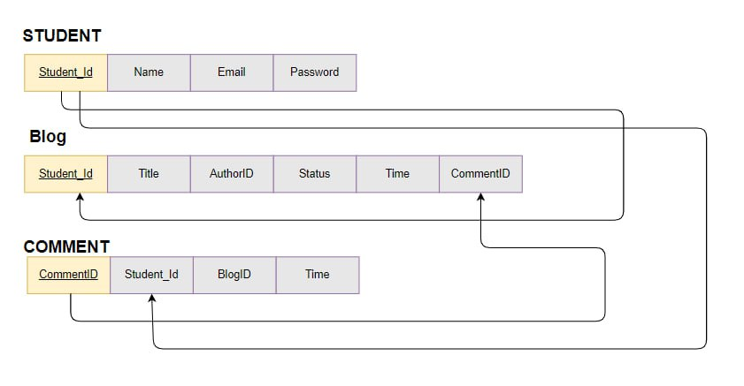

**MODULES DESCRIPTION**

1.**LandingPage :**

This page gives the interface for the blogging platform where the students can register and login with their kletech emailed.

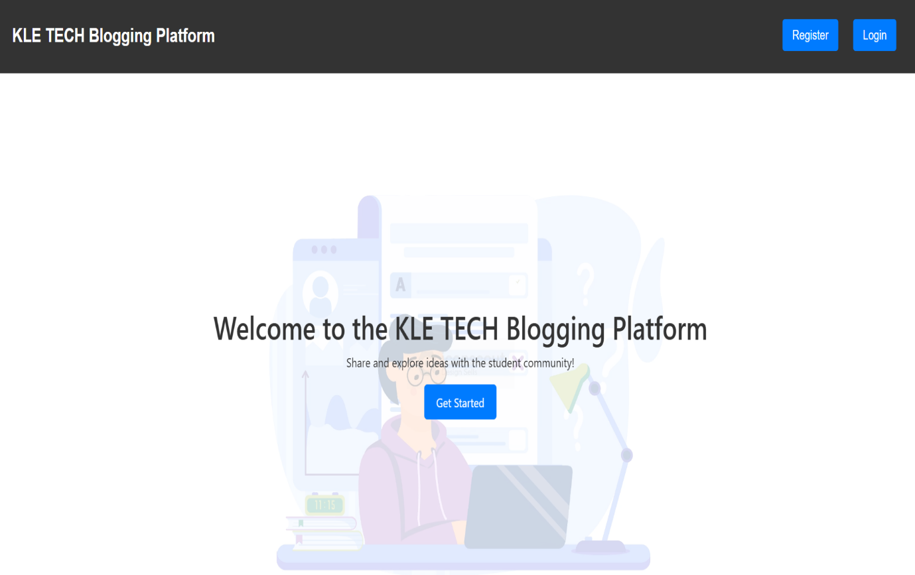

2**. Registration Module:**

This module enables new users to register by providing details like username, email, and password.

It Validates inputs to ensure data accuracy and stores the new user’s information securely. And display the message Registration Successful.

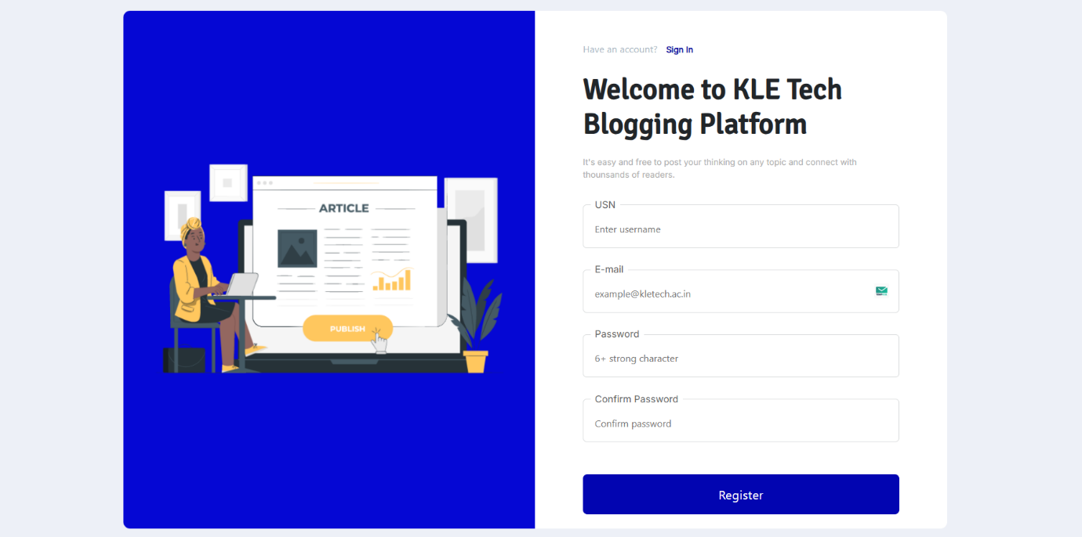

**3. Login Module:**

Allows users to log in using their email and password.

Authenticates user credentials and redirects them to their profile or the homepage upon successful login.

Displays error messages for incorrect login attempts.

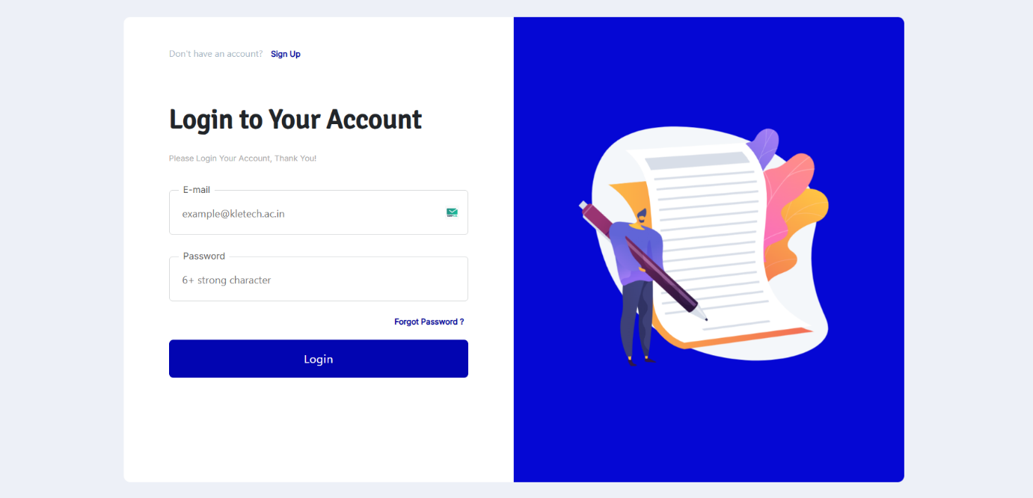

**4. Home page Module:**

Displays a list of recent or popular blog posts.

Includes search functionality to find specific posts.

Links to individual blog posts.

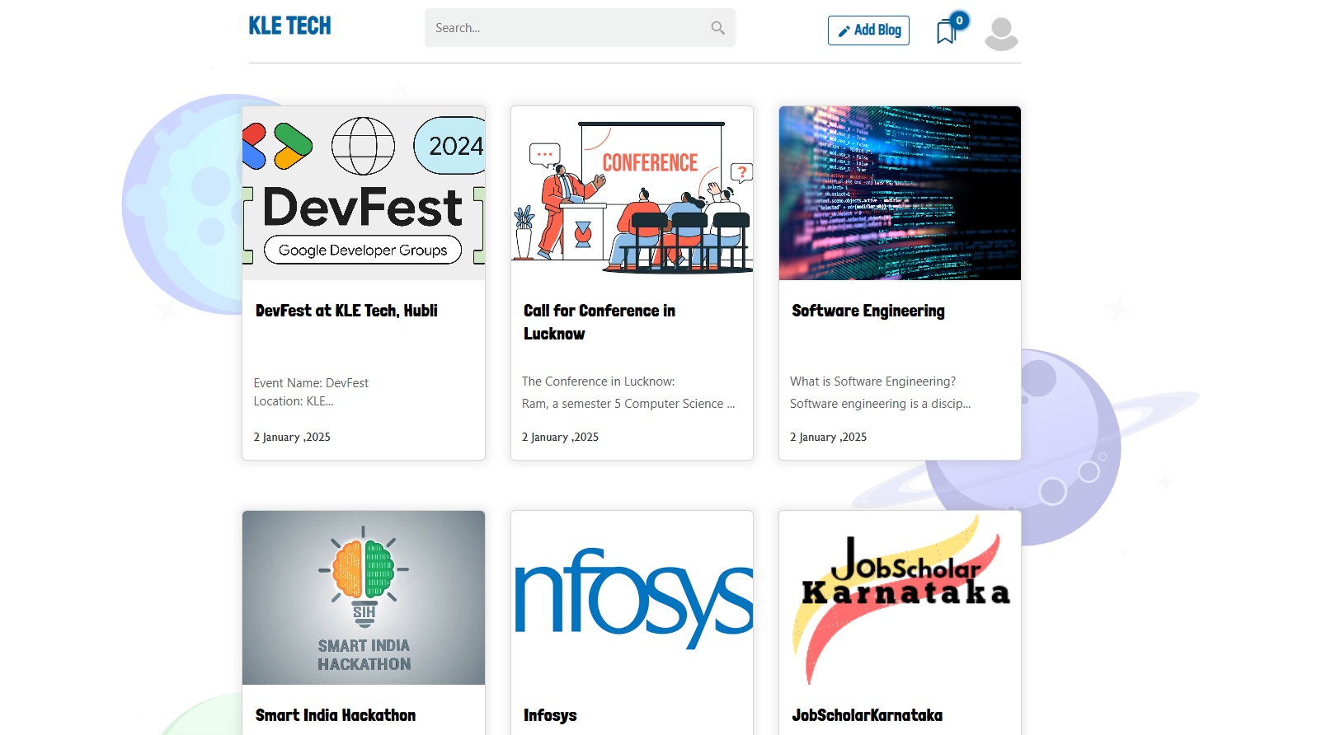

5. Comments Module:

This module enables users to add comments to blog posts. Allows users to edit or delete their own comments.

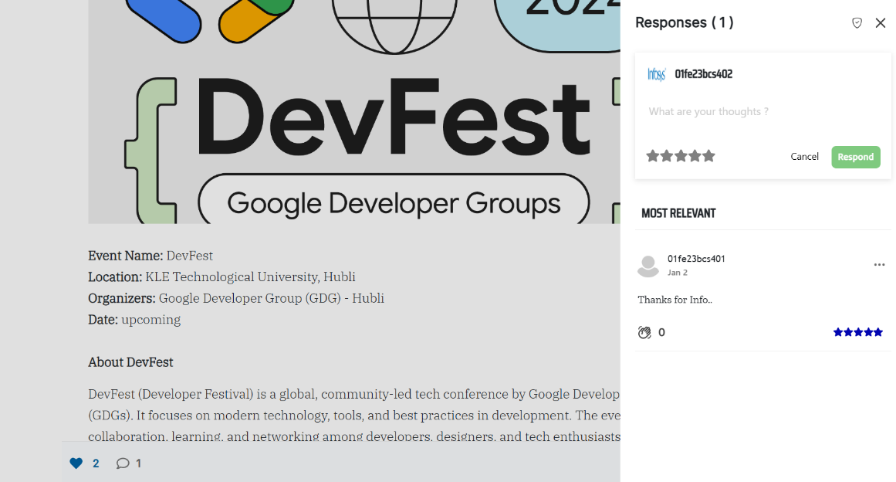

**5. Add Blog Module:**

The Add Blog Module depicts the KLE TECH Blogging Platform's blog editor interface, featuring a title input field, a rich text editor with various formatting tools, an image upload section, a "Publish" button, and a footer with a copyright

notice.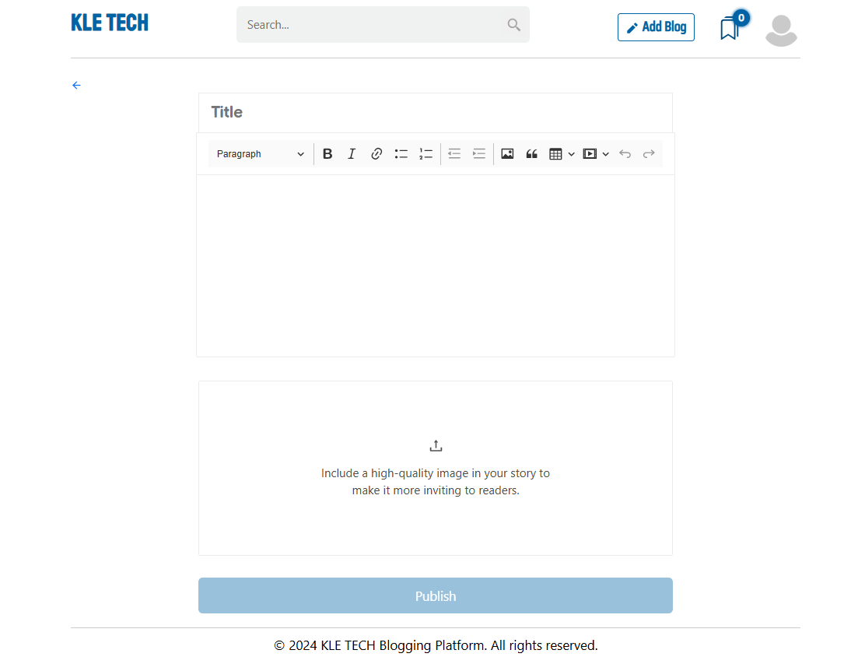

**CONCLUSION:**

The KLE TECH Blogging Platform project successfully delivers a user-friendly interface for content creation and publishing. The platform offers intuitive features, such as a rich text editor, image upload capability, and a straightforward publishing process. By integrating these functionalities, the platform enhances user engagement and simplifies the blogging experience. The final product is a efficient, and accessible for students, aligning with the project's objectives to foster seamless content creation and sharing.