TASK 1:
DASHBOAD:
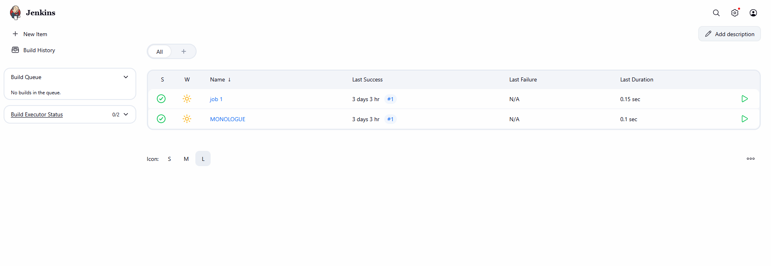
Manage Jenkin:\
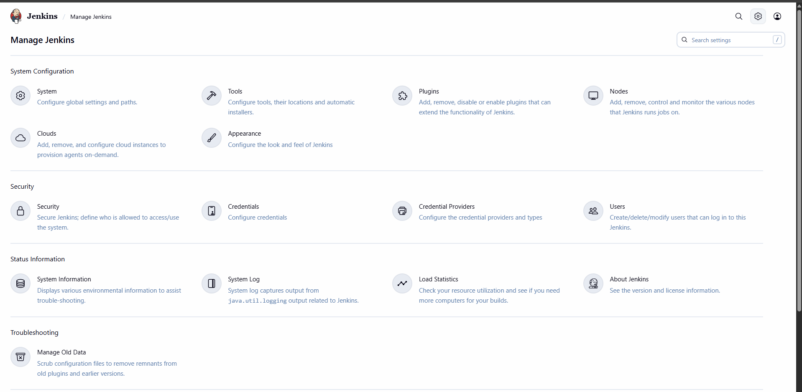
Jenkin Version:

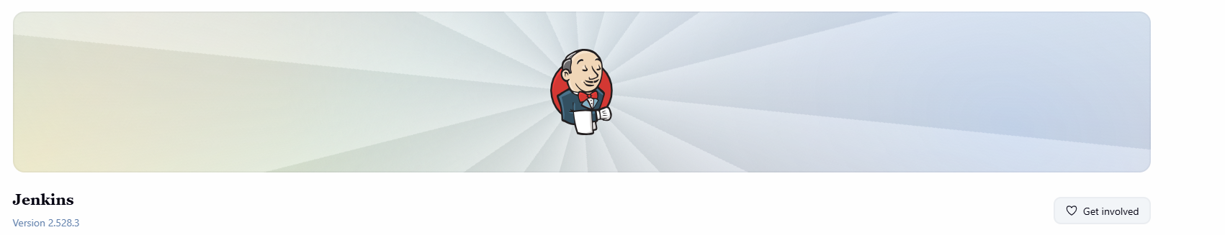

TASK 2:

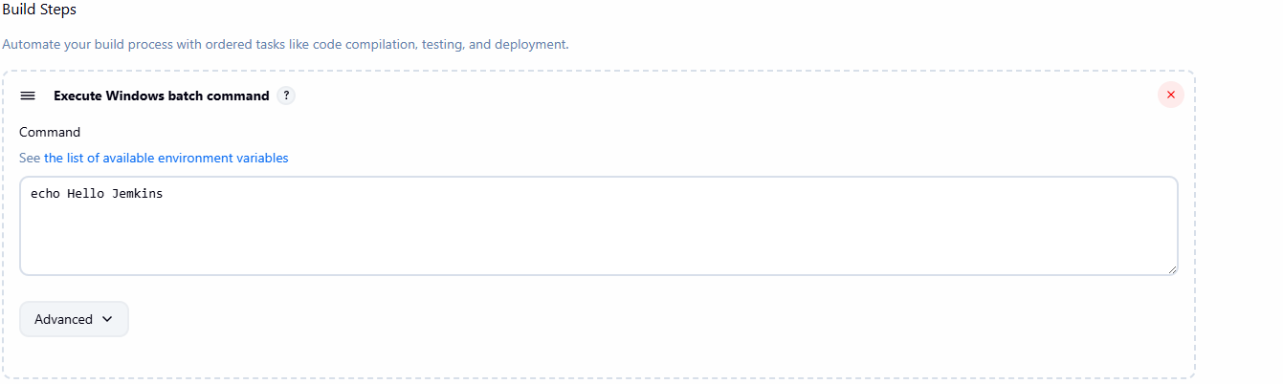

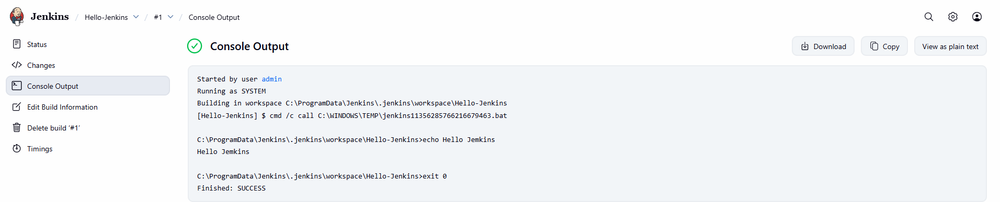
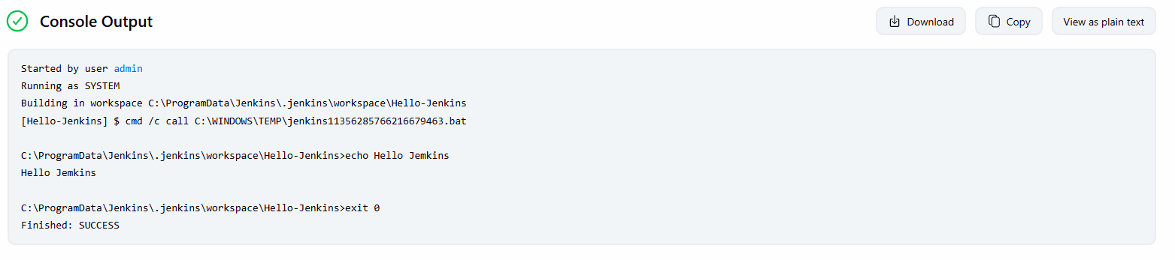

TASK 3:
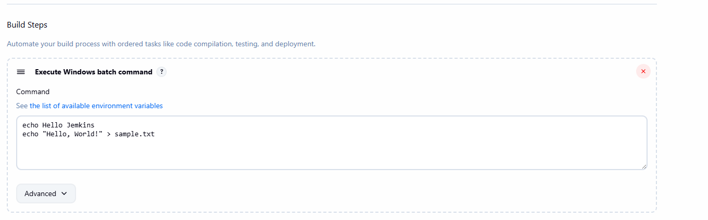
Text file created in workspace using build steps:

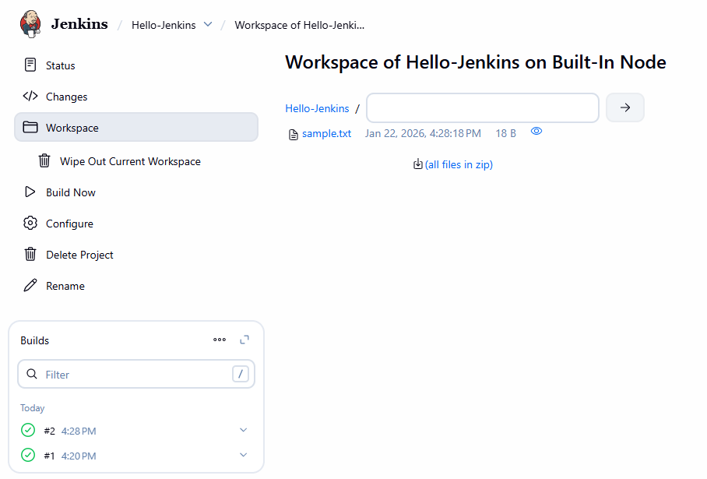

TASK 4:
