**Question:**

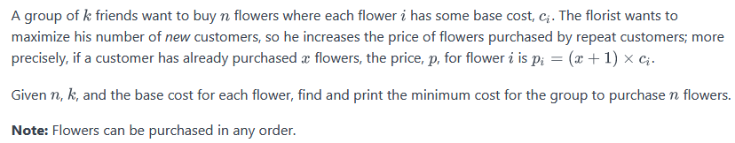

**Sample Input 0**

3 3

2 5 6

**Sample Output 0**

13

|  |  |
| --- | --- |
| EXPNO: | GREEDY FLORIST |
| DATE: |

**AIM:**

To find the min cost to buy all the flowers

**PSEUDOCODE:**

while flowers:

bought = []

for i in range(0, k):

if flowers:

bought.append(flowers.pop())

bought = [round * i for i in bought]

cost += sum(bought)

round += 1

**SOURCE CODE:**

import sys

n, k = [int(i) for i in input().split()]

flowers = [int(i) for i in input().split()]

flowers.sort()

cost = 0

round = 1

while flowers:

bought = []

for i in range(0, k):

if flowers:

bought.append(flowers.pop())

bought = [round * i for i in bought]

cost += sum(bought)

round += 1

print(cost)

**OUTPUT:**

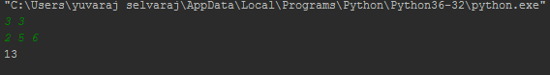

**RESULT:**

Thus the program is compiled and executed successfully.