Game Design Document

Fill up the following document

1. Write the title of your project.

CANDY WORLD

1. What is the goal of the game?

Raj should collect candy and he should not touch the dragen

1. Write a brief story of your game.

In a village raj lived with him gramemother. Every day raj go forest and bring blueberry to him and to him grandmother like every day he went to forest and he see gold butterful and he follow that and he forget the house way and he walk stright he went to candy world .he love candy so…… much he start to collect candy.

1. Which are the playing characters of this game?

* Playing characters are the ones who respond to the user based on the input from the user.
* Cars, monkeys, dinos, wizards, etc., are the playing characters in the game.

|  |  |  |
| --- | --- | --- |
| Number | Character Name | What can this character do? |
| 1 | raj | Collect candy |
| 2 |  |  |
| 3 |  |  |
| 4 |  |  |
| 5 |  |  |
| 6 |  |  |
| 7 |  |  |
| 8 |  |  |

1. Which are the Non-Playing Characters of this game?

* Non-Playing characters are the ones that don't have an action or behavior when the user interacts with the game.
* Hurdles, stones, bananas, coins, etc., are non-playing characters in the game.

|  |  |  |
| --- | --- | --- |
| Number | Character Name | What can this character do? |
| 1 | dragon | Raj should not touch dragon |
| 2 | Candy1 |  |
| 3 | Candy2 |  |
| 4 | Candy3 |  |
| 5 | Candy4 |  |
| 6 | Candy5 |  |
| 7 |  |  |
| 8 |  |  |

Draw your imagination of this game. What does this game look like?

* Draw the game either on your computer or on paper.
* Add images of the game scenes to show each of the playing and non-playing characters at least once.

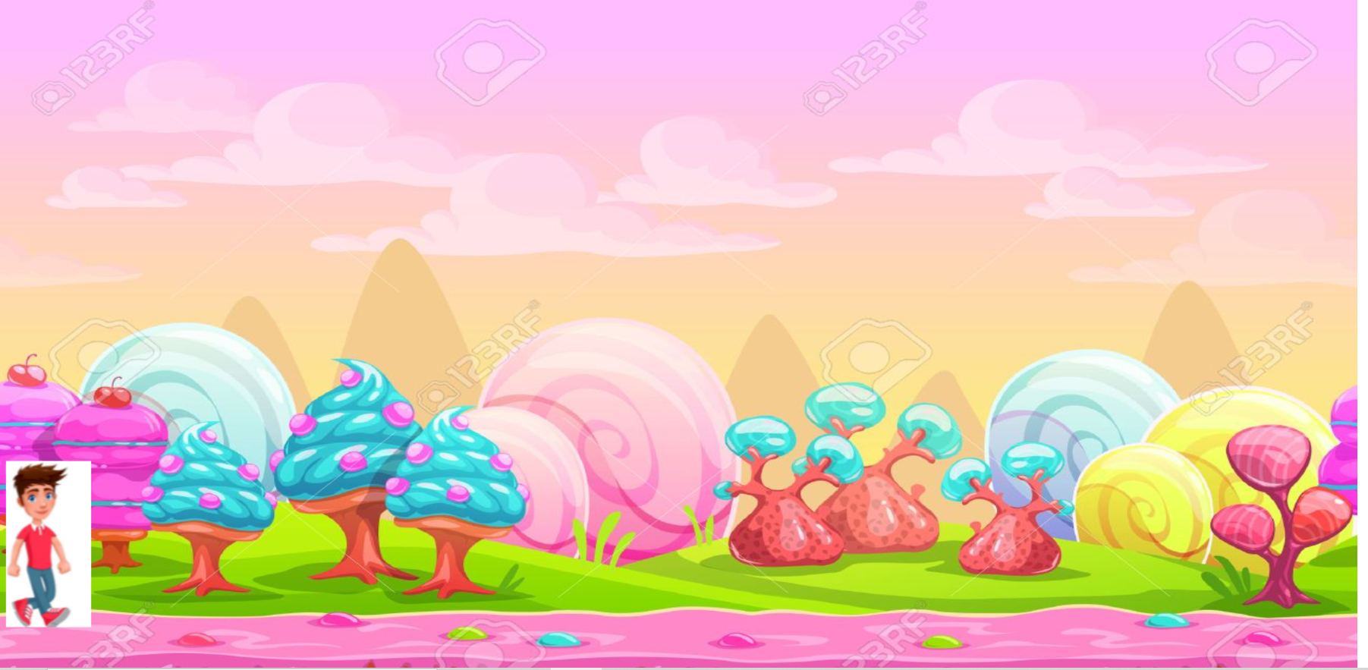

How do you plan to make your game engaging?

I like candy so much so only I plan this game