

DEPARTMENT OF COMPUTER SCIENCE AND ENGINEERING

25CY201 -APPLIED STATISTICS USING PYTHON

ACADEMIC YEAR 2025-2026
PRACTICAL RECORD

Name : M S Yuvashree
Reg.No : 25CS159
Branch & Name : B.E. COMPUTER SCIENCE AND ENGINEERING
Class/Section : I / B.E.CSE B
Year/Sem : I/II



DEPARTMENT OF COMPUTER SCIENCE AND ENGINEERING

25CY201 -APPLIED STATISTICS USING PYTHON

PRACTICALRECORD

Name: M S Yuvashree | Reg.no: 25CS159
Class: I / B.E.CSE B | Branch: B.E. COMPUTER SCIENCE AND ENGINEERING

BONAFIDE CERTIFICATE

Certified bonafide record of work done by Ms. M S Yuvashree
Reg.No 25CS159 during the academic year 2025 – 2026(EVEN SEM)

Faculty Incharge HoD/CSE

Submitted for End Semester practical Examination, held on……………………….

INTERNAL EXAMINER EXTERNAL EXAMINER


INDEX
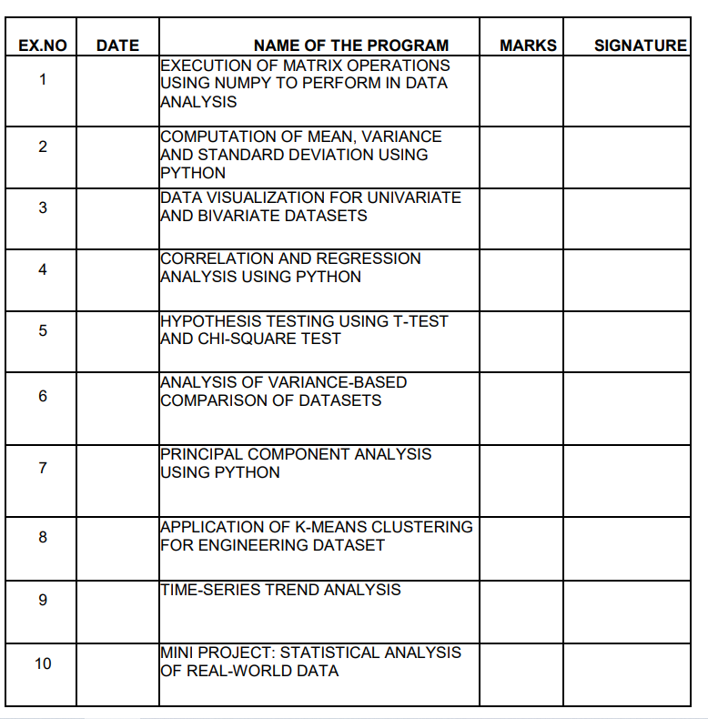

25CY201-APPLIED STATISTICS USING PYTHON

EVEN SEMESTER 2025-2026

Name of the lab In-charge:

CONTINUOUS EVALUATION SHEET RUBRICS TABLE

Criteria |  | RangeofMarks
 | Excellent | Good | Average | BelowAverage
Objective(20) | 18-20 | 14-17 | 10–13 | 0-9
Coding(30) | 27-30 | 21-26 | 15-20 | 0-14
Compilationand  Execution(30) | 27-30 | 21-26 | 15-20 | 0-14
Documentation(10) | 9-10 | 7-8 | 5-6 | 0-4
Viva(10) | 9-10 | 7-8 | 5-6 | 0-4

NAME OF THE  LABORATORY: | 25CY201 -APPLIED STATISTICS  USING PYTHON

YEAR, SEMESTER AND BRANCH: |  |  | I YEAR / II SEMESTER / B.E / B.TECH - COMMON TO CSE, IT, AI&DS, CSD, CYBER
NAME OF THE FACULTY MEMBER:
Sl.  N  o  1 | Criteria | Marks | Excellent | Good | Average | Poor
 |  |  | 91% - 100% | 71% - 90% | 50% - 70% | <50%
 | Objective | 20 | Clear understanding of the objectives with all details and explain very well (4.55 - 5) | Clear  understanding of the objectives but not able to give clear explanation  (3.55 - 4.5) | Moderate understanding of the objectives with less details and unable to explain (2.5 - 3.5) | Not clear about the objectives and explanation  (<2.5)
2 | Coding | 30 | Able to list all  commands and  give relevant explanation to them (13.65 - 15) | Able to list most commands and  give explanation to some extend (10.65 - 13.5) | Able to list popular  commands and explain partially  (7.5 - 10.5) | Not able to list  any commands and no explanation  (<7.5)
3 | Compilation and  Execution | 30 | Materials and Methods are identified properly (54.6 - 60) | Materials are mentioned without methods (30.6 - 54) | Not able to give correct material and involves many mistakes  (30 - 42) | Not able to recognize the materials and methods to proceed (<30)
4 | Documentatio n | 10 | Printouts and documentation fully completed  (9.1 - 10) | Printouts and documentation  mostly completed  (7.1 - 9) | Printouts and partially  completed documentation  (5 - 7) | No printouts and  documentatio  n (<5)
5 | Viva | 10 | Answer all the questions clearly with strong conceptual | Answers most questions correctly with minor hesitation. | Answers basic questions but lacks clarity and depth. | Unable to answer questions properly. Very limited
 |  |  | understanding  and confidence  (9 - 10) | Good understanding.  (7 - 8) | (5 - 6) | understanding (<5)

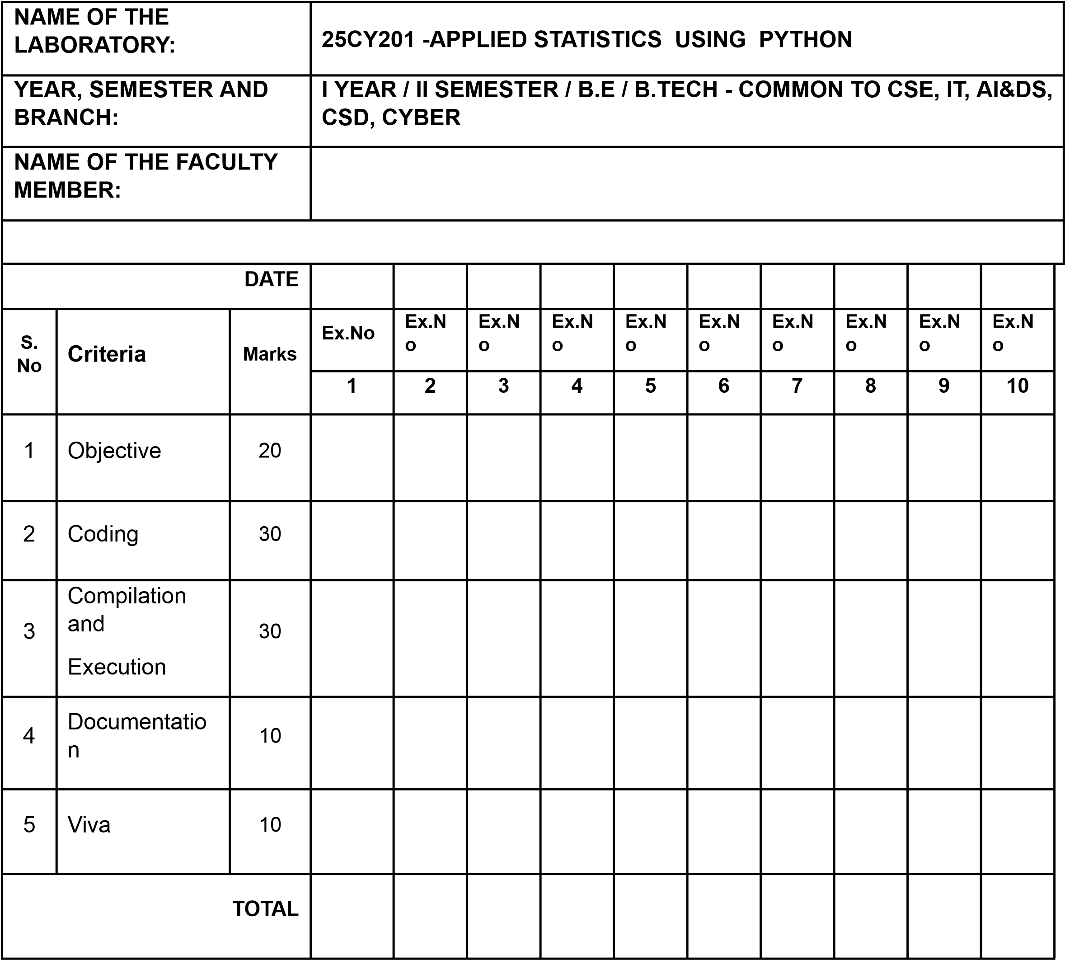
Signature of the Faculty member

EX.No:1 | Execution of matrix operations using NumPy to perform in Data analysis.
DATE:

AIM:
To execute various matrix operations using NumPy in Python for performing efficient computations and analysis of data in data analysis applications.
ALGORITHM:
Step 1: Start.
Step 2:Import the NumPy package to enable numerical and matrix operations.
Step 3:Define matrices using NumPy arrays to represent data for analysis.
Step 4:Execute basic matrix operations such as addition, subtraction, multiplication, transpose, and dot product.
Step 5:Compute statistical measures like mean, sum, standard deviation, and normalize the matrix data.
Step 6: Display the calculated result Step 7: End.

PROGRAM:1 Matrix Operations using NumPy for Data Analysis import numpy as np
# 1. Create matrices (arrays)
- = np.array([[1, 2, 3],
[4, 5, 6],
[7, 8, 9]])
- = np.array([[9, 8, 7],
[6, 5, 4], [3, 2, 1]]) print("Matrix A:\n", A) print("\nMatrix B:\n", B)

# 2. Matrix addition and subtraction add = A + B sub = A - B
print("\nAddition (A + B):\n", add) print("\nSubtraction (A - B):\n", sub)

# 3. Element-wise multiplication and division mul = A * B div = A / B
print("\nElement-wise Multiplication:\n", mul) print("\nElement-wise Division:\n", div)

# 4. Matrix multiplication (Dot product) dot_product = np.dot(A, B)
print("\nMatrix Multiplication (Dot Product):\n", dot_product)

# 5. Transpose of a matrix transpose_A = A.T
print("\nTranspose of A:\n", transpose_A)

# 6. Statistical operations (important in data analysis) print("\nMean of A:", np.mean(A))
print("Median of A:", np.median(A)) print("Standard Deviation of A:", np.std(A)) print("Variance of A:", np.var(A))

# Row-wise and Column-wise mean print("\nRow-wise Mean of A:", np.mean(A, axis=1)) print("Column-wise Mean of A:", np.mean(A, axis=0))

# 7. Maximum and Minimum values print("\nMaximum value in A:", np.max(A)) print("Minimum value in A:", np.min(A))

# 8. Normalization (Feature Scaling) normalized_A = (A - np.min(A)) / (np.max(A) - np.min(A)) print("\nNormalized Matrix A:\n", normalized_A)

# 9. Determinant and Inverse (Linear Algebra) det_A = np.linalg.det(A) print("\nDeterminant of A:", det_A)

# Inverse exists only if determinant is not zero if det_A != 0:
inverse_A = np.linalg.inv(A) print("\nInverse of A:\n", inverse_A) else: print("\nMatrix A is singular, inverse does not exist.")

# 10. Eigenvalues and Eigenvectors (used in PCA) eigenvalues, eigenvectors = np.linalg.eig(A) print("\nEigenvalues of A:\n", eigenvalues) print("\nEigenvectors of A:\n", eigenvectors) Output:
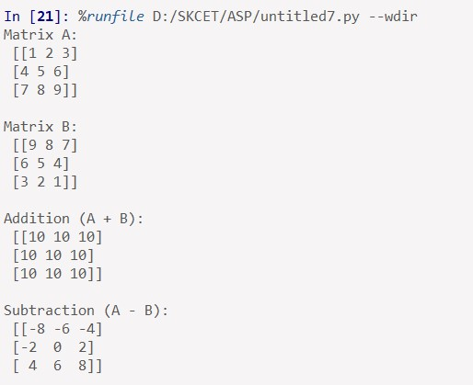
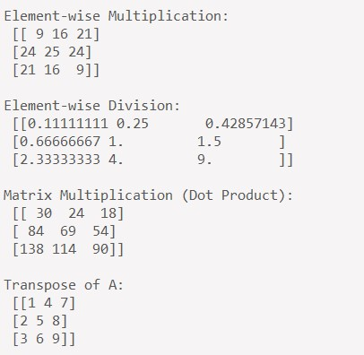
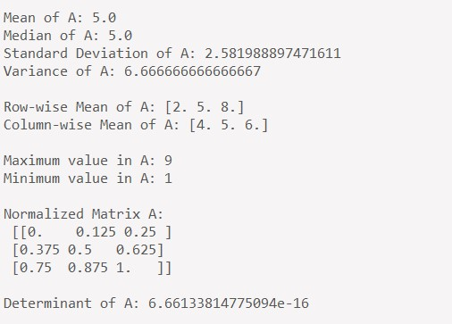
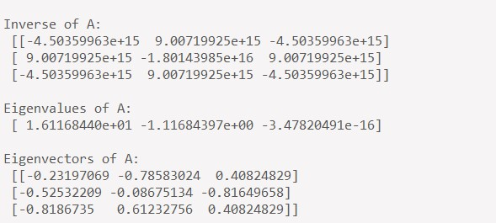

Result:
The program successfully performs matrix operations such as addition, multiplication, transpose, and statistical calculations using NumPy.

EXERCISE:
- Create two 3×3 matrices using NumPy and perform addition, subtraction, element-wise multiplication, and matrix
Output:
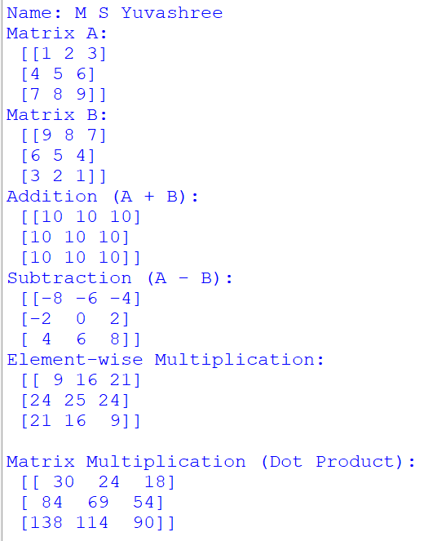
2.Given a 4×3 dataset matrix, calculate the row-wise mean, column-wise mean, standard deviation, and normalize the data
Output:
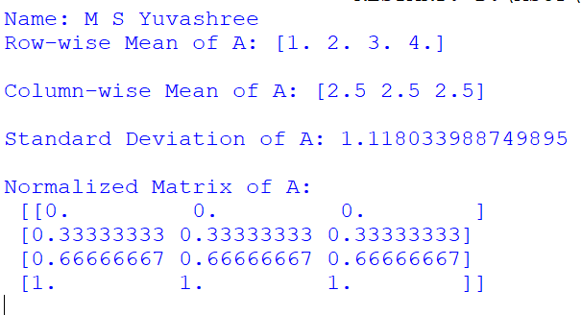

3. Write a NumPy program to find the determinant and inverse of a 2×2 matrix and solvsystem of linear equations using np.linalg.solve().
Output:
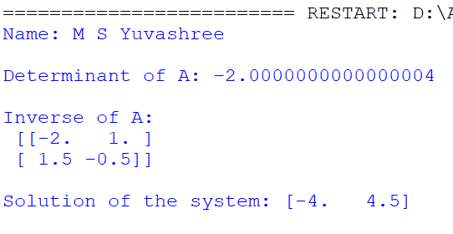

Viva questions:
- What is NumPy and why is it used in data analysis?
- What is the difference between a NumPy array and a Python list?
- How do you create a matrix in NumPy?
- What is broadcasting in NumPy?
- How is matrix multiplication performed in NumPy?
- What is the difference between dot() and matmul()?
- How do you find the transpose of a matrix?
- What are eigenvalues and eigenvectors?
- How do you compute the inverse of a matrix?
- What errors can occur during matrix operations?

EX.No:2 | Computation of mean, variance and standard deviation using Python.
DATE:

AIM:
To write a Python program to compute mean, variance and standard deviation.
ALGORITHM:
Step 1: Start
Step 2: import the NumPy library.
Step 3: Read the number of elements from the user.
Step 4: Accept the data values from the user and store them in an array.
Step 5: Compute the mean, variance, and standard deviation using NumPy functions.
Step 6: Display the calculated statistical values. Step 6: End
PROGRAM:
import numpy as np
# Get number of elements from user n = int(input("Enter number of elements: "))

# Get data values from user data = [] for i in range(n):
value = float(input(f"Enter element {i+1}: ")) data.append(value)

# Convert list to NumPy array data = np.array(data)

# Compute statistics mean = np.mean(data) variance = np.var(data) std_deviation = np.std(data)

# Display results
print("\nData:", data) print("Mean:", mean) print("Variance:", variance)
print("Standard Deviation:", std_deviation)

Output:

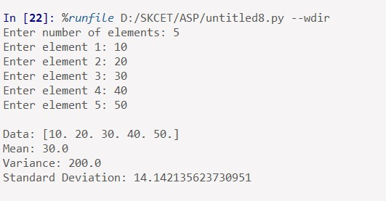

Result:
The program successfully calculates the mean, variance, and standard deviation for the user-entered data.It displays accurate statistical results that help analyze the distribution and spread of the data values.
EXERCISE:
- Write a Python program to calculate the mean and standard deviation of a list of student marks entered by the user.
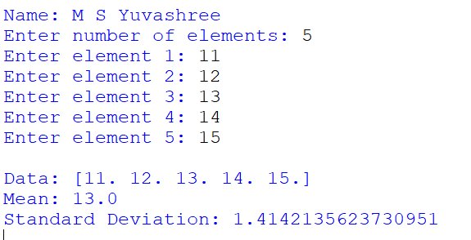

- Modify the program to compute variance and standard deviation for a 2D dataset.

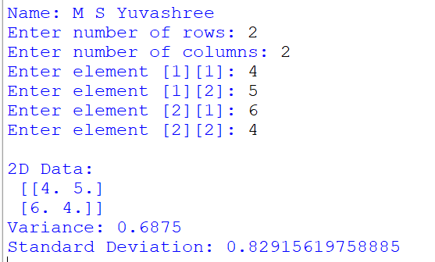

- Create a program to compare the mean and standard deviation of two different datasets using NumPy.
Output:
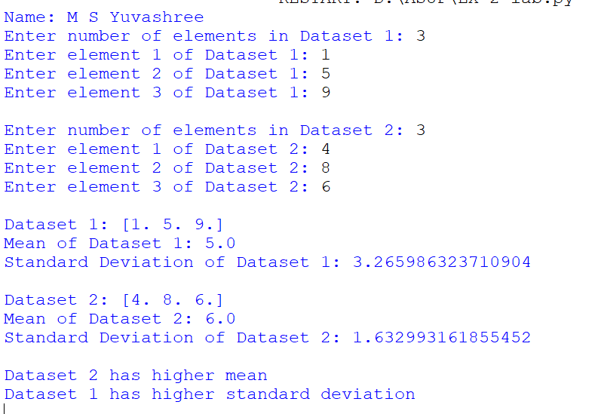
Viva Questions:
- What is mean and how is it calculated?
- What does variance indicate about a dataset?
- Why is standard deviation more interpretable than variance?
- How do population and sample variance differ?
- Which NumPy functions compute mean and standard deviation?
- What happens to mean if outliers are present?
- Can standard deviation be negative? Why?
- What is the relationship between variance and standard deviation?
- How is variance affected by data scaling?
- Where are these measures used in real-world applications?

EX.No:3 | Data visualization for univariate and bivariate datasets.
DATE:

AIM:
To write a python program for data visualization for univariate and bivariate datasets.

ALGORITHM:
Step 1:Start the program
Step 2:import required libraries such as NumPy and Matplotlib.
Step 3:Create or read the univariate and bivariate datasets.
Step 4:Plot a histogram to visualize the univariate data distribution.
Step 5: Plot scatter and line graphs to represent the relationship between bivariate data.
Step 6: Display all the graphs with appropriate titles and axis labels.
Step 7: End.

PROGRAM:
import numpy as np import matplotlib.pyplot as plt # Sample univariate dataset data = np.array([10, 15, 20, 25, 30, 35, 40])

# Histogram
plt.figure() plt.hist(data, bins=5) plt.title("Univariate Data - Histogram") plt.xlabel("Values") plt.ylabel("Frequency")
plt.show() # Sample bivariate dataset x = np.array([1, 2, 3, 4, 5]) y = np.array([2, 4, 6, 8, 10])

# Scatter Plot plt.figure() plt.scatter(x, y) plt.title("Bivariate Data - Scatter Plot") plt.xlabel("X values") plt.ylabel("Y values") plt.show()

# Line Plot plt.figure() plt.plot(x, y) plt.title("Bivariate Data - Line Plot") plt.xlabel("X values") plt.ylabel("Y values") plt.show()

Output:

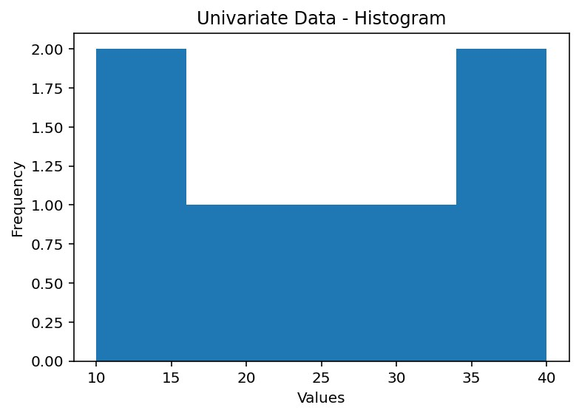
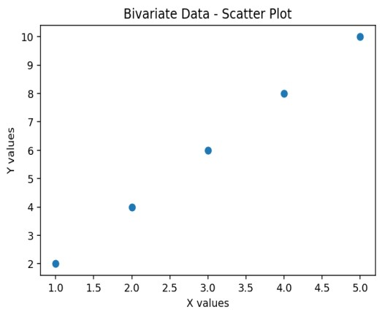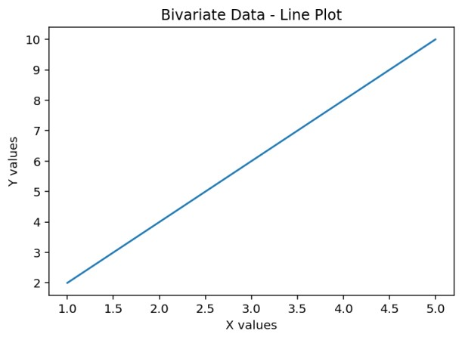
RESULT:
The program successfully visualizes univariate data using a histogram and bivariate data using scatter and line plots.These visualizations clearly represent data distribution and relationships, aiding effective data analysis.
Exercise:
- Write a Python program to visualize univariate data using a bar chart and box plot.
- Create a bivariate visualization program using a scatter plot to show the relationship between height and weight.
- Modify the program to accept user input data and visualize it using appropriate univariate and bivariate plots.

Viva Questions:
- What is data visualization?
- What is univariate data?
- What is bivariate data?
- Which plots are used for univariate analysis?
- Which plots are used for bivariate analysis?
- What is a histogram?
- What is a scatter plot?
- Why is data visualization important?
- What libraries are used for visualization in Python?
- How do visualizations help in decision-making?

EX.No:4 | Correlation and regression analysis using Python.
DATE:

AIM:
To write a program to calculate correlation coefficient, generates a regression equation and graph to visualize and predict data trends.

ALGORITHM:
Step 1:Start the program
Step 2: import required libraries such as NumPy and Matplotlib.
Step 3:Read or define the two related datasets (X and Y values).
Step 4:Compute the correlation coefficient using NumPy to measure the relationship.
Step 5:Perform linear regression to find the best-fit line and regression equation.
Step 5: Display the correlation result and plot the regression line with data points.
Step 5: End.

PROGRAM:
import numpy as np import matplotlib.pyplot as plt

# Sample data
x = np.array([10, 20, 30, 40, 50]) y = np.array([15, 25, 35, 45, 55])

correlation = np.corrcoef(x, y) print("Correlation Matrix:\n", correlation)

# Calculate regression coefficients (y = mx + c) m, c = np.polyfit(x, y, 1) print("\nRegression Equation: y = {:.2f}x + {:.2f}".format(m, c))

# Predicted values y_pred = m * x + c

# Plot regression line plt.figure() plt.scatter(x, y) plt.plot(x, y_pred) plt.title("Regression Analysis") plt.xlabel("X values") plt.ylabel("Y values") plt.show()

OUTPUT:
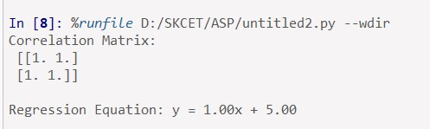

RESULT:
The program calculates the correlation coefficient showing the strength of the relationship between variables.It also generates a regression equation and graph to visualize and predict data trends.

Exercise:
- Write a Python program to find the correlation coefficient between students’ study hours and marks obtained.
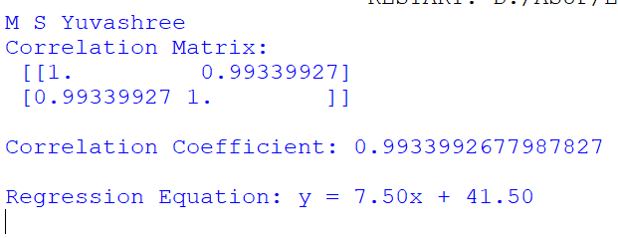
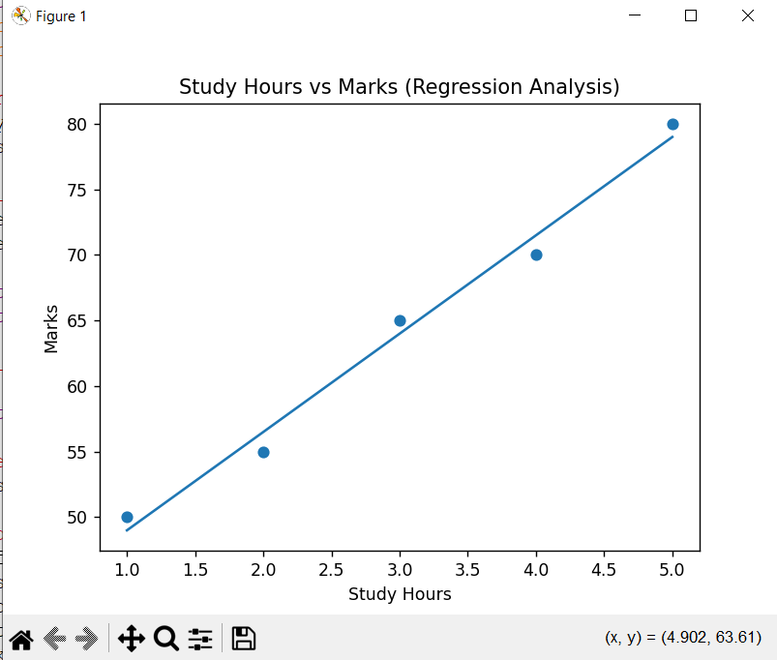

- Modify the regression program to accept user input values for X and Y datasets.
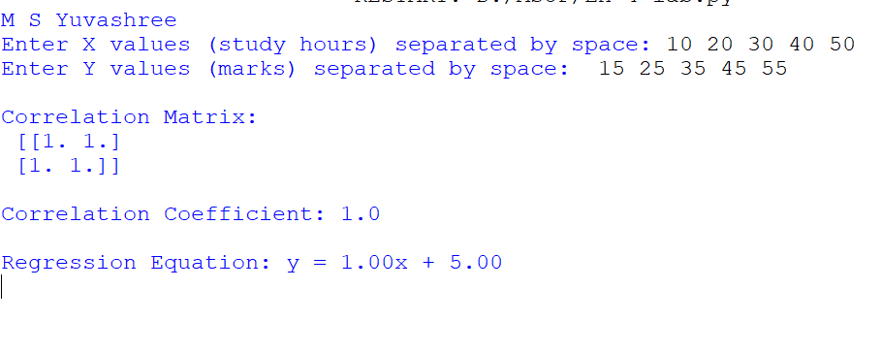
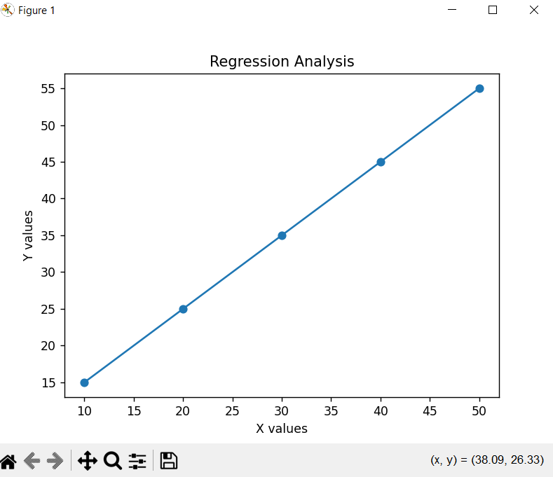

- Create a program to compare regression lines for two different datasets and analyze the results.
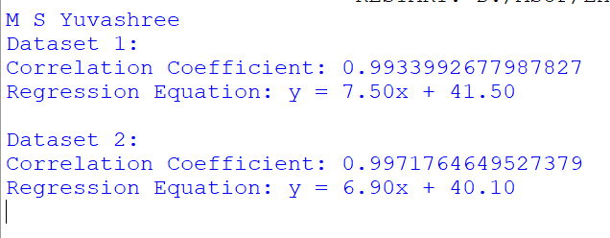
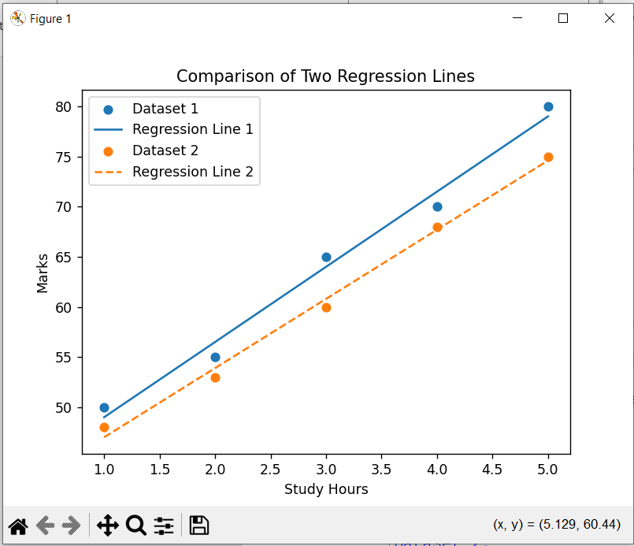

Viva Questions:

- What is correlation?
- What are the types of correlation?
- What is Pearson correlation coefficient?
- What is regression analysis?
- Difference between correlation and regression?
- What is linear regression?
- What does slope represent in regression?
- What is R-squared value?
- Can correlation exist without causation?
- What are real-life applications of regression?

EX.NO:5 | Hypothesis testing using t-test and chi-square test
DATE:

AIM:
To conduct hypothesis testing using:
  - T-Test (for small and large samples)
  - Chi-Square Test (for categorical data)

ALGORITHM:
T-Test:
Step 1: Input sample data for two groups.
Step 2: Calculate means and standard deviations.
Step 3: Apply t-test using scipy.stats.ttest_ind().
Step 4: Print t-statistic and p-value.
Step 5: Interpret the p-value to accept/reject null hypothesis.
Chi-Square Test:
Step 1: Input observed data in matrix form.
Step 2: Use scipy.stats.chi2_contingency().
Step 3: Calculate chi-square statistic, p-value, degrees of freedom. Step 4: Interpret results using significance level.
PROGRAM:
● T-Test Using Python:
from scipy import stats

n = int(input("Enter number of elements in each group: ")) group1 = [float(input(f"Group1 value {i+1}: ")) for i in range(n)] group2 = [float(input(f"Group2 value {i+1}: ")) for i in range(n)]

t_stat, p_value = stats.ttest_ind(group1, group2)

print("T-statistic:", t_stat)
print("P-value:", p_value)

if p_value< 0.05: print("Reject H0: Significant difference.") else: print("Fail to reject H0: No significant difference.")

● Chi-Square Test Using Python:
import numpy as np
from scipy.stats import chi2_contingency

rows = int(input("Enter number of rows: ")) cols = int(input("Enter number of columns: ")) observed = []

for i in range(rows): row = [int(input(f"Value at ({i+1},{j+1}): ")) for j in range(cols)] observed.append(row)

observed_array = np.array(observed)
chi2, p, dof, expected = chi2_contingency(observed_array)

print("Chi-Square Value:", chi2)
print("P-value:", p) print("Degrees of Freedom:", dof)
print("Expected Frequencies:\n", expected)

if p < 0.05:
print("Reject H0: Variables are dependent.") else: print("Fail to reject H0: Variables are independent.")

Output:
t-test:
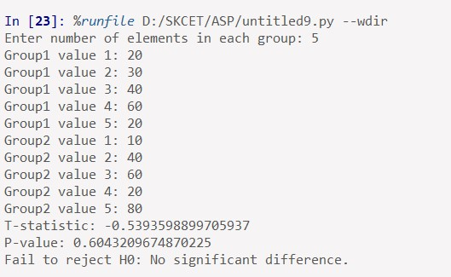

Chi-test:
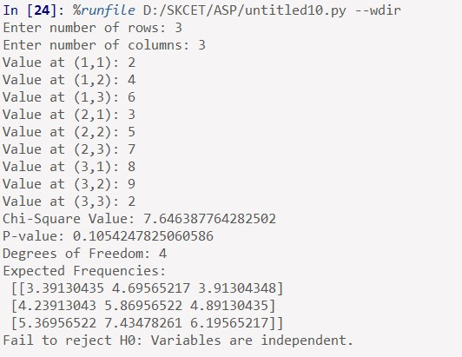

RESULT:
The hypothesis testing was successfully conducted using Python for:
- T-Test on small and large samples
- Chi-Square Test on categorical data

EXERCISE:
- Modify the t-test program to handle unequal sample sizes.
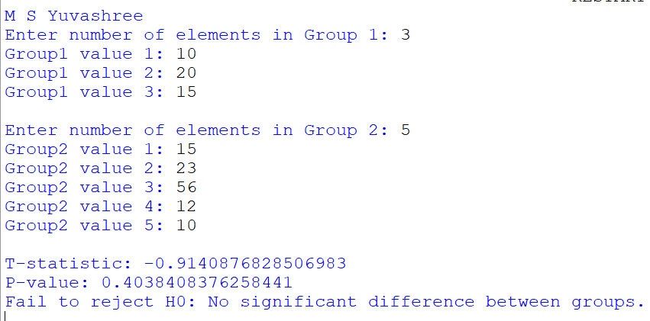
- Implement a one-sample t-test to check if the sample mean is significantly different from a given value.
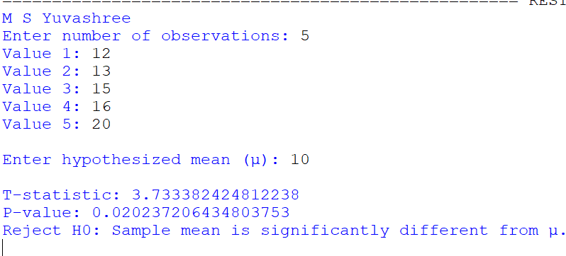
- Extend the chi-square program to handle goodness-of-fit test.

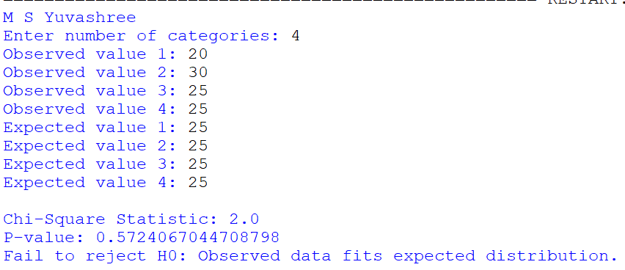

- Use your chi-square program to analyze real-world data such as survey responses.

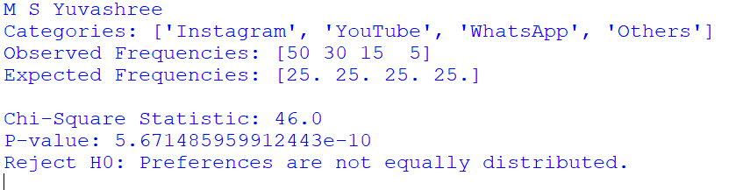

Viva Questions:
- What is hypothesis testing?
- Define null hypothesis and alternative hypothesis.
- What is a t-test?
- What are the types of t-tests?
- What is Chi-square test?
- When is Chi-square test used?
- What is significance level?
- What is a p-value?
- What happens if p-value < α?
- What assumptions are required for t-test?

EX.NO:6 | Analysis of variance - based comparison of datasets.
DATE:
AIM:
To perform Analysis of Variance (ANOVA) using Python in order to compare multiple datasets and determine whether there is a statistically significant difference among their means.
ALGORITHM:
Step 1: Start the program and import required libraries such as NumPy and SciPy.
Step 2: Define or input multiple datasets representing different groups.
Step 3: Apply the one-way ANOVA test using stats.f_oneway() function.
Step 4: Obtain the F-statistic and p-value from the ANOVA test.
Step 5: Compare the p-value with the significance level (0.05) and display the result. Step 6: End the program

PROGRAM:
import numpy as np from scipy import stats
# Sample datasets (e.g., scores from three different groups)
group1 = np.array([85, 88, 90, 92, 86]) group2 = np.array([78, 80, 82, 79, 81]) group3 = np.array([90, 92, 94, 91, 93])

# Perform One-Way ANOVA
f_statistic, p_value = stats.f_oneway(group1, group2, group3)

# Display results print("Group 1:", group1) print("Group 2:", group2) print("Group 3:", group3)

print("\nF-Statistic:", f_statistic) print("P-Value:", p_value)

# Interpretation if p_value< 0.05:
print("\nResult: Significant difference exists between the group means.") else:
print("\nResult: No significant difference exists between the group means.")

Output:
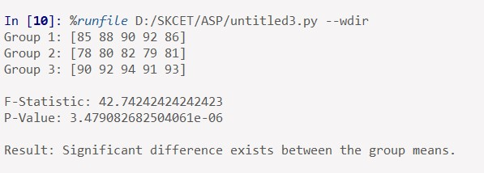

RESULT:
The program successfully computes the F-statistic and p-value for the given datasets. Based on the p-value, it determines whether a significant difference exists between the group means.

EXERCISE:
- Write a Python program to perform ANOVA on the marks of students from four different classes.
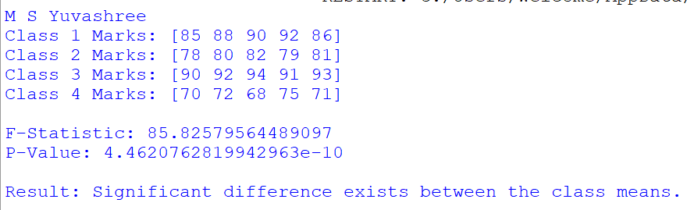
- Modify the program to accept datasets as user input and perform one-way ANOVA.
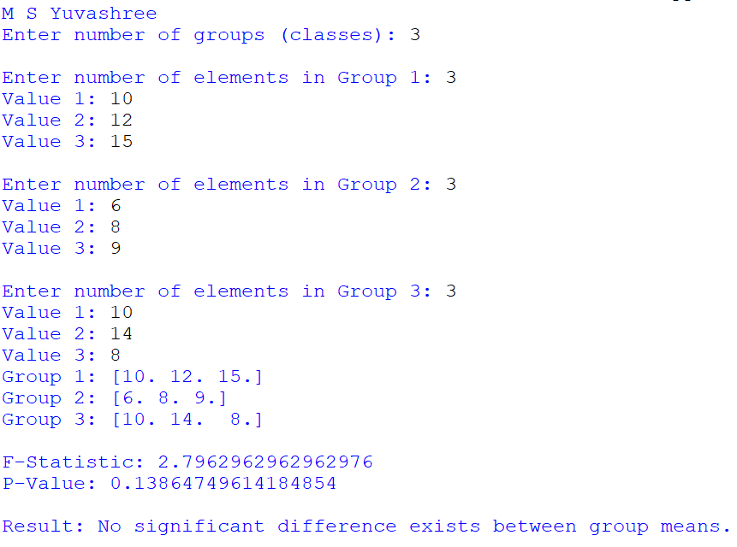

- Create a program to perform two-way ANOVA and analyze the interaction between two independent factors.
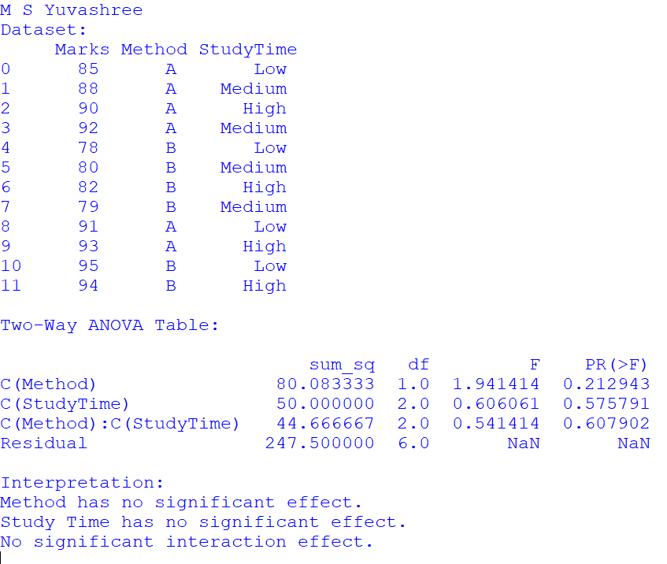

Viva Questions:
- What is ANOVA?
- Why is ANOVA used?
- What is the null hypothesis in ANOVA?
- What is F-statistic?
- Difference between ANOVA and t-test?
- What are types of ANOVA?
- What assumptions does ANOVA make?
- What is within-group variance?
- What is between-group variance?
- Where is ANOVA applied in engineering?

EX.NO:7 | Principal Component Analysis using Python.
DATE:

AIM:
To apply Principal Component Analysis (PCA) using Python to reduce the dimensionality of a dataset while retaining maximum variance for effective data analysis.

ALGORITHM:
- Start the program and import required libraries such as NumPy and Scikit-learn.
- Create or input the dataset containing multiple features.
- Standardize the dataset to bring all features to the same scale.
- Apply PCA to transform the data into principal components.
- Display the principal components and explained variance ratio.

PROGRAM:
import numpy as np from sklearn.decomposition import PCA from sklearn.preprocessing import StandardScaler # Sample dataset (rows = observations, columns = features) data = np.array([
[2.5, 2.4],
[0.5, 0.7],
[2.2, 2.9],
[1.9, 2.2],
[3.1, 3.0],
[2.3, 2.7],
[2.0, 1.6],
[1.0, 1.1],
[1.5, 1.6],
[1.1, 0.9]
])
# Step 1: Standardize the data scaler = StandardScaler() data_scaled = scaler.fit_transform(data)

# Step 2: Apply PCA pca = PCA(n_components=2) principal_components = pca.fit_transform(data_scaled)

# Display results print("Original Data:\n", data) print("\nStandardized Data:\n", data_scaled) print("\nPrincipal Components:\n", principal_components)

# Explained variance print("\nExplained Variance Ratio:", pca.explained_variance_ratio_)

OUTPUT:
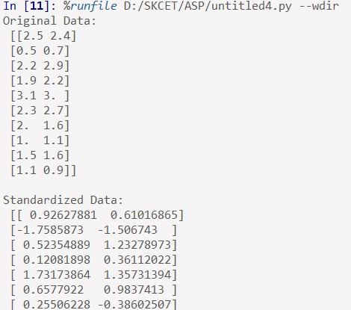
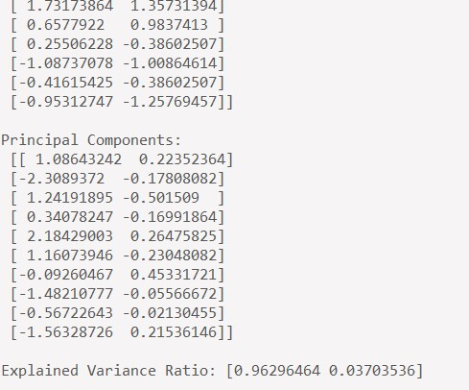
RESULT:
The program successfully transforms the original dataset into principal components. It also displays the explained variance ratio, indicating the amount of information preserved after dimensionality reduction.

EXERCISE:
- Write a Python program to apply PCA on a dataset with three or more features.
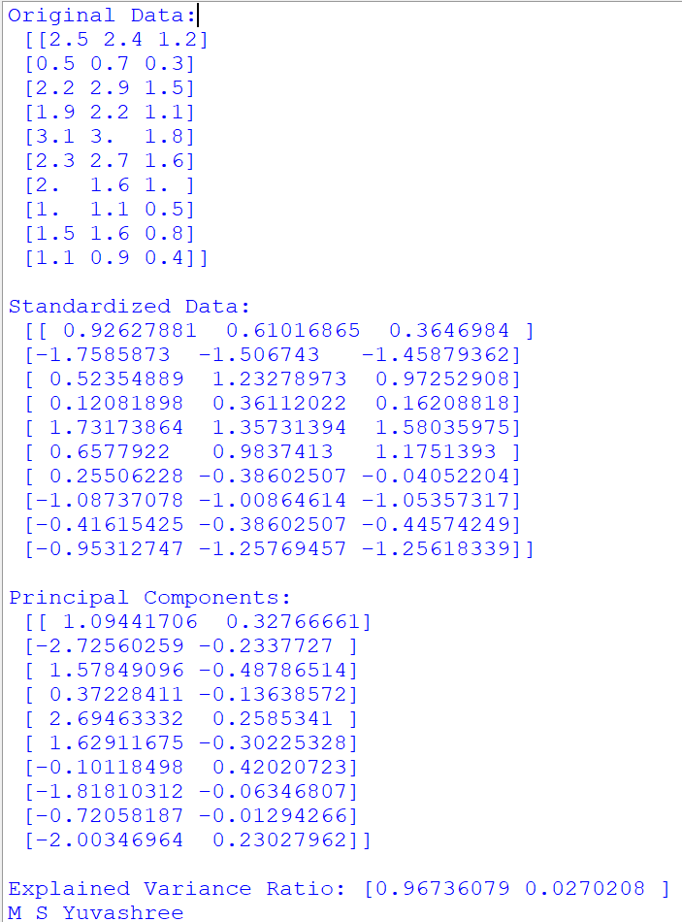

- Modify the program to visualize the first two principal components using a scatter plot.

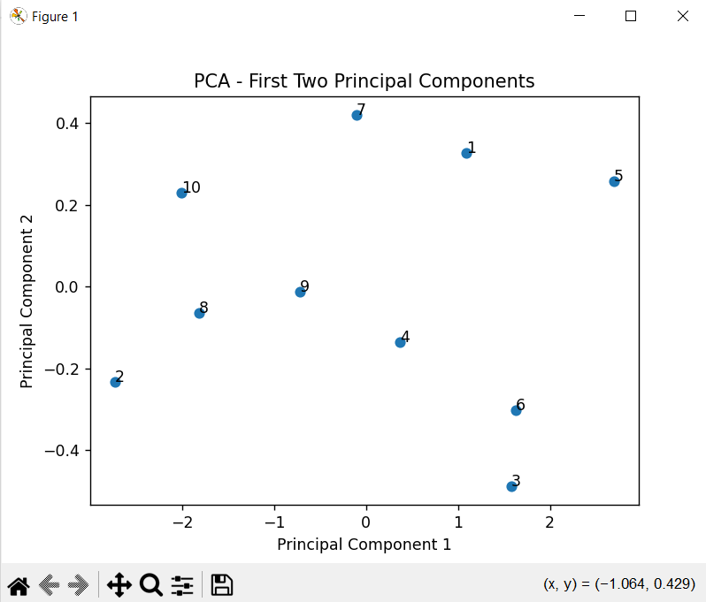

- Create a program to compare model performance before and after applying PCA.

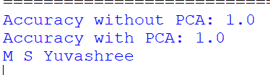

Viva Questions:
- What is PCA?
- Why is PCA used?
- What is dimensionality reduction?
- What are principal components?
- How are principal components selected?
- What is explained variance?
- How does PCA reduce noise?
- Is PCA supervised or unsupervised?
- What are the limitations of PCA?
- Where is PCA used in real life?

EX.NO:8 | Application of K-Means clustering for engineering dataset
DATE:

AIM:
TowriteaprogramthatperformsK-meansClustering
ALGORITHM:
PROGRAM:

importnumpy as np importmatplotlib.pyplotas plt
from sklearn.cluster import KMeans
fromsklearn.datasetsimportmak e_blobs

#Generatesyntheticdata
X,y=make_blobs(n_samples=300,centers=4,cluster_std=0.60,random_state=0) #FitK-meansmodel kmeans=KMeans(n_clusters=4) kmeans.fit(X) y_kmeans=kmeans.predict(X)

# Plot theresults plt.scatter(X[:,0],X[:,1],c=y_kmeans,s=50,cmap='viridis') centers = kmeans.cluster_centers_ plt.scatter(centers[:,0],centers[:,1],c='red',s=200,alpha=0.75,ma
rker='X') plt.title('K-means Clustering') plt.show()
OUTPUT

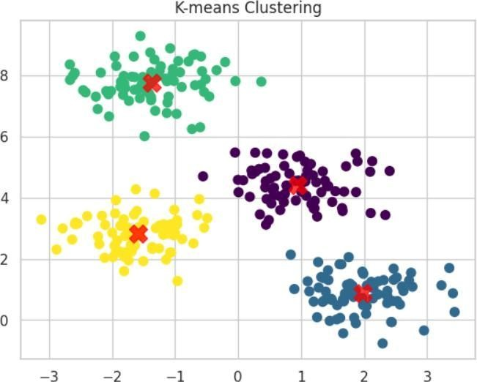

RESULT:
Thus,pythonprogramissuccessfullyimplementedthatperforms K-meansClusteringusingscikit-learn.

WriteaprogramthatperformK-meansClusteringusingscikit-learn

LogisticRegression

importnumpy as np importmatplotlib.pyplotas plt fromsklearn.datasetsimportload_iris from sklearn.model_selection import train_test_split
fromsklearn.linear_modelimportLogistic Regression
fromsklearn.metricsimportconfusion_matrix,accuracy_score
# Load dataset iris=load_iris()
X = iris.data y=iris.target

#Splitdataintotraining andtesting sets
X_train,X_test,y_train,y_test=train_test_split(X,y,test_size=0.2,random_state=42) #Createand fitthemodel model=LogisticRegression(m ax_iter=200)
model.fit(X_train, y_train)

#Predictandevaluate y_pred= model.predict(X_test) print(f'Accuracy: {accuracy_score(y_test, y_pred)}')
print(f'ConfusionMatrix:\n{confusion_matrix(y_test
,y_pred)}')

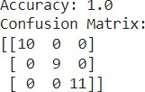

TimeSeriesForecastingwithARIMA

importnumpyasnp importpandasas pd importmatplotlib.pyplotasplt fromstatsmodels.tsa.arima.modelimportARIMA
#Generateasimpletimeseri esdata np.random.seed(0) time=np.arange(100) data=np.sin(time/5)+np.random.normal(scale=0.5,size=len(time))

#CreateaDataFrame
df=pd.DataFrame(data,co lumns=['value']) df['time']
= time

#FitARIMAmodel
model=ARIMA(df['value'],o rder=(5,1,0)) model_fit = model.fit()
#Forecast forecast=model_fit.forecast(steps=10) # Plot plt.figure(figsize=(10,5)) plt.plot(df['value'],label='OriginalData')
plt.plot(np.arange(len(df),len(df)+10),forecast,lab el='Forecast',color='red') plt.legend()
plt.title('TimeSeriesForecasti ngwithARIMA') plt.show

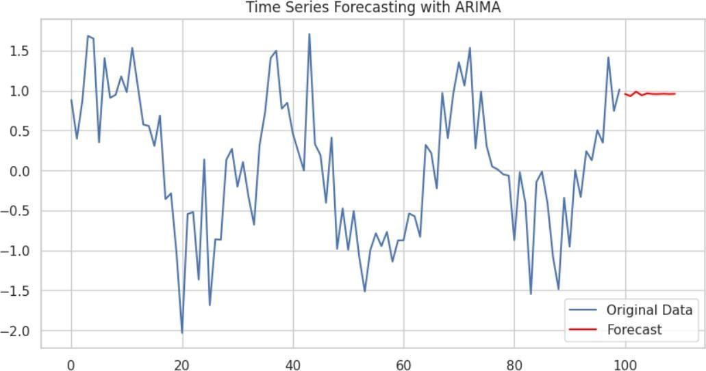

We create the below loop to test and store different model results so that we can make a decision on the best number of clusters.

K = range(2, 8)
fits = []
score = []

for k in K:
# train the model for current value of k on training data
model = KMeans(n_clusters = k, random_state = 0, n_init='auto').fit(X_train_norm)

# append the model to fits
fits.append(model)

# Append the silhouette score to scores
score.append(silhouette_score(X_train_norm, model.labels_, metric='euclidean'))

We can then first visually look at a few different values of k.
First we look at k = 2.
sns.scatterplot(data = X_train, x = 'longitude', y = 'latitude', hue = fits[0].labels_)

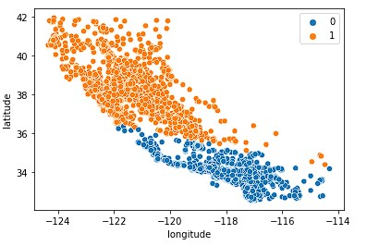

Next, we look at k = 4.

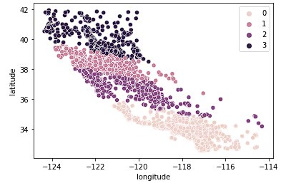

Finally, we look at k = 7.
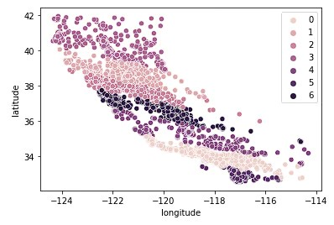
sns.lineplot(x = K, y = score)

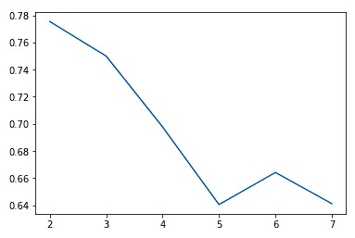 sns.boxplot(x = fits[3].labels_, y = y_train['median_house_value'])

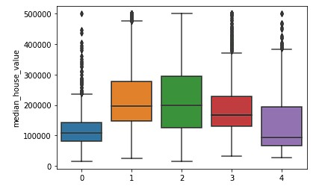

EXERCISE:

- Prepare the data and visualize it in 2D before applying K-Means. Why is feature scaling important before clustering?

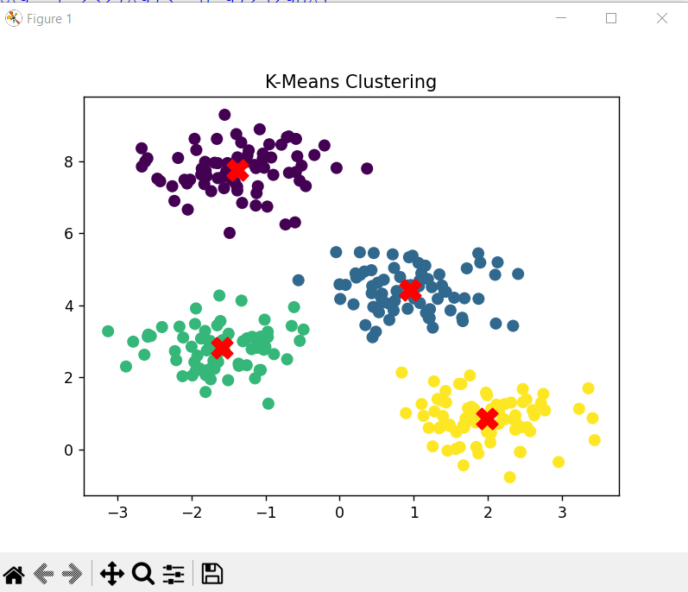

- Plot the elbow curve and silhouette scores to identify the optimal number of clusters. Which value of k do you recommend and why?

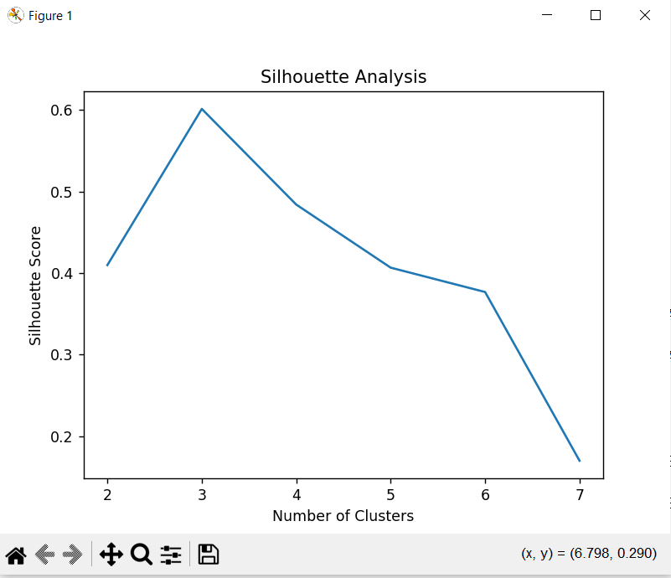

- Interpret each cluster and explain what kind of marketing strategy might work for that segment.

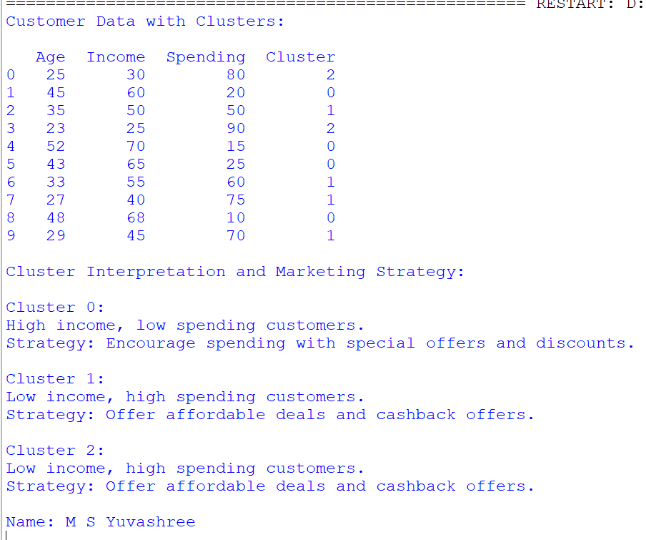

Viva Questions:
- What is clustering?
- What is K-Means algorithm?
- Is K-Means supervised or unsupervised?
- What does the value of K represent?
- How are centroids initialized?
- What is Euclidean distance?
- What is the elbow method?
- What are limitations of K-Means?
- How does K-Means handle large datasets?
- Where is clustering used in engineering?

EX.NO:9 | Time-series trend analysis
DATE:

AIM:
To analyze and visualize time-series data.
ALGORITHM:
- Load date-wise data.
- Set datetime index and resample.
- Plot trends with matplotlib.

PROGRAM: CODE
import pandas as pd import matplotlib.pyplot as plt import seaborn as sns

# Sample COVID-19 time-series dataset (simulated) data = { 'Date': pd.date_range(start='2021-01-01', periods=30, freq='D'),
'Daily_Cases': [
100, 120, 130, 125, 140, 150, 180,
160, 170, 165, 200, 210, 220, 230,
250, 240, 260, 280, 300, 290, 320,
310, 330, 350, 370, 360, 380, 390,
400, 420
]
}

df = pd.DataFrame(data) df['7_day_avg'] = df['Daily_Cases'].rolling(window=7).mean()
# 7-day moving average

# Plotting plt.figure(figsize=(12, 6)) sns.lineplot(x='Date', y='Daily_Cases', data=df, label='Daily Cases') sns.lineplot(x='Date', y='7_day_avg', data=df, label='7-Day Average', color='red') plt.title('COVID-19 Daily Cases (with 7-Day Moving Average)') plt.xlabel('Date')
plt.ylabel('Number of Cases') plt.xticks(rotation=45) plt.grid(True) plt.legend() plt.tight_layout() plt.show()

Output:
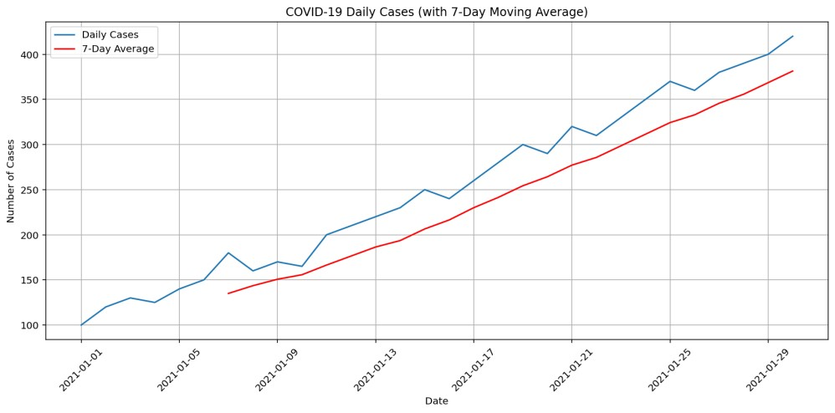

RESULT:
Thus, python program is successfully implemented to analyze and visualize time-series trends from datasets such as COVID-19 case statistics.

EXERCISE:
- Load a CSV file named stock_prices.csv containing columns like Date, Company, Open, Close, High, Low, Volume.Filter the data for a specific company (e.g., "Apple"), convert Date to datetime, and plot the closing price trend over time.
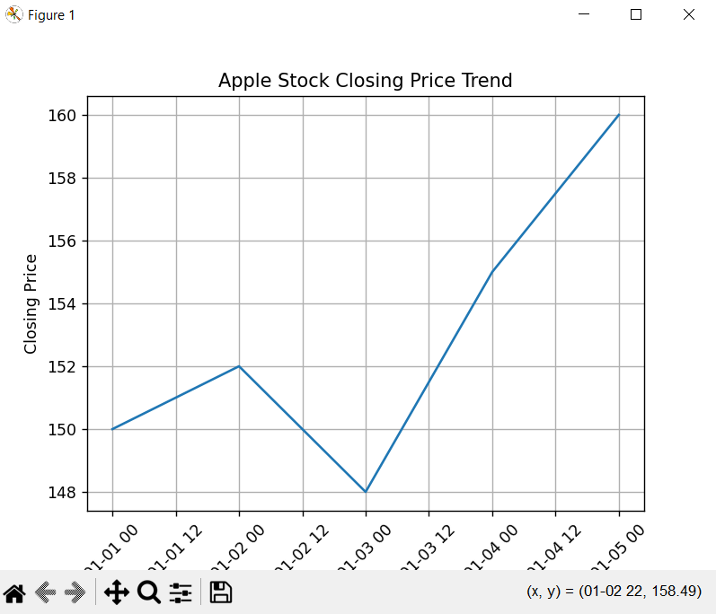

- Given a dataset weather_data.csv with columns Date, City, Temperature, Humidity, Rainfall, filter the data for a city (e.g., "Delhi"), and plot the monthly average temperature trend over a year using a line chart.

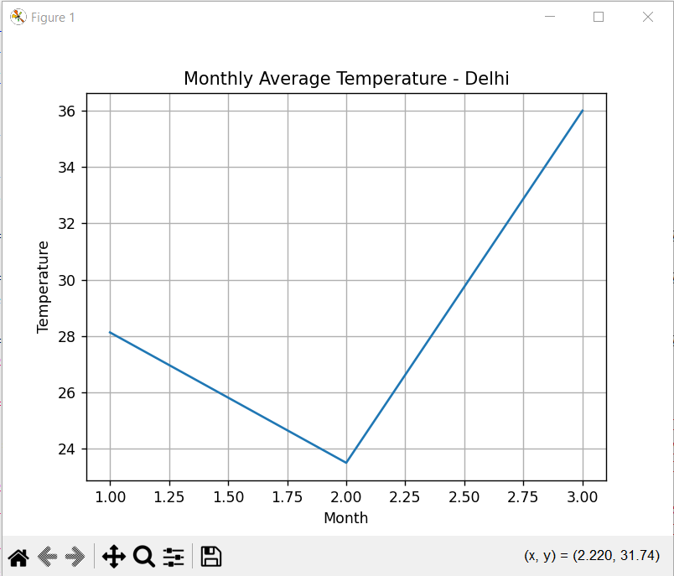

- Load a time-series dataset energy_consumption.csv with Timestamp, Region, Energy_ Consumed(kWh).Convert the timestamp, resample the data weekly, and plot the weekly average energy consumption for a region. Viva Questions:
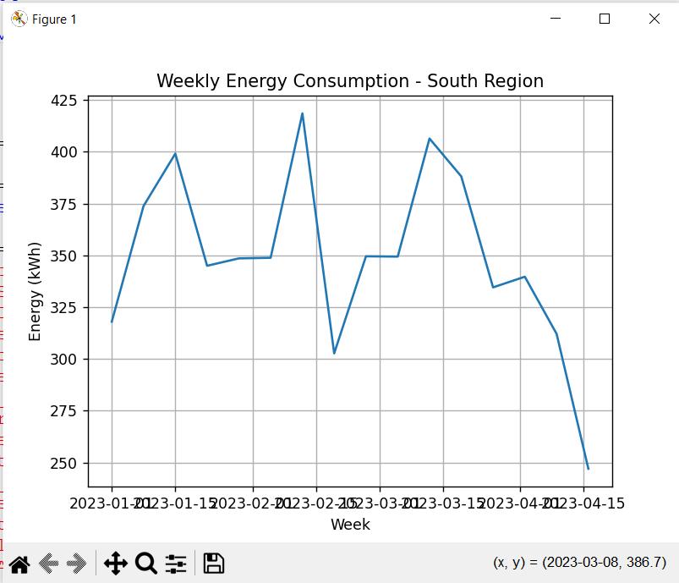
- What is time-series data?
- What are the components of time-series?
- What is trend?
- What is seasonality?
- What is cyclic variation?
- What is random noise?
- How do you visualize time-series data?
- What is moving average?
- Why is trend analysis important?
- Where is time-series analysis applied?

EX.No:10 | Mini project: Statistical analysis of real-world data.
DATE:

AIM:
To perform statistical analysis of real-world data using Python in order to compute descriptive statistics, analyze relationships between variables, and visualize data for meaningful insights.

ALGORITHM:
- Start the program and import required libraries such as NumPy, Pandas, and Matplotlib.
- Create or load a real-world dataset into a DataFrame.
- Compute descriptive statistics such as mean, variance, and standard deviation.
- Perform correlation analysis to study relationships between variables.
- Visualize the data using appropriate plots and display the results.

PROGRAM:

import numpy as np import pandas as pd
import matplotlib.pyplot as plt

# Step 1: Create a Real-World Dataset # Example: Monthly Sales Data data = {
"Month": ["Jan", "Feb", "Mar", "Apr", "May", "Jun"],
"Sales": [12000, 15000, 17000, 16000, 18000, 20000],
"Profit": [3000, 4200, 5000, 4800, 5500, 6200]
}

df = pd.DataFrame(data) print("Dataset:\n", df)

# Step 2: Descriptive Statistics print("\nStatistical Summary:\n") print(df.describe())

# Mean, Variance, Standard Deviation print("\nMean:\n", df.mean(numeric_only=True)) print("\nVariance:\n", df.var(numeric_only=True)) print("\nStandard Deviation:\n", df.std(numeric_only=True))

# Step 3: Correlation Analysis correlation = df[["Sales", "Profit"]].corr() print("\nCorrelation Matrix:\n", correlation)

# Step 4: Data Visualization
# Sales Trend plt.figure() plt.plot(df["Month"], df["Sales"]) plt.title("Monthly Sales Trend") plt.xlabel("Month") plt.ylabel("Sales") plt.show()

# Profit Trend plt.figure() plt.plot(df["Month"], df["Profit"]) plt.title("Monthly Profit Trend") plt.xlabel("Month") plt.ylabel("Profit") plt.show()

# Scatter Plot (Sales vs Profit) plt.figure() plt.scatter(df["Sales"], df["Profit"]) plt.title("Sales vs Profit") plt.xlabel("Sales") plt.ylabel("Profit") plt.show()

# Step 5: Conclusion from Analysis print("\nConclusion:") print("The data shows an increasing trend in sales and profit.") print("A strong positive correlation exists between sales and profit.")
OUTPUT:
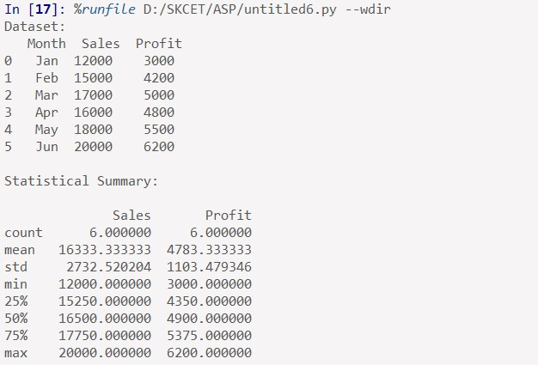
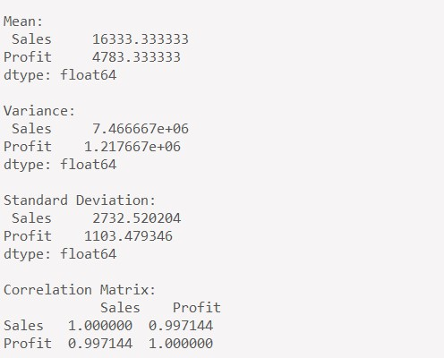
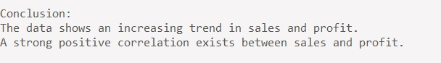
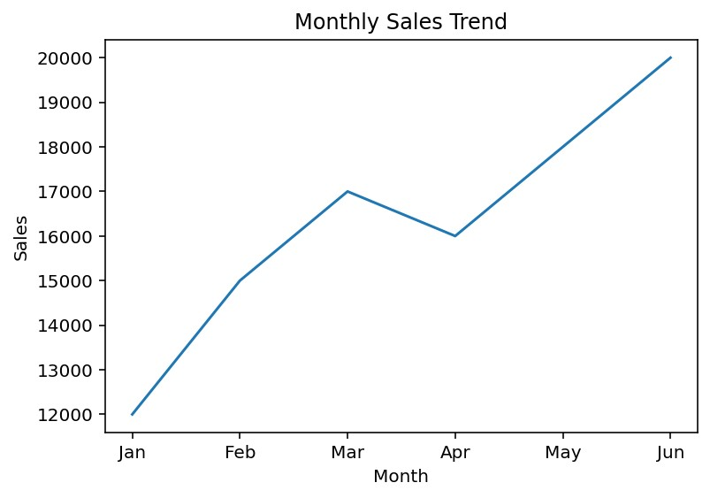
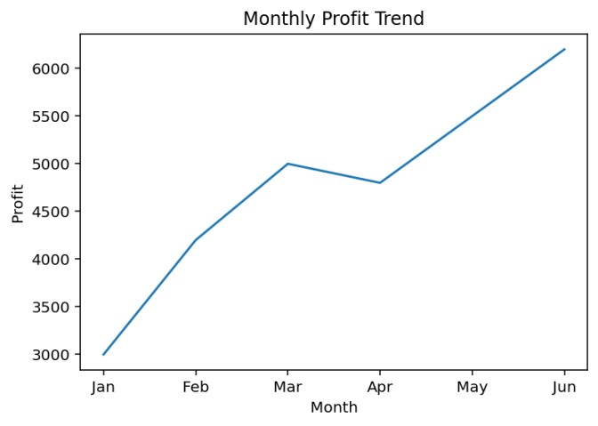
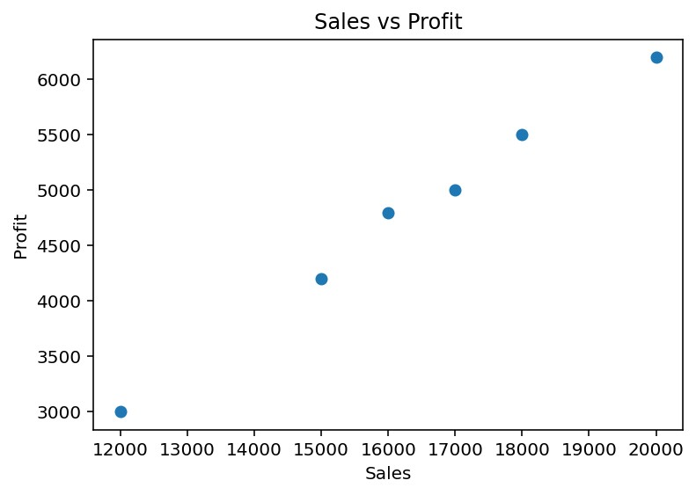
RESULT:
The program successfully analyzes the given real-world dataset and computes key statistical measures.It also visualizes trends and relationships, helping to derive meaningful insights from the data.

Exercise :
- Write a Python program to perform statistical analysis on real-world weather data (temperature and rainfall).

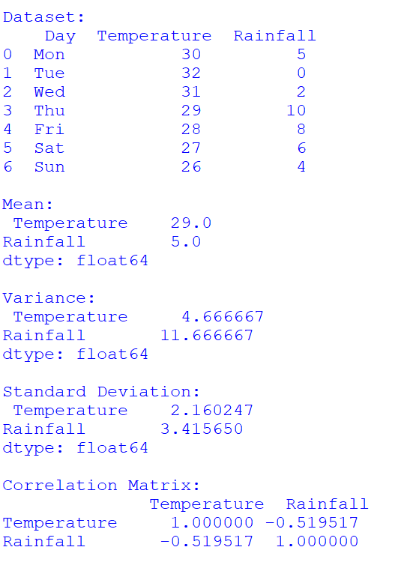
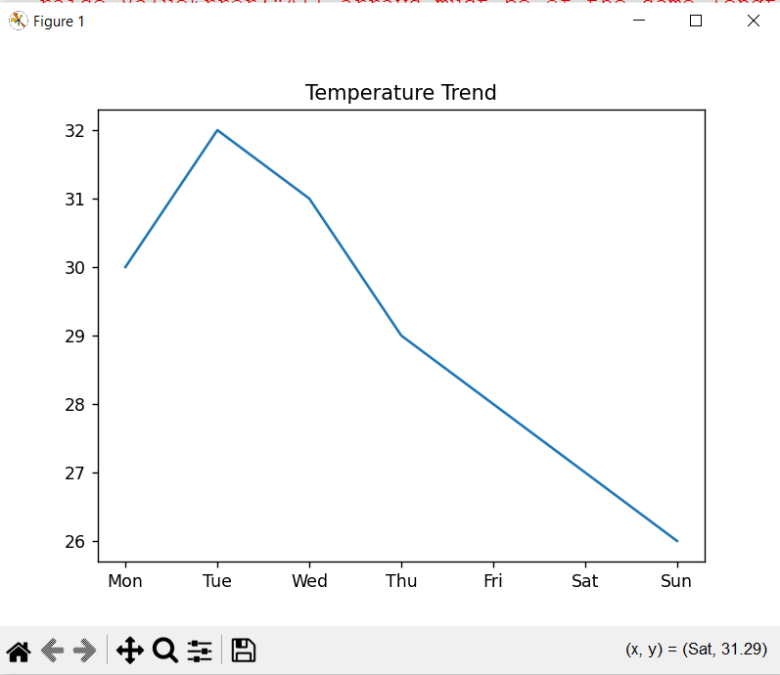
- Modify the program to read data from a CSV file and compute descriptive statistics.
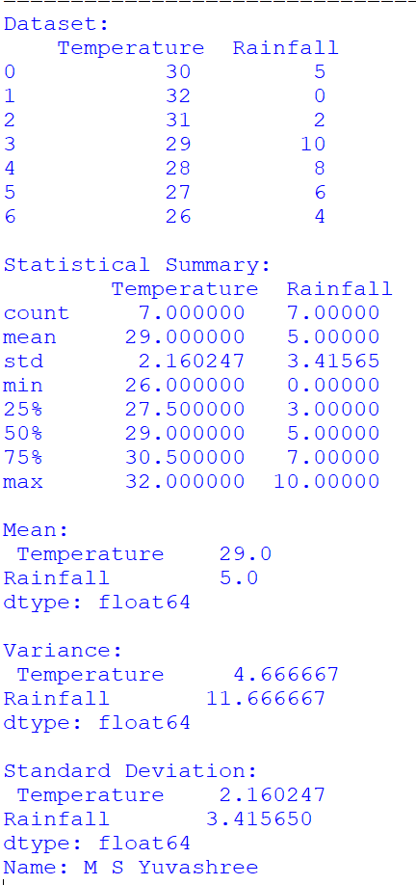
- Extend the mini project to include regression or ANOVA analysis for deeper data interpretation.
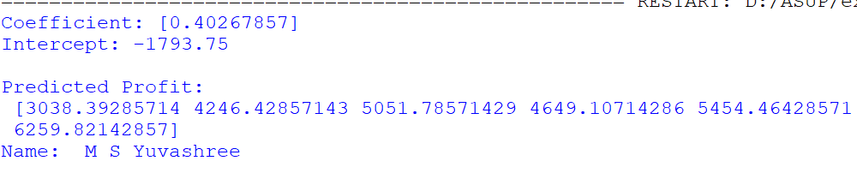

Viva Questions:
- What was the objective of your mini project?
- What type of data did you use?
- How did you collect the dataset?
- What preprocessing steps were applied?
- How did you handle missing values?
- Which statistical techniques were used?
- What challenges did you face?
- How did visualization help your analysis?
- What conclusions were drawn from the data?
- How can your project be improved further?

