PYTHON PROGRAMMING

ASSIGNMENT 2
Task Implementation and Output Report

Student Name | S.M. Yuvashri
Register Number | 1921260135
Course Outcome | CO2
Programming Language | Python
Python Version | Python 3.15

Submitted as part of the Python Programming coursework

1. Introduction
This report documents the implementation and visible execution results of the seven tasks in Python Programming Assignment 2. The work covers decision-making, loops, string validation and construction, function behavior, recursion, iteration, and program redesign.

2. Tools and Libraries
Development environment: Visual Studio Code
Programming language: Python 3.15
Libraries/modules listed for the assignment:
- Python standard library
- time
- functools

3. Task Summary
Task | Title | Main concept
1 | Decisions with Many Boundaries | Conditional statements and boundary handling
2 | OTP Verification Kiosk | while loop and input validation
3 | Vehicle Registration Validator | String checks and format validation
4 | Building Long Text using + and join() | String construction and timing comparison
5 | Mutable Default Argument Bug and Scope | Function arguments, mutable objects, and GST calculation
6 | Recursion and Climbing Stairs | Recursive and iterative problem solving
7 | Diagnose, Redesign and Validate | Program analysis and performance-oriented redesign

4. Task Implementations and Output Screenshots
The following screenshots were supplied as evidence of the task code and/or execution output. Each figure is placed with its corresponding task description.

Task 1: Decisions with Many Boundaries
The subsidy program evaluates household conditions and applies the appropriate subsidy category using conditional logic.
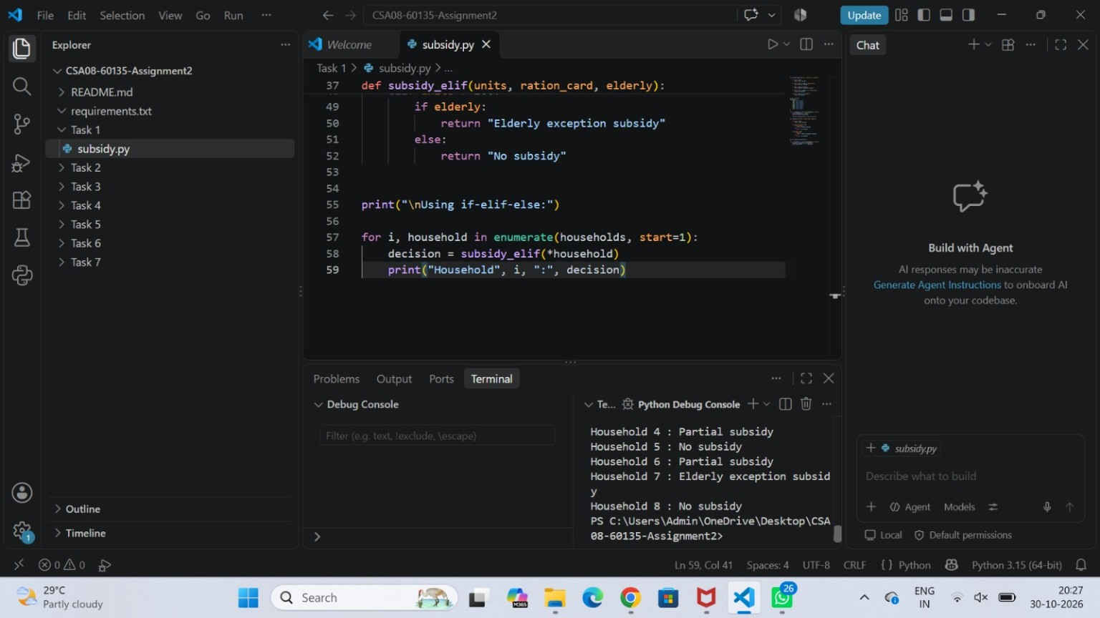
Figure 1. Screenshot for Task 1

Task 2: OTP Verification Kiosk
The OTP kiosk uses a while loop to accept an OTP, check the entered value, and grant access when the correct OTP is entered.
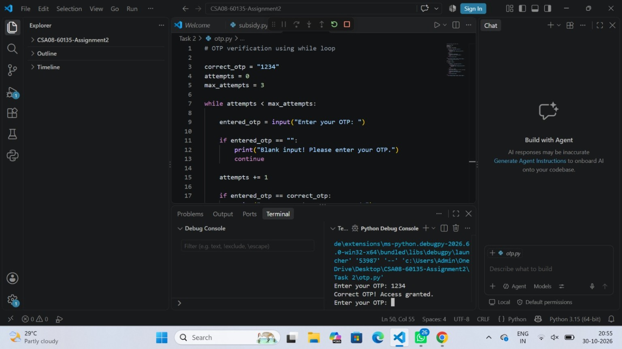
Figure 2. Screenshot for Task 2

Task 3: Vehicle Registration Validator
The validator checks the registration format using string methods such as isalpha() and isdigit(), and reports valid or invalid entries.
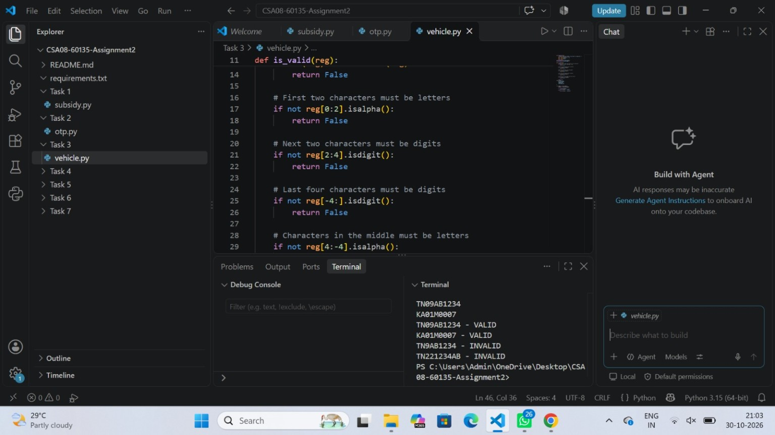
Figure 3. Screenshot for Task 3

Task 4: Building Long Text using + and join()
The program compares repeated string concatenation, join(), and f-string construction, and measures execution time using time.perf_counter().
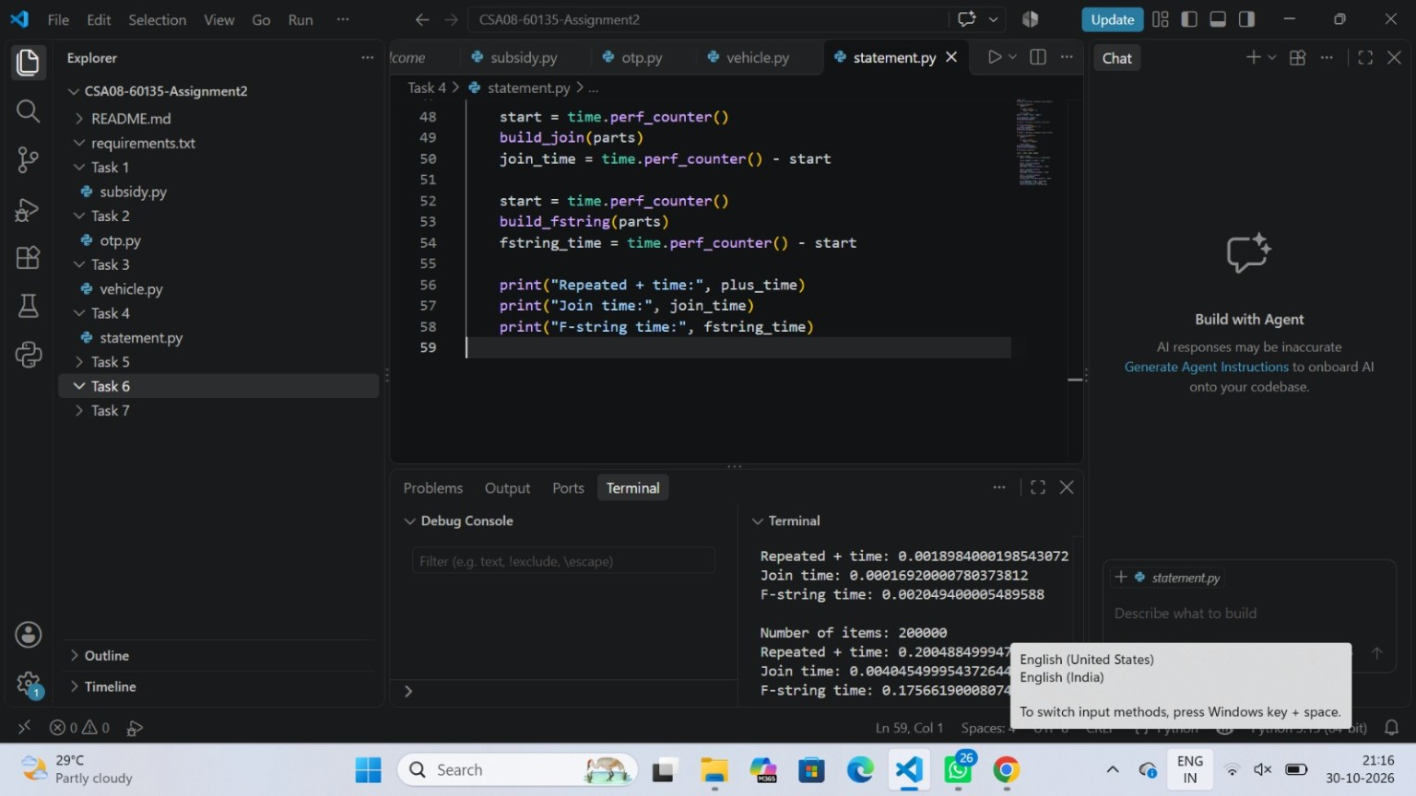
Figure 4. Screenshot for Task 4

Task 5: Mutable Default Argument Bug and Scope
The task demonstrates list/default-argument behavior and calculates a bill with GST. The displayed output includes a GST amount of 50.0 and a total of 1050.0 for an amount of 1000.
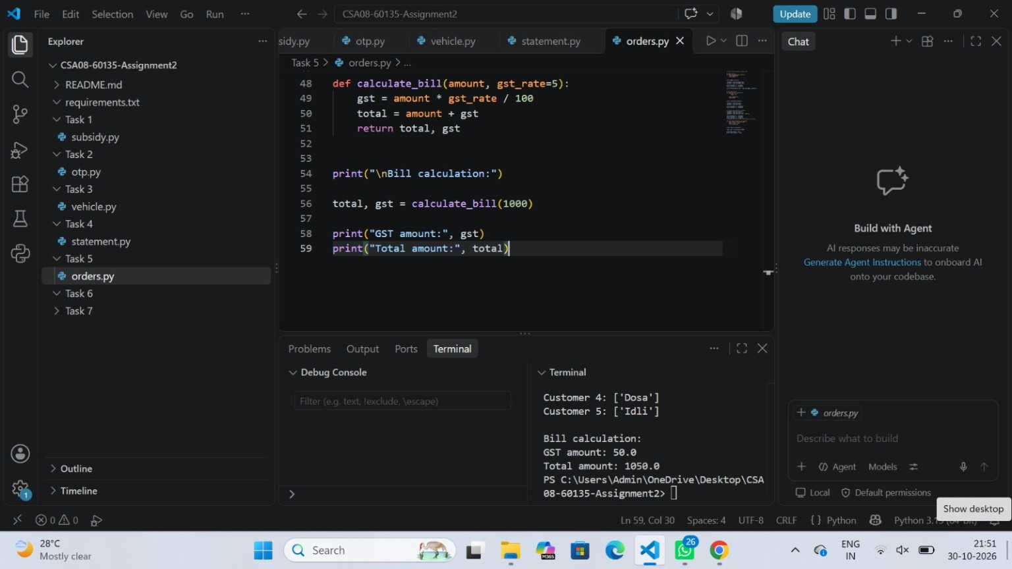
Figure 5. Screenshot for Task 5

Task 6: Recursion and Climbing Stairs
The climbing-stairs solution compares approaches and includes an iterative method. The screenshot shows the large-input result for 1000 steps.
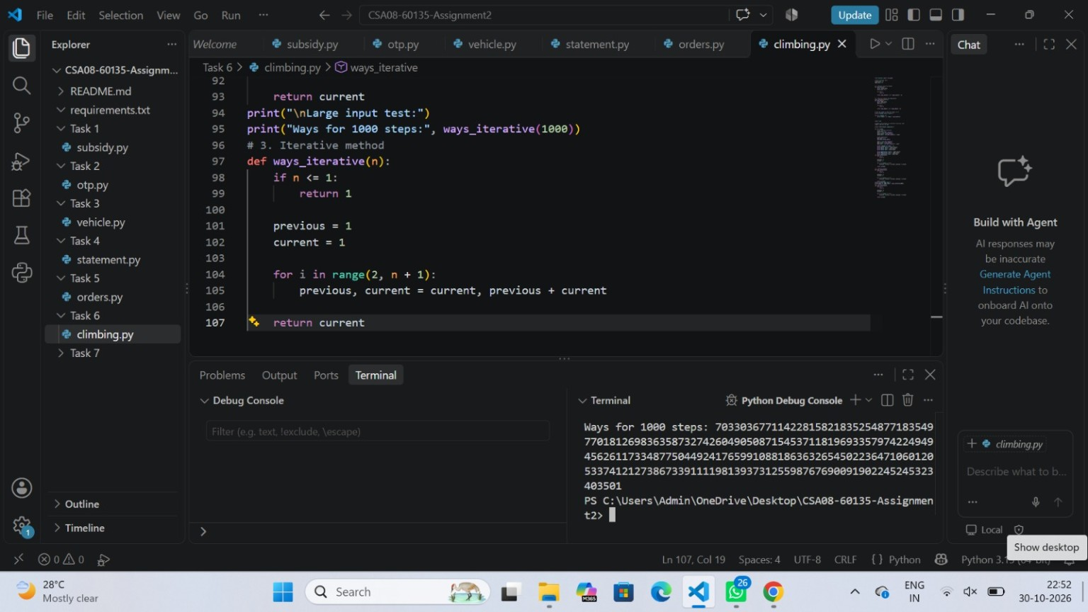
Figure 6. Screenshot for Task 6

Task 7: Diagnose, Redesign and Validate
The redesigned program compares the original and redesigned approaches and reports the loop iteration count for a large input.
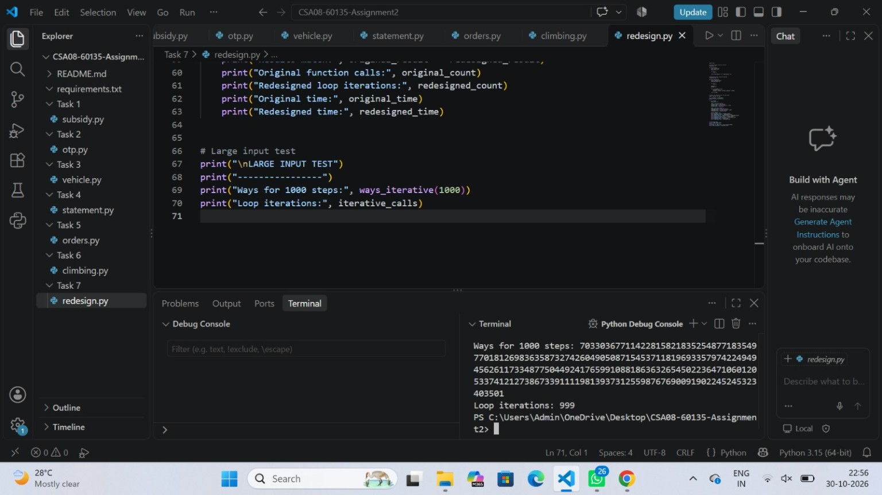
Figure 7. Screenshot for Task 7

5. Conclusion
The assignment brings together key Python programming concepts through seven practical tasks. The supplied screenshots provide visual evidence of the code and execution results in Visual Studio Code. The tasks demonstrate the use of conditional logic, loops, string operations, functions, recursion, iteration, and program redesign.

6. Source Code Repository
GitHub repository: https://github.com/yuvashrimahesh18-create/CSA08-1921260135-Assignment2.git

