**Future Sales Prediction Project Design and Innovation**

|  |  |
| --- | --- |
| **Date** | **10-10-2023** |
| **Team ID** | **3893** |
| **Project Name** | **Future Sales Prediction** |

**Table of Contents**

|  |  |
| --- | --- |
| 1 | Introduction |
| 2 | Problem Statement |
| 3 | Design and Innovation Strategies |
| 3.1 | Data Collection and Feature Engineering |
| 3.2 | Model Selection and Training |
| 3.3 | Market Sentiment Analysis |
| 3.4 | Continuous Learning |
| 4 | Conclusion |

**Future Sales Prediction**

**1. Introduction**

In the pursuit of more accurate sales forecasting, it's imperative to adopt advanced techniques. Traditional methods often fall short in capturing the nuances of sales data. By exploring approaches like Prophet and LSTM networks, we aim to provide businesses with better insights into future sales trends, enabling data-driven decision-making.

**2. Problem Statement**

The primary challenge at hand is the precise prediction of future sales. Conventional forecasting methods frequently struggle to encompass the intricate nuances present in sales data. To overcome this limitation, we are turning to advanced techniques, notably Prophet and LSTM (Long Short-Term Memory) networks. These sophisticated approaches are adept at handling the intricacies and dependencies inherent in time series data. By embracing these advanced methodologies, we aspire to enhance the accuracy of our sales forecasts, enabling us to make more informed decisions in a dynamically evolving business landscape.

**3. Design and Innovation Strategies**

**3.1 - Data Collection and Feature Engineering**

* Collect historical sales data:

Begin by gathering high-quality historical sales data, providing the foundation for forecasting.

* Pre-processing and Feature Extraction:

Pre-process the data by addressing missing values and outliers. Extract relevant features like time, seasonality, and promotional factors.

* Effective Feature Engineering:

Apply feature engineering techniques to create variables that capture important patterns and dependencies in the data, enhancing the accuracy of advanced forecasting models.

**3.2 - Model Selection and Training**

* Importance of Model Choice:

Choosing the right forecasting model is critical for accuracy and decision-making.

* Advanced Model Options:

We're considering two advanced models: Prophet for time series forecasting and LSTM networks for capturing long-term data dependencies.

* Model Training Process:

Involves feeding historical sales data to these models and fine-tuning their parameters to optimize accuracy.

* Parameter Fine-Tuning:

Careful parameter adjustments ensure models align with sales data characteristics for more accurate predictions..

**3.3 - Market Sentiment Analysis**

* Enhancing Sales Forecasting:

Market sentiment analysis elevates sales forecasting by providing insights beyond historical data.

* Data Sources for Analysis:

We gather sentiment data from social media, news, and external sources to gauge public perception and market sentiment.

* Proactive Response to Market Conditions:

This analysis enables businesses to respond proactively to changing market sentiment, optimizing marketing, inventory, and product strategies for improved adaptability in dynamic markets.

**3.4 - Continuous Learning**

* Dynamic Field of Sales Forecasting:

Acknowledging the dynamic nature of sales forecasting due to market changes and consumer behaviors.

* Ongoing Model Refinement:

Committed to continuously improving our forecasting models by regularly updating them with fresh data.

* Strategies Evaluation:

Constantly assess and adapt our strategies to ensure that our forecasts remain accurate and responsive to changing market conditions.

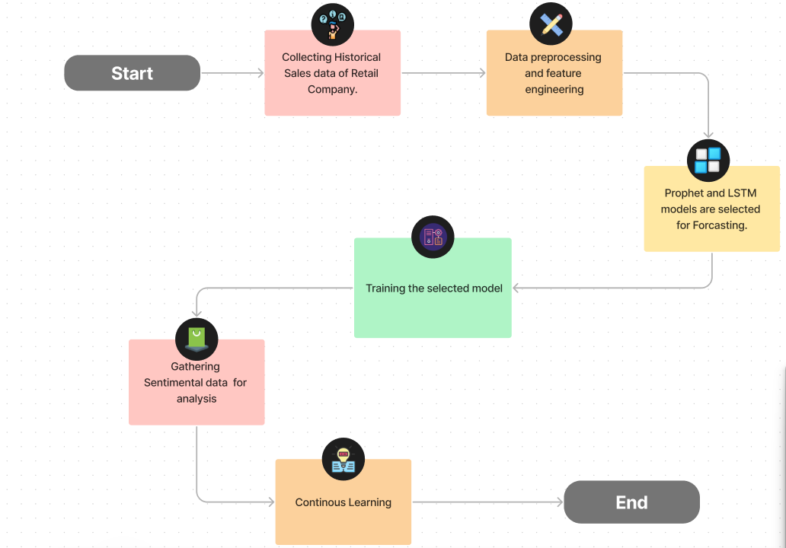

**4. Conclusion**

In conclusion, the exploration of advanced time series forecasting techniques, such as Prophet and LSTM networks, holds the promise of significantly enhancing the accuracy and reliability of future sales predictions. These innovative approaches have the potential to capture intricate patterns and dependencies in sales data, providing businesses with more precise insights. As we strive for enhanced accuracy in forecasting sales, the incorporation of such advanced techniques becomes a pivotal step in our pursuit of excellence and innovation.