**CODING CHALLENGE**

create database coding_challenge;

use coding_challenge;

CREATE TABLE Crime (

CrimeID INT PRIMARY KEY,

IncidentType VARCHAR(255),

IncidentDate DATE,

Location VARCHAR(255),

Description TEXT,

Status VARCHAR(20)

);

CREATE TABLE Victim (

VictimID INT PRIMARY KEY,

CrimeID INT,

Name VARCHAR(255),

ContactInfo VARCHAR(255),

Injuries VARCHAR(255),

FOREIGN KEY (CrimeID) REFERENCES Crime(CrimeID)

);

INSERT INTO Crime (CrimeID, IncidentType, IncidentDate, Location, Description, Status)

VALUES

(1, 'Robbery', '2023-09-15', '123 Main St, Cityville', 'Armed robbery at a convenience store', 'Open'),

(2, 'Homicide', '2023-09-20', '456 Elm St, Townsville', 'Investigation into a murder case', 'Under

Investigation'),

(3, 'Theft', '2023-09-10', '789 Oak St, Villagetown', 'Shoplifting incident at a mall', 'Closed');

INSERT INTO Victim (VictimID, CrimeID, Name, ContactInfo, Injuries)

VALUES

(1, 1, 'John Doe', 'johndoe@example.com', 'Minor injuries'),

(2, 2, 'Jane Smith', 'janesmith@example.com', 'Deceased'),

(3, 3, 'Alice Johnson', 'alicejohnson@example.com', 'None');

INSERT INTO Suspect (SuspectID, CrimeID, Name, Description, CriminalHistory)

VALUES

(1, 1, 'Robber 1', 'Armed and masked robber', 'Previous robbery convictions'),

(2, 2, 'Unknown', 'Investigation ongoing', NULL),

(3, 3, 'Suspect 1', 'Shoplifting suspect', 'Prior shoplifting arrests');

1. Select all open incidents.

select * from crime where status="open";

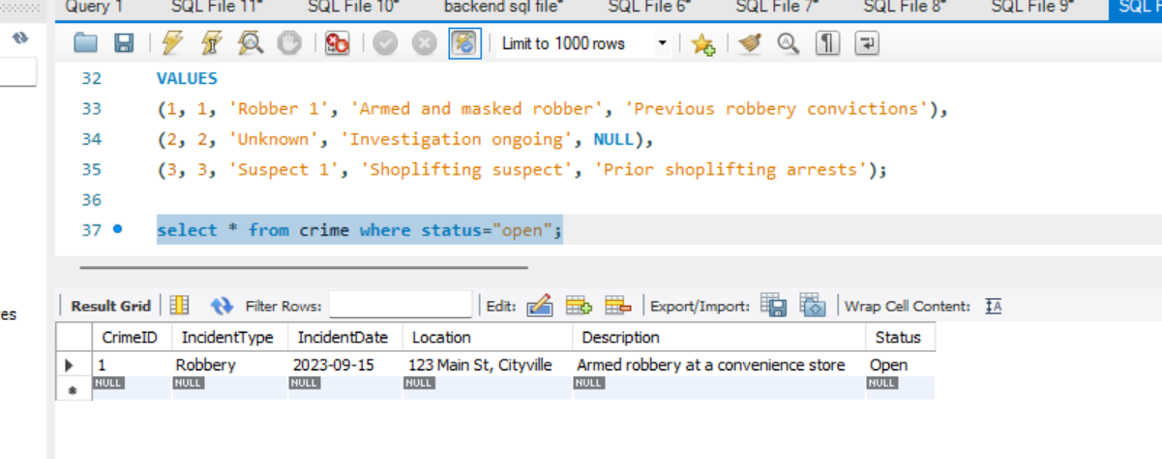

2. Find the total number of incidents.

select count(*) as totalIncidents from crime;

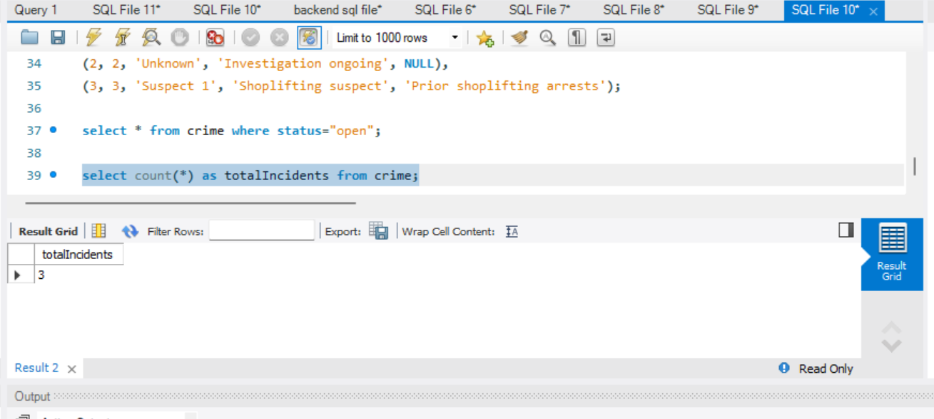

3. List all unique incident types.

select distinct IncidentType from crime;

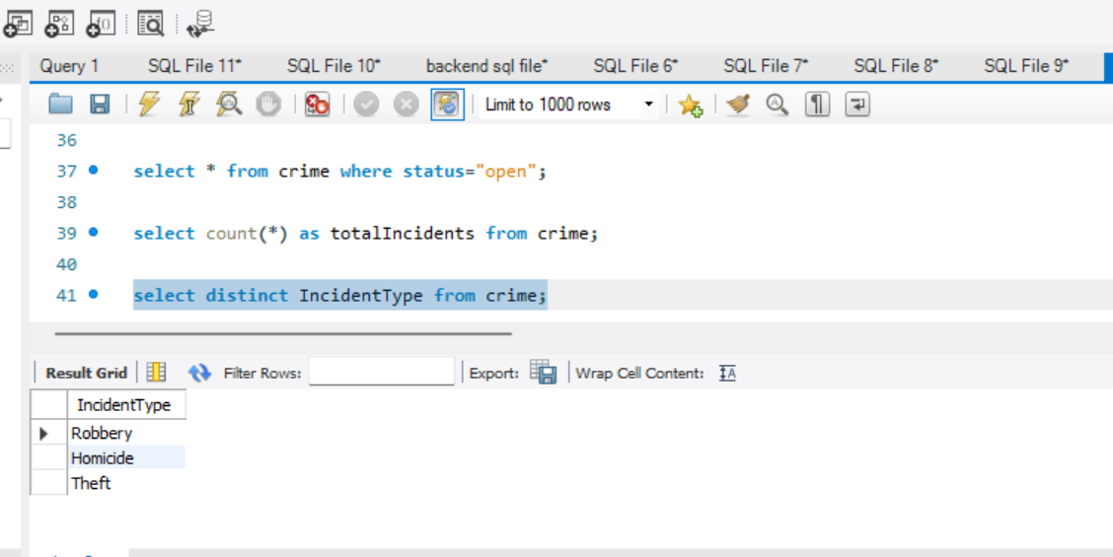

4. Retrieve incidents that occurred between '2023-09-01' and '2023-09-10'.

select * from crime where IncidentDate between "2023-09-01" and "2023-09-10";

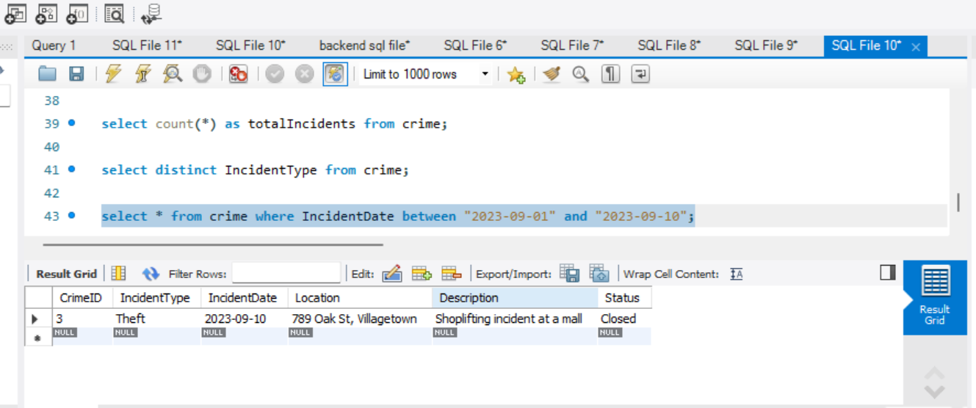

5. List persons involved in incidents in descending order of age.

select name,age from victim union all select name,age from suspect

order by age desc;

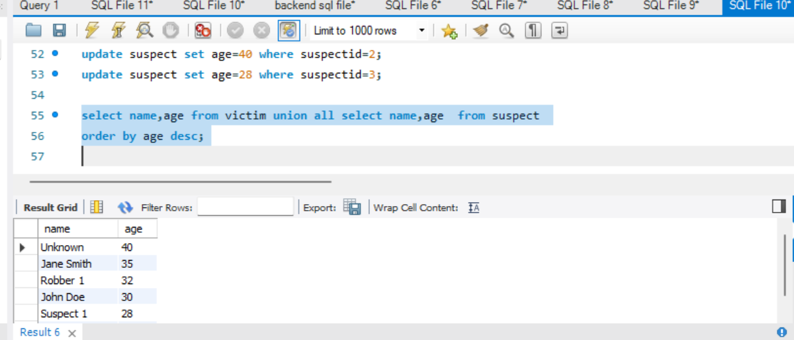

6. Find the average age of persons involved in incidents.

select avg(age) as avgAge from (select age from victim union all select age from suspect) as person;

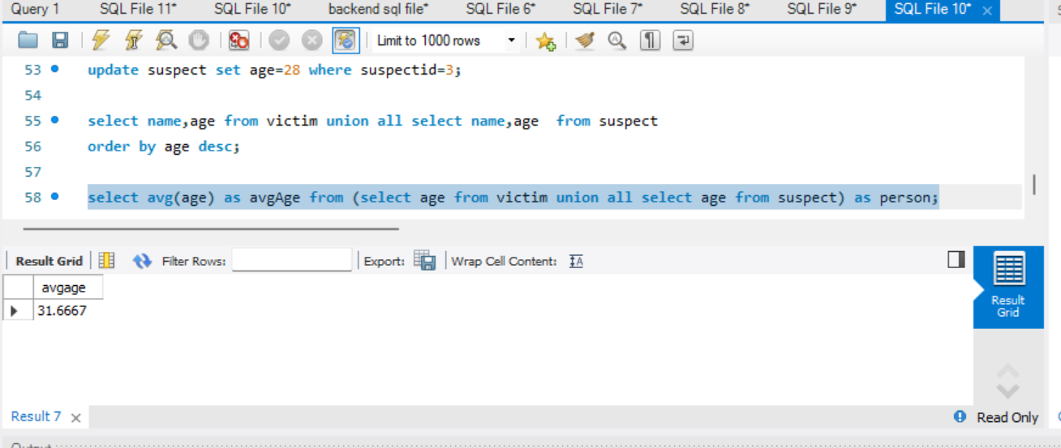

7. List incident types and their counts, only for open cases.

select incidentType ,count(*) as count from crime where status='open' group by incidentType;

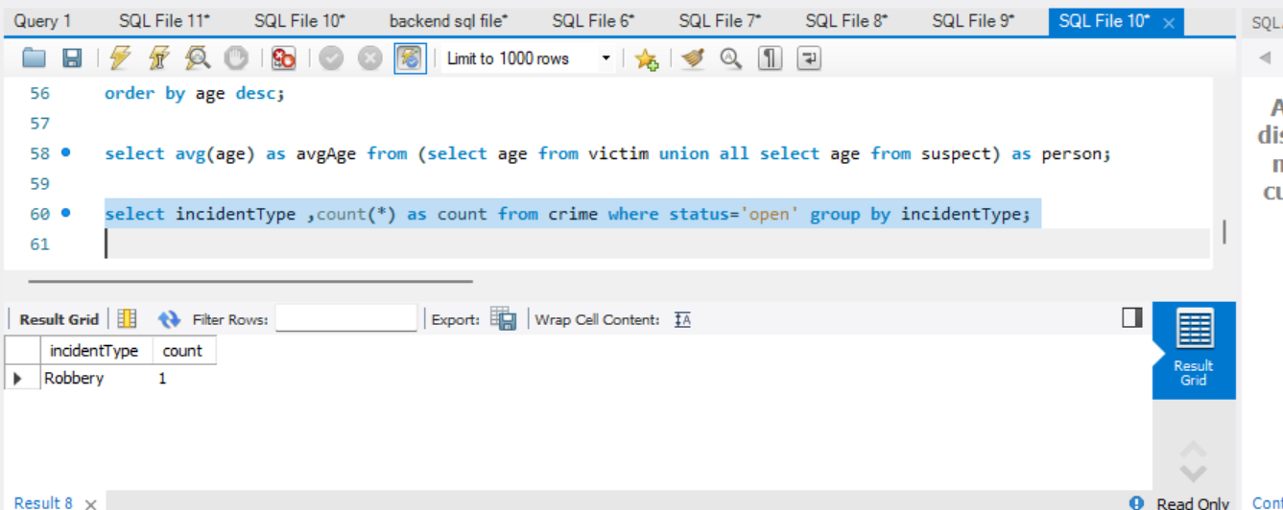

8. Find persons with names containing 'Doe'.

insert into victim(victimid,crimeid,name,contactinfo,injuries,age)

values(4,1,'rahul deo','rahuldeo@example.com','none',29);

select name from victim where name like '%deo%' union select name from suspect where name like'%deo';

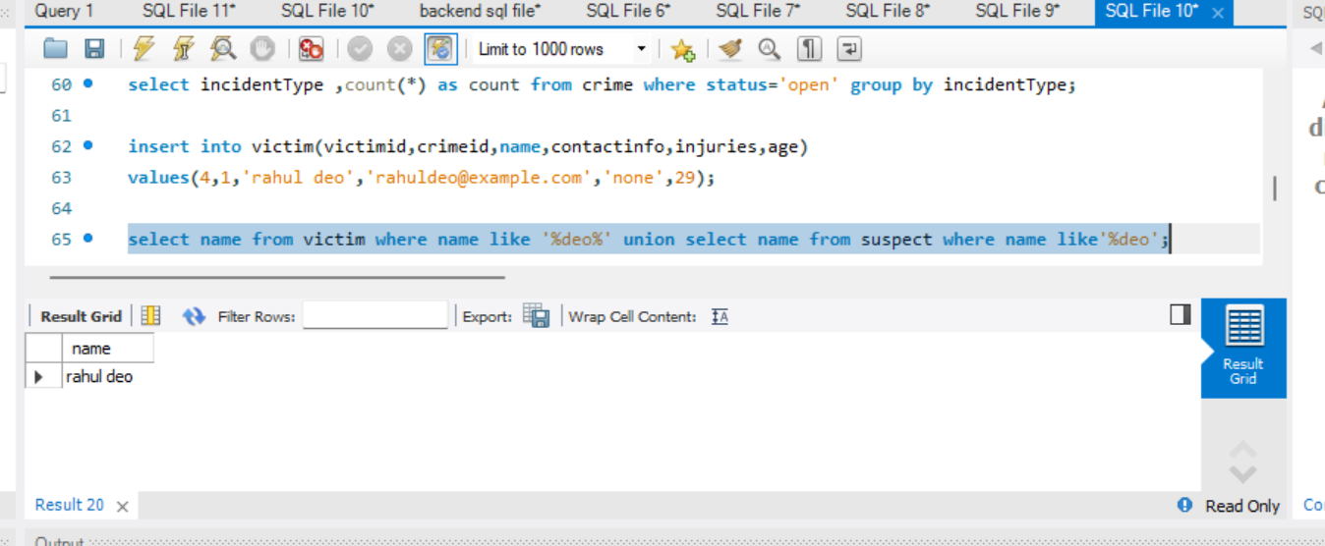

9. Retrieve the names of persons involved in open cases and closed cases.

select v.name from victim v join crime c on v.crimeid=c.crimeid where c.status in ('open','closed')

union select s.name from suspect s join crime c on s.crimeid=c.crimeid where c.status in ('open','closed');

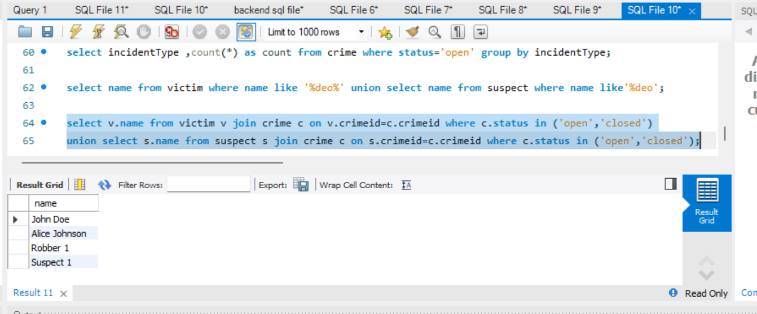

10. List incident types where there are persons aged 30 or 35 involved.

select distinct c.incidentType from crime c join victim v on c.crimeId=v.crimeid where v.age in (30,35)

union select distinct c.incidentType from crime c join suspect s on c.crimeid=s.crimeid where s.age in (30,35);

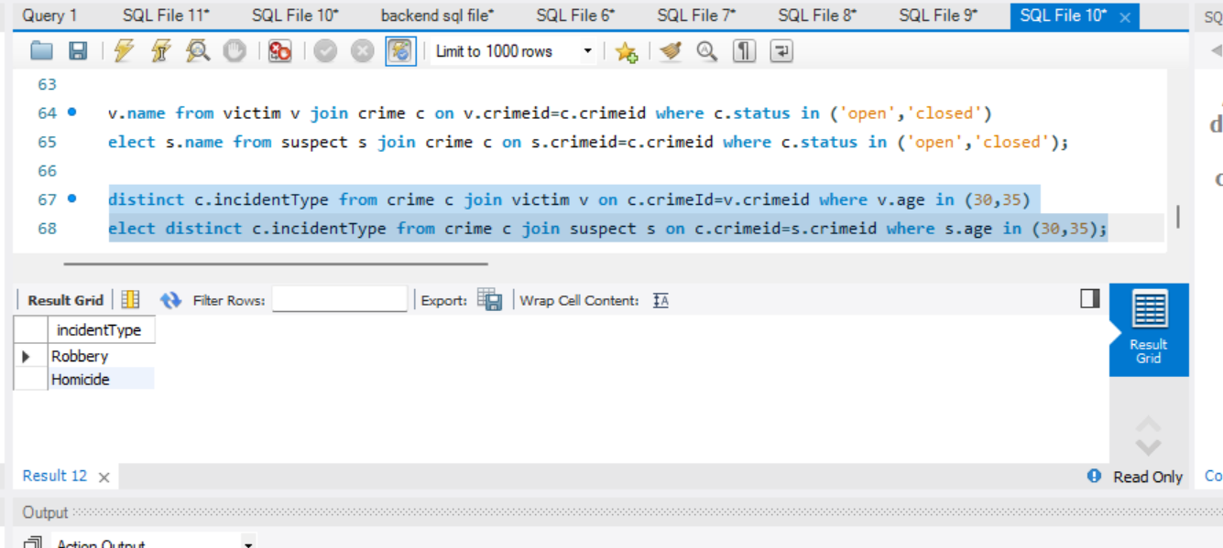

11. Find persons involved in incidents of the same type as 'Robbery'.

select v.name from victim v join crime c on(v.crimeid=c.crimeid) where c.incidenttype='robbery' union

select s.name from suspect s join crime c on(s.crimeid=c.crimeid) where c.incidenttype='robbery';

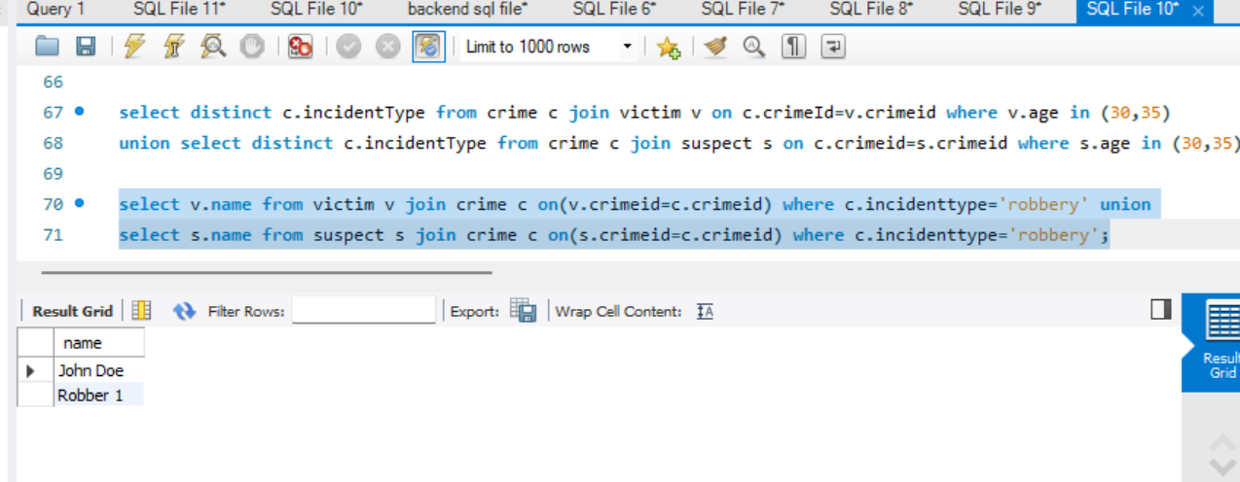

12. List incident types with more than one open case.

insert into crime(crimeid,incidenttype,incidentdate,location,description,status)values

(4,'robbery','2023-09-25','12 lakeview rd','robbery at a gas station','open'),

(5,'robbery','2023-10-01','34 riverbank','armed robbery at a home','open');

insert into victim(victimid,crimeid,name,contactinfo,injuries,age)

values(5,2,'rohit sharma','rohit@example.com','minor',30);

insert into suspect(suspectid,crimeid,name,description,criminalhistory,age)

values(4,2,'rohit sharma','repeat offender','assault history',34);

select incidenttype,count(*) as opencasecount from crime where status='open' group by incidenttype having count(*)>1;

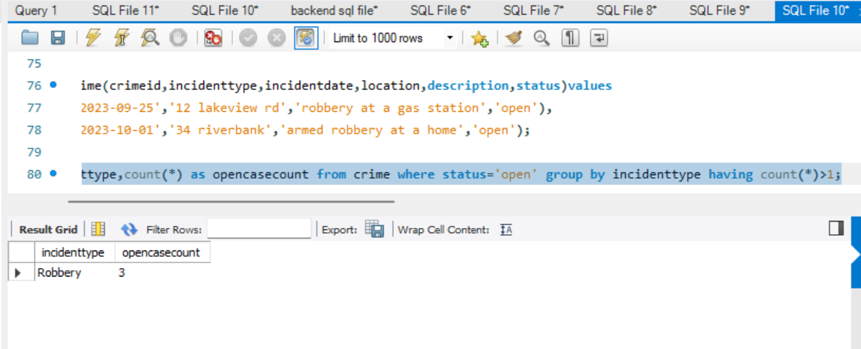

13. List all incidents with suspects whose names also appear as victims in other incidents.

select distinct c.* from crime c join suspect s on(c.crimeid=s.crimeid) where s.name in(select name from victim);

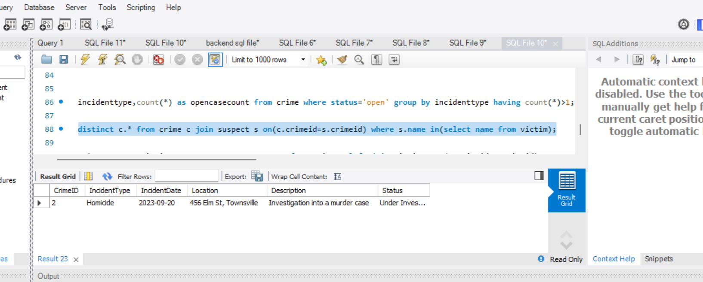

14. Retrieve all incidents along with victim and suspect details.

select c.*,v.name as victimname,s.name as suspectname from crime c left join victim v on(c.crimeid=v.crimeid)

left join suspect s on(c.crimeid=s.crimeid);

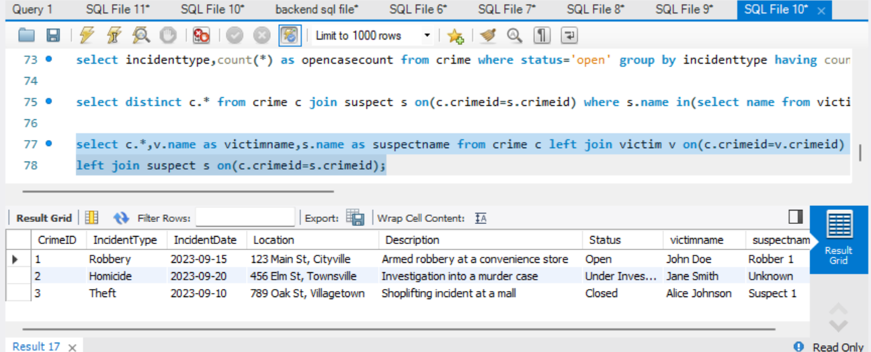

15. Find incidents where the suspect is older than any victim.

select distinct c.* from crime c join suspect s on(c.crimeid=s.crimeid) where s.age>all(select v.age from victim v where v.crimeid=c.crimeid);

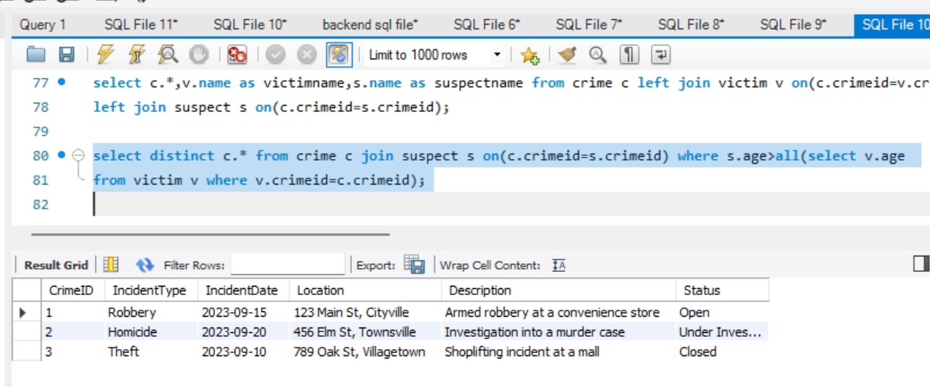

16. Find suspects involved in multiple incidents:

select name,count(*) as incidentcount from suspect group by name having count(*)>1;

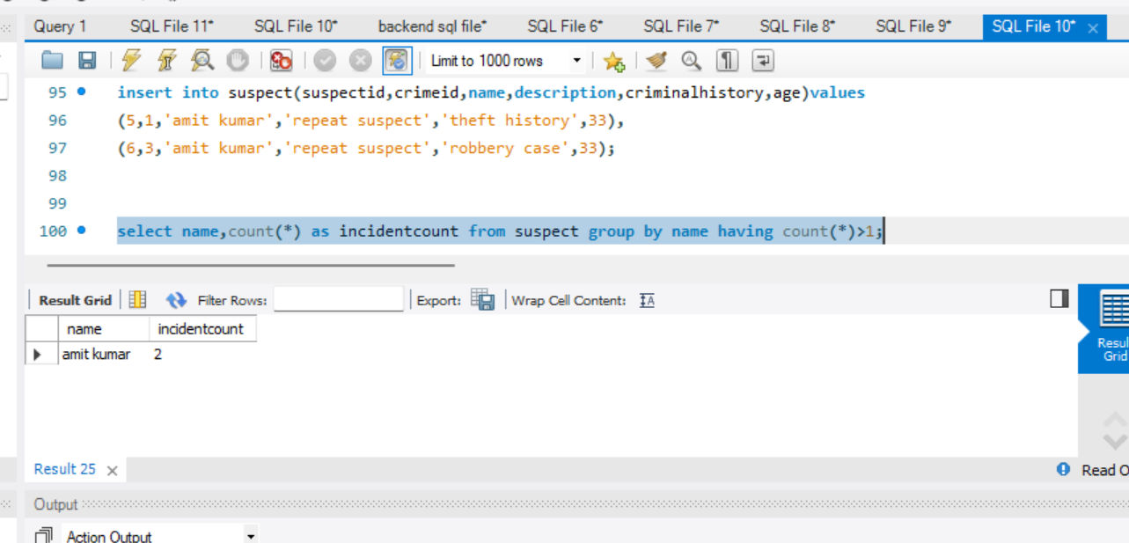

17. List incidents with no suspects involved.

select * from crime where crimeid not in(select distinct crimeid from suspect);

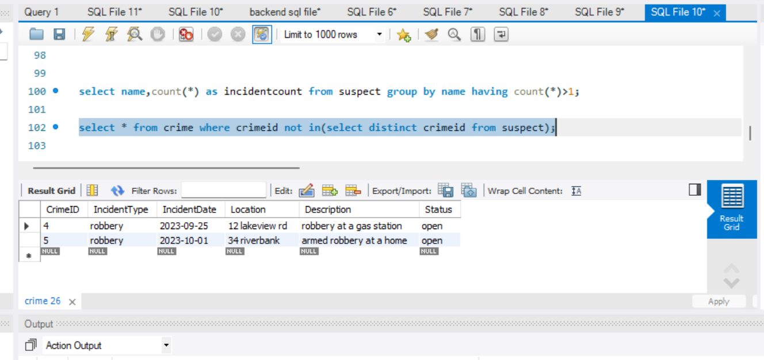

18. List all cases where at least one incident is of type 'Homicide' and all other incidents are of type

'Robbery'.

select * from crime

where exists(select 1 from crime where incidenttype='homicide')

and not exists(select 1 from crime where incidenttype not in('robbery','homicide'));

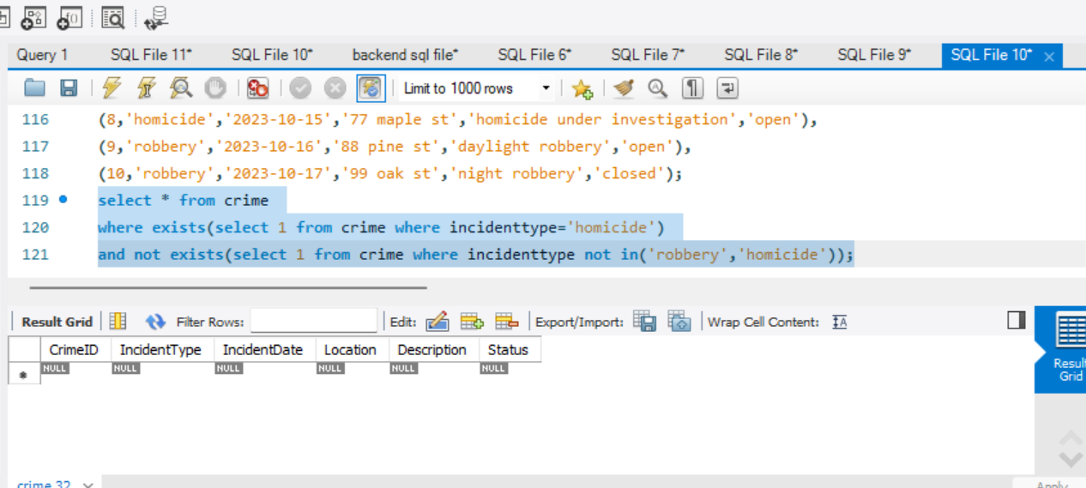

19. Retrieve a list of all incidents and the associated suspects, showing suspects for each incident, or

'No Suspect' if there are none.

select c.crimeid,c.incidenttype,ifnull(s.name,'no suspect') as suspectname from crime c left join suspect s on(c.crimeid=s.crimeid);

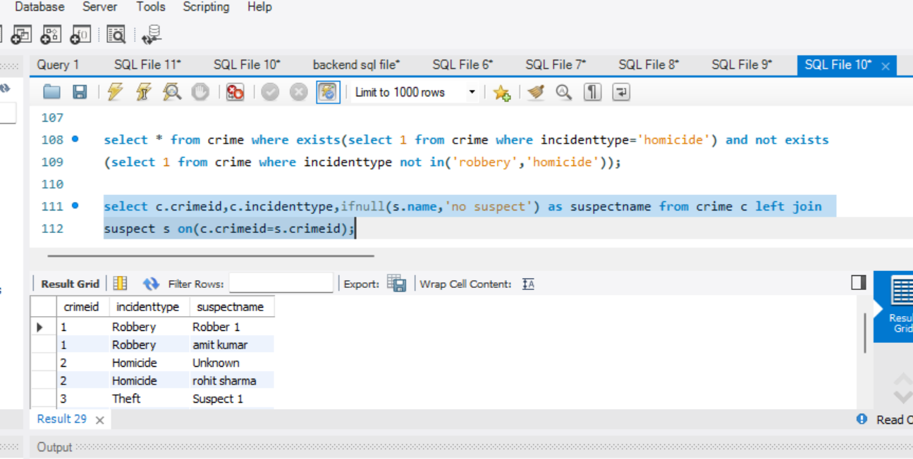

20. List all suspects who have been involved in incidents with incident types 'Robbery' or 'Assault'

select distinct s.name from suspect s join crime c on(s.crimeid=c.crimeid) where c.incidenttype in('robbery','assault');

