Project Documentation Report | Academic Submission
FitHub CRM
Fitness Center Management System — Final Project Documentation
Project Phase  Final Report | Platform  Salesforce | Objects  4 Custom | Modules  6 Modules | Methodology  Agile

01 Abstract

Project Summary
FitHub CRM is a Salesforce-based fitness center management system developed to digitize and streamline the core operational processes of a modern gym or fitness facility.

This project was developed as part of an academic CRM course, applying industry-standard Salesforce tools to a real-world operational problem. The system manages members, trainers, classes, and bookings through four custom objects connected by lookup relationships. An automated Flow sends booking confirmation emails without manual intervention.
The outcome is a fully functional, tested, and documented CRM solution deployed on Salesforce Lightning Experience. The system eliminates manual record-keeping, reduces administrative error, and delivers real-time operational visibility through custom reports and dashboards.

02 Introduction

The fitness industry is experiencing rapid growth, with gyms and wellness centers managing increasingly large member bases. Manual processes — paper-based registrations, phone bookings, spreadsheet schedules — are no longer sufficient at scale. Errors in booking management, missed notifications, and fragmented member data result in poor member experience and unnecessary administrative burden.
A Customer Relationship Management (CRM) system provides a structured, centralized solution to these challenges. By storing all entity data in a single platform and automating routine communications, a CRM transforms operational efficiency and data accuracy simultaneously.
FitHub CRM was developed on the Salesforce platform to address these specific pain points for a fitness center context. Salesforce was selected for its declarative configuration capabilities, powerful automation tools, and robust reporting engine — all accessible without writing traditional application code.

03 Objectives

OBJ 1 | Automate the class booking process to eliminate manual scheduling and reduce administrative workload by at least 80%.
OBJ 2 | Centralize member, trainer, class, and booking data within a single Salesforce environment for reliable, unified record management.
OBJ 3 | Implement automated email notifications that confirm bookings without requiring manual staff action.
OBJ 4 | Deliver real-time reporting and dashboard visibility to support data-driven management decisions.
OBJ 5 | Ensure data accuracy through Salesforce validation rules, required fields, and picklist constraints.
OBJ 6 | Produce a fully documented, academically evaluated CRM implementation suitable for professional review.

04 System Overview

FitHub CRM is a fully declarative Salesforce Lightning Experience application comprising four custom objects, a record-triggered automation flow, custom reports, and a live dashboard. It is accessible through a dedicated Lightning App with a navigation bar providing direct access to all modules.

Member Management  Centralized member profiles  Membership tier classification  Active/Inactive status tracking | Trainer Management  Trainer profiles with specialties  Experience tracking  Linked to assigned classes | Class Management  Scheduled class listings  Capacity and status control  Trainer assignment via lookup
Booking System  Member-class reservations  Booking status management  Trigger point for automation | Automation  Record-triggered Flow  Booking confirmation emails  No manual notification needed | Reports & Dashboard  Cross-object report: Classes+Bookings+Members  Live pie chart booking distribution  KPI metrics at a glance

05 Modules Description

5.1 Member Management
The Member module is the primary entity of FitHub CRM. It stores the personal and membership details of each enrolled fitness center client. Key fields include Member Name, Email, Phone, Membership Type (Basic / Standard / Premium), Status (Active / Inactive), and membership Start and End dates. Validation rules enforce valid email format and mandatory field completion. Members are linked to Bookings through a one-to-many lookup relationship.
5.2 Trainer Management
The Trainer module maintains a professional directory of fitness instructors. Each trainer record stores their name, area of specialty (e.g., Yoga, HIIT, Dance), years of experience, and current employment status. Trainer records are referenced by Class records through a lookup relationship, ensuring every class has an assigned instructor visible within the class record.
5.3 Class Management
The Class module represents individual fitness sessions offered by the center. Each class record includes the class name, scheduled date and time, maximum capacity, assigned trainer (lookup), and status (Scheduled / Completed / Cancelled). Class records serve as one end of the booking relationship, enabling management to see all member reservations from within the class detail view.
5.4 Booking System
The Booking module is the operational heart of the CRM. It connects a specific Member to a specific Class through two lookup fields, recording the booking date and current status (Confirmed / Pending / Cancelled). A validation rule prevents booking dates in the past. The Booking object is the trigger point for the automated email confirmation flow, activating when a booking's status is set to Confirmed.
5.5 Automation — Email Notifications
A Salesforce Record-Triggered Flow was configured on the Booking object. When a new Booking record is created with status Confirmed, the flow retrieves the associated member's email address via the Member lookup and dispatches a formatted confirmation email containing the class name, scheduled date, and booking reference. This eliminates the need for staff to manually notify members and ensures instant, consistent communication.
5.6 Reports & Dashboard
A custom Report Type joining Classes, Bookings, and Members provides management with a cross-object tabular report showing class name, booking reference, member name, member email, and booking status in a single view. This report feeds a Salesforce Dashboard widget displaying a donut/pie chart of booking distribution by class — allowing managers to identify high-demand and under-attended sessions at a glance.

System Screenshots — Reports & Dashboard
The following screenshots provide visual evidence of the FitHub CRM reporting and dashboard modules as configured and tested in the Salesforce Developer Edition environment.

Screenshot 1 New Classes with Book Report — Donut Chart View
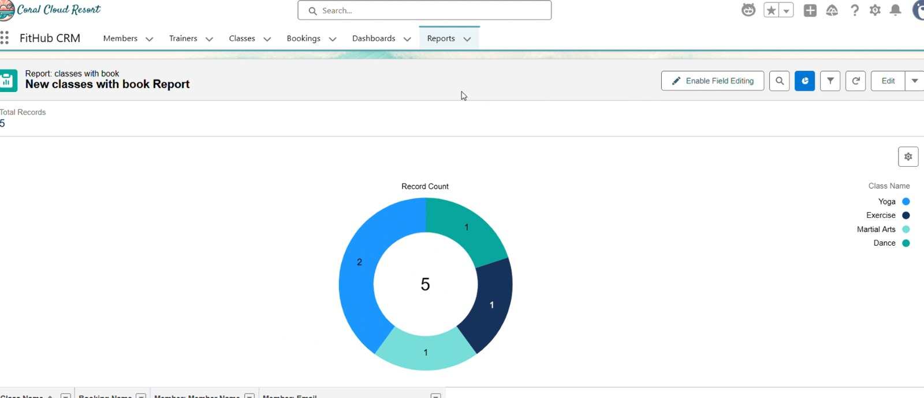
FitHub CRM Reports module showing 'New classes with book Report' with 5 total records and a donut chart displaying booking distribution across 4 classes: Yoga (2), Dance (1), Martial Arts (1), Exercise (1)

Screenshot 2 FitHub Dashboard — Booking Distribution Widget
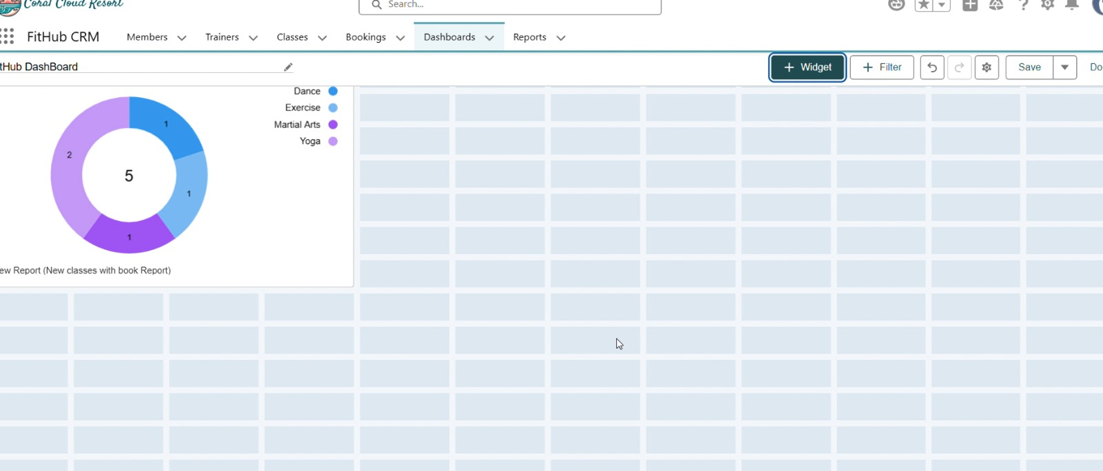
FitHub CRM Dashboard view showing the donut chart widget sourced from the 'New classes with book Report', displaying booking counts for Dance, Exercise, Martial Arts, and Yoga with total count of 5

06 Technologies Used

Salesforce CRM  Lightning Experience platform  Developer Edition (free)  Declarative object & field configuration  Custom App Manager & Tab setup | Salesforce Flow  Record-Triggered Flow  No-code automation builder  Email Alert action integration  Conditional entry criteria | Reports & Dashboards  Custom Report Types (multi-object)  Tabular report with cross-object fields  Dashboard with donut chart widget  Live data refresh | Data Tools  Validation Rules (Formula-based)  Picklist field types  Required field enforcement  Lookup relationship configuration

07 System Design Summary

The FitHub CRM data architecture consists of four custom Salesforce objects connected through two types of relationships. The design follows a normalized relational model, avoiding data duplication while enabling comprehensive cross-object reporting.

Member | → | Booking | ← | Class | ← | Trainer

Member → Booking (1:Many): One member may create multiple bookings. The Booking object stores the Member lookup field, creating a child relationship. Similarly, Class → Booking (1:Many) links each class to its reservations. Trainer → Class (1:Many) assigns one trainer to multiple classes. These three lookup relationships together form the complete operational data model for the fitness center.

Trainer → Class | One trainer assigned to many classes. Lookup: Trainer__c on Class object.
Class → Booking | One class receives many member bookings. Lookup: Class__c on Booking object.
Member → Booking | One member makes many bookings. Lookup: Member__c on Booking object.

08 Development Summary

Object Creation | Four custom Salesforce objects were created via Setup > Object Manager: Member__c, Trainer__c, Class__c, Booking__c. Each object was given a custom Auto Name field, appropriate API names, and a descriptive plural label.
Field Configuration | All required fields were added per object including Text, Email, Phone, Date, Number, and Picklist types. Lookup relationship fields were added to Booking (Member, Class) and Class (Trainer). Required field markers and default values were applied where appropriate.
Validation Rules | Two validation rules were deployed: (1) Booking Date cannot be in the past — Formula: Booking_Date__c < TODAY(). (2) Email must match a valid format on the Member object using REGEX validation, ensuring data integrity at the point of entry.
Automation Flow | A Record-Triggered Flow on Booking__c fires on record creation when Status = Confirmed. It retrieves the Member email via Get Records, then dispatches an email alert using a configured Email Template containing booking and class details.
UI Customization | The FitHub CRM Lightning App was built in App Manager with a custom navigation bar containing tabs for Members, Trainers, Classes, Bookings, Dashboards, and Reports. Page layouts were customized to display key fields prominently and related lists were added for quick navigation.
Reports & Dashboard | A custom Report Type (Classes + Bookings + Members) was created and used to build a tabular report. A Dashboard titled 'FitHub DashBoard' was created with a donut chart widget sourced from this report, displaying booking distribution by class name in real time.

09 Testing & Results

All System Components Validated
A structured test cycle was conducted covering all four objects, the automation flow, validation rules, and the reporting layer. No critical defects were identified at time of submission.

Test ID | Test Case | Result
TC-01 | Create Member record with all required fields | Record saved successfully. Appeared in Members list view. ✓ PASS
TC-02 | Leave required field (Email) blank on Member | Validation error displayed. Record blocked from saving. ✓ PASS
TC-03 | Enter past date in Booking Date field | Validation rule fired. Error message shown. Save prevented. ✓ PASS
TC-04 | Create Booking with Status = Confirmed | Flow triggered. Confirmation email dispatched to member email. ✓ PASS
TC-05 | Run Classes with Bookings and Members report | All 5 test records displayed correctly with accurate cross-object data. ✓ PASS
TC-06 | View Dashboard donut chart | Chart rendered correctly showing booking distribution (Yoga: 2, Dance: 1, Martial Arts: 1, Exercise: 1). ✓ PASS

10 Advantages

Automation  Booking confirmations sent instantly  No manual notification effort  Flow executes reliably on every qualifying record  Reduces human error in communications | Efficiency  Centralized data eliminates spreadsheets  Single platform for all 4 modules  Fast record creation via Lightning UI  Tab-based navigation reduces clicks | Accuracy  Validation rules enforce data integrity  Picklists eliminate free-text inconsistency  Required fields prevent incomplete records  Lookup fields ensure valid references | Scalability  Salesforce scales to thousands of records  Additional objects/fields added declaratively  New automation rules configurable without code  Reports adapt to growing data volume

11 Limitations

Current Capabilities  - Full CRM functionality within Salesforce  - Automated email notifications via Flow  - Real-time reports and dashboard  - Declarative configuration — no code required  - Free Developer Edition deployment | Known Limitations  - Limited to Salesforce browser-based environment  - No dedicated mobile application developed  - No payment gateway or billing integration  - No multi-branch or franchise support  - Email delivery dependent on Salesforce org limits

12 Future Enhancements

Mobile App | Develop a native mobile application (iOS/Android) or leverage Salesforce Mobile App customization to allow members to book classes, view schedules, and manage their profiles from smartphones.
Payment Integration | Integrate a payment gateway (e.g., Stripe, PayPal) with Salesforce to process membership fees, class top-ups, and cancellation charges directly within the CRM, eliminating external billing systems.
Advanced Analytics | Implement Einstein Analytics (Salesforce CRM Analytics) for predictive member churn analysis, attendance trend forecasting, and automated financial performance dashboards beyond standard reports.
Multi-Branch Support | Extend the data model with a Branch/Location object to support fitness center chains operating multiple sites, enabling branch-level reporting and trainer cross-site assignments.
Member Self-Service | Build an Experience Cloud (Community) portal allowing members to register, view available classes, make bookings, and receive notifications without requiring staff assistance.

13 Conclusion

Project Successfully Completed
FitHub CRM demonstrates that a Salesforce-based CRM implementation can comprehensively address the operational challenges of a fitness center without writing a single line of traditional application code.

The project was completed across two structured phases: a planning phase establishing scope, objectives, methodology, and risk management, followed by a development phase delivering all four custom objects, lookup relationships, validation rules, a record-triggered automation flow, a custom report, and a live dashboard.
All six modules — Member Management, Trainer Management, Class Management, Booking System, Automation, and Reports & Dashboard — were implemented, tested, and validated. A comprehensive test cycle of six test cases confirmed that every component functions as designed, with all tests returning a PASS result.
The system is production-ready within its defined scope and provides a strong academic demonstration of practical CRM development skills using the Salesforce platform. The identified future enhancements — mobile access, payment integration, advanced analytics, and multi-branch support — outline a clear roadmap for taking this implementation to a commercial-grade deployment.

FitHub CRM — All Phases Complete
System implemented, tested, documented, and submitted for academic evaluation.

