Project Design Phase-II
Data Flow Diagram & User Stories
Date | 01 October 2026
Team ID | SWTID-2026-8437
Project Name | Auto Ticket Classification using Flow Designer
Maximum Marks | 4 Marks

Data Flow Diagrams:
The DFD represents how incident information enters the system, is processed by Flow Designer, and results in classification and routing. It follows the supplied template's purpose of showing how data enters, changes, and leaves the system.
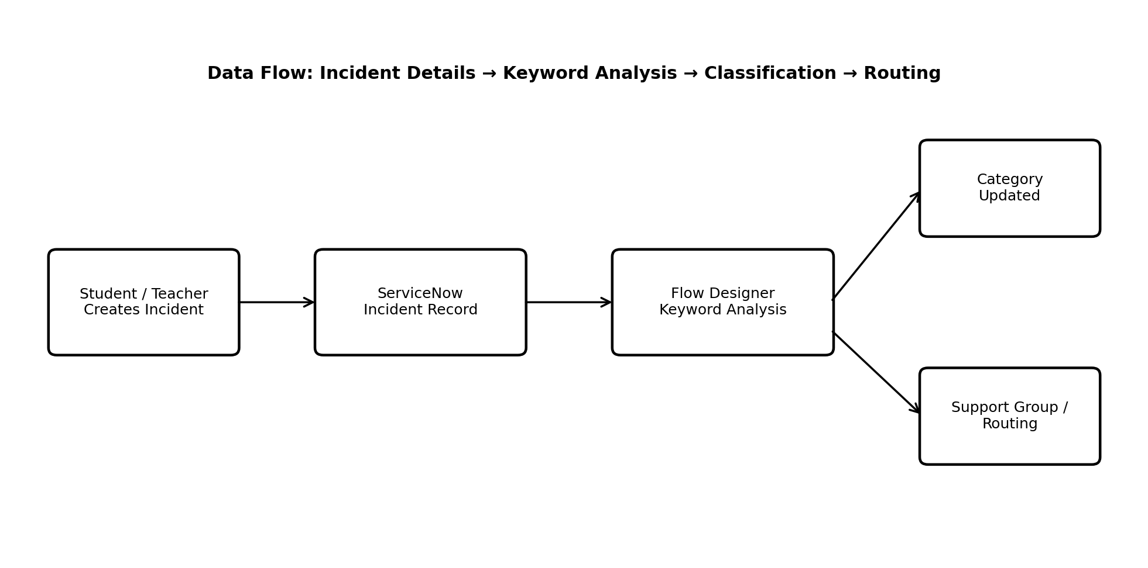
DFD Level-0 / Simplified Flow: Student or Teacher → Incident Record → Flow Designer Keyword Analysis → Category Update / Routing.

User Stories
The following user stories are written using the supplied template structure.
User Type | Functional Requirement (Epic) | User Story Number | User Story / Task | Acceptance criteria | Priority | Release
IT Helpdesk Agent | Incident Classification | USN-1 | As an IT helpdesk agent, I can receive a newly created incident with its Short Description and Description available for processing. | A new incident is available in ServiceNow with the required text fields. | High | Sprint-1
IT Helpdesk Agent | Automatic Classification | USN-2 | As an IT helpdesk agent, I can have an incident automatically classified based on predefined keywords. | A matching keyword condition assigns the intended category. | High | Sprint-1
IT Helpdesk Agent | Automatic Classification | USN-3 | As an IT helpdesk agent, I can have keywords from both Short Description and Description considered during classification. | The flow evaluates the configured incident text fields before assigning the category. | High | Sprint-1
IT Helpdesk Agent | Ticket Routing | USN-4 | As an IT helpdesk agent, I can use the automatically assigned category to support appropriate ticket routing. | The incident contains the updated category and can be handled by the relevant support area. | High | Sprint-1
ServiceNow Administrator | Rule Maintenance | USN-5 | As a ServiceNow administrator, I can add or modify classification keywords and conditions in Flow Designer. | The updated rule is saved and applies to subsequent matching incidents. | High | Sprint-1
ServiceNow Administrator | Rule Maintenance | USN-6 | As a ServiceNow administrator, I can maintain the classification logic without modifying application source code. | Classification conditions can be changed through Flow Designer configuration. | Medium | Sprint-2
Student / Teacher | Incident Submission | USN-7 | As a student or teacher, I can submit an incident describing my technical problem. | The incident is created with a Short Description and/or Description for processing. | High | Sprint-1

