Project Design Phase-II
Technology Stack (Architecture & Stack)
Date | 01 October 2026
Team ID | SWTID-2026-8437
Project Name | Auto Ticket Classification using Flow Designer
Maximum Marks | 4 Marks

Technical Architecture:
The architecture is centered on the ServiceNow platform. Users create incidents, the Incident table stores the incident information, and Flow Designer processes the incident text to apply classification rules and support routing.
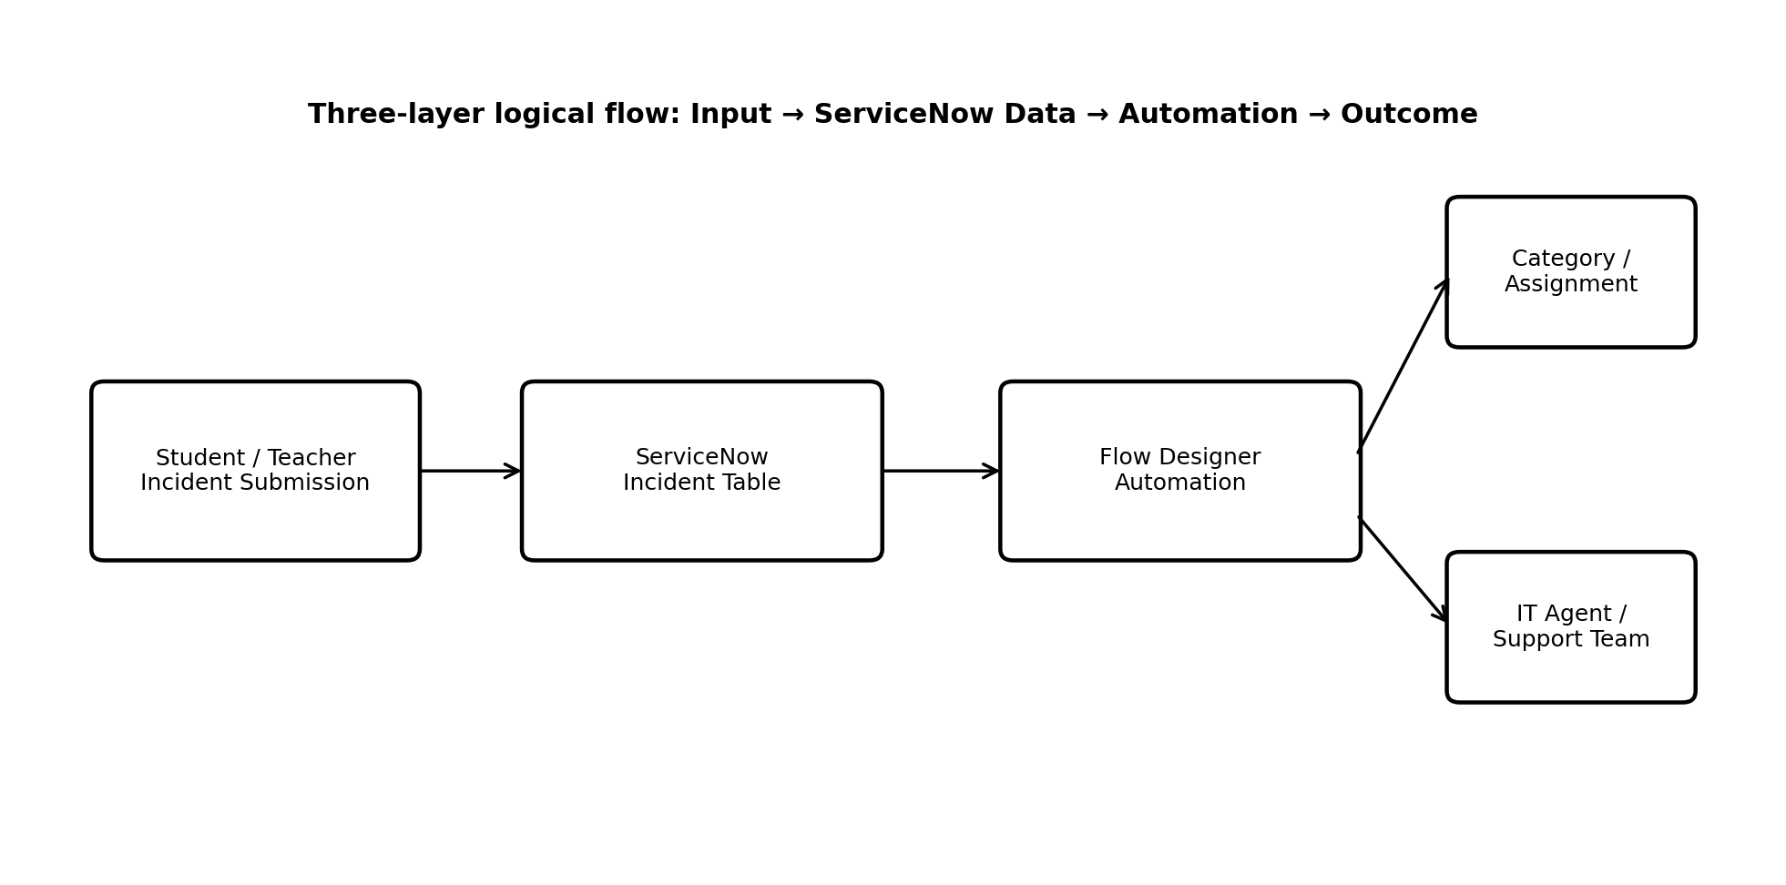
Table-1 : Components & Technologies:
S.No | Component | Description | Technology
1 | User Interface | ServiceNow incident form used by students/teachers or IT users to submit incident details. | ServiceNow Web UI
2 | Application Logic-1 | Flow trigger that starts processing when a new incident is created. | ServiceNow Flow Designer
3 | Application Logic-2 | Conditional logic that analyzes predefined keywords in Short Description and Description. | Flow Designer Conditions / If-Then Logic
4 | Application Logic-3 | Action that updates the incident category and supports routing. | Flow Designer Actions
5 | Database | Stores incident records including Short Description, Description, category, assignment, and other incident fields. | ServiceNow Incident Table
6 | Cloud Database | Platform-managed data storage for ServiceNow application data. | ServiceNow Platform Database
7 | File Storage | Not required for the core classification workflow. | Not Applicable
8 | External API-1 | No external API is required for the core keyword-based solution. | Not Applicable
9 | External API-2 | No external API is required for the core keyword-based solution. | Not Applicable
10 | Machine Learning Model | Not used in the current version; classification is rule/keyword based. | Not Applicable
11 | Infrastructure (Server / Cloud) | The solution runs within the ServiceNow cloud/platform environment. | ServiceNow Platform / Cloud

Table-2: Application Characteristics:
S.No | Characteristics | Description | Technology
1 | Open-Source Frameworks | No separate open-source application framework is required for the core solution. | Not Applicable
2 | Security Implementations | Use ServiceNow roles and configured access controls so only authorized users can manage incidents and Flow Designer configuration. | ServiceNow Roles / Access Controls
3 | Scalable Architecture | Keyword rules can be extended with additional conditions and categories as incident types grow. | Flow Designer
4 | Availability | The workflow operates as part of the ServiceNow platform when the instance and required platform services are available. | ServiceNow Platform
5 | Performance | Automated rule evaluation at incident creation reduces repeated manual classification and avoids a separate external processing application. | Flow Designer / ServiceNow

References: The supplied Technology Stack template identifies C4 Model, IBM Cloud Architecture, AWS Architecture, and technical architecture diagram guidance as reference material. For this project, the implementation is specifically scoped to ServiceNow Flow Designer and the ServiceNow platform.

