Project Design Phase
Solution Architecture
Date | 01 October 2026
Team ID | SWTID-2026-8437
Project Name | Auto Ticket Classification using Flow Designer
Maximum Marks | 4 Marks

Solution Architecture:
The solution architecture bridges the school IT helpdesk problem and the ServiceNow technology solution. It defines the structure, behaviour, data flow, and major components needed to automatically classify incidents.
- Find a practical technology solution for the manual incident-classification problem.
- Describe the structure and behaviour of the Flow Designer automation to project stakeholders.
- Define the major processing stages: incident creation, text evaluation, keyword matching, classification, and routing/handling.
- Provide a clear specification for implementing and maintaining the solution in ServiceNow.

Architecture and Data Flow Diagram:
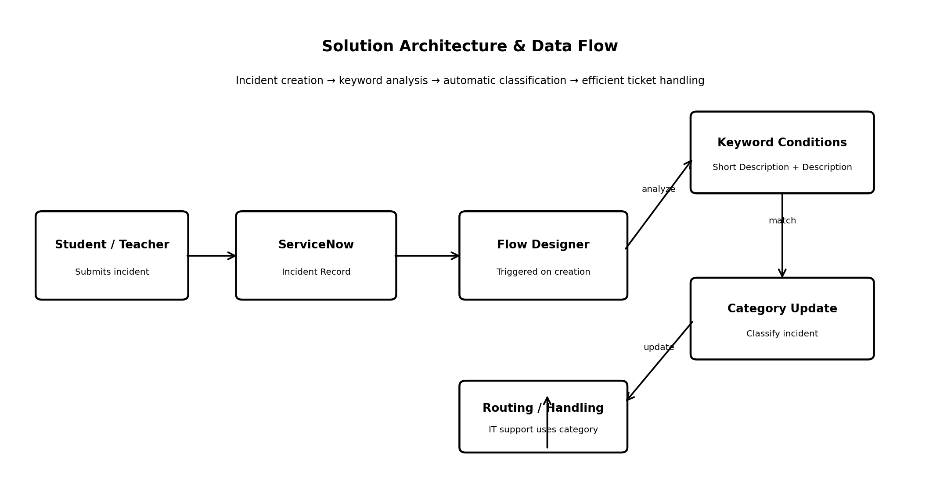
Figure 1: Architecture and data flow of the Auto Ticket Classification using Flow Designer solution

Architecture Components:
S.No. | Component | Role in Solution
1 | Incident Submission | Students or teachers submit an IT incident containing a Short Description and Description.
2 | ServiceNow Incident Record | The incident record stores the request information and provides the data consumed by the automation.
3 | Flow Designer Trigger | The flow starts when a new incident is created.
4 | Keyword Analysis | Flow Designer evaluates configured keywords in the Short Description and Description.
5 | Classification Logic | Conditional rules determine the appropriate incident category based on matching keywords.
6 | Category Update | The flow updates the incident with the selected category.
7 | Ticket Handling / Routing | IT staff use the classification to support efficient handling and routing of the incident.

End-to-End Flow: Student/Teacher submits incident → ServiceNow creates incident → Flow Designer triggers → Short Description and Description are analyzed → predefined keyword condition matches → incident category is updated → IT staff handle/route the classified incident.

