Project Planning Phase
Project Planning Template (Product Backlog, Sprint Planning, Stories, Story Points)
Date | 01 October 2026
Team ID | SWTID-2026-8437
Project Name | Auto Ticket Classification using Flow Designer
Maximum Marks | 5 Marks

Product Backlog, Sprint Schedule, and Estimation
The backlog below translates the project objectives into implementable user stories. Story points are proposed estimates for planning and can be adjusted by the team after implementation experience.
Sprint | Functional Requirement (Epic) | User Story Number | User Story / Task | Story Points | Priority | Team Members
Sprint-1 | Incident Intake & Trigger | USN-1 | As an IT helpdesk agent, I can have the flow trigger automatically when a new incident is created. | 2 | High | ________________
Sprint-1 | Incident Intake & Trigger | USN-2 | As an IT helpdesk agent, I can use the incident Short Description and Description as inputs to the classification flow. | 2 | High | ________________
Sprint-1 | Keyword Classification | USN-3 | As an IT helpdesk agent, I can classify Wi-Fi-related incidents using predefined keywords. | 2 | High | ________________
Sprint-1 | Keyword Classification | USN-4 | As an IT helpdesk agent, I can classify projector-related incidents using predefined keywords. | 2 | High | ________________
Sprint-2 | Keyword Classification | USN-5 | As an IT helpdesk agent, I can classify password-related incidents using predefined keywords. | 2 | High | ________________
Sprint-2 | Keyword Classification | USN-6 | As an IT helpdesk agent, I can classify slow-computer incidents using predefined keywords. | 2 | High | ________________
Sprint-2 | Category Update | USN-7 | As an IT helpdesk agent, I can have the incident category updated automatically after a keyword match. | 2 | High | ________________
Sprint-3 | Routing & Maintainability | USN-8 | As an IT helpdesk agent, I can use the assigned category to support efficient ticket routing and handling. | 2 | High | ________________
Sprint-3 | Routing & Maintainability | USN-9 | As a ServiceNow administrator, I can add or modify keyword conditions in Flow Designer without changing source code. | 2 | Medium | ________________
Sprint-3 | Testing & Validation | USN-10 | As a project team member, I can test representative incidents and verify that the expected category is assigned. | 2 | High | ________________

Project Tracker, Velocity & Burndown Chart
Proposed three-sprint schedule. Actual completed points and actual release dates should be updated by the team after each sprint.
Sprint | Total Story Points | Duration | Sprint Start Date | Sprint End Date (Planned) | Story Points Completed (as on Planned End Date) | Sprint Release Date (Actual)
Sprint-1 | 8 | 6 Days | 05 Oct 2026 | 10 Oct 2026 | 8 | 10 Oct 2026
Sprint-2 | 6 | 6 Days | 12 Oct 2026 | 17 Oct 2026 | 6 | 17 Oct 2026
Sprint-3 | 6 | 6 Days | 19 Oct 2026 | 24 Oct 2026 | 6 | 24 Oct 2026

Velocity:
Planned total = 20 story points across 18 working/project days (3 × 6-day sprints). Planned average velocity = 20 ÷ 3 = 6.67 story points per sprint. Planned average throughput = 20 ÷ 18 ≈ 1.11 story points per project day. These are planning estimates, not measured team performance.

Burndown Chart:
The chart below shows an ideal planned reduction from 20 story points to 0 across the proposed 18 project days. Replace the ideal line with actual remaining story points during execution.
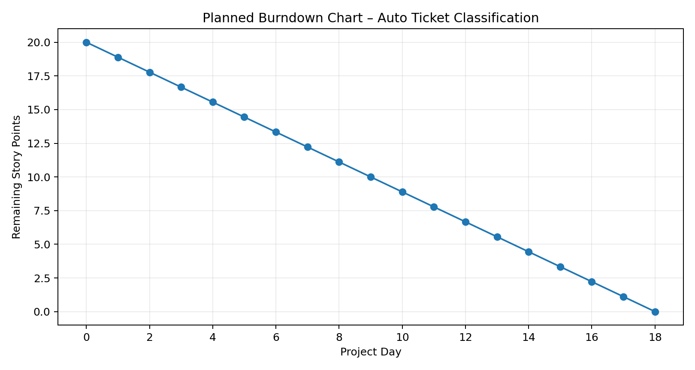

Planning Notes:
- Sprint-1 focuses on incident creation, Flow Designer trigger, input fields, and initial keyword rules.
- Sprint-2 expands keyword classification and automatic category update for the main school IT issue types.
- Sprint-3 focuses on routing/handling, rule maintainability, and end-to-end testing.
- Team member names and actual completed story points should be entered by the project team.
- The dates and story-point allocation are a proposed project plan because no team calendar or deadline was supplied.

