PROJECT DOCUMENTATION
FINAL PROJECT REPORT
ServiceNow Flow Designer Automation

Project Title | Auto Ticket Classification using Flow Designer
Team Members | Yuvedha G, Yukthayazhini S, Reshma K, Swetha R, Prabha R
Team ID | SWTID-2026-8437
Date | 01 October 2026

1. INTRODUCTION
1.1 Project Overview
The Auto Ticket Classification using Flow Designer project addresses a repetitive activity in a school IT helpdesk: manually reviewing incoming incident requests and assigning an appropriate category. The helpdesk receives requests from students and teachers for issues such as Wi-Fi connectivity, projector failures, password problems, and slow computers. The proposed solution uses ServiceNow Flow Designer to analyze keywords in an incident’s Short Description and Description and automatically classify the incident when it is created.
1.2 Purpose
The purpose of the project is to reduce repetitive manual classification work, improve the efficiency of ticket routing and handling, and provide a no-code solution that can be maintained through Flow Designer conditions. The automation is intended to make classification more consistent and immediate at incident creation.
Project Objectives
- Automatically classify incidents at the time of creation.
- Reduce manual effort for IT agents.
- Improve ticket routing efficiency.
- Implement a no-code, easily maintainable solution.
2. IDEATION PHASE
2.1 Problem Statement
The school IT helpdesk receives multiple incident requests daily from students and teachers. Requests may concern Wi-Fi issues, projector failures, password problems, slow computers, and similar technical issues. Currently, IT staff manually review each request and assign a category. This manual process is time-consuming and inefficient. The project therefore proposes an automated classification flow in ServiceNow that analyzes keywords in the Short Description and Description fields.
2.2 Empathy Map Canvas
Perspective | Project-specific understanding
Says | Users describe technical problems in natural incident text, for example Wi-Fi, projector, password, or slow-computer issues.
Thinks | The request should be understood and categorized quickly so that it can be handled by the appropriate support process.
Does | Student/teacher submits an incident; IT staff review the text and manually choose a category.
Feels / Pain Point | The current manual classification creates repetitive effort for IT staff and can slow down efficient ticket handling.
Needs / Gains | Immediate classification, reduced manual work, consistent rule-based categorization, and easier ticket routing.
2.3 Brainstorming
- Use Flow Designer as a no-code automation layer.
- Trigger the flow when an incident is created.
- Inspect Short Description and Description.
- Create keyword-based conditional branches for common school IT issue types.
- Update the incident category automatically after a match.
- Keep the rules editable so administrators can maintain them as issue types change.
- Use the resulting category to support downstream ticket handling and routing.
3. REQUIREMENT ANALYSIS
3.1 Customer Journey Map
Stage | User / IT Activity | Pain Point | Automation Opportunity
1. Report issue | Student/teacher creates an incident. | Issue description must be reviewed by IT staff. | Use incident text as flow input.
2. Receive incident | IT helpdesk receives the incident. | Manual classification is repetitive. | Trigger Flow Designer on creation.
3. Interpret request | IT staff read Short Description and Description. | Time is spent identifying the issue type. | Evaluate configured keywords.
4. Categorize | IT staff select a category. | Manual selection can be inefficient at scale. | Update category automatically.
5. Handle / route | IT staff continue support handling. | Routing depends on useful classification. | Use category as a support input.
3.2 Solution Requirement
ID | Requirement | Type
FR-01 | The system shall trigger the classification flow when a new incident is created. | Functional
FR-02 | The flow shall use the incident Short Description and Description as classification inputs. | Functional
FR-03 | The flow shall evaluate predefined keywords using Flow Designer conditions. | Functional
FR-04 | The flow shall classify configured issue types such as Wi-Fi, projector, password, and slow-computer incidents. | Functional
FR-05 | The flow shall update the incident category when a configured condition matches. | Functional
FR-06 | The resulting category shall support efficient ticket handling/routing. | Functional
NFR-01 | The solution should be maintainable through no-code Flow Designer configuration. | Non-functional
NFR-02 | The flow should behave consistently for repeated incidents with the same configured keyword conditions. | Non-functional
NFR-03 | The automation should complete classification without unnecessary manual intervention after incident creation. | Non-functional
NFR-04 | Only authorized ServiceNow users should be able to modify the flow configuration. | Non-functional
NFR-05 | The design should allow additional keywords and categories to be added as requirements evolve. | Non-functional
3.3 Data Flow Diagram
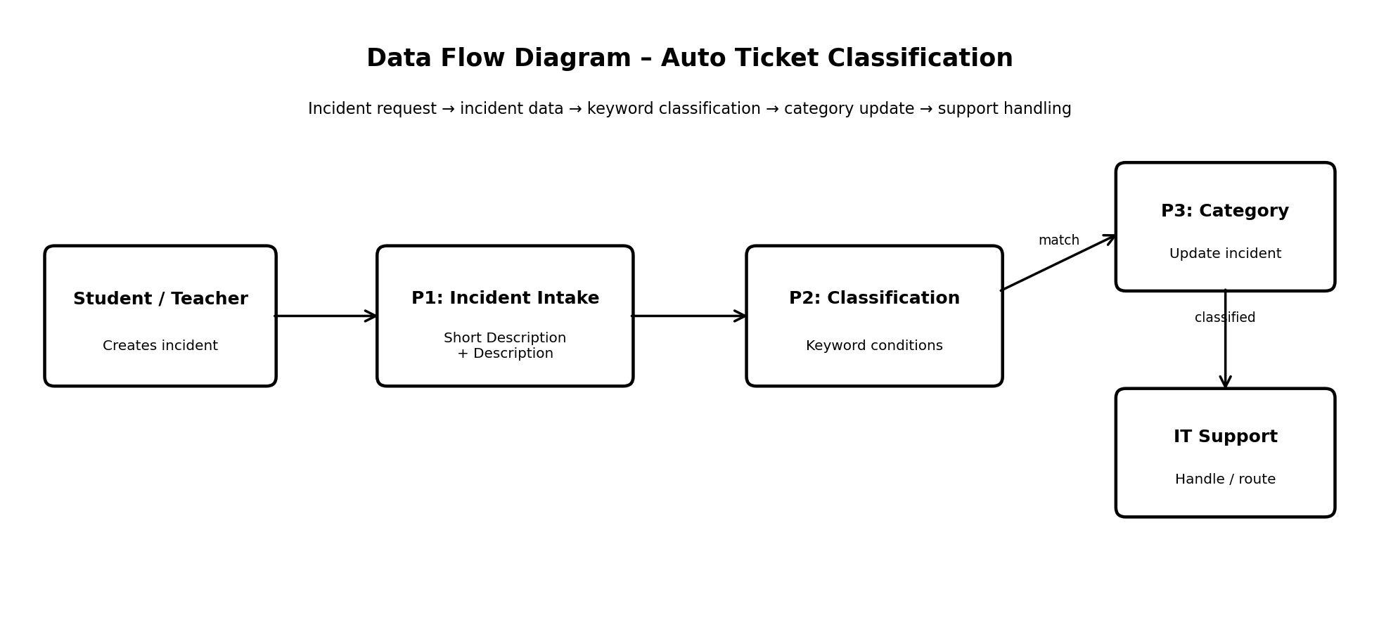
Figure 1: Data flow for incident intake, keyword classification, category update, and support handling.
3.4 Technology Stack
Layer / Component | Technology / Service | Purpose
ITSM Platform | ServiceNow | Hosts the incident records and workflow automation.
Automation | Flow Designer | Triggers and executes the no-code classification flow.
Input Data | Incident Short Description + Description | Text fields inspected by the classification rules.
Logic | Flow Designer Conditions / Branches | Matches predefined keywords and selects the configured outcome.
Record Update | Incident Category field | Stores the classification result.
Access Control | ServiceNow roles / permissions | Controls who can maintain or administer the flow.
4. PROJECT DESIGN
4.1 Problem Solution Fit
Canvas Area | Project Fit
Customer Segment(s) | School IT helpdesk agents; students and teachers who submit incidents.
Jobs-to-be-Done / Problems | Classify incoming incidents quickly, consistently, and with less repetitive manual work.
Customer Constraints | Multiple requests arrive daily; IT staff must currently review and categorize each one.
Available Solution | Current manual review and category assignment.
Problem Root Cause | Classification is performed manually and there is no automated keyword evaluation at incident creation.
Triggers | Creation of a new incident containing issue-related text.
Behaviour | IT staff read the incident, identify the issue type, choose a category, and proceed with handling.
Your Solution | A Flow Designer flow evaluates Short Description and Description, applies keyword conditions, and updates the category.
Channels | ServiceNow incident records are the online system channel; no separate offline channel is specified.
Emotions / Outcomes | Before: repetitive manual effort. After: faster, more consistent classification and improved routing efficiency.
4.2 Proposed Solution
- Create a Flow Designer flow with an incident-created trigger.
- Read Short Description and Description from the newly created incident.
- Use predefined keyword conditions for common issue types.
- Branch according to the matching condition.
- Update the incident category with the configured classification.
- Allow authorized administrators to maintain keyword conditions without source-code changes.
- Use the category as an input for efficient support handling and routing.
4.3 Solution Architecture
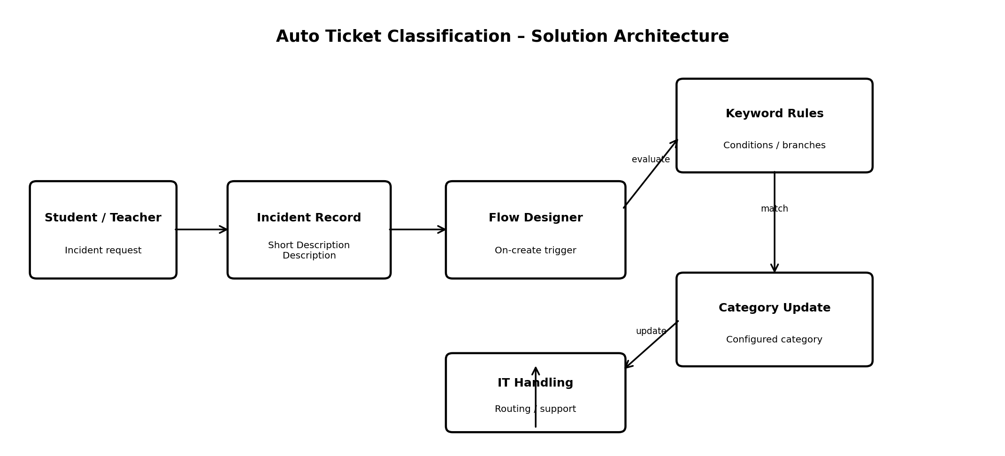
Figure 2: Solution architecture for Auto Ticket Classification using ServiceNow Flow Designer.
Component | Responsibility
Student / Teacher | Provides the incident request.
ServiceNow Incident Record | Stores Short Description and Description.
Flow Designer Trigger | Starts automation on incident creation.
Keyword Rules | Checks configured keywords using conditions/branches.
Category Update | Writes the configured category to the incident.
IT Handling / Routing | Uses the classification to support subsequent ticket processing.
5. PROJECT PLANNING & SCHEDULING
5.1 Project Planning
Sprint | Focus | Story Points | Planned Duration
Sprint 1 | Incident trigger, input fields, initial keyword rules | 8 | 6 project days
Sprint 2 | Main issue-type classification and category update | 6 | 6 project days
Sprint 3 | Routing support, rule maintenance, testing | 6 | 6 project days
Planned total = 20 story points. Planned average velocity = 20 / 3 = 6.67 story points per sprint. These are planning estimates and should be replaced with actual sprint measurements during execution.
Project Backlog
ID | Epic | User Story | Points | Priority
USN-1 | Incident Intake | As an IT agent, I want the flow to trigger automatically when an incident is created. | 2 | High
USN-2 | Incident Intake | As an IT agent, I want Short Description and Description to be used as inputs. | 2 | High
USN-3 | Classification | As an IT agent, I want Wi-Fi keywords to classify Wi-Fi incidents. | 2 | High
USN-4 | Classification | As an IT agent, I want projector keywords to classify projector incidents. | 2 | High
USN-5 | Classification | As an IT agent, I want password keywords to classify password incidents. | 2 | High
USN-6 | Classification | As an IT agent, I want slow-computer keywords to classify slow-computer incidents. | 2 | High
USN-7 | Category Update | As an IT agent, I want the matching category to be updated automatically. | 2 | High
USN-8 | Routing | As an IT agent, I want classification to support efficient ticket handling/routing. | 2 | High
USN-9 | Maintainability | As an administrator, I want to modify keyword conditions without source-code changes. | 2 | Medium
USN-10 | Testing | As a team member, I want to test representative incidents and verify classification. | 2 | High
6. FUNCTIONAL AND PERFORMANCE TESTING
6.1 Performance Testing
The project is a rule-based Flow Designer automation, not a machine-learning model. Therefore, ML metrics such as training accuracy, validation accuracy, confusion matrix, MAE, MSE, RMSE, and R² are not applicable to the current implementation. Testing focuses on functional correctness, successful flow execution, and observed processing time in the ServiceNow test instance.
Test ID | Scenario | Expected Result | Actual Result | Status
PT-01 | Create matching incident and measure time to category update. | Classification completes within an acceptable time for the test environment. | ________________ | Pass/Fail
PT-02 | Create representative incidents sequentially for each configured issue type. | Each incident is processed consistently. | ________________ | Pass/Fail
PT-03 | Create incident with keywords in Description rather than Short Description. | Configured Description rule can classify the incident. | ________________ | Pass/Fail
PT-04 | Create incident with no configured keyword. | No incorrect classification is assigned. | ________________ | Pass/Fail
7. RESULTS
7.1 Output Screenshots
Actual ServiceNow screenshots should be inserted here after implementation and execution. The following placeholders identify the recommended evidence.
Screenshot 1 – Incident form before submission
[INSERT ACTUAL SERVICENOW SCREENSHOT HERE]
Screenshot 2 – Flow Designer flow showing the incident-created trigger
[INSERT ACTUAL SERVICENOW SCREENSHOT HERE]
Screenshot 3 – Keyword condition / branch configuration
[INSERT ACTUAL SERVICENOW SCREENSHOT HERE]
Screenshot 4 – Classified incident showing the updated category
[INSERT ACTUAL SERVICENOW SCREENSHOT HERE]
Screenshot 5 – End-to-end incident handling/routing result
[INSERT ACTUAL SERVICENOW SCREENSHOT HERE]
8. ADVANTAGES & DISADVANTAGES
Advantages | Disadvantages / Limitations
Reduces repetitive manual classification. | Keyword rules may not recognize wording that is not covered by configured conditions.
Classifies incidents at creation time. | Overlapping keywords may require carefully designed condition order/logic.
No-code Flow Designer implementation. | The current solution is rule-based rather than semantic/AI-based.
Easy for authorized administrators to maintain. | Classification quality depends on the completeness of the configured keyword rules.
Supports more efficient ticket handling and routing. | Actual processing performance should be measured in the target ServiceNow instance.
9. CONCLUSION
The Auto Ticket Classification using Flow Designer project provides a practical no-code approach to a clearly identified school IT helpdesk problem. By evaluating keywords in the Short Description and Description when an incident is created, the flow can automatically classify common issue types and reduce repetitive manual categorization. The resulting category can support more efficient ticket handling and routing. The solution remains maintainable because its conditions can be adjusted in Flow Designer without developing a separate application.
10. FUTURE SCOPE
- Expand the keyword library based on real incident data.
- Add additional issue categories and more detailed classification rules.
- Add assignment-group or priority actions after classification if required by the helpdesk process.
- Introduce more advanced text classification only if keyword rules become insufficient.
- Add reporting dashboards to measure classification volume, unmatched incidents, and processing time.
- Periodically review and update rules using actual helpdesk incident patterns.
11. APPENDIX
Source Code (if any)
No standalone source-code application is required for the current no-code Flow Designer implementation. The primary implementation artifact is the ServiceNow Flow Designer configuration.
Dataset Link
Not applicable. The current solution uses incident Short Description and Description fields as live ServiceNow inputs rather than a separate training dataset.

