**Git Commands**

Local repo and three files created

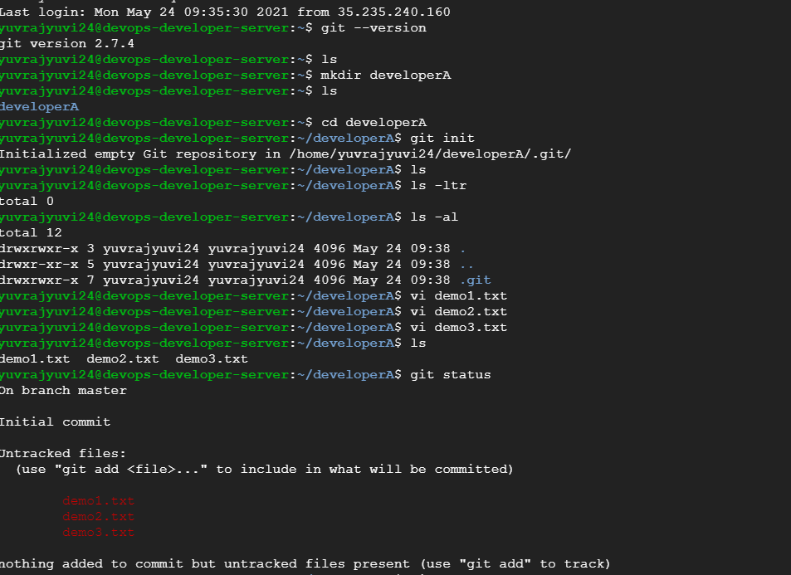

Three files committed to repo

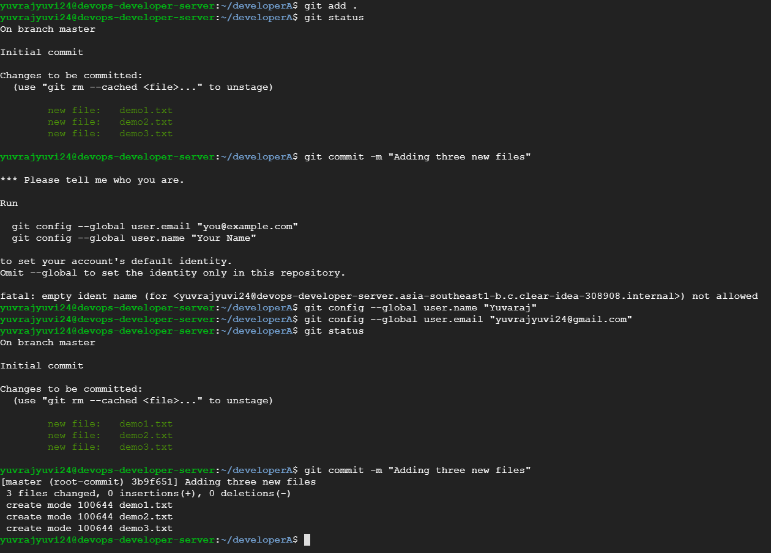

Remote repo created

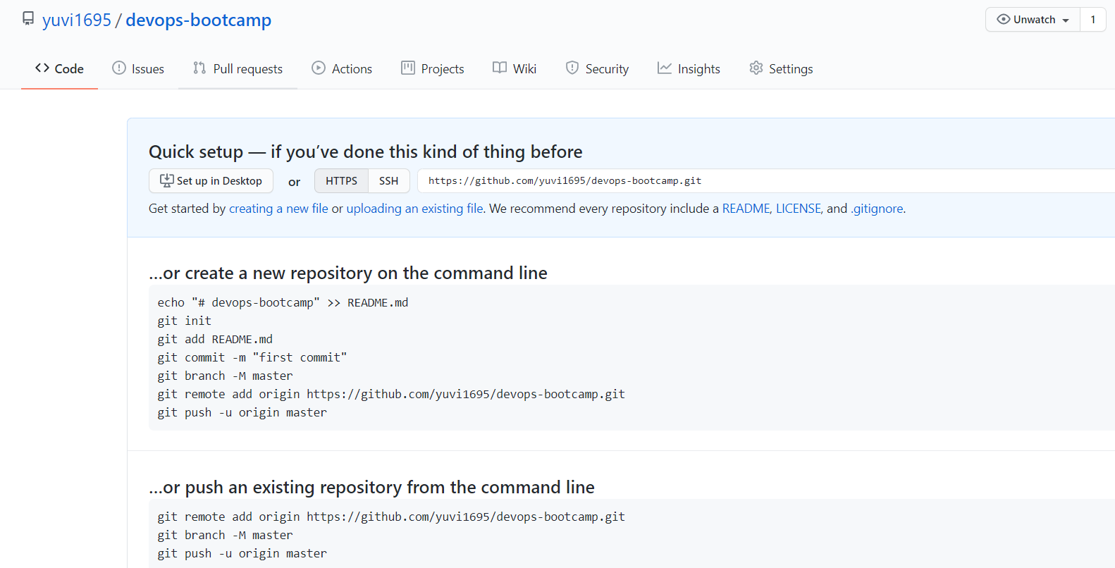

Adding and Pushing local repo changes to remote repo

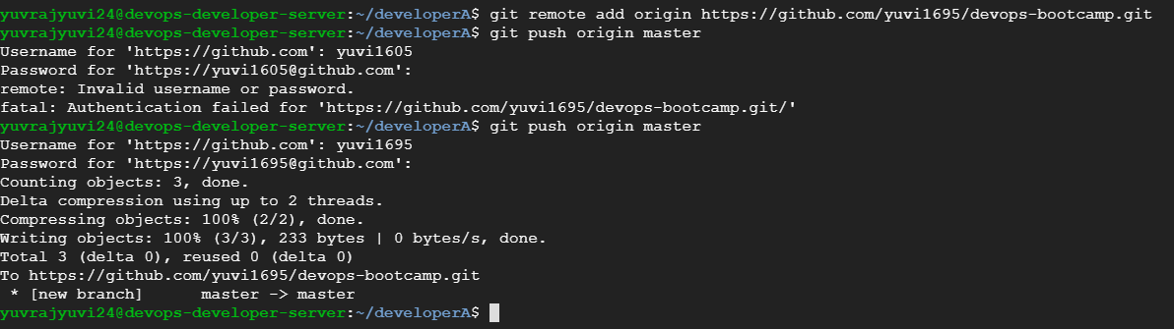

Remote repo has the three files now.

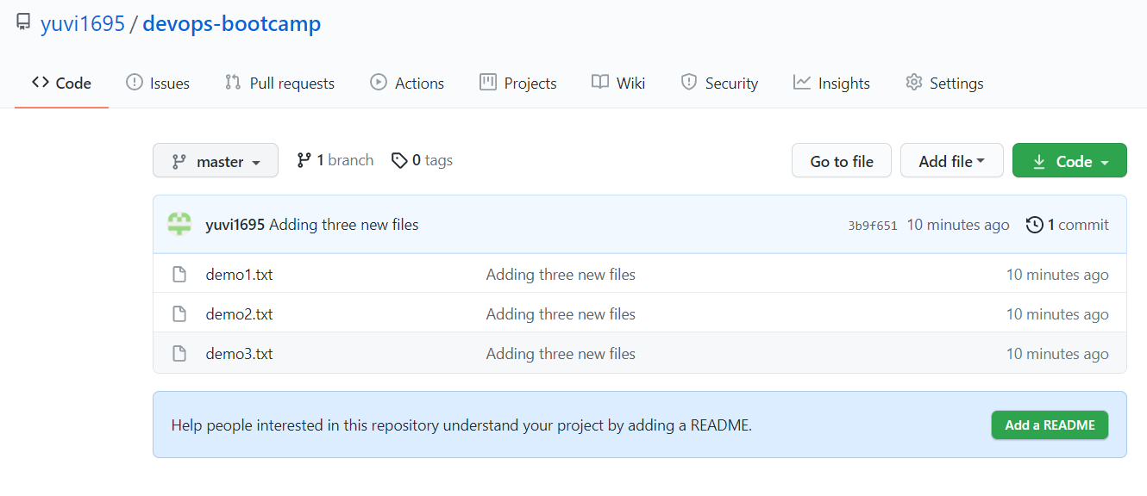

developerB folder created, cloned remote repo, made changes to demo1.txt and pushed to remote repo

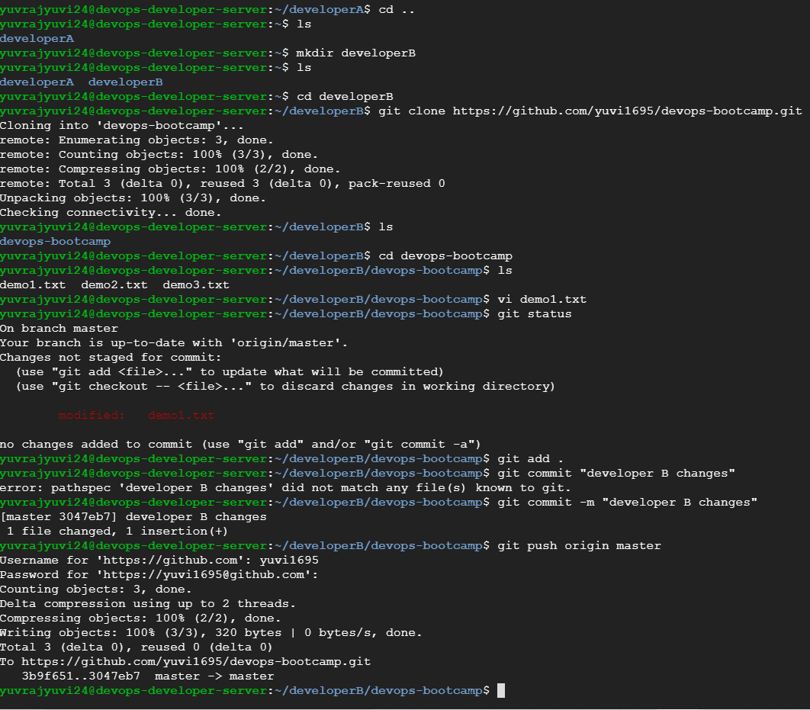

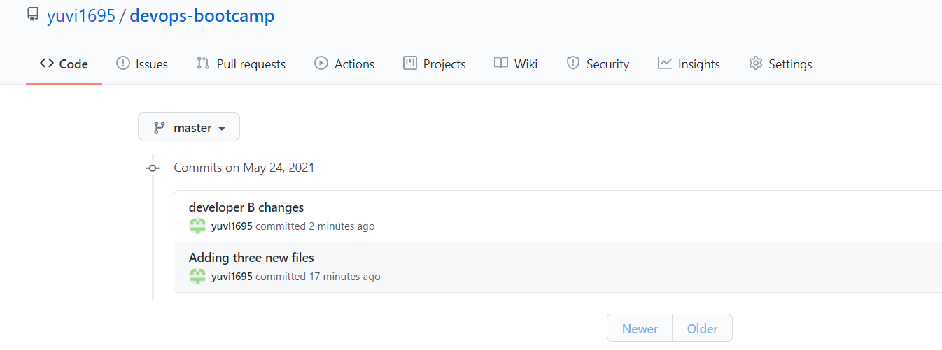

Synchronized developerB changes into developerA

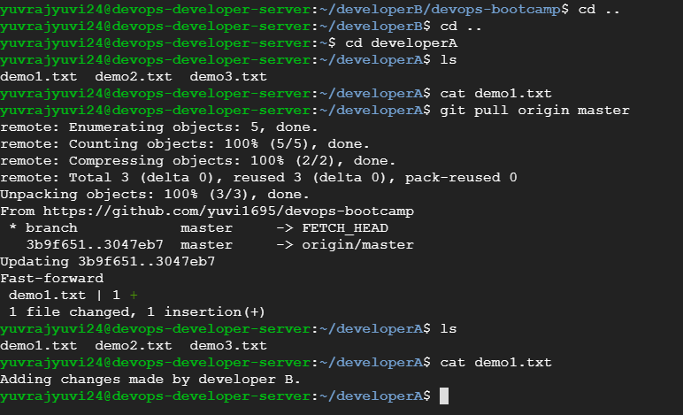

Create new branch (feature1), make changes, merge it to master and delete it.

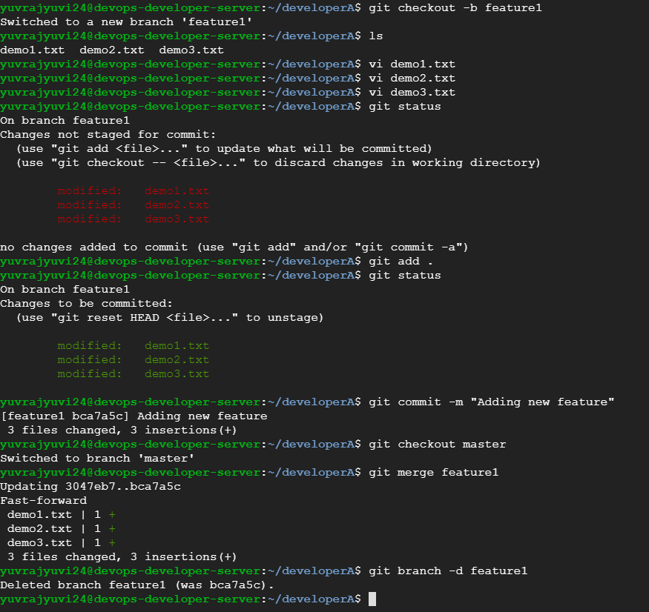

Changes available in master after merging.

