**Git Merge Conflict**

Setting up merge tool and then creating two branches – feature1 and feature2

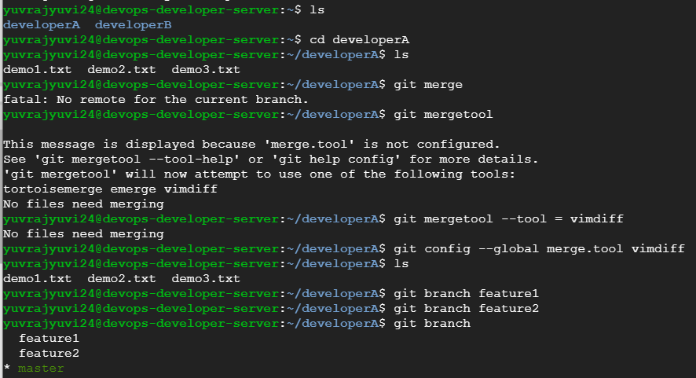

Checking out feature1 and adding “Adding changes from feature1 branch” line to demo1.txt file.

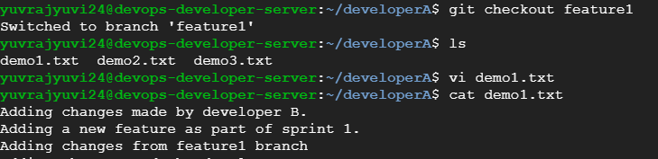

Committing the changes and then merging it to master branch.

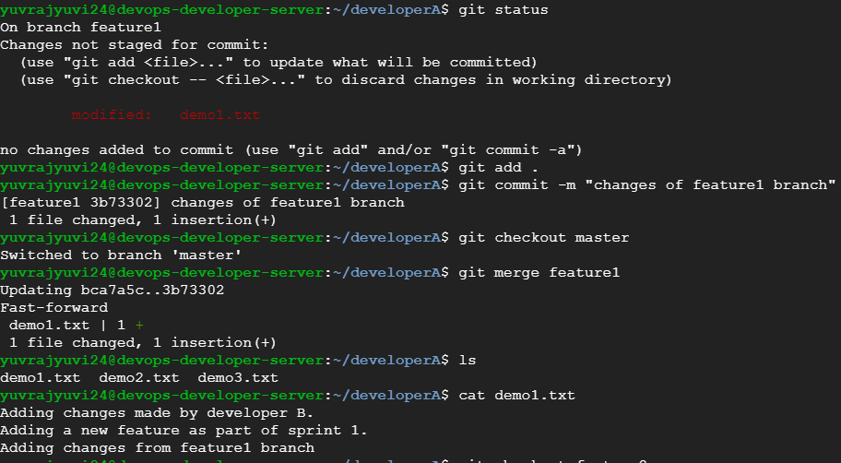

Checking out feature2 branch and adding “Adding changes from feature2” line to demo1.txt file.

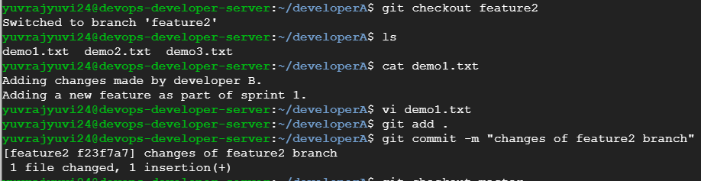

Trying to merge feature2 to master, getting conflict, resolving it with merge tool and then committing.

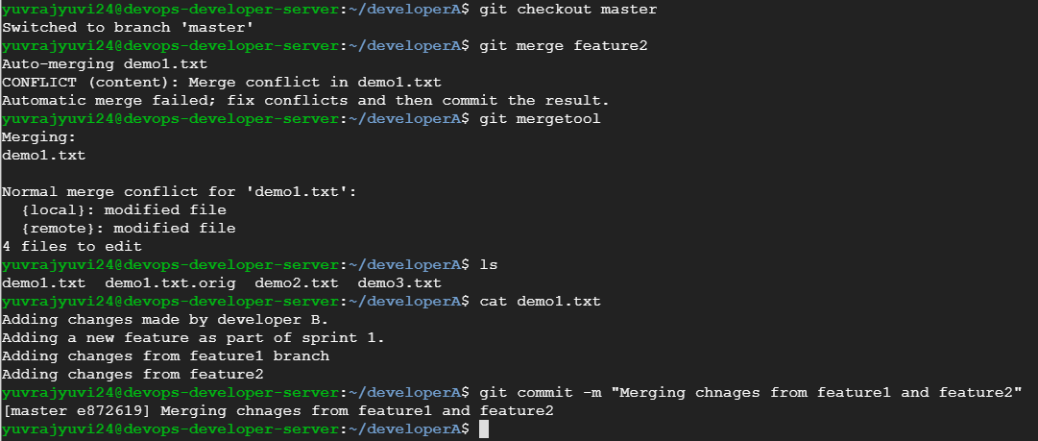

**Jenkins**

Three jobs are created.

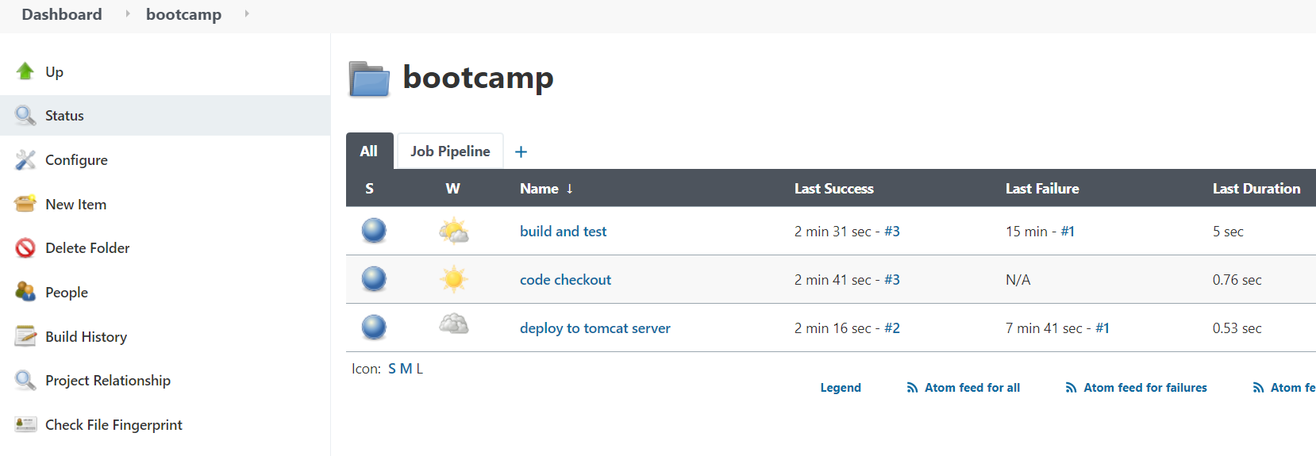

Output of code checkout job

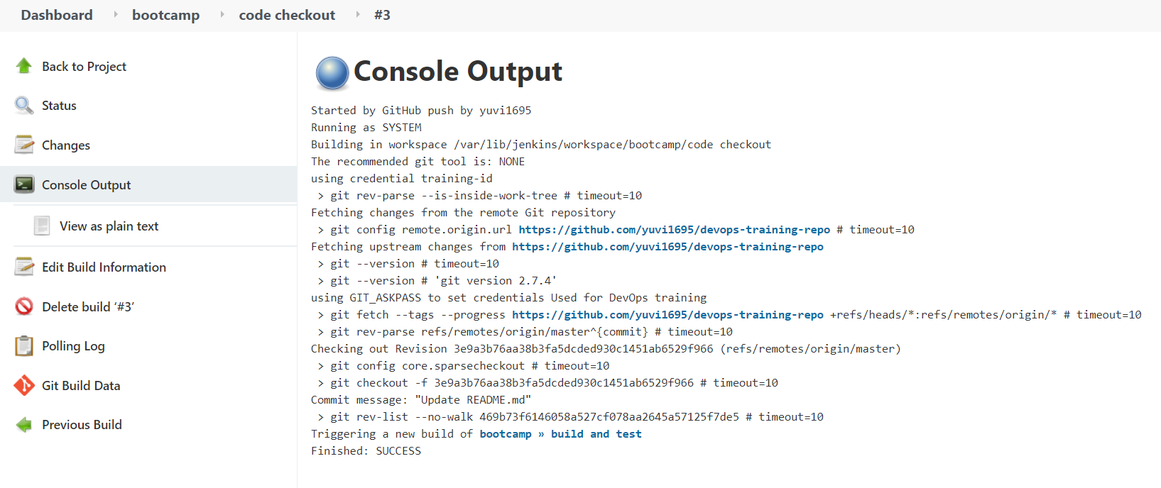

Output of build and test job.

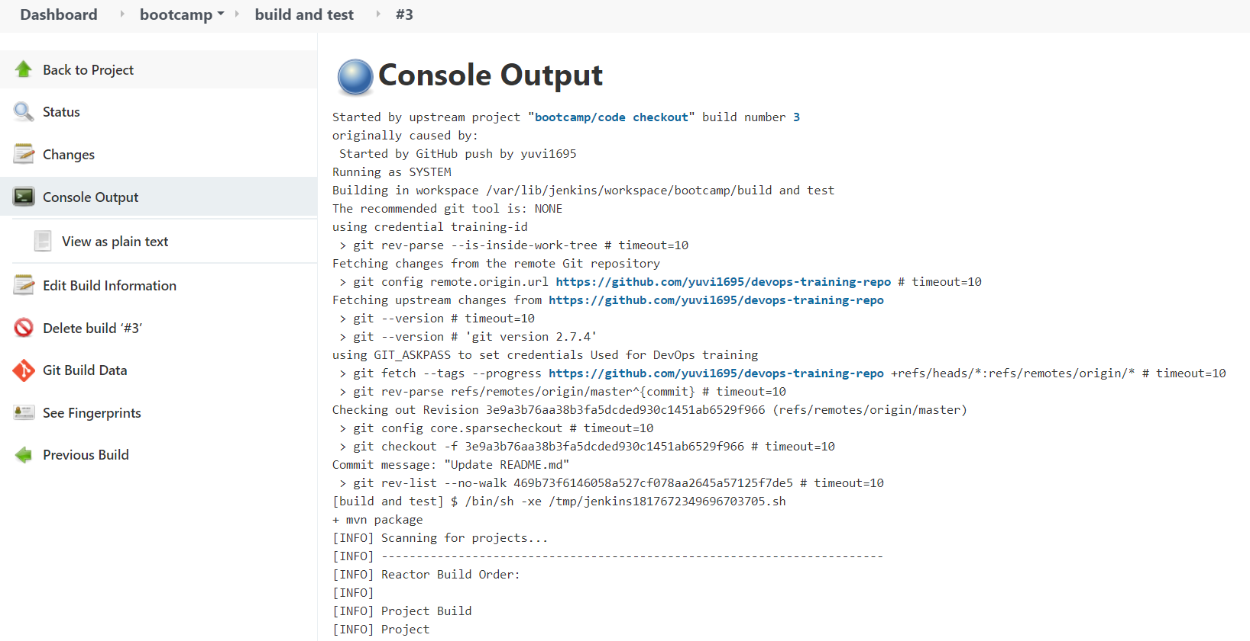

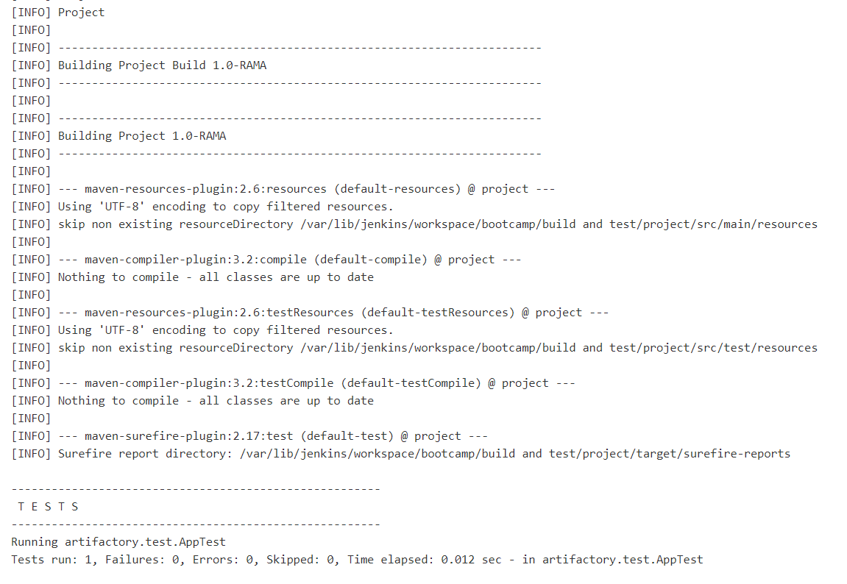

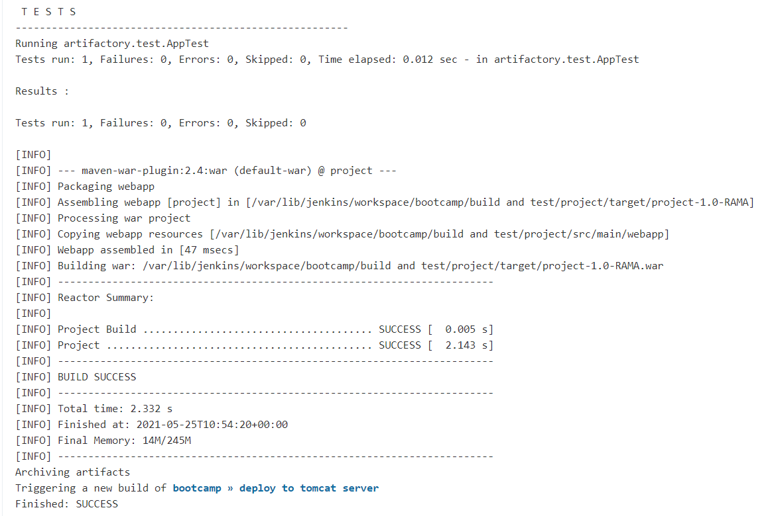

Output of deploy to tomcat server job

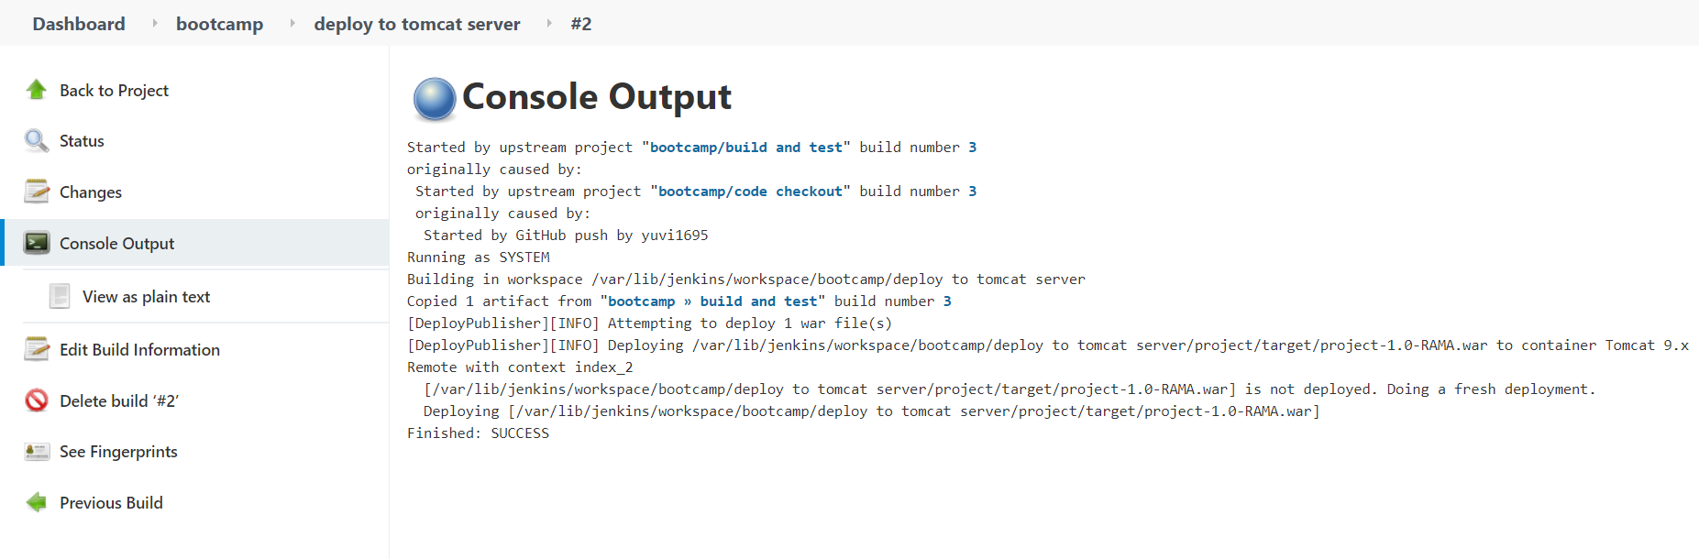

Build pipeline view.

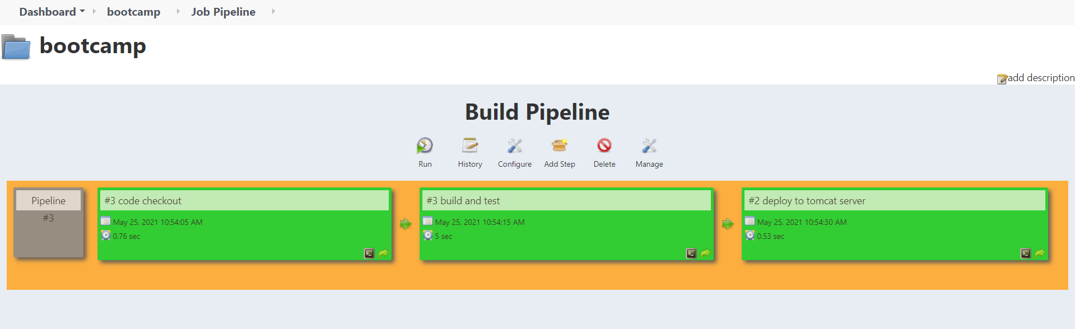

Output in tomcat server

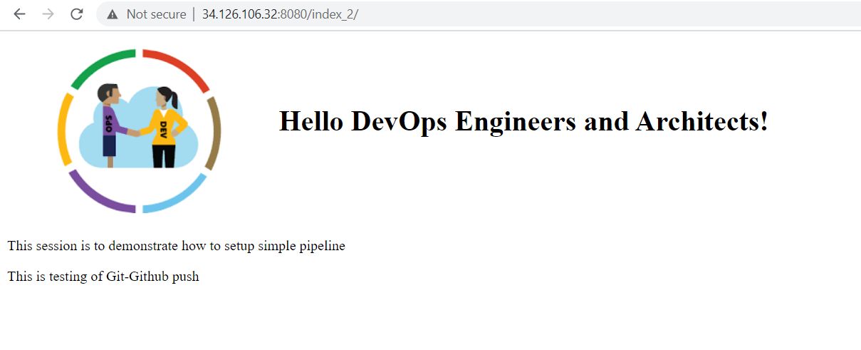

**Jenkins Pipeline Job**

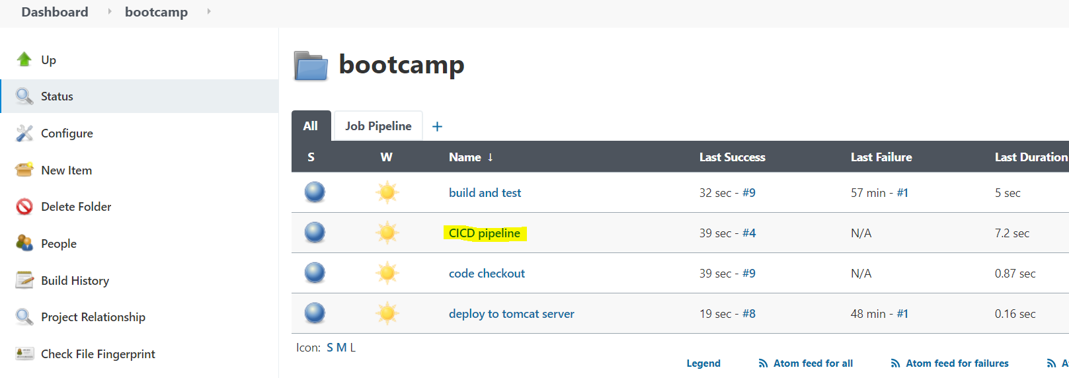

Pipeline script

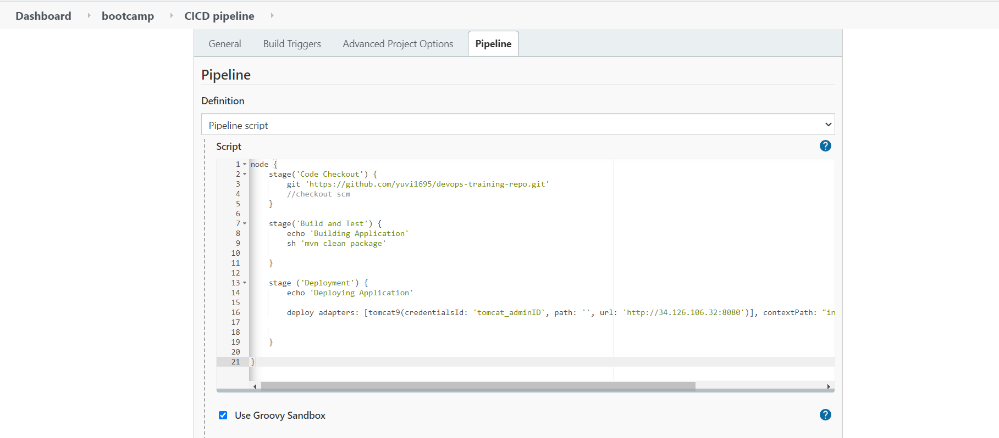

Console output

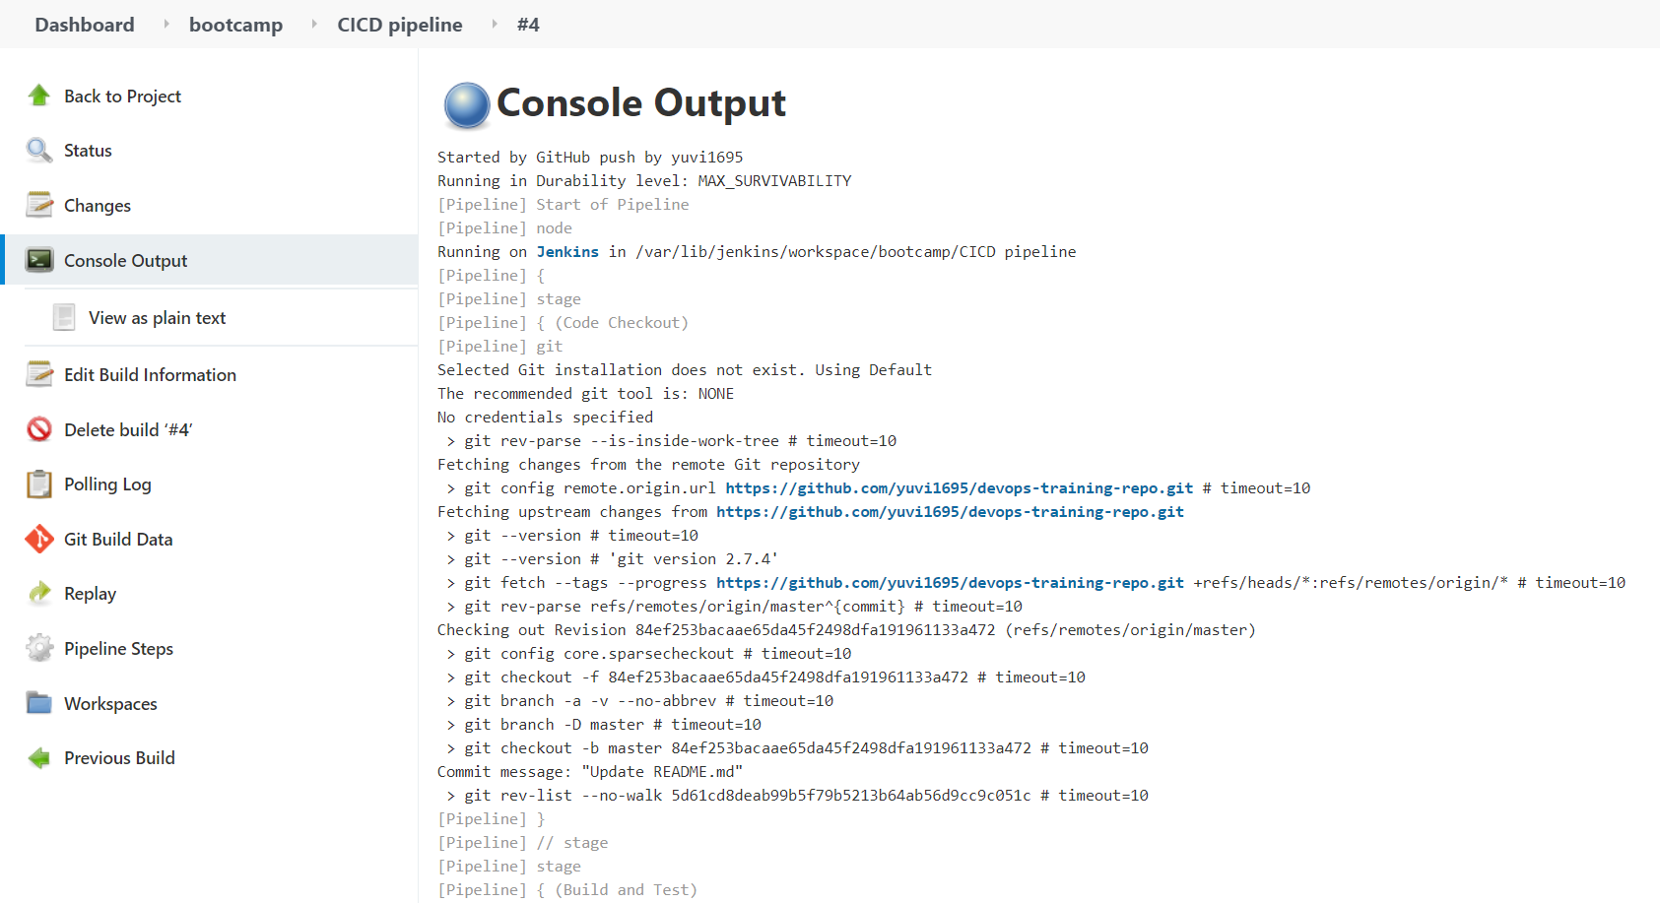

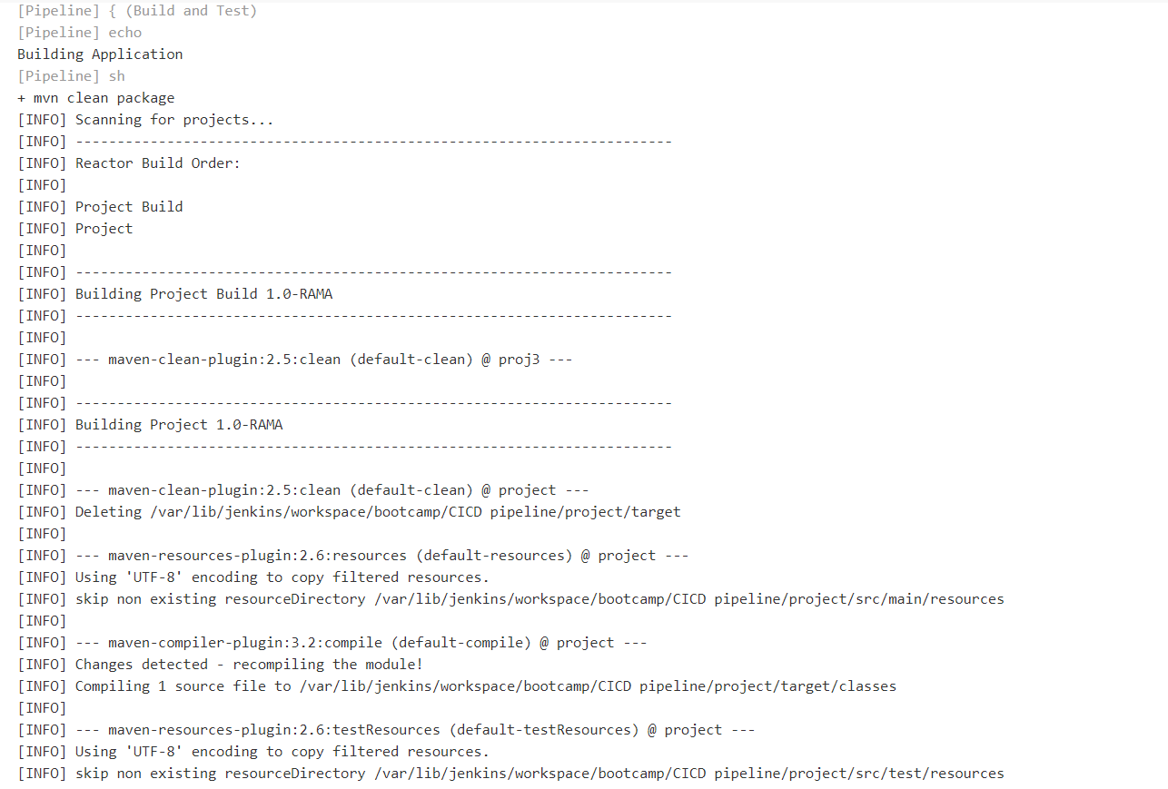

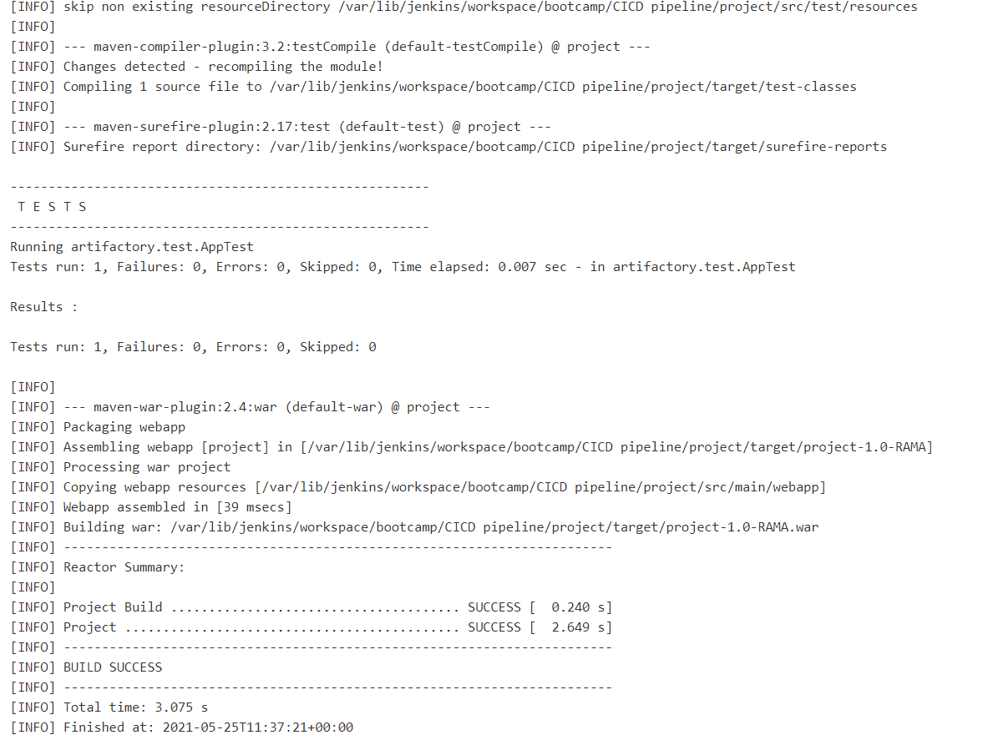

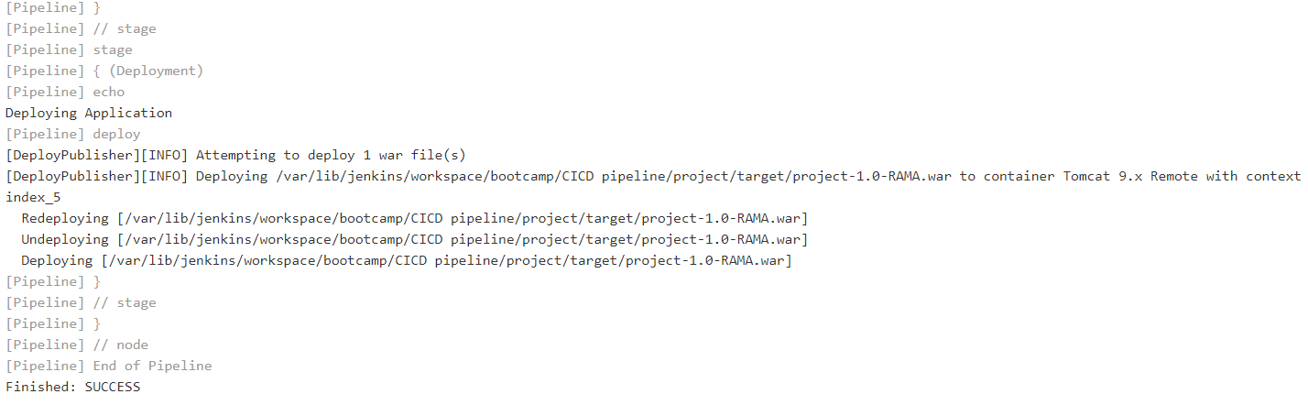

Output in tomcat server

