**Docker File Creation**

Creating the Dockerfile under devops_bootcamp folder

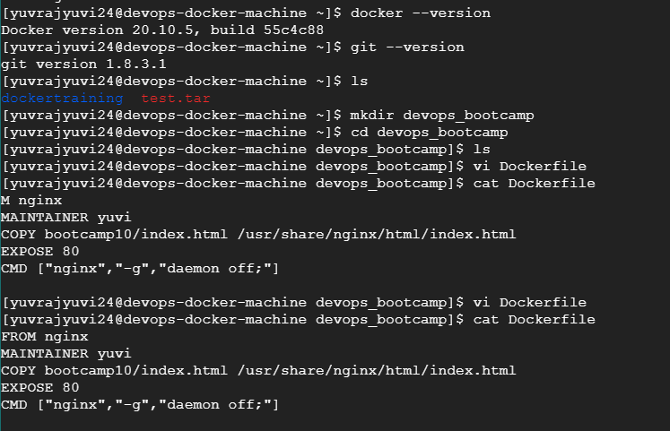

Cloning the repository and then building the image.

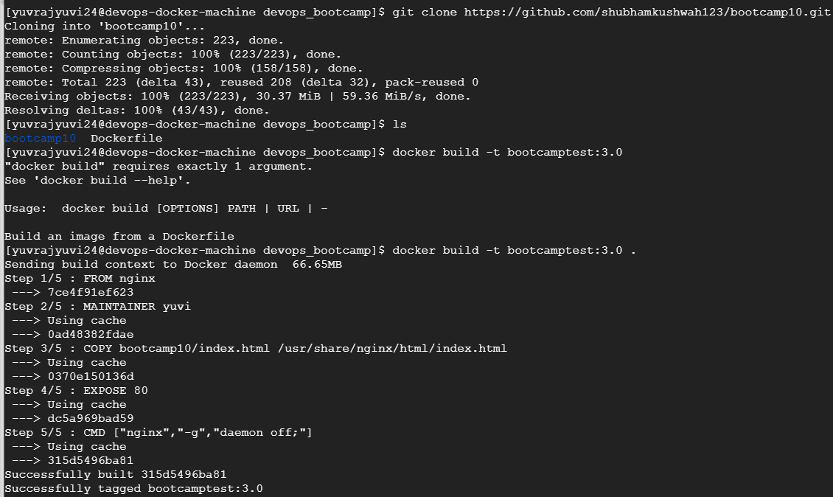

The image created is available

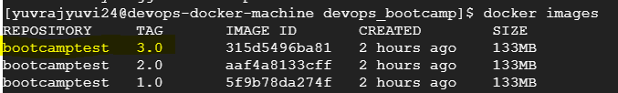

Trying to push the image to docker hub but was not able to. So re-built the image with “docker_hub_name/image_name:version” name.

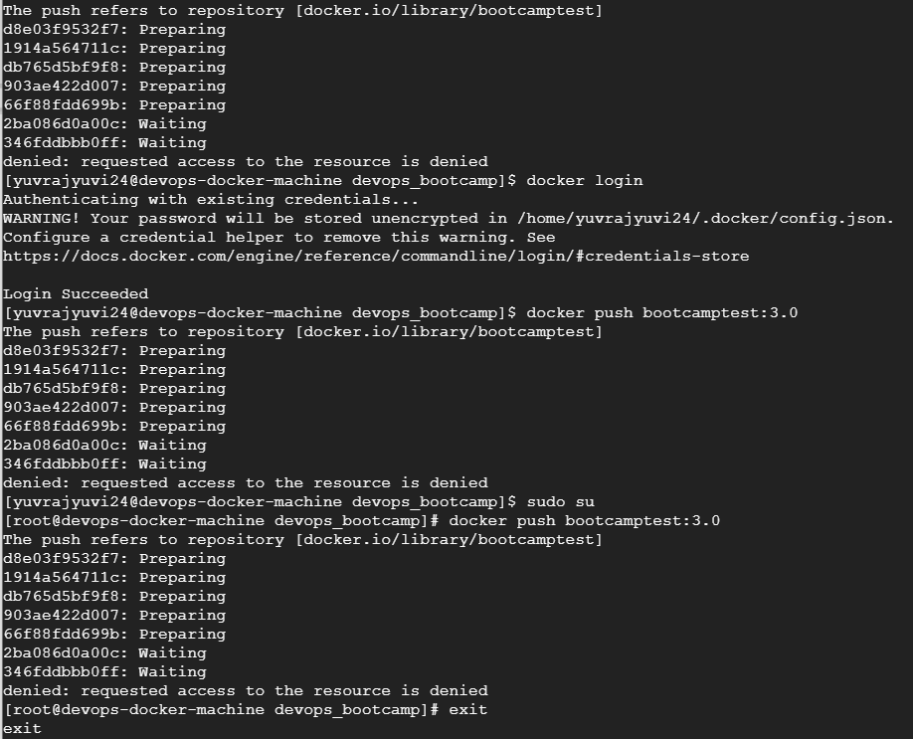

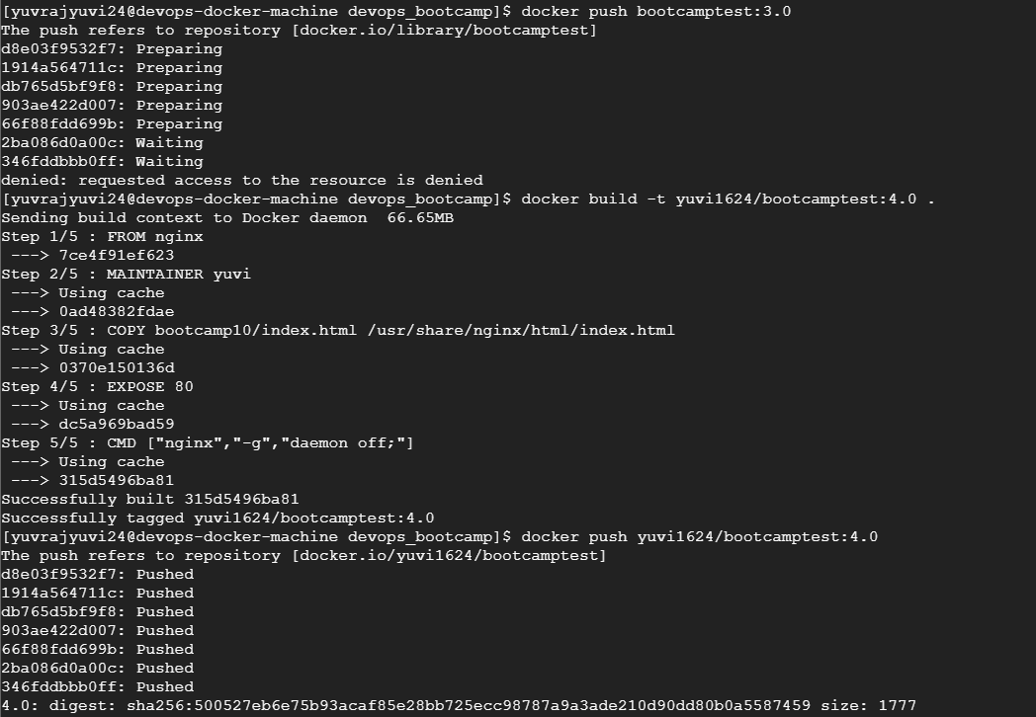

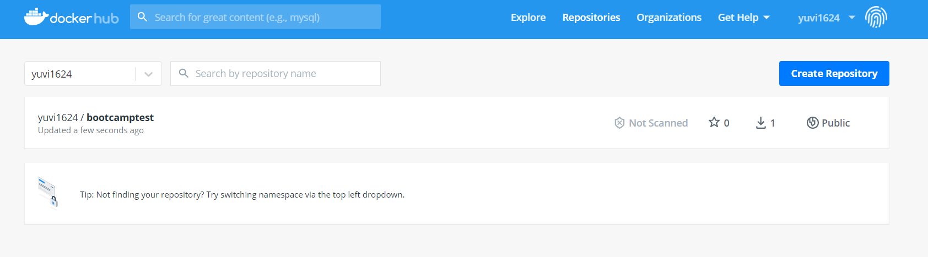

After pushing to docker hub, deleting the image locally and then pulling it from docker hub.

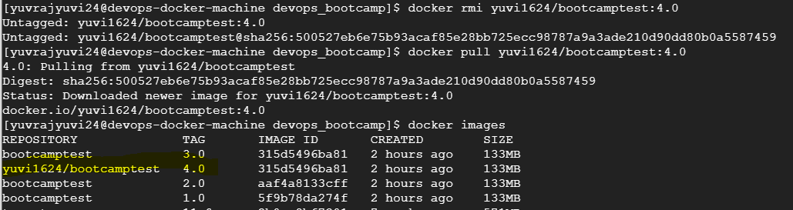

Then running the image.

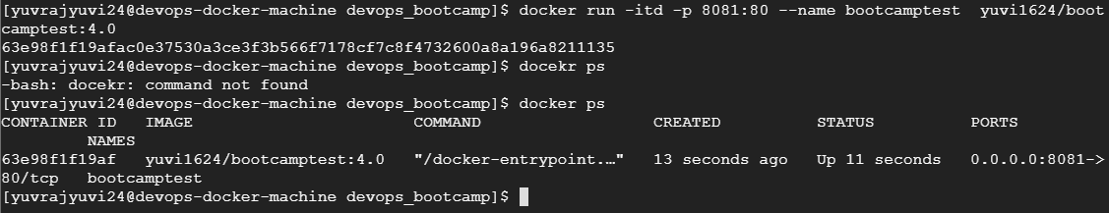

Output in browser.

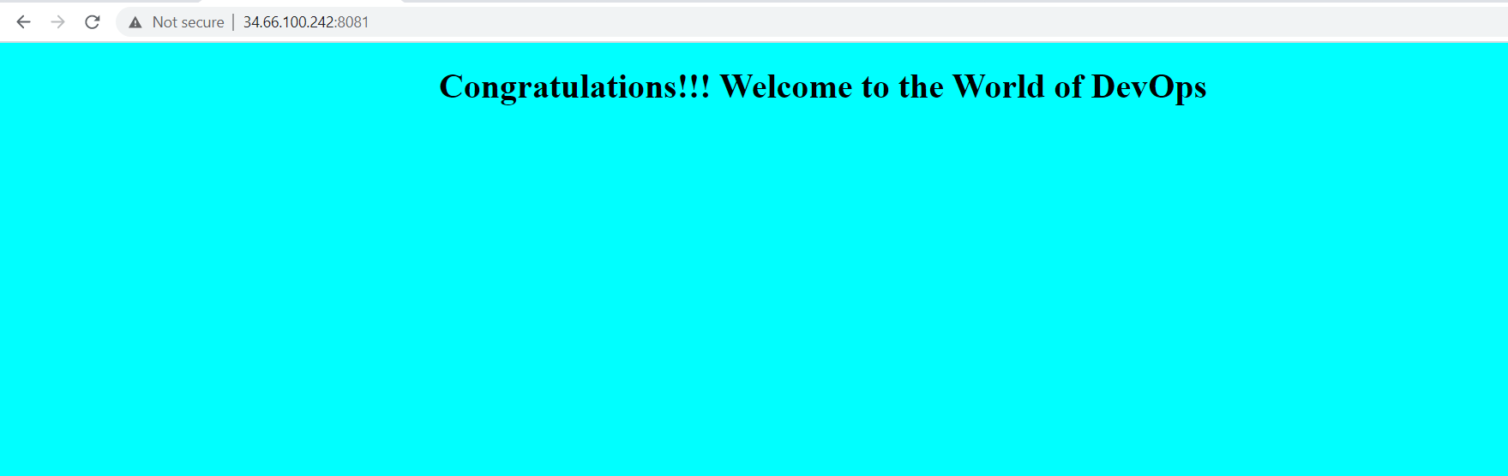

**Docker Compose**

Creating docker compose file

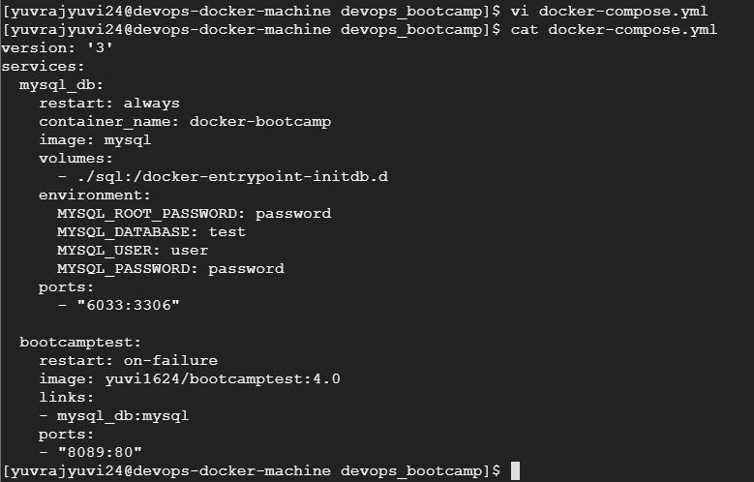

Running docker compose command to run in background



Running mysql container

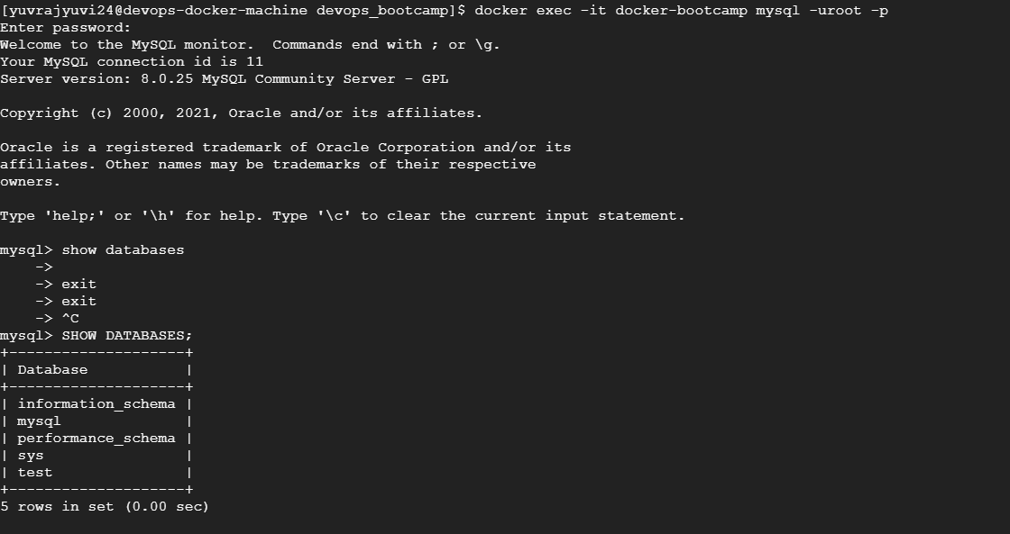

Creating table “test” inside “test” database.

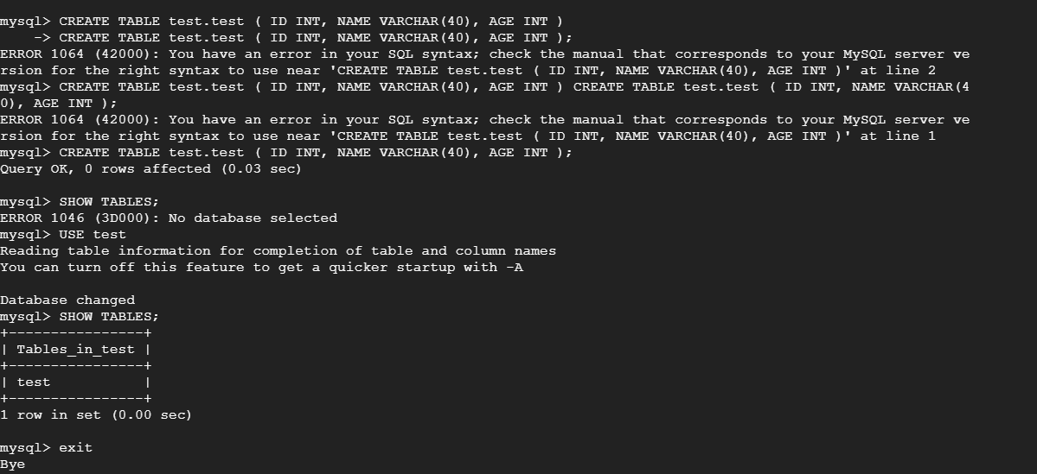

Output in browser for nginx container

