**Ansible Modules**

Installing ansible

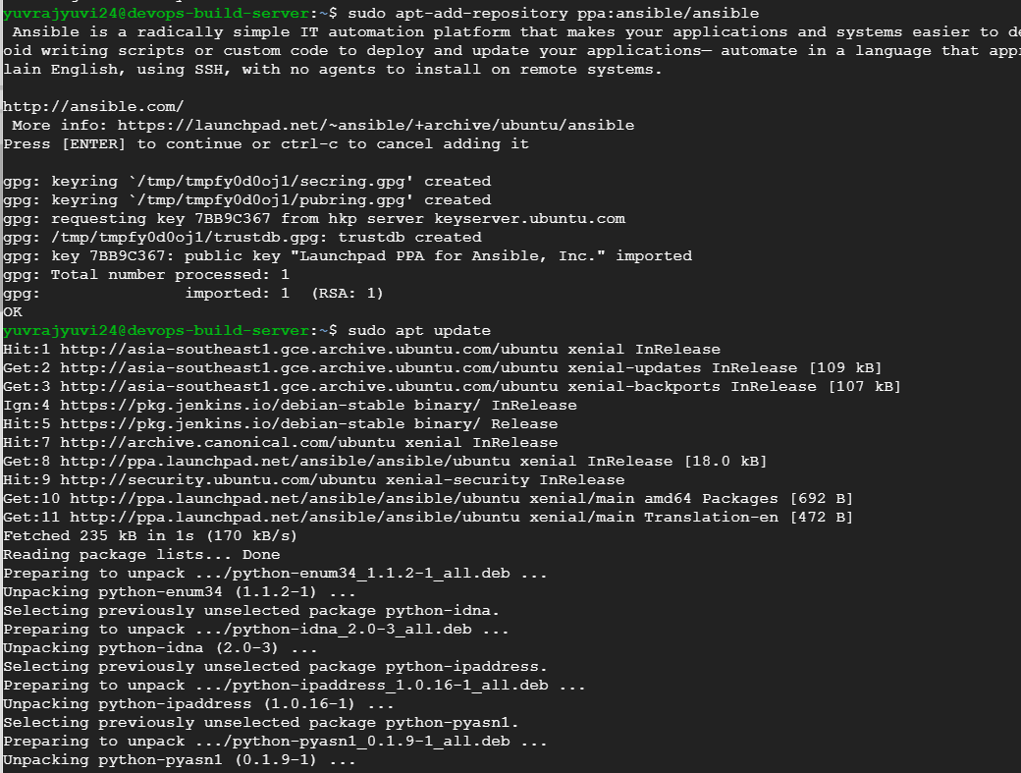

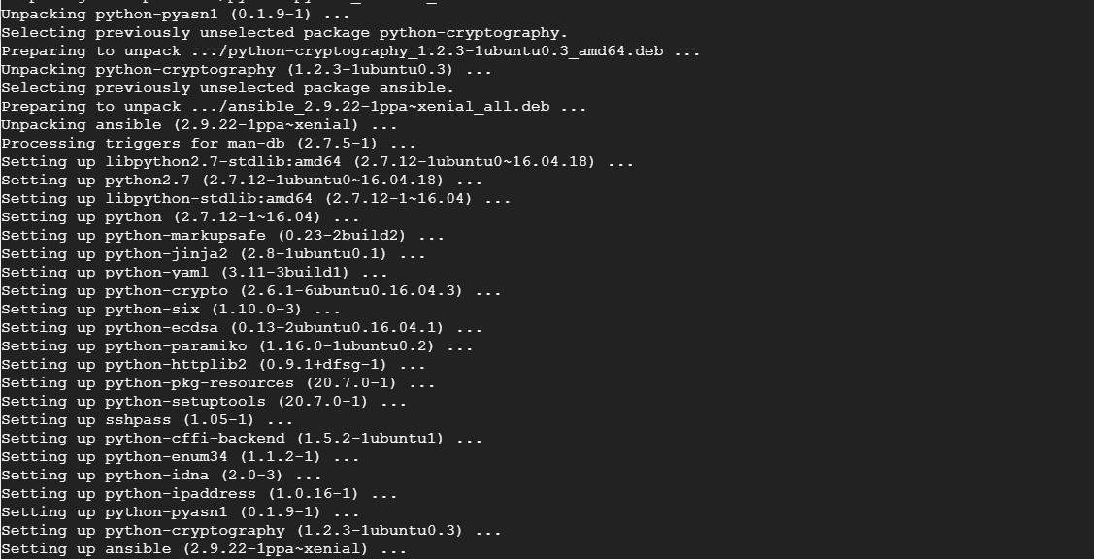

Added target node to hosts and tried pinging, but it was not working since ssh keys were not configured.

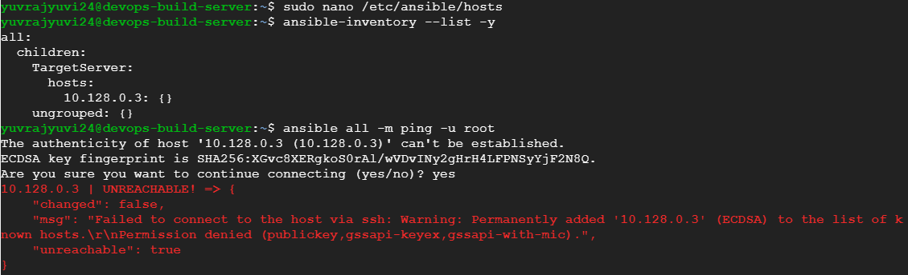

After generating public key for ansible controller and adding it to metadata of GCP console, it was working.

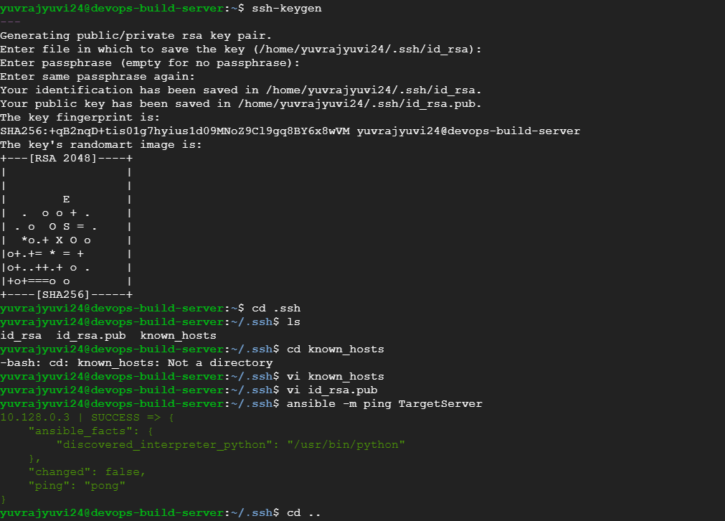

Creating the “testPlaybook.yml” playbook inside “bootcamp_ansible” folder

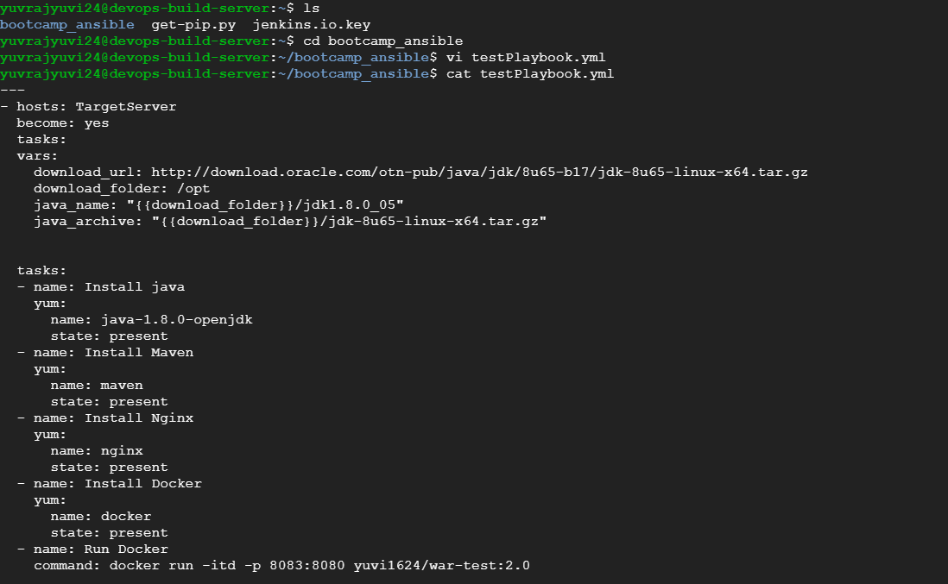

Before running the playbook, the war-test application was built using docker and pushed to docker hub from another machine. The application will run inside an ubuntu machine where tomcat is installed.

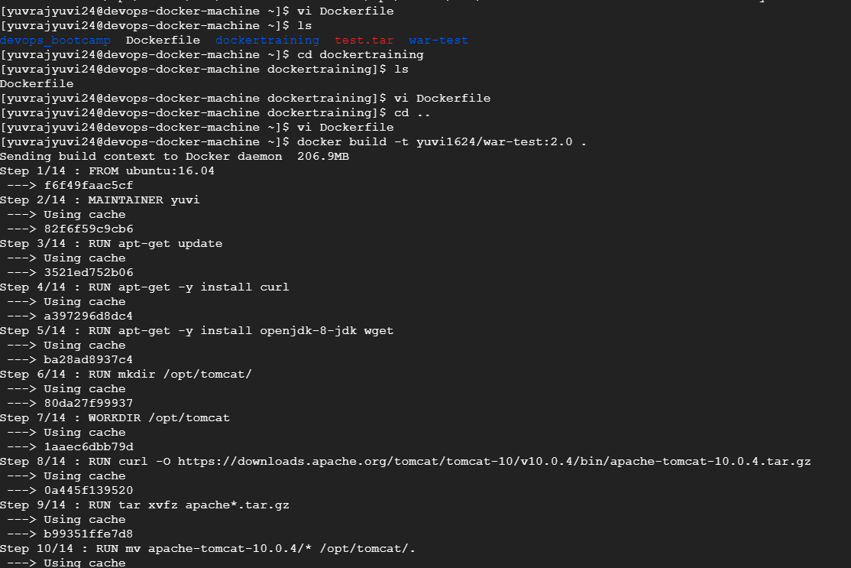

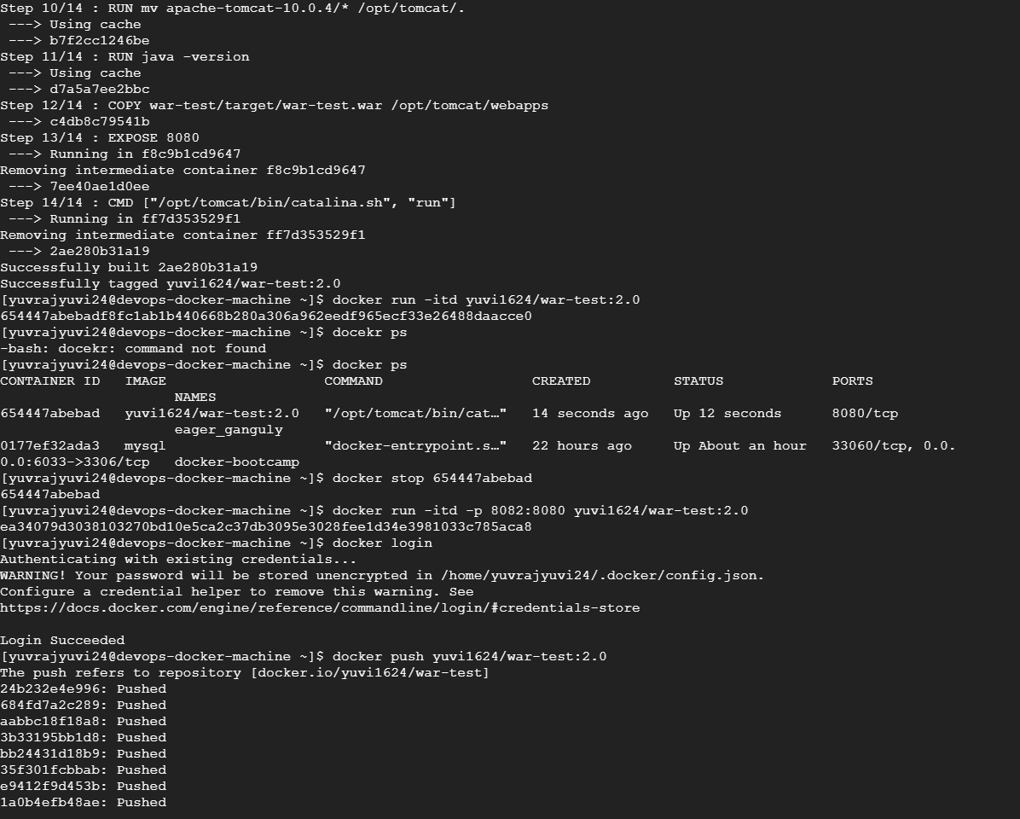

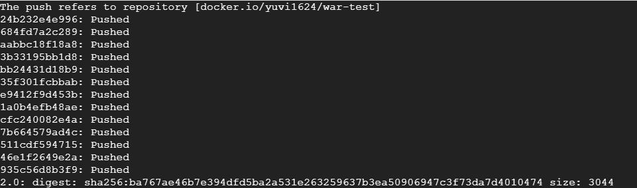

Once the image is pushed to docker hub, playbook is triggered from ansible controller,

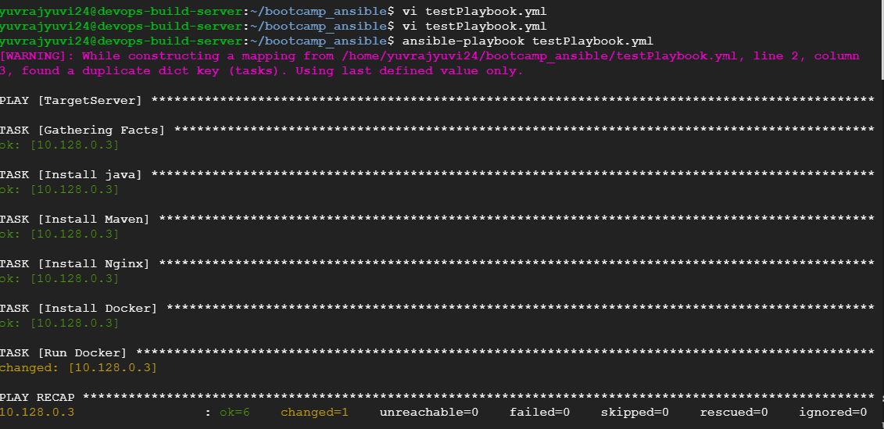

Output in target node

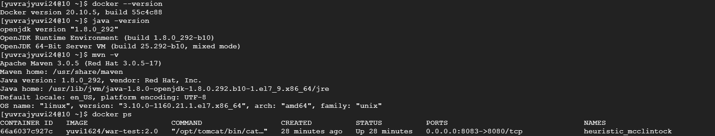

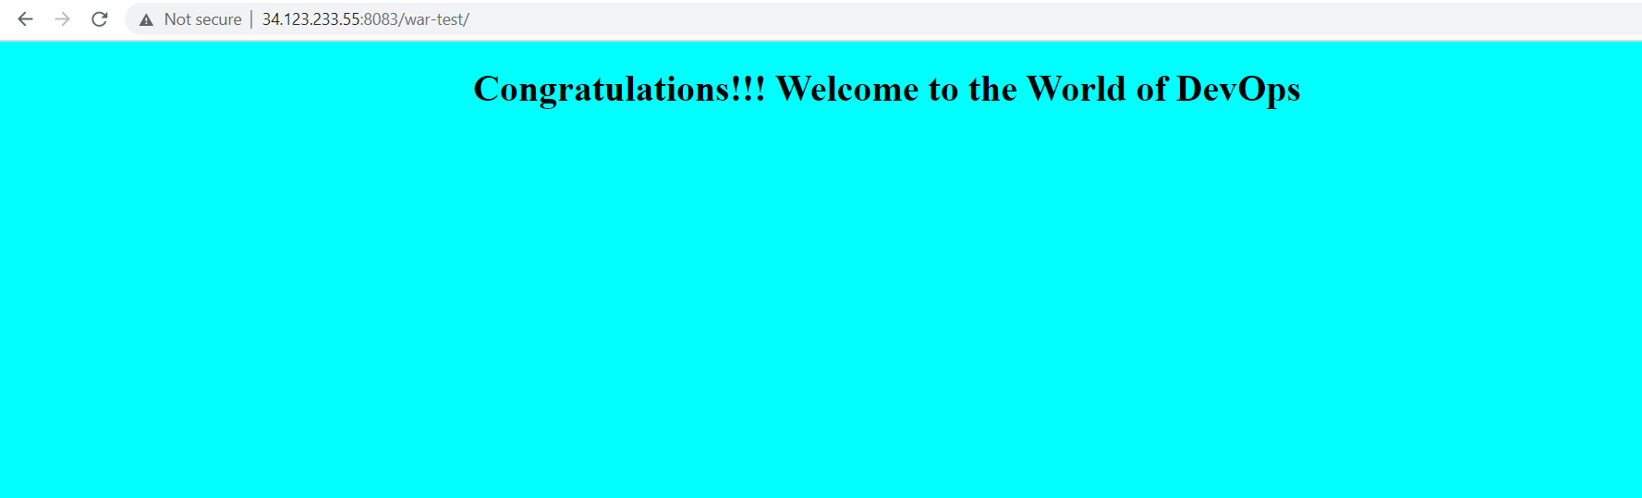

Private IP Public IP

