EXAM CELL MANAGEMENT SYSTEM

- Abstract:

Exam Cell Management System is developed for the college to manage and allot exam halls for academic exams. The application includes other functionalities like allotting seats for various classes and invigilation allotment. The project aims to bring in a defined system which would ease the jobs of exam cell in just few clicks of work.

Proposed to develop a web application, which can be operated anywhere inside the college network by the exam cell coordinators. The project keeps track of various details in modules such as Students details, Staff details, exam hall details and auto generating emails for student’s hall tickets. It also has some features to generate reports for exam sheets and extra answer sheets handover, absentee’s statement and role lists etc.

- Introduction:

The Exam cell management system is an web based application that is designed to manage and handle the operations in an educational institute during the time of examinations. It is an application that can be used by the exam coordinators. The application is easily adaptable. The exam cell management system is developed for the educational institute to simplify the allocation of halls, seating arrangement of students and allocating staff to the examination halls. The Students details have information about all the students who are all going to attend the examination. It contains the name of the student, department of the student and other details. The time table contains the exam name and the date of the exam. Hall Details have total number of halls available in the institution and the name of the hall. Seating plan has the register numbers of the student allotted to a particular hall. Invigilation details has the list of faculties allotted to particular hall. The attendance sheet contains the number of students present and absent. The project keeps track of various details in modules such as Students details, Staff details, and Hall details with proper descriptions.

3. Softwares used-
Mysql server version 5.5
Eclipse IDE (Luna)
Apache tomcat version 8
Java JDK version 8

4. System study:
Screen details-
- Nominal role / Student Profile
- Subjects for the classes
- Exam time table entry
- Seating plan
- Invigilation entry
- Hall wise attendance view
- Hall slip preparation
- Dispatchment of answer sheet.

- Nominal role

The screen is designed to gather and store the information about students from all academics. This could be done by two ways: a. Bulk upload b. Candidate entry.

a. Bulk uploads:

This is possible by receiving an excel sheet about students in a predefined format.

b. Candidate entry:

This is generally a Single candidate entry, where the admin / any user can update the student details one by one.

The details gathered and stored through this screen are as follows:

Register number
Name
Degree
Dept
Section
Date of joining

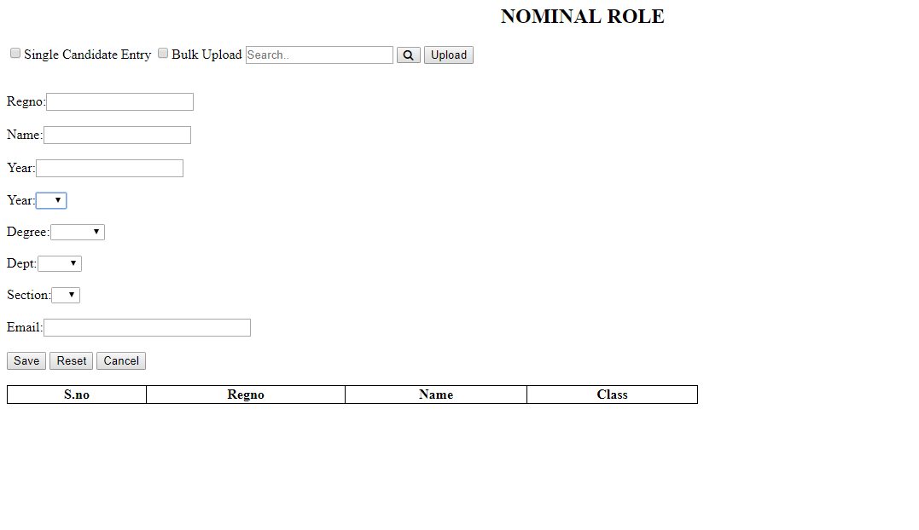

2. Subjects for the classes

The screen is designed to choose the subjects for each class. The below details has to be provided in the screen to perform the process. These details are validated and created/modified to store in database.

Degree
Dept
Academic year
Semester
Papers

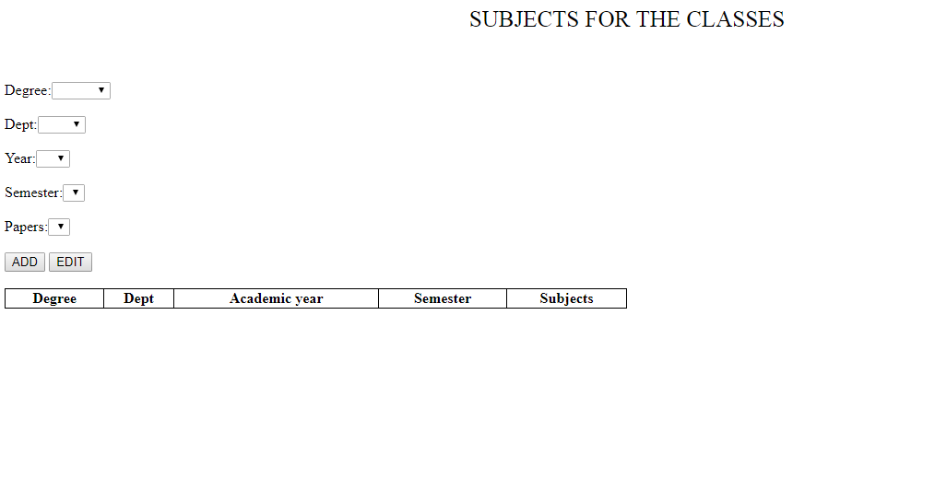3. Exam time table entry

The screen is designed in a table format to create the examination time table. The exam dates and the subjects has to be selected in the screen for each courses. The date of the exams and subjects can be validated and modified to view.

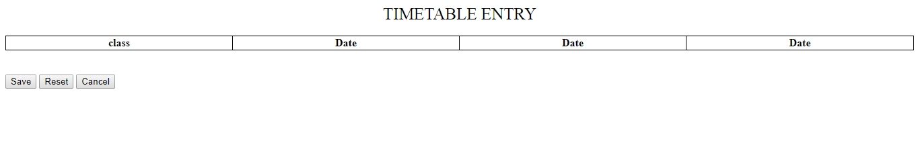4. Seating plan

The screen is designed to create seating arrangement and allocation of exam halls for each classes. The below information as to be provided on the screen to perform this process.

Hall no
Total number of students in each hall
Seating capacity in each hall

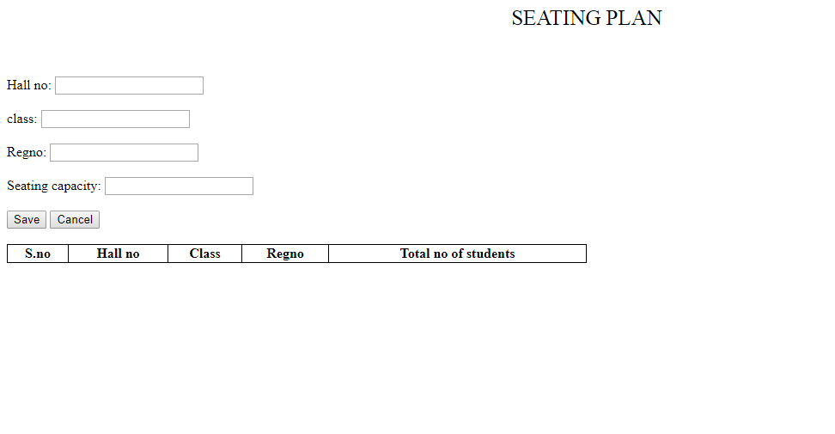5. Invigilation

The screen is designed to allocate invigilators for each examination hall. The faculty availability and total number of examination halls are validated to create time table for faculties. The below information has to be provided in the screen to perform the process.

Hall number
Faculty id
Faculty name
Date of examination

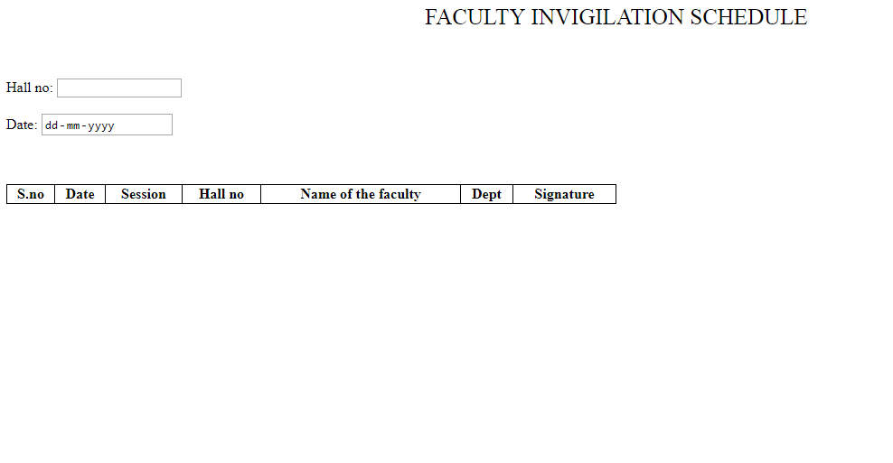

6. Hall wise attendance

The screen is designed to create the attendance list of the students for each examination hall. The hall number has to be provided in the screen and the attendance list is created by retrieving the information from the database.

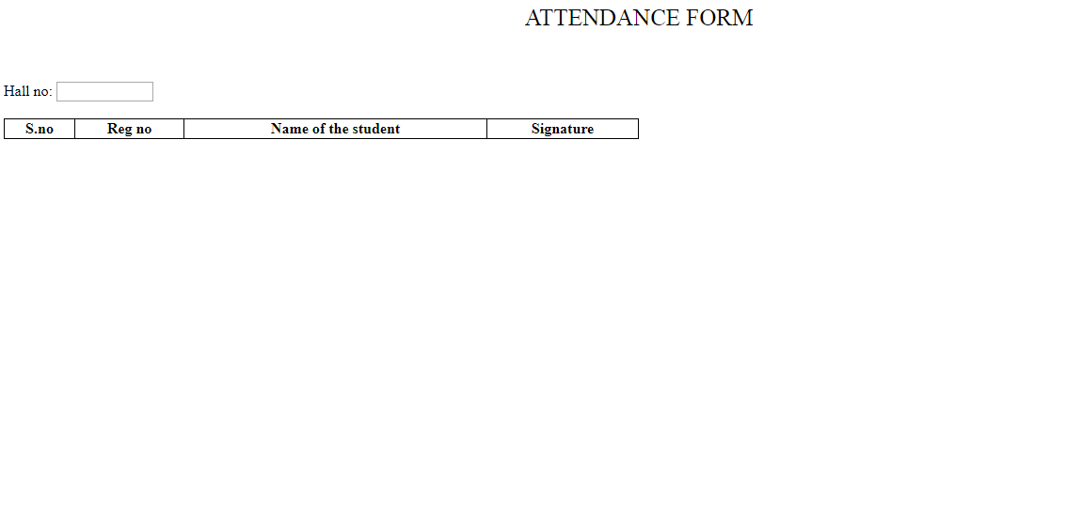
7. Hall slip preparation

The screen is designed to create a hall slip for each examination hall by retrieving the information from the database. The hall number along with date and session has to be provided in the screen to perform the process.

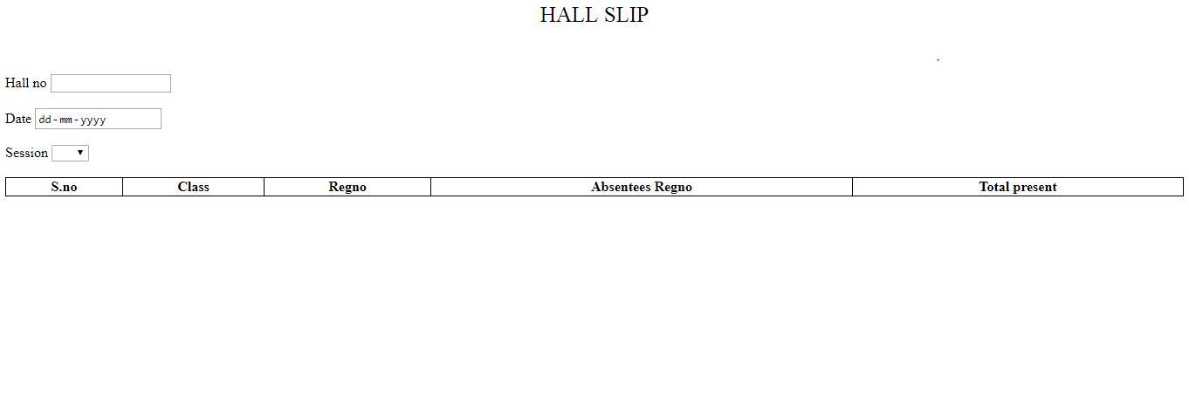8. Dispatchment of answer sheet

The screen is designed to view the number of remaining answer sheets which has to be returned to the controller of examination. The below information has to be provided to perform the process.

Hall number
Total number of students
Total number of absentees

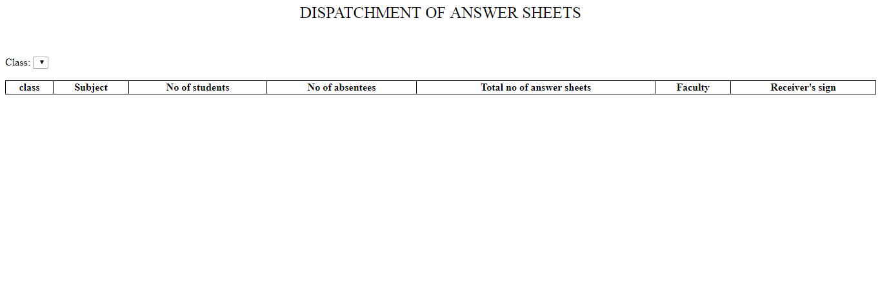

  - INPUT DESIGN

A project involves the transformation of inputs into an output. The input is a raw data that is processed to produce output. It should serve specific purpose effectively such as storing, recording and retrieving the information.
The inputs can be given to the exam cell management system by using two ways:
- Single entry
- Bulk upload
SINGLE ENTRY
The single entry option is used when the input has to be submitted one by one into the database. We have to enable the single candidate entry check box on the screen and type all the required input values on the screen, the save button has to be clicked to submit the input values into the database.

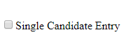
BULK UPLOAD
The bulk upload option is used when we have the input data in an excel sheet or in any other document. The document can be uploaded into the database by enabling the bulk upload check box in the screen and browse the location of the input file using search button once the required location of the input file is chosen we can use the upload button to submit the file into the database.



  - OUTPUT DESIGN
The output should meet the requirements of the end users and present the information clearly. In output design it is determined how the results should be displayed in the screen.
The output of the system is presented to the user in two ways:
- Grids
- Jasper reports
GRIDS
The output can be displayed to the end user using the table grids. When a certain input is given the system will produce the required results in the form of grids and the end user can view the outputs on the screen.
SNO | REG NO | NAME | CLASS

JASPER REPORTS
The required output will be produced to the end user through jasperReports that can write to a variety of targets, such as: screen, a printer into PDF, HTML, MICROSOFT EXCEL, RTF, ODT or XML files.

7. DATABASE DESIGN
Table: tbl_mst_degree
It is master table that is used to store all the degrees that are available in the college
Columns:
num_degree_id int(11) AI PK
vch_degree_name varchar(90)
vch_degree_type varchar(30)
num_dept_id int(11)
Table: tbl_mst_dept
It is a master table that is used to store all the departments that are available in the college
Columns:
num_dept_id int(11) AI PK
vch_dept_name varchar(50)
Table: tbl_mst_section
It is a master table that is used to store the total number of sections
Columns:
num_section_id int(11) PK
vch_section varchar(2)
Table: tbl_mst_year
Columns:
num_year_id int(20) PK
num_year int(10)

Table: tbl_mst_nominal_role
It is a master table that is used to store the personal & educational information of each students
Columns:
num_nominal_role_id int(11) PK
vch_reg_number varchar(10)
vch_name varchar(50)
dtt_date_of_joining date
num_year_id int(11)
num_degree_id int(11)
num_dept_id int(11)
num_section_id int(11)
vch_email_id Varchar(90)
Table: tbl_mst_semesters
It is a master table that is used to store the name of the semesters
Columns:
num_sem_id int(11) AI PK
vch_sem_name varchar(20)
Table: tbl_mst_papers_lists
It is a master table that is used to store the name of all the papers
Columns:
num_paper_id int(11) AI PK
vch_paper_name varchar(90)

Table: tbl_mst_degree_wise_semesters
It is a master table that is used to store the total number of semesters for each department
Columns:
num_sem_degree_id int(11) AI PK
num_sem_id int(11)
num_degree_id int(11)
Table: tbl_mst_dept_wise_papers
It is a master table that is used to store the list of papers department wise
Columns:
num_dept_paper_id int(11) AI PK
num_paper_id int(11)
num_dept_id int(11)
num_sem_id int(11)
Table: tbl_trn_papers
It is a transaction table that is used to store the papers studied in each semester
Columns:
num_trn_paper_id int(11) PK
num_year_id int(10)
num_degree_id int(11)
num_dept_id int(11)
num_sem_id int(11)
num_paper_id int(11)

Table: tbl_trn_timetable
It is a transaction table that is used to store the examination timetable for students
Columns:
num_trn_timetable_id int(11) PK
num_year_id int(11)
num_degree_id int(11)
num_dept_id int(11)
num_paper_id int(11)
dtt_date date
Table: tbl_mst_hall
It is a transaction table that is used to store the total number of exam halls
Columns:
num_hall_id int(11) PK
vch_hall_no varchar(20)
Table: tbl_trn_seating
It is transaction table that is used to store seating arrangement of students during exam
Columns:
num_trn_seating_id int(11) PK
num_hall_id int(11)
num_year_id int(11)
num_degree_id int(11)
num_dept_id int(11)
num_nominal_role_id int(11)
num_total_no_of_students int(20)

Table: tbl_mst_faculty
It is a master table that is used to store the faculty details
Columns:
num_faculty_id int(10) PK
vch_faculty_name varchar(40)
vch_faculty_dept varchar(40)
Table: tbl_trn_invigilation
It is used to store the list of invigilators allotted to each hall
Columns:
num_trn_invigilation_id int(11) PK
dtt_date date
vch_session varchar(10)
num_hall_id int(11)
num_faculty_id int(10)
Table: tbl_trn_attendance
It is a transaction table that is used to store the attendance list of the students in each hall
Columns:
num_trn_attendance int(11) PK
num_nominal_role_id int(11)
Table: tbl_trn_hall_slip
It is a transaction table that is used to store data of the hall slip
Columns:
num_trn_hall_slip_id int(11) PK
num_year_id int(11)
num_degree_id int(11)
num_dept_id int(11)
vch_Absentess_reg_no varchar(20)
num_total_no_of_students int(20)
num_total_present int(11)
Table: tbl_trn_dispatch
It is a transaction table that is used to store total number of remaining answer sheets in each hall
Columns:
num_year_id int(11)
num_degree_id int(11)
num_dept_id int(11)
num_paper_id int(11)
num_total_no_of_students int(11)
num_no_of_absentees int(11)
num_total_no_of_ans_sheets int(11)
num_faculty_id int(11)

8. GANTT CHART:

