A Motion-Compensated Learned Video Codec with Context-Adaptive Entropy Coding: Measured Bitstreams and a Diagnosis of the Gap to H.264/H.265
Aditya Aggarwal
Amity University
Noida, Uttar Pradesh, India
aggarwaladitya2006@gmail.com
Yuvraj Dewan
Amity University
Noida, Uttar Pradesh, India
yuvrajdewan2005@gmail.com
Vatsala Upadhyay
Amity University
Noida, Uttar Pradesh, India
vupadhyay2@amity.edu

Abstract—Learned video codecs now match or exceed H.264/AVC and H.265/HEVC, but published systems use 10–30 M-parameter transforms, hyperpriors and learned optical flow trained on large GPU budgets, which makes it hard to attribute their gains to individual components. This paper reports a complete neural video codec built from first principles, measured in real arithmetic-coded bytes and benchmarked against libx264 and libx265 in a single pass that scores every codec on identically decoded frames. A 593,411-parameter convolutional autoencoder maps each frame to a 64×16×16 latent. P-frames are predicted by pixel-domain block motion compensation and coded as latent residuals by a 13 k-parameter channel-autoregressive entropy model; its predictions are routed to a shared codebook of 512 frequency tables, which drive a native C range coder that writes a self-describing, bit-exact bitstream. Every component was admitted through a pre-registered gating protocol. On the DAVIS 2017 test split (9 sequences, 719 frames) the codec spans 0.317–0.721 bpp at 28.31–29.82 dB, yet still needs about 5.5× the bits of default x264 (BD-rate +450.7% PSNR, +378.3% MS-SSIM). Diagnostic experiments place the deficit in transform capacity, with entropy coding already close to its limit, and show that a wider latent pays for every extra channel: a 192-channel GDN/residual transform costs 3.2× the bytes for +0.43 dB, while the same transform with a 64-channel latent (identical symbol count) halves the intra-only deficit from +176.2% to +87.9%. Adding capacity at the same rate makes it worse, and the remaining loss is quantization fragility. The diagnosis predicted that quantization-aware fine-tuning would recover most where the quantizer is coarsest. It did, and the intra deficit halved again to +46.5%.
Keywords—Neural Video Compression, Learned Image Compression, Convolutional Autoencoder, Motion Compensation, Context-Adaptive Entropy Coding, Arithmetic Coding, Rate–Distortion Optimization, BD-Rate, Generalized Divisive Normalization, H.264/AVC, H.265/HEVC.
- Introduction
Video is the largest share of internet traffic, and almost all of it is carried by hybrid block-based codecs. H.264/AVC [1] and H.265/HEVC [2] combine motion-compensated prediction, block transforms, scalar quantization and context-adaptive arithmetic coding, refined over twenty-five years of standardisation. Every one of those tools is hand designed. The transforms are fixed, the motion model is block-translational, and nothing in the probability models is learned. Further gains on that path are increasingly expensive in encoder complexity.
Learned image compression replaces those tools with networks optimised jointly for rate and distortion. Ballé et al. [3] trained an analysis transform, a quantizer and a synthesis transform end to end under a rate–distortion objective; the scale hyperprior [4] and the joint autoregressive and hierarchical prior of Minnen et al. [5] then made learned entropy models competitive with, and better than, HEVC intra coding.
Learned video compression extends this across time. DVC [6] replaced every block of the hybrid codec with a network and reached H.264; scale-space flow [7] simplified motion compensation; and the DCVC family [8], [9] replaced residual coding with conditional coding in feature space, surpassing H.265 and later H.266. These systems use 10–30 M parameters and large GPU budgets, and their papers report the final state of a large jointly trained system. That leaves two questions open: how much of the published gain survives in a small, recombinable codec, and which parts of it survive.
This paper answers both by measurement. Every component (transforms, quantizers, motion model, learned entropy model, arithmetic coder and bitstream container) is built from first principles, trained at student-scale compute, and measured in real arithmetic-coded bytes on a held-out test split. The codec is compared against libx264 and libx265 in a single pass in which every codec is scored on the same decoded 8-bit frames by the same code.
The contributions are: (i) an end-to-end motion-compensated latent-residual video codec that emits a real, bit-exact bitstream through a native C range coder; (ii) a context-adaptive learned entropy coder in which a 13 k-parameter channel-autoregressive model is made affordable by a shared 512-entry codebook of frequency tables; (iii) a pre-registered gating protocol under which six changes were admitted and nine rejected, each judged on real coded bytes; and (iv) a diagnosis that localises the remaining gap to H.264 in transform capacity, not entropy coding, shows that without a hyperprior a wider latent pays for every extra channel, and predicts where quantization-aware training should help, a prediction a later run confirms.
- Related Work
Learned compression has progressed from image to video codecs. Theis et al. [10] proposed compressive autoencoders with a differentiable surrogate for quantization, and Ballé et al. [3] introduced the analysis–quantization–synthesis structure most later work follows, using generalized divisive normalization (GDN) [11] and an additive-uniform-noise relaxation of quantization. The most productive axis since has been the entropy model: the scale hyperprior [4] transmits side information predicting each latent's scale, Minnen et al. [5] combined it with an autoregressive context model to produce the first learned codec to beat BPG, and later work matched VVC intra coding with Gaussian mixture likelihoods and attention [12] or transformer transforms [13].
In video, Lu et al. [6] proposed DVC, jointly training learned optical flow, a motion-vector autoencoder and a residual autoencoder, and reported results favourable to H.264. Agustsson et al. [7] replaced bilinear warping with scale-space flow to handle disocclusion and fast motion. Li et al. introduced deep contextual video compression (DCVC) [8], which conditions on a learned temporal context instead of subtracting a prediction, and DCVC-DC [9] exploited wider temporal and spatial contexts to exceed the H.266/VVC reference software. All of these rely on a lossless back end, either arithmetic coding [14] or range coding [15], and are evaluated by Bjøntegaard delta rate (BD-rate) [16] on PSNR and multi-scale SSIM [17], trained on Vimeo-90K [18] and tested on sequences such as DAVIS [19].
These papers establish that learned codecs can beat the standards, but they report the outcome of large, jointly trained systems, and the classical anchors they compare against differ in GOP structure, colour space and quality convention. Comparatively little work analyses a minimal learned codec component by component, on real bitstreams, against anchors scored under one convention. This paper does that.
- Method
The proposed codec is a motion-compensated learned video codec: a convolutional analysis/synthesis transform, pixel-domain block motion compensation, latent-domain residual coding and a learned context-adaptive entropy model. Frames are grouped into GOPs of ten; the first frame of each group is intra coded and the rest are predicted from the previously decoded frame. Every symbol written, motion vectors included, is entropy coded and counted in the reported rate. Fig. 1 shows the architecture.
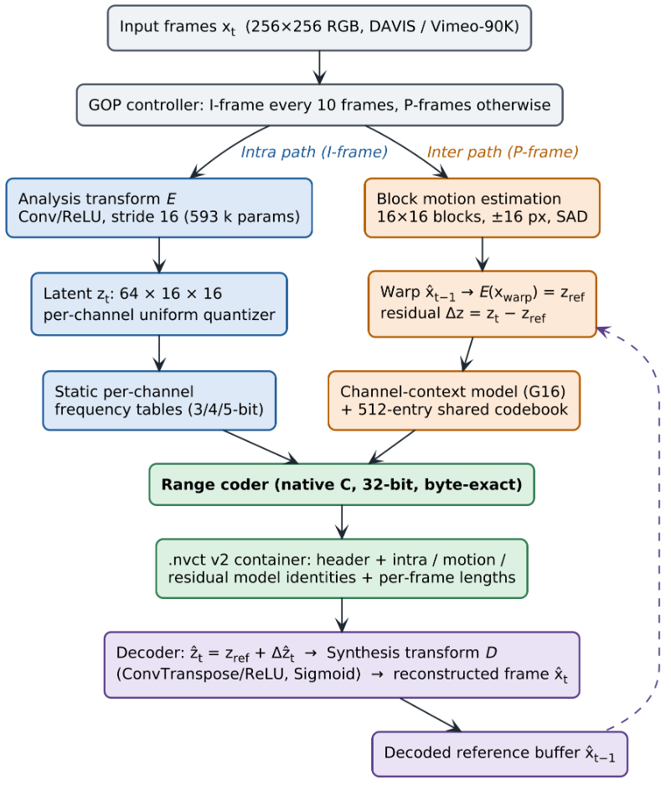
Fig. 1. Overall system architecture
- Learned Transform and Rate-Aware Training
The analysis transform E is a four-stage convolutional encoder (3→32→64→128→64 channels), each stage a stride-2 convolution followed by ReLU; the synthesis transform D mirrors it with a sigmoid output. A 256×256 RGB frame maps to a 64×16×16 latent, i.e. 16,384 symbols per frame, and the whole model has 593,411 parameters. Weights were warm-started on Vimeo-90K [18] and then fine-tuned on DAVIS TRAIN under a rate-aware objective [3] with additive uniform quantization noise,
L = d(x, x̂) + λ·R(ẑ), λ = 3×10⁻⁴ (1)
where d is mean-squared error and R is a differentiable rate proxy. An early version of that proxy scored against a frozen quantization bin width, and gradient descent exploited it: the model shrank its latent 2.5× to report a 3.7× lower proxy rate while the real bitstream grew slightly, because the deployed quantizer recalibrates its grid to the latent range. Tracking the latent scale and adapting the proxy density removed 97.3% of that spurious reward. Two seeds then selected λ = 3×10⁻⁴, which improved BD-rate by 18.12% over a distortion-only control trained under identical conditions.
- Motion-Compensated Latent Residual Coding
Temporal redundancy is removed by predicting each P-frame from a motion-warped copy of the previously decoded frame. Warping is performed in pixel space, where it is meaningful, while the prediction residual is formed in latent space, because the decoder's sigmoid output cannot represent signed pixel residuals:
x_{warp} = W(x̂_{t−1}, m̂v_{t}), z_{ref} = E(x_{warp}), Δz = z_{t} − z_{ref} (2)
ẑ_{t} = z_{ref} + Q⁻¹(Q(Δz)), x̂_{t} = D(ẑ_{t}) (3)
Motion is estimated by full-search block matching on 16×16 blocks over a ±16-pixel range under sum of absolute differences, with a deterministic tie-break favouring smaller vectors. Vectors are integer-pel so the warp is bit-exact, and are coded with two 64-symbol tables, one per component. The encoder searches between the decoded reference and the current frame, so encoder and decoder share the same reference by construction. Motion costs about 2% of the stream at 8-bit and 5.5% at 4-bit, and buys back more than twice its cost in residual bytes; against an all-intra configuration it is worth −32.22% BD-rate on PSNR and −41.86% on MS-SSIM.
- Context-Adaptive Learned Entropy Coding
The P-frame payload is dominated by residual symbols, so the entropy model of Δz received the most attention. It was developed in three stages, each measured only on held-out data.
1) Reference-conditioned model
The decoder holds the reference latent z_ref before it reads any residual symbol, so the residual distribution can be conditioned on it with no side information. A small network (two 3×3 convolutions of 32 channels plus a learned per-channel embedding) predicts a categorical distribution at each of the 16,384 positions, trained on pure rate, with 11,880–12,672 parameters depending on alphabet size.
2) Channel-autoregressive context
Where motion compensation fails, the residual is large across many channels at the same spatial position, which z_ref alone does not reveal but already-decoded channels do. Three causal input planes per channel (previous-group magnitude, running channel activity and an availability flag) are added, and the 64 channels are decoded in four sequential groups of sixteen (G16). The final model has 12,744–13,536 parameters and is worth −4.81% BD-rate over the codebook model it replaced. It improves every test sequence, most of all the high-motion ones.
3) Shared codebook and recalibration
Building integer frequency tables, one per symbol position or 16,384 per frame, dominated coding time. Instead, K = 512 prototype distributions are fitted on TRAIN, and each predicted distribution p is routed to the prototype minimising expected code length,
k* = arg min_{k} Σ_{s} p(s) · (−log₂ q_{k}(s)) (4)
which reduces to a single matrix product. Prototype frequencies were then re-fitted to the true TRAIN symbol histogram with assignments held fixed, so symbols and reconstructions are unchanged and only coding cost falls. The codebook retains the context model's gain to within +0.02% while removing 70–88% of residual-coding time and 91–95% of table memory. Recalibrating the prototypes later returned a further +1.42%/+2.64%/+4.04% of coded bytes at 5/4/3-bit, realising 99.97–100.02% of the offline prediction.
- Quantization and Calibration
Latents and residuals are quantized by per-channel affine uniform quantizers at 3, 4 or 5 bits, giving the codec's three operating points. All grids and tables are calibrated on DAVIS TRAIN only, from 400 frames sampled uniformly across sequences; a sampling study showed that calibrations generalise through coverage of the sequences, not frame count: 400 uniformly sampled frames recover 97.3% of the gain that 576 broadly sampled frames give over 576 sequential ones. The residual grid was initially regressed on each channel's 0.1st and 99.9th percentiles; re-centring it symmetrically about zero,
h_{c} = max(|P_{0.1}(Δz_{c})|, |P_{99.9}(Δz_{c})|), grid = [−h_{c}, h_{c}] (5)
left the step size essentially unchanged (ratio 1.02) but moved the zero position in 37 of the 64 channels, cutting 0th-order residual symbol entropy at 3-bit from 1.568 to 1.239 bits. That is 21% fewer bits for the same residuals, at the same step size and with the same reconstruction.
- Pre-Registered Gating Protocol
Individual changes to this codec are worth 1–5%, comparable to the variation induced by calibration noise or by tuning on evaluation data. Every candidate was therefore admitted under a fixed procedure: candidates, thresholds and quality guards are written down before any result is read; parameters are fitted on TRAIN; the candidate is tuned on one validation subset (VAL-A) and confirmed on a disjoint one (VAL-B); a survivor is verified in real arithmetic-coded bytes with bit-exact decoding and provenance hashes; and the test split is read once, at the end.
- System Implementation
The codec is a Python package with a native C entropy coder. Models are implemented and trained in PyTorch; local experiments run on an NVIDIA RTX 5060 laptop GPU (8 GB) and long Vimeo-90K training on a hosted notebook service. FFmpeg produces the classical anchors, and all metrics and BD-rate computations run in the project's own evaluation package.
The range coder [14], [15] was prototyped in Python, translated to C and loaded through ctypes; its realised length is within 0.026% of the model cross-entropy it is driven by. Streams use a self-describing container carrying a header, three 8-byte entropy-model identities and explicit per-frame motion and residual lengths, so motion bytes are counted on their own and cannot hide inside the residual, and a decoder refuses any stream whose identities do not match its own models. A codec bundle freezes the autoencoder weights, quantization grids, context model, codebooks and motion tables in one file and recomputes every identity on load: across six bundles and all nine test sequences, 54 of 54 streams were byte-identical to the research path and decoded bit-exactly.
Profiling the encoder on a CPU-only laptop showed full-search block matching consuming 85% of encode time, because the PyTorch implementation dispatches thousands of tiny tensor operations per frame. Reimplementing the search in C with AVX2 intrinsics and a runtime-selected scalar fallback, accumulating blocks in the reference order so vectors remain bit-identical, cut encoding from 463 to 96 ms/frame (4.8×) and the motion stage from 437 to 16 ms per P-frame (27×); both searches agreed on all 720 DAVIS frame pairs, so every result below is independent of which is used. Determinism needs this care: an equally valid floating-point summation order changed 38 of 196,608 codebook assignments (0.019%), which would desynchronise encoder and decoder. Decoding runs at 118–170 ms/frame.
- Results and Discussion
- Experimental Setup
All results are measured on the DAVIS 2017 test split at 256×256: nine sequences (bmx-bumps, car-turn, cat-girl, cows, drift-chicane, drone, gold-fish, schoolgirls, surf) and 719 frames. The proposed codec is evaluated at 3, 4 and 5 bits with a GOP of ten. libx264 and libx265 are evaluated both in their default GOP structure and in a low-delay configuration forced to the proposed codec's structure (an I-frame every ten frames, no B-frames). BD-rate is positive when the proposed codec needs more bits than the anchor for equal quality. One caveat applies throughout: the codec's three operating points span 28.31–29.82 dB, so every BD-rate here is integrated over that 1.5 dB window. The figures compare codecs within one harness and should not be read as absolute figures of merit against results computed over wider overlaps.
- Rate–Distortion Performance
Table I lists the operating points and Fig. 2 the rate–distortion curves. Every stream decodes bit-exactly, spanning 28.31–29.82 dB PSNR and 0.947–0.974 MS-SSIM. Against default x264 the codec needs 4.76×, 5.71× and 7.47× the bits at its 3-, 4- and 5-bit points, a BD-rate of +450.7% on PSNR and +378.3% on MS-SSIM (Table II).
TABLE I. Rate–Distortion Operating Points (DAVIS Test)
Codec / setting | BPP | PSNR (dB) | MS-SSIM
Proposed, 3-bit | 0.3170 | 28.31 | 0.9468
Proposed, 4-bit | 0.5043 | 29.46 | 0.9676
Proposed, 5-bit | 0.7211 | 29.82 | 0.9737
H.264, CRF 28 | 0.1194 | 30.67 | 0.9701
H.264, CRF 32 | 0.0743 | 28.77 | 0.9522
H.264, CRF 36 | 0.0480 | 26.92 | 0.9227
H.265, CRF 28 | 0.1323 | 31.29 | 0.9721
H.265, CRF 32 | 0.0805 | 29.34 | 0.9557

The gap widens with quality because finer quantization stops buying quality: the 593 k-parameter decoder approaches the limit of what it can synthesise, gaining 1.3 dB per rate doubling against H.264's 2.8 dB. GOP structure explains some of the difference, though less than half of it: forcing x264 into the proposed codec's structure narrows the deficit from +450.7% to +300.5%.
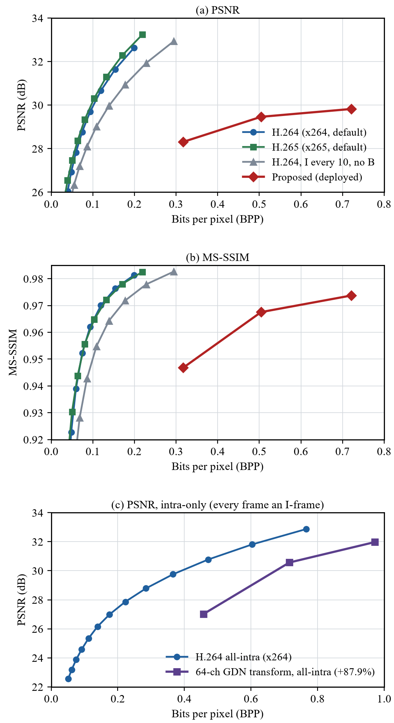
Fig. 2. Rate–distortion curves on the DAVIS test split
TABLE II. BD-Rate of the Proposed Codec Against Classical Anchors
Anchor | PSNR | MS-SSIM
H.264, default | +450.7% | +378.3%
H.265, default | +485.0% | +371.5%
H.264, I every 10, no B | +300.5% | +244.7%
H.265, I every 10, no B | +336.0% | +244.8%
593 k baseline, all-intra | +176.2% | +167.6%
GDN/residual 192-ch, all-intra | +560.6% | +456.1%
GDN/residual 64-ch, all-intra | +87.9% | +110.1%
GDN/residual 64-ch, 2 blocks, all-intra | +101.5% | +118.8%
GDN/residual 64-ch + QAT, all-intra | +46.5% | +55.8%

- Contribution of Individual Components
Each admitted milestone contributed as follows. The two large steps are rate-aware training (−18.12%) and motion-compensated P-frames (−32.22% against all-intra coding); motion compensation also improved quality, reaching a better PSNR at 4 bits than previous-frame prediction achieved at 8 bits for a third of the bitrate. The largest entropy-coding gain is the channel-autoregressive context model (−4.81%), and the shared codebook preserved that gain to within +0.02% while removing 70–88% of residual-coding time. At every entropy-model milestone PSNR and MS-SSIM were bit-identical before and after, and the coder realised 99.97–100.02% of the modelled gain.
The most recent admitted change is residual-grid re-centring, worth 1.06%, 1.31% and 1.76% of total bytes at 5, 4 and 3 bits on the full test split (BD-rate −2.47%), and PSNR also improved at 5 and 4 bits, so the change is a strict Pareto improvement. Its 3-bit test result (1.76%) exceeded its validation estimate (1.63%).
- Negative Results and Diagnosis of the Gap
The same protocol rejected nine candidates. Four were spatial-context modelling, a change of calibration sampling policy, the 192-channel latent discussed in Section V-E, and the two-residual-block transform; the remaining five are summarised here. A GOP-boundary motion asymmetry was real but bounded at +0.36% of the stream. An oracle that coded residuals against an oracle reference gave a +2.0–14.9% upper bound, but requires information no real decoder has. Recalibrating the intra quantizer, adding hysteresis to codebook assignment, and causal reference refinement each failed to turn a known mechanism into coded bytes; the last improved VAL-B by +0.71% but test by only +0.14%. All three attacked the entropy and quantization layers, which already operate within a few percent of their inputs' entropy. This pattern, more than any single result, moved the work on to the transform.
An intra-only benchmark separates the deficit into spatial and temporal parts. Coded all-intra, the codec is +176.2% BD-rate against x264 all-intra, against +300.5–306.2% when both use an I-frame every ten frames. Measured the other way, removing P-frames costs x264 2.8× its bitrate but the proposed codec only 1.8×: its motion compensation is the weaker half relative to H.264's, but the larger single deficit is the transform, with no motion involved at all.
- Transform Capacity and Latent Shape
To test the capacity hypothesis directly, the transform was replaced by one with GDN/IGDN nonlinearities [11] and residual blocks (8,437,827 parameters, 192-channel latent) and trained on Vimeo-90K. The first run diverged. GDN normalises by a square root whose gradient is unbounded as its denominator approaches the lower bound, so a single batch destroyed the weights; the run then recorded eighteen consecutive epochs of NaN while reporting every data chunk as completed. Gradient-norm clipping, a finite-loss check that aborts before writing, and a guard against recording a failed chunk as complete were added; the subsequent runs showed no divergence.
The salvaged checkpoint gated at +560.6% intra-only BD-rate (Table II), worse than the 593 k baseline, and diagnosis traced the cause to latent shape; training was not at fault. With no quantizer in the path the wider transform reconstructs at 30.56 dB against the baseline's 30.14 dB, a gain of only +0.43 dB, while coding 3.16–3.26× the bytes. That ratio is the symbol count: at the same stride, 192 channels against 64 is exactly 3× the symbols per frame. The cost is also largely decoupled from content. A channel carrying one twentieth of the busiest channel's energy still pays 68% of full bit depth, because the per-channel quantizer fits each channel's scale to its own spread and re-spreads near-idle channels across the whole alphabet (Spearman correlation between channel energy and channel cost, +0.22). Rate-aware training therefore has little to exploit, and reverse water-filling bit allocation recovers nothing on this transform.
Narrowing the latent while keeping the depth resolves this. Retaining 192 internal channels but a 64-channel latent gives 7,208,899 parameters (12× the baseline) at precisely the baseline's symbol count, and gates at +87.9% intra-only BD-rate on PSNR and +110.1% on MS-SSIM (Table II): the intra deficit halves, on all eight averaging conventions, and at matched bit depth the stream is within 2% of the baseline's size for up to +2.37 dB. Adding capacity beyond this does not help. A two-residual-block variant with 9,864,643 parameters at an identical symbol count, and so no extra rate, regressed to +101.5%, losing at every operating point while fitting Vimeo better (validation loss 1.19× lower, validation PSNR 0.9 dB higher), which points to a generalisation gap; training itself went well. Fig. 3 shows the deployed codec's qualitative behaviour at 3 bits: structure such as the road edge and fence posts survives while fine texture in grass and rock is flattened, as expected from a capacity-limited transform.
At 64 channels the remaining loss is quantization fragility. With no quantizer in the path the transform leads the baseline by a flat +2.450 dB, yet it surrenders +0.179, +0.627 and +1.710 dB more than the baseline at 5, 4 and 3 bits; subtracting the two reproduces its measured advantage of +2.37, +1.88 and +0.79 dB almost exactly, so by 3 bits fragility consumes 70% of what the transform earned. It had never seen a quantized latent in training, where the baseline had. This reading predicts that quantization-aware fine-tuning should recover most at the coarsest quantizer. Fine-tuning the same transform under 4-bit per-channel noise confirms it: the intra deficit halves again to +46.5% on PSNR and +55.8% on MS-SSIM (Table II), improving on all eight conventions, at a stream within 0.7% of its previous size. The float ceiling separates the two effects. It rose from 32.589 to 33.092 dB, so +0.503 dB of the gain is better reconstruction, and the loss to quantization fell by +0.332, +0.391 and +0.633 dB at 5, 4 and 3 bits. The two components sum to within 0.06 dB of the measured +0.86, +0.95 and +1.16 dB at every point, and the fragility share grows from 40% to 56% as the quantizer coarsens, as predicted. The excess shrinks but remains: the transform still loses 1.08 dB more than the baseline at 3 bits.
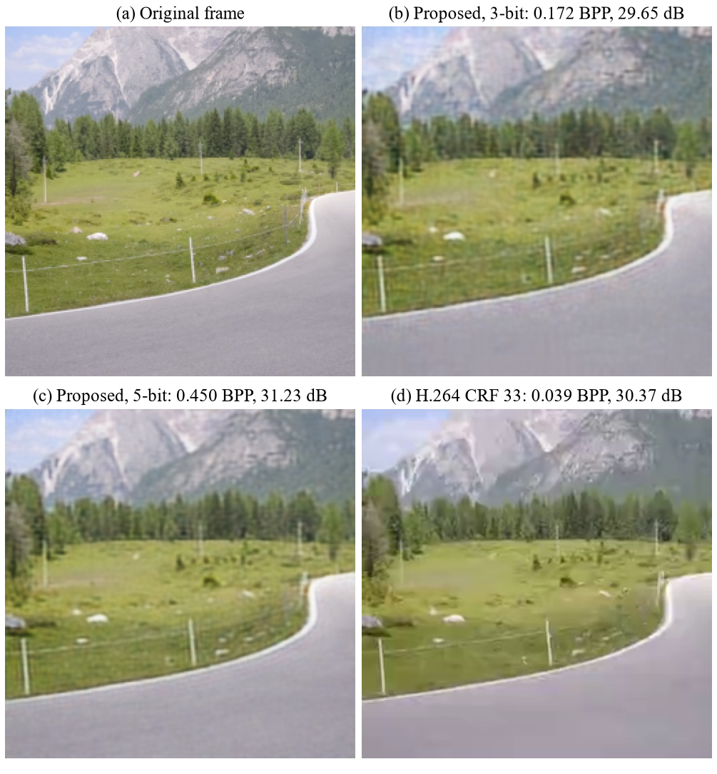
Fig. 3. Decoded P-frame (car-turn). The codec preserves structure but flattens fine texture, consistent with a capacity-limited transform.
- Per-Frame Coding Behaviour
Fig. 4 comes from an interactive demonstration: a local FastAPI web application that shows four views for any chosen frame, namely the motion vectors, the motion-compensated prediction, the magnitude of the latent residual and the decoding error (amplified 8×). The rows are P-frames 13 to 16 of the bmx-bumps test sequence. The camera pan dominates the motion field, and block search captures it as an almost uniform set of vectors; only the blocks on the rider point elsewhere, because the rider moves against the background. The prediction from the previous decoded frame matches the current frame everywhere except around the rider, and that is where the latent residual concentrates. It follows the rider from frame to frame, while the background costs little. The error map shows the same pattern, with the largest errors on the rider and on fine texture such as the fence and the grass, which the transform smooths out. The demonstration build pairs the quantization-aware fine-tuned transform with an entropy model that has not yet been refit to it, so the panels show where the codec spends its bits and are not a bitrate result.
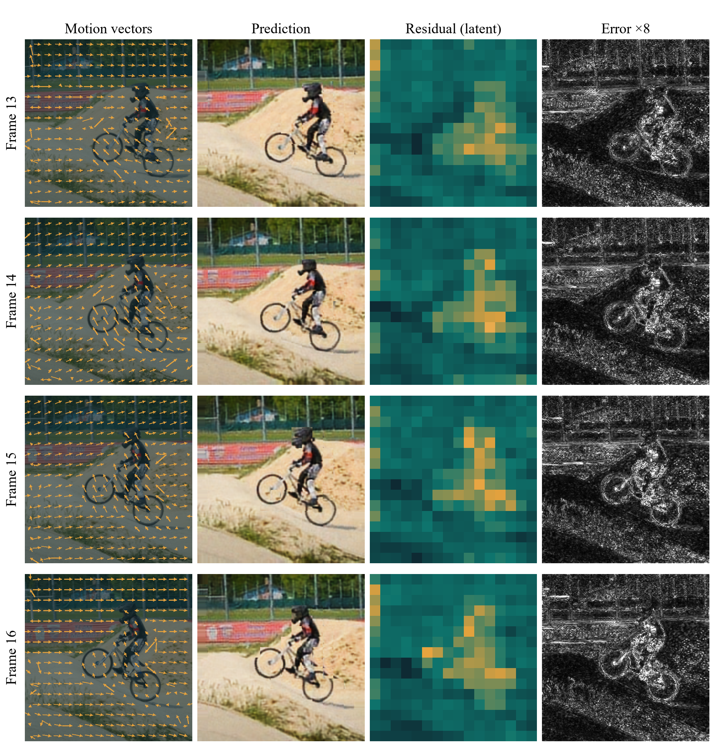
Fig. 4. Per-frame coding views for frames 13 to 16 of bmx-bumps (interactive demonstration)
- Conclusion
This paper presented a complete neural video codec, built from first principles and measured against H.264 and H.265 on real, bit-exact bitstreams. It combines a convolutional autoencoder, pixel-domain block motion compensation, latent-domain residual coding, a 13 k-parameter channel-autoregressive entropy model made affordable by a shared 512-entry codebook, and a native C range coder writing a self-describing container.
Rate-aware training and motion compensation provided the two large gains, and six entropy-coding and quantization changes added 0.02–4.81% each, every one admitted under a pre-registered protocol and confirmed on held-out test sequences. The same protocol rejected nine further candidates, several of which looked promising offline, a case for judging changes on real coded bytes.
The codec does not yet reach H.264: on the DAVIS test split it needs about 5.5× the bits of default x264. The diagnosis of why is specific enough to make predictions. The bottleneck is the transform's capacity, while the entropy and quantization layers already work within a few percent of their inputs' entropy. Without a hyperprior a wider latent is expensive, because at fixed stride the channel count sets the symbol count and per-channel quantization decouples cost from content. Once symbol parity is restored, the transform's remaining loss is quantization fragility. Acting on that reading in the order it implies (narrow the latent, then train against the quantizer) took the intra-only deficit from +176.2% to +87.9% and then to +46.5%. Each step was confirmed on the full test split in real coded bytes, and the second landed where the measurements predicted.
- Limitations and Future Work
The work has clear limitations. All measurements are at 256×256 and the ratios should not be extrapolated to 1080p; the test set is DAVIS, where most of the literature uses UVG or the HEVC common test conditions, so the anchors are reproduced here instead of taken from published tables. The GDN/residual transform changes two things at once relative to the Conv/ReLU baseline (the nonlinearity and the residual blocks), and the experiments here do not separate their contributions. The quantization-aware fine-tune likewise trained for further epochs on top of its warm start, so it does not isolate the effect of the noise alone; only the fragility component is isolated, via the float ceiling. The transform has no hyperprior, motion is block-translational and integer-pel, and training is staged and frozen, with no joint optimisation. The three rate points span 28.3–29.8 dB, so every BD-rate is integrated over that window. Coding is bit-exact on one machine; cross-platform decoding remains untested, because codebook assignment depends on the last bit of a floating-point matrix product. Most results come from a single seed; only the λ selection was repeated across two. Finally, the implementation is not real-time on a CPU: 96 ms/frame to encode with the native motion search and 118–170 ms/frame to decode.
Future work follows from the diagnosis. The immediate step is to refit the P-frame machinery (the channel-autoregressive context model, the codebooks and the motion table) to the new transform. That turns the intra-only result into a full-video one, and it is the largest question this paper leaves open. A scale hyperprior added to the context model would then make a wider latent affordable by pricing channels conditionally instead of independently. Per-channel bit allocation is worth revisiting too: on the fine-tuned transform it saves 3.3% of bytes, where before it saved nothing. Beyond that, learned optical flow with a motion autoencoder and a compensation network, and joint end-to-end training at several λ, are the route towards H.265. In parallel, codebook assignment will move to C, as the motion search already has.
References
- Wiegand T, Sullivan GJ, Bjøntegaard G, Luthra A (2003) Overview of the H.264/AVC Video Coding Standard. IEEE Transactions on Circuits and Systems for Video Technology, 13(7):560–576. DOI: 10.1109/TCSVT.2003.815165.
- Sullivan GJ, Ohm JR, Han WJ, Wiegand T (2012) Overview of the High Efficiency Video Coding (HEVC) Standard. IEEE Transactions on Circuits and Systems for Video Technology, 22(12):1649–1668. DOI: 10.1109/TCSVT.2012.2221191.
- Ballé J, Laparra V, Simoncelli EP (2017) End-to-end Optimized Image Compression. International Conference on Learning Representations (ICLR 2017). arXiv:1611.01704.
- Ballé J, Minnen D, Singh S, Hwang SJ, Johnston N (2018) Variational Image Compression with a Scale Hyperprior. International Conference on Learning Representations (ICLR 2018). arXiv:1802.01436.
- Minnen D, Ballé J, Toderici G (2018) Joint Autoregressive and Hierarchical Priors for Learned Image Compression. Advances in Neural Information Processing Systems (NeurIPS 2018), 31. arXiv:1809.02736.
- Lu G, Ouyang W, Xu D, Zhang X, Cai C, Gao Z (2019) DVC: An End-to-End Deep Video Compression Framework. Proceedings of the IEEE/CVF Conference on Computer Vision and Pattern Recognition (CVPR 2019), 11006–11015. arXiv:1812.00101.
- Agustsson E, Minnen D, Johnston N, Ballé J, Hwang SJ, Toderici G (2020) Scale-Space Flow for End-to-End Optimized Video Compression. Proceedings of the IEEE/CVF Conference on Computer Vision and Pattern Recognition (CVPR 2020), 8503–8512.
- Li J, Li B, Lu Y (2021) Deep Contextual Video Compression. Advances in Neural Information Processing Systems (NeurIPS 2021), 34. arXiv:2109.15047.
- Li J, Li B, Lu Y (2023) Neural Video Compression with Diverse Contexts. Proceedings of the IEEE/CVF Conference on Computer Vision and Pattern Recognition (CVPR 2023). arXiv:2302.14402.
- Theis L, Shi W, Cunningham A, Huszár F (2017) Lossy Image Compression with Compressive Autoencoders. International Conference on Learning Representations (ICLR 2017). arXiv:1703.00395.
- Ballé J, Laparra V, Simoncelli EP (2016) Density Modeling of Images using a Generalized Normalization Transformation. International Conference on Learning Representations (ICLR 2016). arXiv:1511.06281.
- Cheng Z, Sun H, Takeuchi M, Katto J (2020) Learned Image Compression with Discretized Gaussian Mixture Likelihoods and Attention Modules. Proceedings of the IEEE/CVF Conference on Computer Vision and Pattern Recognition (CVPR 2020), 7939–7948. arXiv:2001.01568.
- Zhu Y, Yang Y, Cohen T (2022) Transformer-based Transform Coding. International Conference on Learning Representations (ICLR 2022).
- Witten IH, Neal RM, Cleary JG (1987) Arithmetic Coding for Data Compression. Communications of the ACM, 30(6):520–540. DOI: 10.1145/214762.214771.
- Martin GNN (1979) Range Encoding: An Algorithm for Removing Redundancy from a Digitised Message. Video & Data Recording Conference, Southampton, UK.
- Bjøntegaard G (2001) Calculation of Average PSNR Differences between RD-Curves. ITU-T SG16/Q6 Video Coding Experts Group (VCEG), Document VCEG-M33, Austin, TX.
- Wang Z, Simoncelli EP, Bovik AC (2003) Multiscale Structural Similarity for Image Quality Assessment. Proceedings of the 37th Asilomar Conference on Signals, Systems and Computers, 2:1398–1402. DOI: 10.1109/ACSSC.2003.1292216.
- Xue T, Chen B, Wu J, Wei D, Freeman WT (2019) Video Enhancement with Task-Oriented Flow. International Journal of Computer Vision, 127(8):1106–1125. DOI: 10.1007/s11263-018-01144-2.
- Pont-Tuset J, Perazzi F, Caelles S, Arbeláez P, Sorkine-Hornung A, Van Gool L (2017) The 2017 DAVIS Challenge on Video Object Segmentation. arXiv preprint. arXiv:1704.00675.

