Real-Time Neural Video Compression: A Motion-Compensated Learned Codec with Context-Adaptive Entropy Coding, Benchmarked Against H.264 and H.265
Aditya Aggarwal
Amity University
Noida, Uttar Pradesh, India
aggarwaladitya2006@gmail.com
Yuvraj Dewan
Amity University
Noida, Uttar Pradesh, India
yuvrajdewan2005@gmail.com
Vatsala Upadhyay
Amity University
Noida, Uttar Pradesh, India
vupadhyay2@amity.edu

Abstract— Learned video codecs have recently matched and surpassed hand-engineered standards such as H.264/AVC and H.265/HEVC, but the published systems rely on transforms of 10–30 million parameters, hyperpriors and learned optical flow trained end to end on large GPU budgets, which makes their gains difficult to reproduce or to attribute at small scale. This paper presents a complete neural video codec built from first principles and measured byte for byte against libx264 and libx265. Each frame is mapped by a convolutional autoencoder to a 64×16×16 latent. I-frames are coded with per-channel uniform quantization and static frequency tables, while P-frames use integer-pel block motion compensation in pixel space and code only the latent residual between the current frame and its motion-warped reference. The residual is entropy coded by a 13 k-parameter channel-autoregressive context model whose predictions are mapped onto a shared codebook of 512 frequency tables, driving a range coder implemented in C that writes a self-describing bitstream. Every component was admitted through a pre-registered, held-out gating protocol. On the DAVIS 2017 test split (9 sequences, 719 frames), the deployed codec operates from 0.317 BPP at 28.31 dB to 0.721 BPP at 29.82 dB with bit-exact decoding. Rate-aware training and motion compensation reduced BD-rate by 18.1% and 32.2% respectively, and six entropy-coding and quantization refinements by a further 0.7–4.8% each. Against default x264 the codec still needs about 5.5× the bits (BD-rate +450.7% on PSNR, +378.3% on MS-SSIM). Diagnostic experiments locate this deficit in the 593 k-parameter transform rather than in entropy coding, and an analysis of a GDN residual transform shows that a 192-channel latent costs 3.2× the rate for 0.43 dB, motivating a capacity-preserving 64-channel design.
Keywords—Neural Video Compression, Learned Image Compression, Convolutional Autoencoder, Motion Compensation, Context-Adaptive Entropy Coding, Arithmetic Coding, Rate–Distortion Optimization, BD-Rate, H.264/AVC, H.265/HEVC.
- Introduction
Video accounts for the majority of internet traffic, and almost all of it is carried by hybrid block-based codecs. H.264/AVC [1] and its successor H.265/HEVC [2] combine motion-compensated prediction, block transforms, scalar quantization and context-adaptive arithmetic coding, refined over two decades of standardization. Each of these tools is hand-engineered: the transforms are fixed, the motion model is block-translational, and the probability models are designed rather than learned. Further gains from this route have become increasingly expensive in encoder complexity.
Learned image compression replaces these hand-designed tools with neural networks optimized jointly for rate and distortion. Ballé et al. [3] showed that an analysis transform, a quantizer and a synthesis transform can be trained end to end under a rate–distortion objective; the scale hyperprior [4] and the joint autoregressive and hierarchical prior of Minnen et al. [5] then made learned entropy models competitive with, and eventually better than, intra coding in HEVC.
Learned video compression extends the same idea in time. DVC [6] replaced every block of the hybrid codec with a network and reached H.264-level efficiency; scale-space flow [7] simplified motion compensation; and the DCVC family [8], [9] moved from residual coding to conditional coding in feature space and surpassed H.265 and later H.266. These systems, however, use 10–30 million parameters, learned optical flow and end-to-end training on large GPU budgets. Their papers report the end state of a large system, which leaves two practical questions open: how much of the published gain survives in a small, reproducible codec, and which component is responsible for what remains.
This work answers those questions empirically. We build a complete neural video codec from first principles, including the transforms, quantizers, motion model, learned entropy models, the arithmetic coder and the bitstream container, under student-scale compute, and we measure every change as real arithmetic-coded bytes on a held-out test set. The codec is benchmarked against libx264 and libx265 in a single pass in which every codec is scored on the same decoded 8-bit frames by the same code.
The contributions of this paper are: (i) an end-to-end motion-compensated latent-residual video codec producing a real, bit-exact bitstream through a native C range coder; (ii) a context-adaptive learned entropy coder in which a 13 k-parameter channel-autoregressive model is made practical by a shared 512-entry codebook of frequency tables; (iii) a pre-registered gating methodology and a reproducible benchmark harness that together admitted nine improvements and rejected seven other candidate changes; and (iv) an honest diagnosis of the remaining gap to H.264, which shows that transform capacity, not entropy coding, is the binding constraint, and which shapes the design of the next-generation transform.
- Literature Survey
Research on learned compression has progressed from image codecs to full video codecs. Theis et al. [10] introduced compressive autoencoders with a differentiable surrogate for quantization. Ballé et al. [3] proposed end-to-end optimized image compression with the generalized divisive normalization (GDN) nonlinearity [11] and an additive-uniform-noise relaxation of quantization, establishing the analysis–quantization–synthesis structure that most later work follows.
The entropy model has been the most productive axis of improvement in image coding. The scale hyperprior [4] transmits side information that predicts the scale of each latent, and Minnen et al. [5] combined it with an autoregressive context model, the first learned codec to outperform BPG, an HEVC-intra based image format. Cheng et al. [12] added Gaussian mixture likelihoods and attention modules and reached the efficiency of VVC intra coding, while Zhu et al. [13] showed that Swin-Transformer transforms can replace convolutions at comparable or better rate–distortion performance.
For video, Lu et al. [6] proposed DVC, which uses learned optical flow, a motion-vector autoencoder and a residual autoencoder trained jointly, and reported results better than H.264 on PSNR. Agustsson et al. [7] replaced bilinear warping with scale-space flow to handle disocclusion and fast motion. Li et al. introduced deep contextual video compression (DCVC) [8], which conditions the coding of the current frame on a learned temporal context instead of subtracting a prediction, and its successor DCVC-DC [9] uses diverse temporal and spatial contexts to surpass the H.266/VVC reference software.
All of these codecs share a lossless back end, arithmetic coding [14] or its byte-oriented form, range coding [15], whose realized length is within a small fraction of the model's cross-entropy. They are evaluated by Bjøntegaard delta rate (BD-rate) [16], which averages the bitrate difference between two rate–distortion curves at equal quality, using PSNR and multi-scale SSIM [17], and are typically trained on Vimeo-90K [18] and tested on standard sequences such as DAVIS [19].
Although these studies establish that learned codecs can surpass the standards, they report the end state of large, jointly trained systems. Comparatively little work examines a minimal learned codec component by component with real bitstreams, and comparisons against classical anchors frequently differ in GOP structure, colour handling and quality conventions. Table I summarizes the analysed literature. The present work addresses this gap with a fully measured codec and a single-pass benchmark in which every codec is scored identically.
TABLE I. Analysis of Existing Research
Ref. | Research Focus | Strengths | Research Gap
[1] | H.264/AVC standard | Mature hybrid coding; universal hardware support | Hand-engineered tools; nothing is learned
[2] | H.265/HEVC standard | About half the bitrate of H.264 at equal quality | Fixed transforms; high encoder complexity
[3] | End-to-end image compression | Joint rate–distortion training of transforms | Images only; no temporal model
[4] | Scale hyperprior | Learned side information for the entropy model | Intra only; adds model size
[5] | Autoregressive + hierarchical prior | First learned codec to beat BPG (HEVC-intra) | Serial context decoding is slow
[12] | Mixture likelihood + attention | VVC-intra level image coding | Heavy model; GPU-bound
[6] | DVC: end-to-end video | H.264-level learned video coding | Learned flow; large training budget
[7] | Scale-space flow | Robust warping under fast motion | Training cost; no small-scale baseline
[8] | DCVC: conditional coding | Feature-space context; beats H.265 | 10–30 M parameters, heavy compute
[9] | DCVC-DC: diverse contexts | Surpasses H.266/VVC reference | Very large; hard to reproduce

- Methodology
This section presents the proposed codec, a motion-compensated learned video codec that combines a convolutional analysis/synthesis transform with pixel-domain block motion compensation, latent-domain residual coding and a context-adaptive learned entropy model. Frames are organized in groups of pictures (GOPs) of ten: the first frame of each GOP is intra coded (I-frame) and the remaining nine are predicted from the previously decoded frame (P-frames). Every symbol, including every motion vector, is entropy coded into the bitstream and counted in the reported rate. Fig. 1 shows the overall architecture.
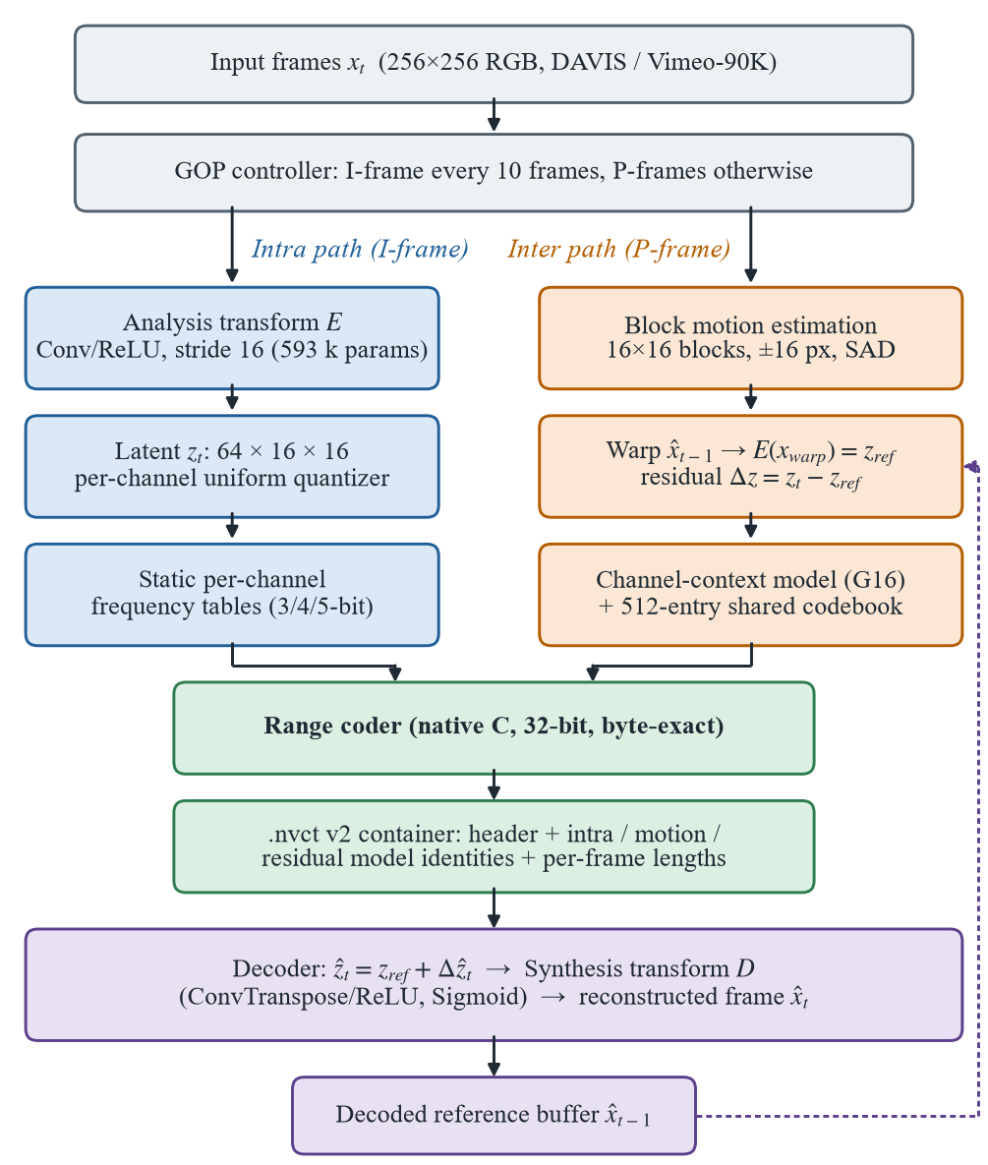
Fig. 1. Overall System Architecture
- Learned Transform and Rate-Aware Training
The analysis transform E is a four-stage convolutional encoder (3→32→64→128→64 channels), each stage a stride-2 convolution followed by ReLU, and the synthesis transform D mirrors it with transposed convolutions and a final Sigmoid. A 256×256 RGB frame is mapped to a 64×16×16 latent, i.e. 16,384 symbols per frame, and the complete model has 593,411 parameters. The weights were first trained on Vimeo-90K [18] and then fine-tuned on DAVIS TRAIN with additive uniform quantization noise [3] and the rate-aware objective
L = d(x, x̂) + λ·R(ẑ), λ = 3×10⁻⁴ (1)
where d is the mean-squared error and R a differentiable rate proxy. An early version of the proxy scored rate against a fixed quantization bin width, and gradient descent exploited it: a model shrank its latent 2.5× to obtain a 3.7× lower proxy rate while the real bitstream became slightly larger, because the deployed quantizer recalibrates its grid to the latent range. Tracking the latent scale and adapting the density in the proxy removed 97.3% of this shrinkage reward. A λ sweep with two seeds then selected λ = 3×10⁻⁴, which improved BD-rate by 18.12% over a distortion-only control trained identically.
- Motion-Compensated Latent Residual Coding
Temporal redundancy is removed by predicting each P-frame from a motion-warped copy of the decoded previous frame. Warping is performed in pixel space, where motion is meaningful, and the prediction residual is formed in the latent domain, since the decoder's Sigmoid output cannot represent signed pixel residuals:
x_{warp} = W(x̂_{t−1}, m̂v_{t}), z_{ref} = E(x_{warp}), Δz = z_{t} − z_{ref} (2)
ẑ_{t} = z_{ref} + Q⁻¹(Q(Δz)), x̂_{t} = D(ẑ_{t}) (3)
Motion is estimated by full-search block matching with 16×16 blocks, a ±16 pixel range and the sum of absolute differences, with a deterministic tie-break that prefers smaller vectors. At 256×256 this yields exactly one vector per latent position. Vectors are integer-pel so that the warp is bit-exact, and are coded with two 64-symbol tables (vertical and horizontal). The encoder warps with the decoded vectors and the decoded reference, so the encoder and decoder references are identical by construction (Fig. 2). Motion costs 2–5% of the stream and saves about twice its own cost in residual bytes.
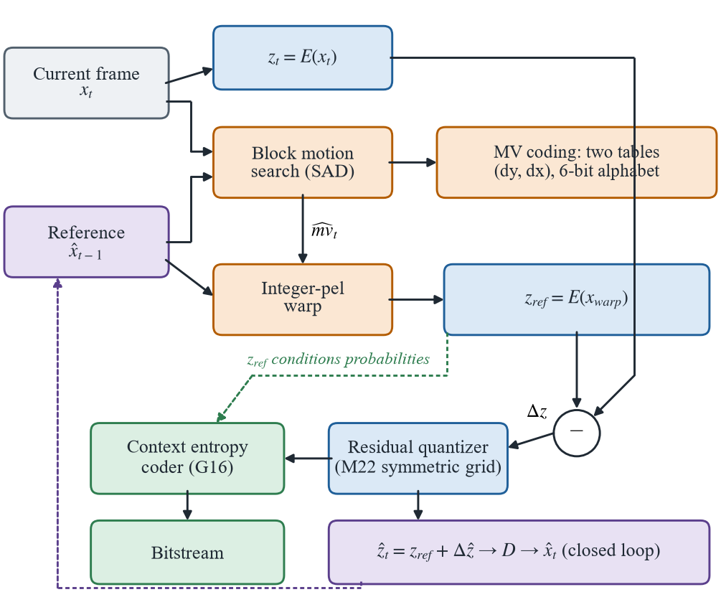
Fig. 2. Closed-Loop P-Frame Coding
- Context-Adaptive Learned Entropy Coding
The residual symbols dominate the P-frame payload, so the entropy model for Δz received the most attention. It was developed in three steps, each admitted only after measurement on held-out data.
1) Reference-conditioned model
The warped reference z_{ref} is available to the decoder before any residual symbol is read, so it can condition the residual distribution without side information. A small network applies two 3×3 convolutions (32 channels) and a learned channel embedding to each latent channel of z_{ref} and predicts a categorical distribution at each of the 16,384 positions. It is trained on pure rate, −log₂ p(Δz | z_{ref}, channel), and has between 11,880 and 12,672 parameters depending on the alphabet size.
2) Channel-autoregressive context
Where motion compensation fails, the residual is large in every channel at the same position, which z_{ref} cannot know. Once some channels are decoded, their activity reveals it. Three causal input planes per channel (previous-group magnitude, running activity and an availability flag) are added, and channels are decoded in four sequential groups of sixteen (G16), which keeps decoding to four steps. The final model has 12,744–13,536 parameters (Fig. 3).
3) Shared codebook and recalibration
Building 16,384 integer frequency tables per frame consumed 77–87% of the coding time. Instead, K = 512 prototype distributions are fitted once on TRAIN, and each predicted distribution p is assigned to the prototype that minimizes its expected code length:
k* = arg min_{k} Σ_{s} p(s) · (−log₂ q_{k}(s)) (4)
which is a single matrix product. The prototype frequencies were later refitted from the actual TRAIN symbol histogram while keeping the assignment fixed, so symbols and reconstructions are provably unchanged and only the coding cost falls.
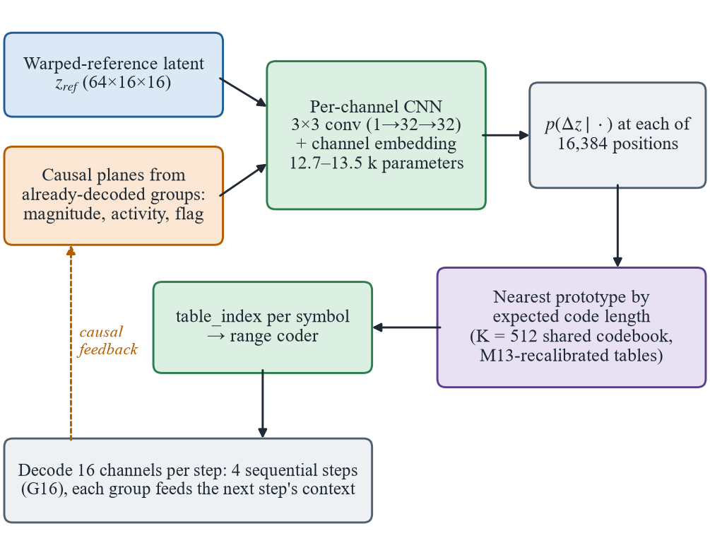
Fig. 3. Context-Adaptive Entropy Coding Pipeline
- Quantization and Calibration
Latents and residuals are quantized with per-channel affine uniform quantizers at 3, 4 or 5 bits, which define the three operating points of the codec. All grids and tables are calibrated on DAVIS TRAIN only, from 400 frames sampled uniformly across sequences; an experiment comparing sampling policies showed that this coverage, rather than the number of frames, is what makes a calibration generalize. The residual grid was originally fitted to the 0.1st–99.9th percentile range of each channel. Re-centering it symmetrically about zero,
h_{c} = max(|P_{0.1}(Δz_{c})|, |P_{99.9}(Δz_{c})|), grid = [−h_{c}, h_{c}] (5)
left the step size almost unchanged (ratio 1.02) but moved the zero point on 37 of the 64 channels and reduced the zero-order residual entropy at 3 bits from 1.568 to 1.239 bits per symbol.
- Pre-Registered Gating Protocol
Small codec changes produce effects of 1–5%, which is comparable to the variation caused by calibration noise or by tuning on the evaluation data. Every candidate was therefore admitted through the protocol in Fig. 4. Candidates, thresholds and quality guards are written down before any result is read; parameters are fitted on TRAIN, tuned on one validation subset (VAL-A) and gated on a disjoint subset (VAL-B); survivors are confirmed with real arithmetic-coded bytes, bit-exact decoding and provenance hashes; and the DAVIS test split is read once, at the end. Table II lists the components that passed.
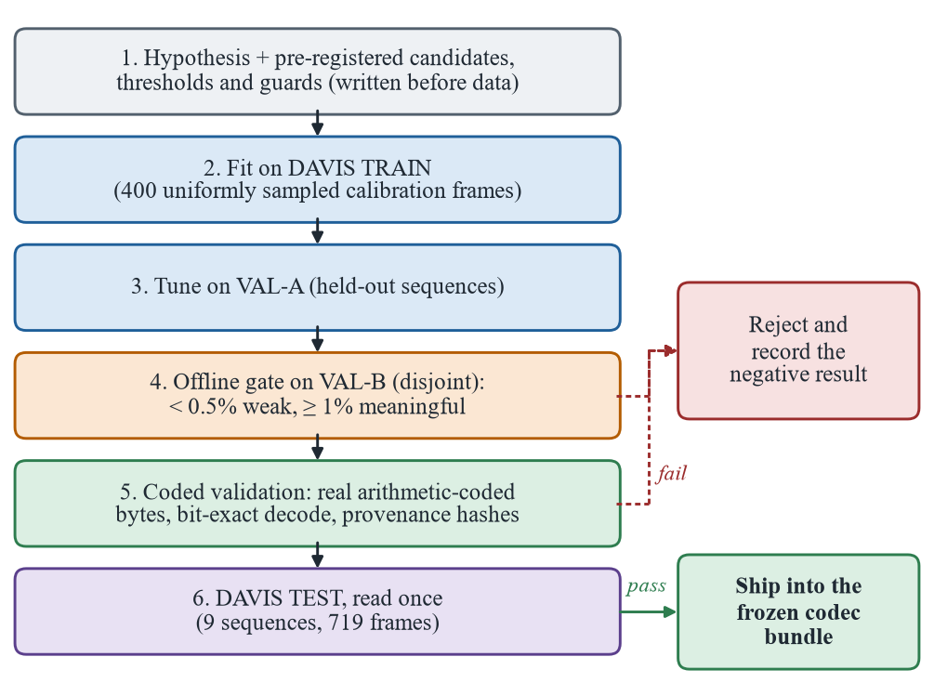
Fig. 4. Pre-Registered Gating Protocol
TABLE II. Major Components of the Codec
Component | Primary Responsibility
Analysis transform E | 256×256 RGB frame to a 64×16×16 latent (Conv/ReLU, stride 16)
Synthesis transform D | Latent to reconstructed frame (ConvTranspose, Sigmoid)
Intra quantizer | Per-channel uniform quantization with static per-channel tables
Motion estimator | 16×16 full search, ±16 px, integer-pel, deterministic SAD tie-break
Motion coder | Two 64-symbol tables (dy, dx), recalibrated on a broad TRAIN sample
Residual quantizer | Symmetric, re-centered grid for the latent residual Δz
Context model (G16) | 12.7–13.5 k-parameter CNN; four causal channel-group steps
Shared codebook | 512 prototype tables; assignment by expected code length
Range coder | Native C arithmetic coder, byte-exact, loaded via ctypes
Container and bundle | .nvct v2 framing, model identities, frozen codec bundles

- System Implementation
The codec was developed as a Python package, nvc, with a native C extension for entropy coding. Research code for each milestone is kept separately as the record of how every component was derived, and the deployed codec is exposed through a two-call interface, nvc.encode(frames, bundle) and nvc.decode(data, bundle).
- Technology Stack
Models are implemented and trained in PyTorch, using CUDA on an NVIDIA RTX 5060 laptop GPU (8 GB) for local experiments and Google Colab for long Vimeo-90K training runs. Classical anchors are produced with FFmpeg, and all metrics, BD-rate computation and plotting are implemented in the project's evaluation package. Table III summarizes the stack.
TABLE III. Technology Stack
Layer | Technology
Language | Python 3.11; C (range coder)
Deep learning | PyTorch 2.13 with CUDA 13.0
Training data | Vimeo-90K septuplets (256×256 crops)
Evaluation data | DAVIS 2017 TRAIN / VAL / TEST splits
Classical anchors | FFmpeg 9.0: libx264, libx265 (preset medium)
Metrics | PSNR, MS-SSIM, BD-rate (piecewise linear)
Hardware | RTX 5060 Laptop GPU (8 GB); Google Colab
Testing and CI | pytest (1,702 tests); GitHub Actions on Ubuntu
Packaging | nvc package with frozen, self-verifying codec bundles

- Native Range Coder and Bitstream
The arithmetic coder [14], [15] was first written in Python and then migrated to C, loaded through ctypes and compiled automatically on first import. The C coder is 47.8× faster for encoding and 32.5× faster for decoding, produces byte-identical output, and has no Python fallback, so a missing build fails loudly instead of silently slowing down. Its realized length is within 0.026% of the ideal code length of the model it is driven by.
Streams are written in the .nvct v2 container, which records a header, three 8-byte identities for the intra, motion and residual entropy models, and explicit motion and residual lengths for every frame, so that motion bytes are attributable rather than hidden inside the residual. A decoder refuses any stream whose structure or identities do not match its own models before reading a single symbol, and table indices and decoded motion vectors are range-checked, which fixed a decoder hang on malformed input.
- Frozen Codec Bundles
A codec bundle freezes everything one operating point needs (autoencoder weights, quantization grids, context model, codebooks and motion tables) in a single file, and recomputes all identities when loaded, so a drifted bundle is rejected. Six bundles were exported, and the package was verified against the original research code on all nine test sequences: all 54 of 54 streams were byte-identical, decoding was bit-exact, and every byte total matched the recorded milestone results.
- Benchmark Harness and Reproducibility
The benchmark encodes every codec in a single pass and scores all of them with one function on the 8-bit frames a real decoder delivers. Rates are whole files on disk, .nvct containers for the proposed codec and .mp4 files for FFmpeg. Four quality-averaging conventions are reported, and every run records the SHA-256 digests of its checkpoint and calibration files. Building the harness exposed two measurement errors: an earlier comparison had scored H.264 and the proposed codec with different PSNR definitions, and MS-SSIM read up to 0.005 too high on channels-last CUDA tensors. Both were fixed before the results below were produced.
- Results and Discussion
- Experimental Setup
All results are measured on the DAVIS 2017 test split at 256×256: nine sequences (bmx-bumps, car-turn, cat-girl, cows, drift-chicane, drone, gold-fish, schoolgirls and surf) totalling 719 frames. The proposed codec is evaluated at 3, 4 and 5 bits with a GOP of ten. H.264 and H.265 are evaluated with libx264 and libx265 at preset medium, yuv420p, at thirteen CRF values from 20 to 44, both with their default GOP structure and in a low-delay configuration forced to the proposed codec's structure (an I-frame every ten frames, no B-frames). BD-rate is positive when the proposed codec needs more bits than the anchor at equal quality.
- Rate–Distortion Performance
Table IV lists the operating points and Fig. 5 the rate–distortion curves. The codec decodes every stream bit-exactly and spans 28.31–29.82 dB PSNR and 0.947–0.974 MS-SSIM. Against default x264 it requires 4.76×, 5.71× and 7.47× the bits of H.264 at its 3-, 4- and 5-bit points, a BD-rate of +450.7% on PSNR and +378.3% on MS-SSIM (Table V).
TABLE IV. Rate–Distortion Operating Points (DAVIS Test)
Codec / setting | BPP | PSNR (dB) | MS-SSIM
Proposed, 3-bit | 0.3170 | 28.31 | 0.9468
Proposed, 4-bit | 0.5043 | 29.46 | 0.9676
Proposed, 5-bit | 0.7211 | 29.82 | 0.9737
H.264, CRF 28 | 0.1194 | 30.67 | 0.9701
H.264, CRF 32 | 0.0743 | 28.77 | 0.9522
H.264, CRF 36 | 0.0480 | 26.92 | 0.9227
H.265, CRF 28 | 0.1323 | 31.29 | 0.9721
H.265, CRF 32 | 0.0805 | 29.34 | 0.9557

The shape of the curve explains why the gap widens with quality. Across the measured range, each doubling of rate buys the proposed codec 1.3 dB, against 2.8 dB for H.264 and H.265 over the same quality window; moving from 4 to 5 bits gains only 0.36 dB for 43% more bits. Finer quantization no longer buys quality because the 593 k-parameter decoder is close to the ceiling of what it can reconstruct. GOP structure is a minority of the gap: forcing x264 into the proposed codec's structure reduces the deficit from 5.5× to about 4.0× (BD-rate +300.5%), roughly one fifth of the gap in logarithmic terms.
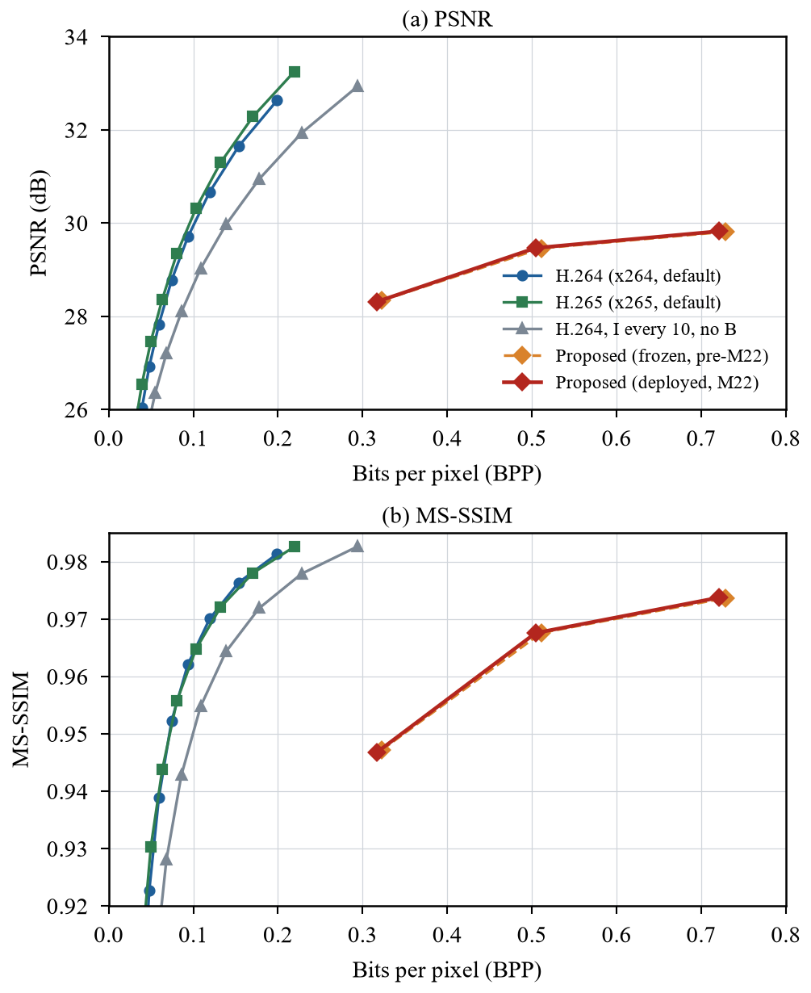
Fig. 5. Rate–Distortion Curves on DAVIS Test
TABLE V. BD-Rate of the Proposed Codec Against Classical Anchors
Anchor | PSNR | MS-SSIM
H.264, default | +450.7% | +378.3%
H.265, default | +485.0% | +371.5%
H.264, I every 10, no B | +300.5% | +244.7%
H.265, I every 10, no B | +336.0% | +244.8%
H.264 all-intra (vs. all-intra) | +176.2% | +167.6%

- Contribution of Individual Components
Fig. 6 reports the BD-rate of each admitted milestone against the codec it replaced. Rate-aware training (−18.1%) and motion-compensated P-frames (−32.2% against all-intra coding) are the two large steps. Motion compensation also improved quality: at 4 bits it produced a higher PSNR than previous-frame prediction at 8 bits at a third of the bitrate. The channel-autoregressive context model is the largest entropy-coding gain (−4.81% over the codebook model, with every test sequence improving and the largest gains on the high-motion sequences), and the shared codebook kept the learned model's gain within 0.02% while cutting residual-coding time by 70–88%. For every entropy-model milestone, PSNR and MS-SSIM were bit-identical before and after, and the coder realized essentially all of the modelled gain (99.97–100.02%).
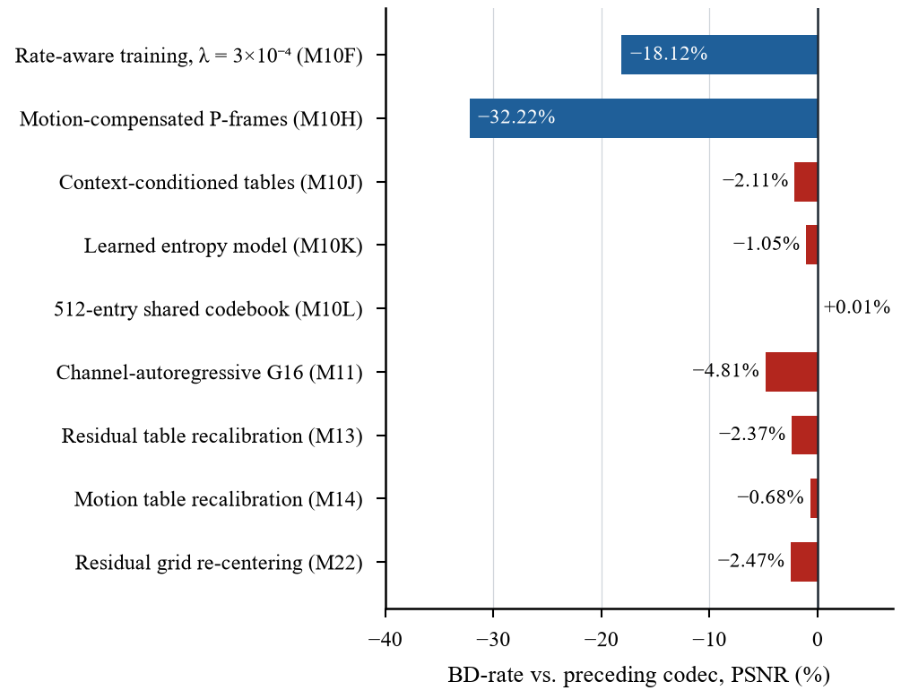
Fig. 6. BD-Rate Contribution of Each Admitted Milestone
Residual-grid re-centering is the most recent gain: 1.06%, 1.31% and 1.76% fewer total bytes at 5, 4 and 3 bits on the full test split, with higher PSNR at 5 and 4 bits, a strict Pareto improvement. Its validation estimate (1.63% at 3 bits) was met on test (1.76%), and all nine sequences improved individually.
- Negative Results and Diagnosis of the Gap
The protocol also rejected seven candidate changes, and the rejections are informative. A GOP-boundary motion anomaly was real but worth at most 0.36% of the stream; an oracle that coded residuals against the oracle reference showed a 2.0–14.9% upper bound, but the oracle needs information no real decoder has; recalibrating the intra quantizer, adding hysteresis to codebook assignment (+0.0007%) and causal reference refinement (+0.71% on VAL-B, only +0.14% on test) all failed to convert a measured mechanism into coded bytes. Each of these targeted the entropy and quantization layers, which already sit within a few percent of what their inputs allow.
An intra-only benchmark separated the deficit into a spatial and a temporal part. Coded all-intra, the codec is +176.2% BD-rate against x264 all-intra, against +300.5–306.2% when both use an I-frame every ten frames. Disabling P-frames costs x264 2.8× in bitrate but the proposed codec only 1.8×, so its motion compensation is measurably weaker than H.264's, while the transform remains the largest single deficit, with no motion involved at all.
- Analysis of a Higher-Capacity Transform
A replacement transform with GDN/IGDN nonlinearities [11] and residual blocks, 8,437,827 parameters with a 192-channel latent, was implemented and trained on Vimeo-90K. The first run diverged: GDN normalizes by a square root whose gradient is unbounded near its lower bound, and without gradient clipping a single batch destroyed the weights, after which the run trained on NaN values for eighteen epochs. Gradient-norm clipping, finite-loss checks and a guard against recording a failed chunk as complete were added.
The surviving checkpoint gated at +560.6% intra-only BD-rate, far worse than the baseline's +176.2%, and measuring it showed that the latent shape, not training, was the problem. Without quantization the wider transform reconstructs at 30.56 dB against 30.14 dB (+0.43 dB), yet it codes 3.16–3.26× the bytes, matching its exactly 3× larger symbol count. The cost is decoupled from content: a channel carrying one twentieth of the energy of the busiest channel still pays 68% of full bit depth, because per-channel scaling re-spreads near-idle channels across the whole alphabet, so rate-aware training cannot recover the penalty. The next transform therefore keeps 192 internal channels but a 64-channel latent: 7,208,899 parameters, twelve times the baseline, at exactly the baseline symbol count. Reverse water-filling bit allocation, already implemented but inactive, was also found to save 6.65–8.33% of bytes for 0.06–0.16 dB.
Fig. 7 shows a decoded P-frame of the car-turn sequence. The proposed codec preserves structure such as the road edge and fence posts but smooths fine texture in the grass and rock face, consistent with a capacity-limited transform. H.264 at CRF 33 exceeds the PSNR of the 3-bit point with less than a quarter of its bits.
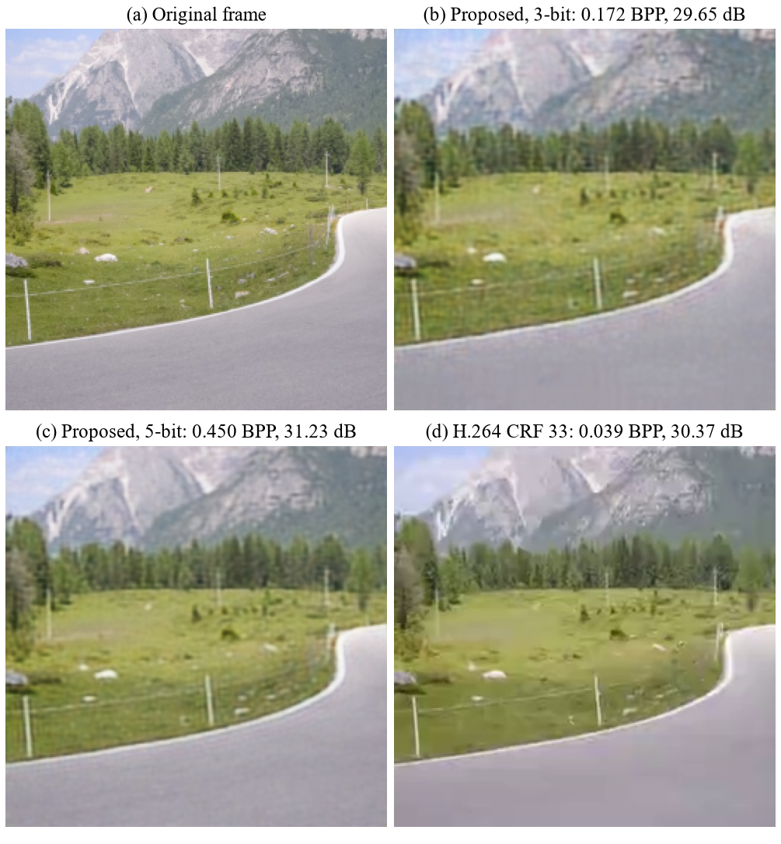
Fig. 7. Decoded P-Frame (car-turn, Frame 7 of a 20-Frame Clip)
- Conclusion
This research presented a complete neural video codec, built from first principles and measured against H.264 and H.265 with real, bit-exact bitstreams. The codec combines a convolutional autoencoder with pixel-domain block motion compensation, latent-domain residual coding, a 13 k-parameter channel-autoregressive entropy model made practical by a shared 512-entry codebook, and a native C range coder writing a self-describing container.
Rate-aware training and motion compensation provided the two large improvements, and a sequence of entropy-coding and quantization refinements, each admitted through a pre-registered protocol and confirmed on held-out test data, added gains of 0.7–4.8% each. The same protocol rejected seven other candidates, several of which looked promising offline, which shows the value of measuring real coded bytes rather than model estimates.
The codec does not yet reach H.264: on the DAVIS test split it needs about 5.5× the bits of default x264. The diagnosis is nevertheless precise. The deficit lies in the capacity of the 593 k-parameter transform and, secondarily, in block motion compensation, not in entropy coding, and a wider latent is not a free upgrade without a hyperprior. These findings convert an open-ended goal into a staged plan whose every step is measured against H.264 with the same harness.
- Limitations & Future Work
The present results have several limitations. All measurements are at 256×256, and the ratios should not be extrapolated to 1080p. The codec offers only three rate points spanning 28.3–29.8 dB, so every BD-rate is averaged over that window. The transform has no hyperprior, motion is block-translational and integer-pel, and training is staged and frozen rather than joint. Encoding and decoding have been verified bit-exact on one machine; because codebook assignment depends on the last bit of a floating-point matrix product, cross-platform decoding remains to be tested. Finally, the codec is not yet real-time on a CPU: block motion search accounts for 85% of encoding time, and a single-threaded C prototype of it is 25–31× faster but not yet integrated.
Future work follows the staged plan. The 64-channel GDN residual transform will be trained on the full Vimeo-90K set and gated against the intra-only benchmark. A scale hyperprior [4] will be combined with the existing context model to form a joint autoregressive and hierarchical prior [5]. Block motion will be replaced by learned optical flow with a motion autoencoder and a compensation network [6], [7], followed by end-to-end joint training at several λ values and feature-space conditional coding [8], [9] as the route toward H.265. In parallel, the motion-search and codebook-assignment kernels will be integrated in C, and the networks exported through ONNX to GPU and NPU runtimes toward real-time operation.
References
- Wiegand T, Sullivan GJ, Bjøntegaard G, Luthra A (2003) Overview of the H.264/AVC Video Coding Standard. IEEE Transactions on Circuits and Systems for Video Technology, 13(7):560–576. DOI: 10.1109/TCSVT.2003.815165.
- Sullivan GJ, Ohm JR, Han WJ, Wiegand T (2012) Overview of the High Efficiency Video Coding (HEVC) Standard. IEEE Transactions on Circuits and Systems for Video Technology, 22(12):1649–1668. DOI: 10.1109/TCSVT.2012.2221191.
- Ballé J, Laparra V, Simoncelli EP (2017) End-to-end Optimized Image Compression. International Conference on Learning Representations (ICLR 2017). arXiv:1611.01704.
- Ballé J, Minnen D, Singh S, Hwang SJ, Johnston N (2018) Variational Image Compression with a Scale Hyperprior. International Conference on Learning Representations (ICLR 2018). arXiv:1802.01436.
- Minnen D, Ballé J, Toderici G (2018) Joint Autoregressive and Hierarchical Priors for Learned Image Compression. Advances in Neural Information Processing Systems (NeurIPS 2018), 31. arXiv:1809.02736.
- Lu G, Ouyang W, Xu D, Zhang X, Cai C, Gao Z (2019) DVC: An End-to-End Deep Video Compression Framework. Proceedings of the IEEE/CVF Conference on Computer Vision and Pattern Recognition (CVPR 2019), 11006–11015. arXiv:1812.00101.
- Agustsson E, Minnen D, Johnston N, Ballé J, Hwang SJ, Toderici G (2020) Scale-Space Flow for End-to-End Optimized Video Compression. Proceedings of the IEEE/CVF Conference on Computer Vision and Pattern Recognition (CVPR 2020), 8503–8512.
- Li J, Li B, Lu Y (2021) Deep Contextual Video Compression. Advances in Neural Information Processing Systems (NeurIPS 2021), 34. arXiv:2109.15047.
- Li J, Li B, Lu Y (2023) Neural Video Compression with Diverse Contexts. Proceedings of the IEEE/CVF Conference on Computer Vision and Pattern Recognition (CVPR 2023). arXiv:2302.14402.
- Theis L, Shi W, Cunningham A, Huszár F (2017) Lossy Image Compression with Compressive Autoencoders. International Conference on Learning Representations (ICLR 2017). arXiv:1703.00395.
- Ballé J, Laparra V, Simoncelli EP (2016) Density Modeling of Images using a Generalized Normalization Transformation. International Conference on Learning Representations (ICLR 2016). arXiv:1511.06281.
- Cheng Z, Sun H, Takeuchi M, Katto J (2020) Learned Image Compression with Discretized Gaussian Mixture Likelihoods and Attention Modules. Proceedings of the IEEE/CVF Conference on Computer Vision and Pattern Recognition (CVPR 2020), 7939–7948. arXiv:2001.01568.
- Zhu Y, Yang Y, Cohen T (2022) Transformer-based Transform Coding. International Conference on Learning Representations (ICLR 2022).
- Witten IH, Neal RM, Cleary JG (1987) Arithmetic Coding for Data Compression. Communications of the ACM, 30(6):520–540. DOI: 10.1145/214762.214771.
- Martin GNN (1979) Range Encoding: An Algorithm for Removing Redundancy from a Digitised Message. Video & Data Recording Conference, Southampton, UK.
- Bjøntegaard G (2001) Calculation of Average PSNR Differences between RD-Curves. ITU-T SG16/Q6 Video Coding Experts Group (VCEG), Document VCEG-M33, Austin, TX.
- Wang Z, Simoncelli EP, Bovik AC (2003) Multiscale Structural Similarity for Image Quality Assessment. Proceedings of the 37th Asilomar Conference on Signals, Systems and Computers, 2:1398–1402. DOI: 10.1109/ACSSC.2003.1292216.
- Xue T, Chen B, Wu J, Wei D, Freeman WT (2019) Video Enhancement with Task-Oriented Flow. International Journal of Computer Vision, 127(8):1106–1125. DOI: 10.1007/s11263-018-01144-2.
- Pont-Tuset J, Perazzi F, Caelles S, Arbeláez P, Sorkine-Hornung A, Van Gool L (2017) The 2017 DAVIS Challenge on Video Object Segmentation. arXiv preprint. arXiv:1704.00675.

