Platform – HackerEarth
Question – Count Divisors
Problem Statement Link - https://www.hackerearth.com/practice/basic-programming/input-output/basics-of-input-output/practice-problems/algorithm/count-divisors/
C Source Code –
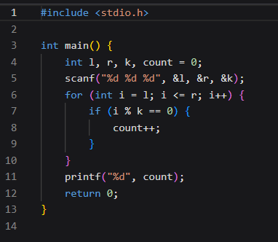
Submission –


