Platform – HackerEarth
Question – Prime Numbers
Problem Statement Link - https://www.hackerearth.com/problem/algorithm/prime-numbers/
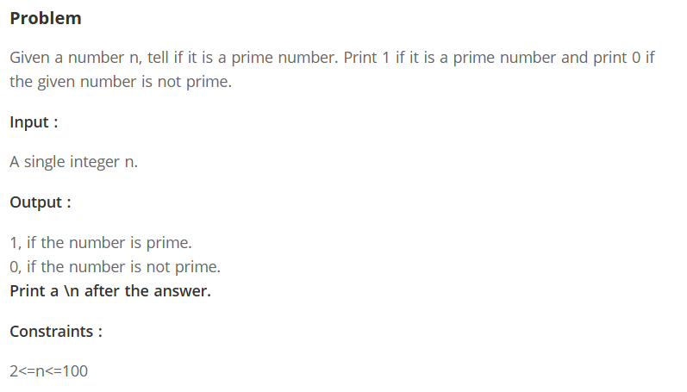
C Source Code –
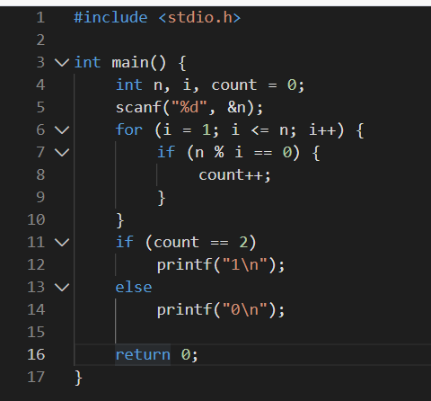
Submission –


