Platform – LeetCode
Question – 1281. Subtract the Product and Sum of Digits of an Integer
Problem Statement Link - https://leetcode.com/problems/subtract-the-product-and-sum-of-digits-of-an-integer/description/
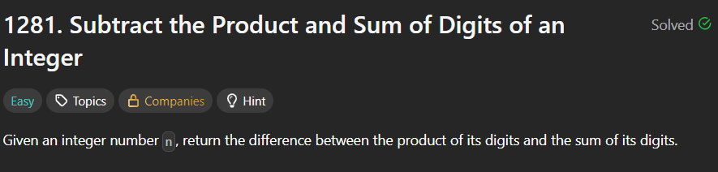
C Source Code –
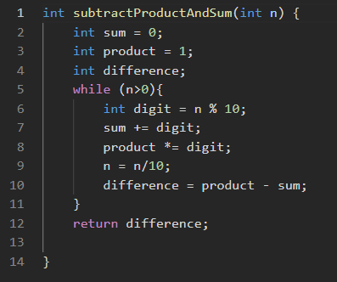
Submission –


