Platform – LeetCode
Question – 231. Power of Two
Problem Statement Link - https://leetcode.com/problems/power-of-two/
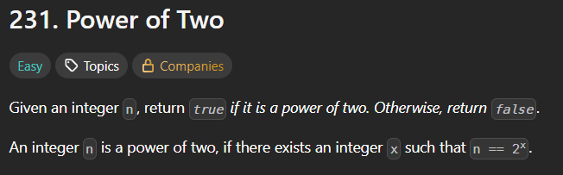
C Source Code –
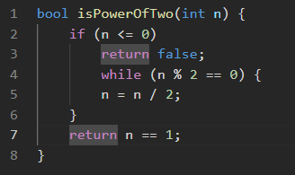
Submission –


