Platform – LeetCode
Question – 2520. Count the Digits That Divide a Number
Problem Statement Link - https://leetcode.com/problems/count-the-digits-that-divide-a-number/description/
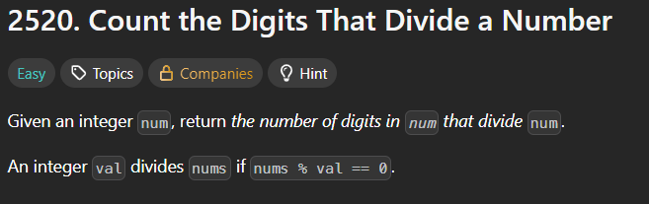
C Source Code –
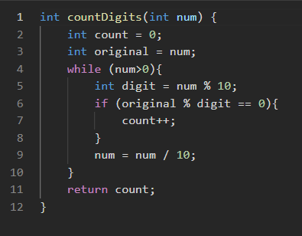
Submission –


