Platform – LeetCode
Question – 326. Power of Three
Problem Statement Link - https://leetcode.com/problems/power-of-three/
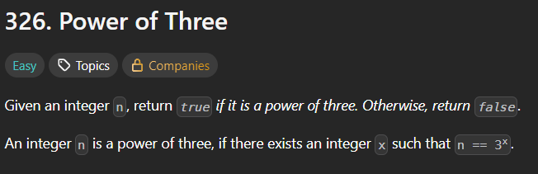
C Source Code –
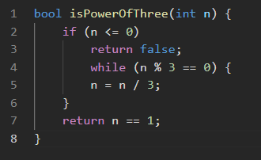
Submission –


