Platform – LeetCode
Question – 507. Perfect Number
Problem Statement Link - https://leetcode.com/problems/perfect-number/description/
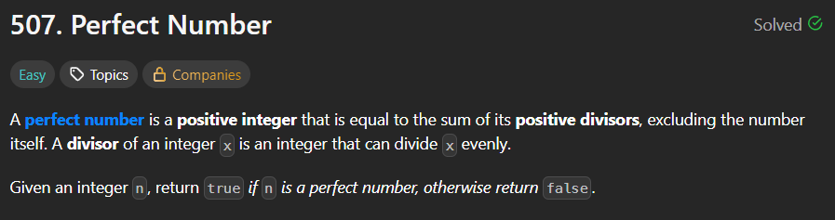
C Source Code –
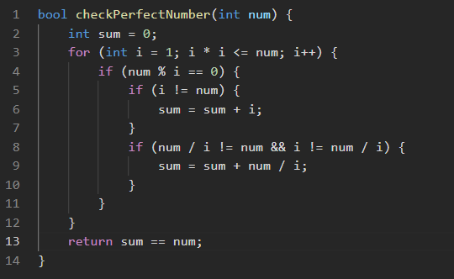
Submission –


