Platform – LeetCode
Question – 7. Reverse Integer
Problem Statement Link - https://leetcode.com/problems/reverse-integer/description/
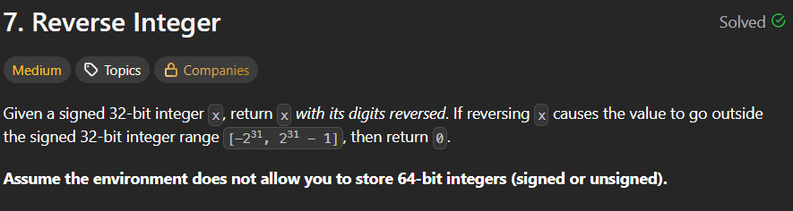
C Source Code –
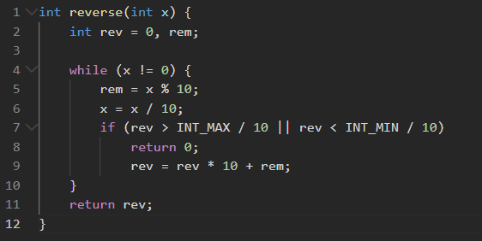
Submission –


