Platform – LeetCode
Question – 9. Palindrome Number
Problem Statement Link - https://leetcode.com/problems/palindrome-number/description/
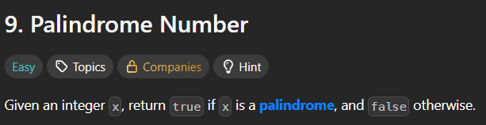
C Source Code –
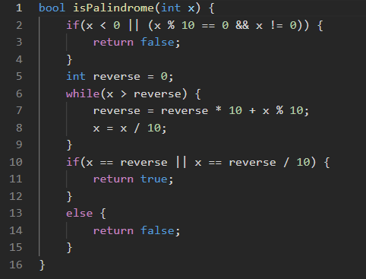
Submission –


