Platform – HackerRank
Question – Printing Pattern Using Loops
Problem Statement Link - https://www.hackerrank.com/challenges/printing-pattern-2/problem
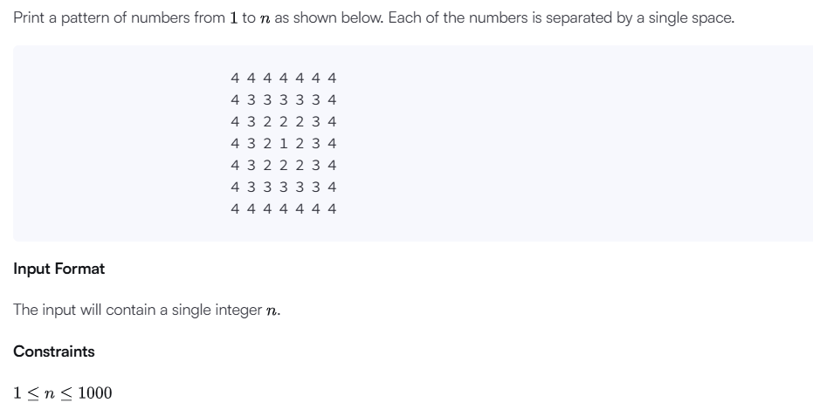
C Source Code –
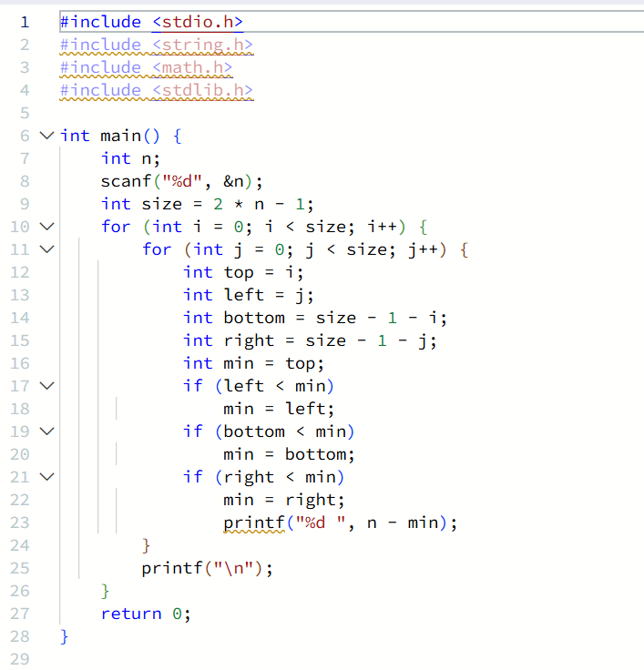
Submission –


