Platform – HackerRank
Question – Staircase
Problem Statement Link - https://www.hackerrank.com/challenges/staircase/problem
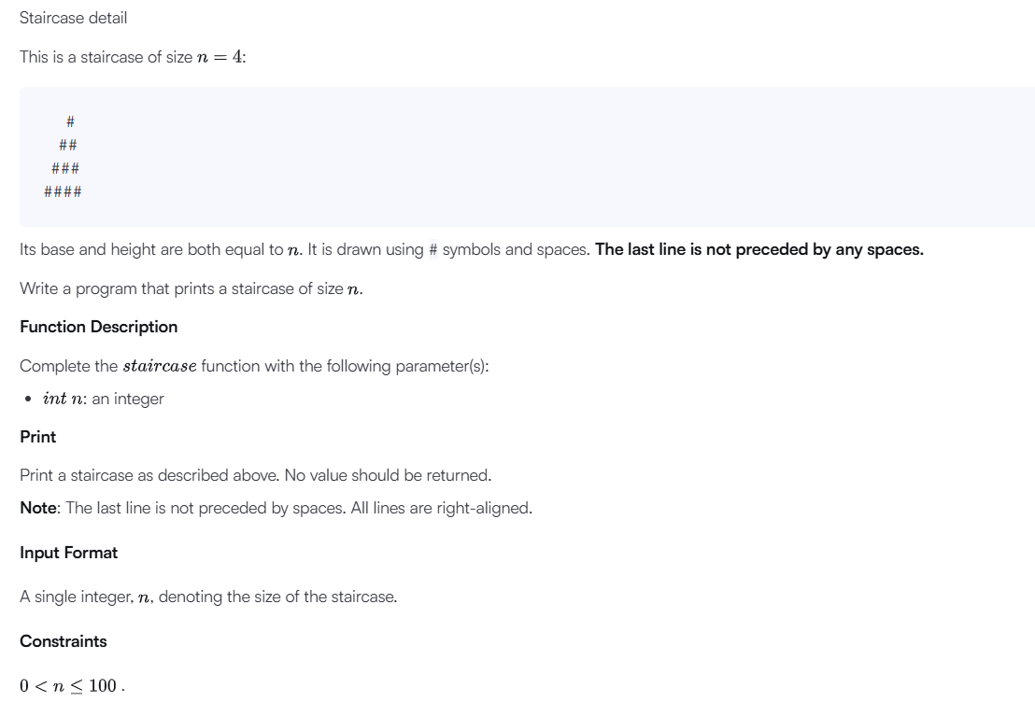
C Source Code –
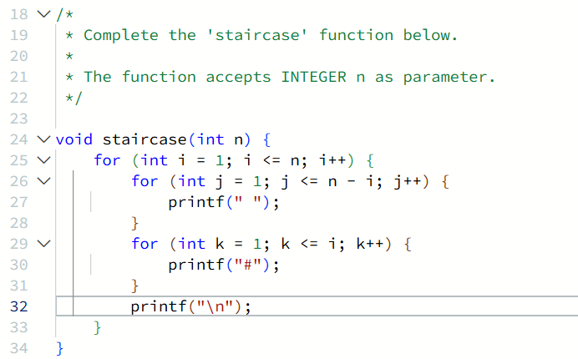
Submission –


