Platform – HackerEarth
Question – Digit Sum
Problem Statement Link - https://www.hackerearth.com/problem/algorithm/digit-sum-4/
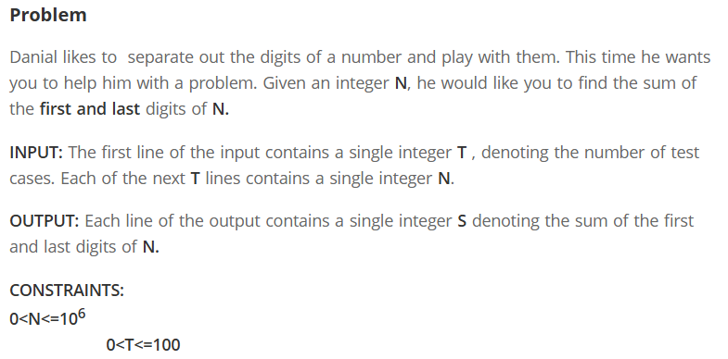
C Source Code –
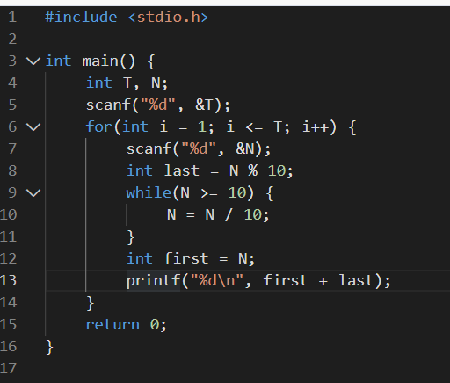
Submission –


