Platform – HackerRank
Question – Find Digits
Problem Statement Link - https://www.hackerrank.com/challenges/find-digits/problem
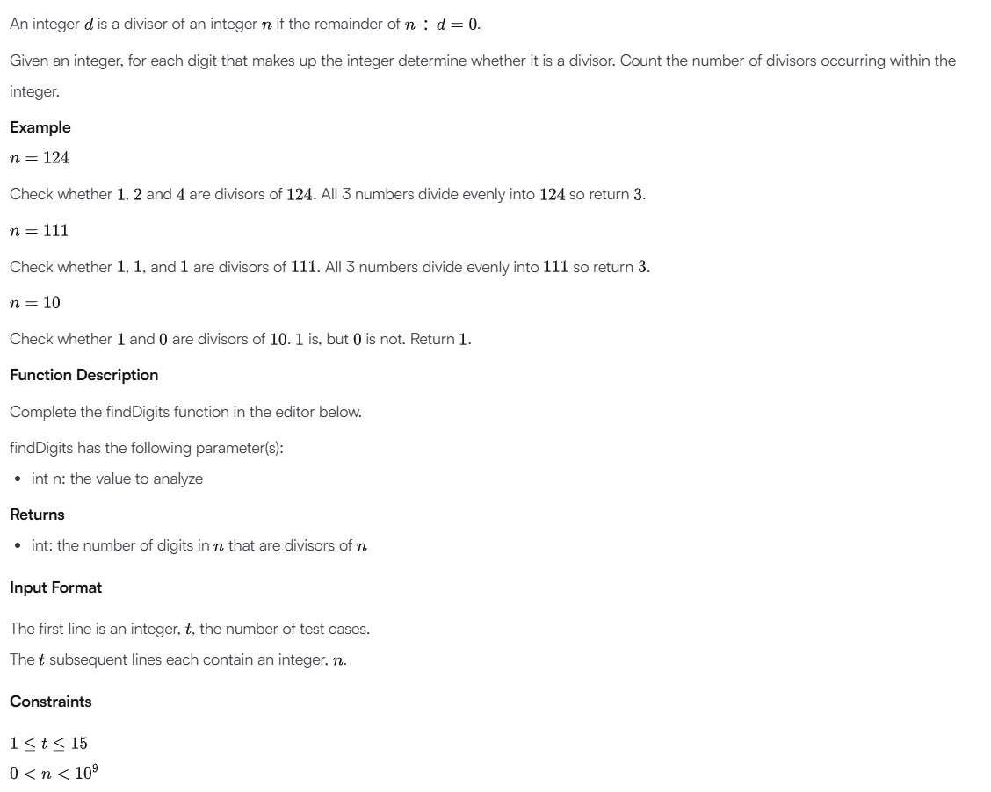
C Source Code –
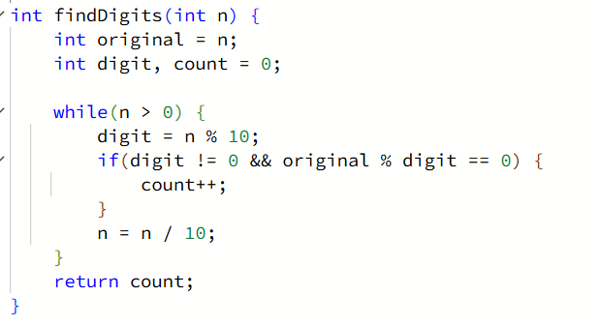
Submission –


