Platform – HackerRank
Question – Number Line Jumps
Problem Statement Link - https://www.hackerrank.com/challenges/kangaroo/problem
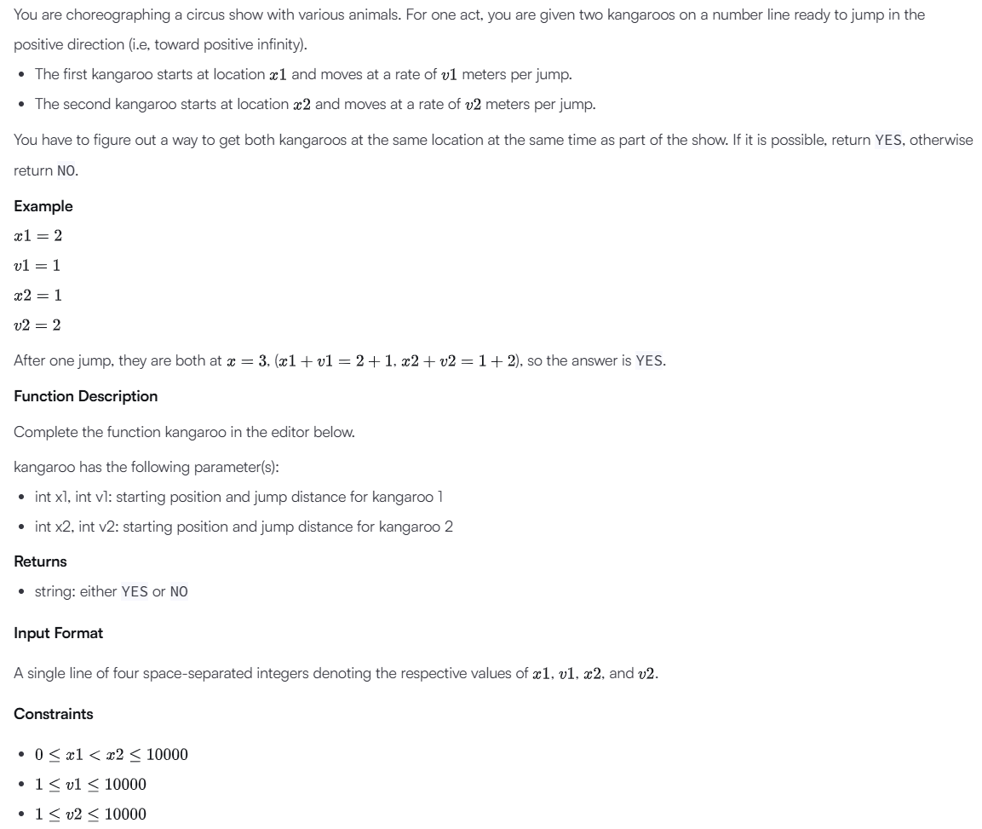
C Source Code –
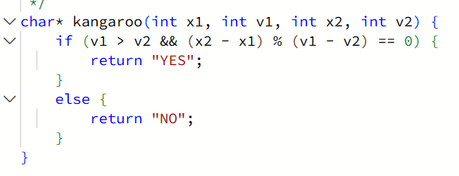
Submission –


