Platform – LeetCode
Question – 1523. Count Odd Numbers in an Interval Range
Problem Statement Link - https://leetcode.com/problems/count-odd-numbers-in-an-interval-range/description/
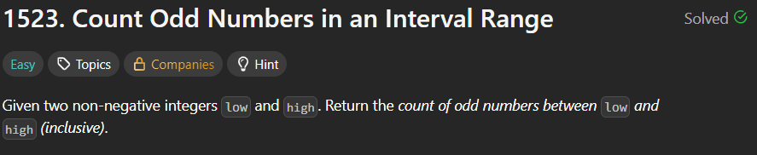
C Source Code –
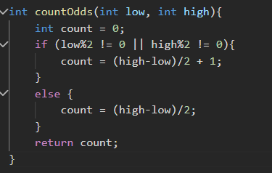
Submission –


