Platform – LeetCode
Question – 2652. Sum Multiples
Problem Statement Link - https://leetcode.com/problems/sum-multiples/description/
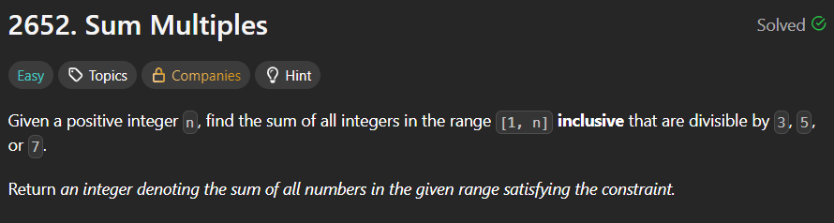
C Source Code –
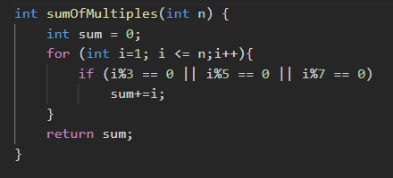
Submission –


