Platform – HackerRank
Question - Solve Me First
Problem Statement Link - https://www.hackerrank.com/challenges/solve-me-first/problem
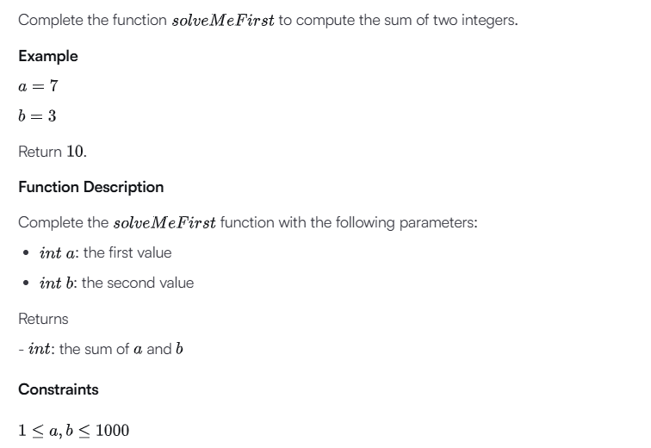
C Source Code –
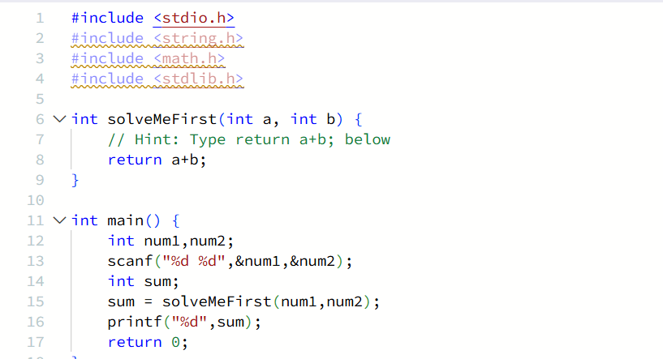
Submission –


