Platform – HackerEarth
Question – Roy and Profile Picture
Problem Statement Link - https://www.hackerearth.com/practice/basic-programming/input-output/basics-of-input-output/practice-problems/algorithm/roy-and-profile-picture/
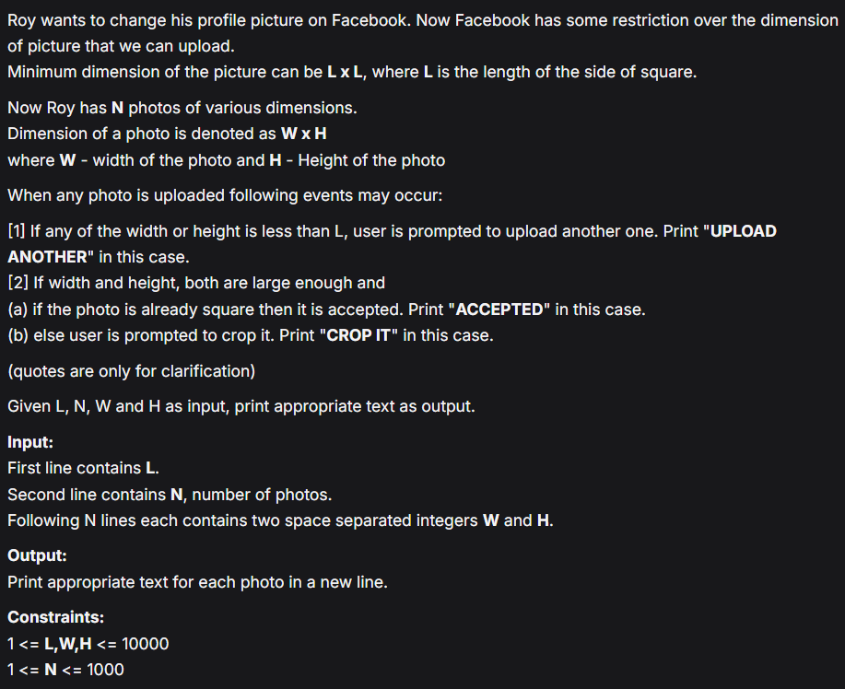
C Source Code –
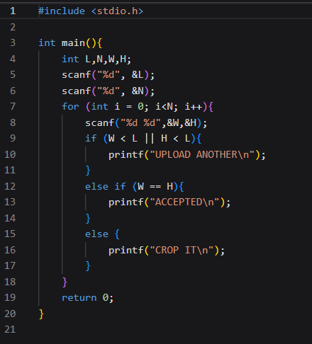
Submission –


